1. Specification

1.1 Perfomance Specification

Item |  | Description
Transmission Speed |  | 1Mbps
Encoding type |  | Manchester Biphase-L
Electric | Transmission Distance  (Segment) | Max. 750m
Electric | Total Transmission  Distance  (Using Repeaters) | Max. 750m × (6 repeater + 1) = 5.25 km
Electric | Cable | Twisted pair shielded cable
Optical | Transmission Distance  (Segment) | Max. 3km
Optical | Total Transmission  Distance  (Using EOC) | Max. 3km × (6 EOC +1) = 21km
Optical | Cable | Optical cable
Max. No. of Station |  | Master + slave = 64Station  (1 Master, 63 Slave)
Access Method |  | Circulated token passing

♣Note !

Max. Transmission size per station
Modules |  | Send + Receive  per Station | Send  per Station | No. of  Block | Block | Remarks
Fnet  Module | G3L-FUEA  (K7F-FUEA) | 3840 words | 1920 words  (32block  × 60word) | 64 blocks | 60 words
Fnet  Module | K3L-RBEA
Fnet  Module | G4L-FUEA  (K4F-FUEA)
Fnet  Module | G6L-FUEA  (K3F-FUEA)
Fnet  Module | G0L-FUEA

1.2 Twisted pair cable for Fnet

Cable contents
Product name |  | Low Capacitance LAN Interface Cable
Type name |  | LIREV-AMESB
Size |  | 2 × 1.0mm (GS 92-3032, 18 AWG)
Maker |  | LG CABLE CO.,LTD
Electric characteristics
Item |  | Unit | Characteristic | Test Condition
Conductor resistance |  | Ω/km | 21.8 or less | Normal Temp.
Withstanding voltage(DC) |  | V/min | Withstands at 500V for 1 minute | In air
Insulation resistance |  | MEGA Ω-km | 1,000 or more | Normal Temp.
Static electricity capacity |  | pF/m | 45 or less | 1 kHz
Characteristic impedance |  | Ω | 120 ± 12 | 10 MHz
Characteristics in appearance
Conductor | Number of core | CORE | 2
Conductor | Specification | AWG | 18
Conductor | Configuration | NO./mm | 1/1.0
Conductor | Outer diameter | mm | 1.0
Insulator | Thickness | mm | 0.9
Insulator | Outer diameter | mm | 2.8

● Structural drawing

Conductor
Braided material
Sheath material
Insulator
AL/Mylar Tape
Ground line
1.3 Optical cable for Fnet

Type name : G0C-F□□□ (□□□ is length of cable, unit : m)
Ex.) Optical cable 10m : G0C-F010

Specifications of optical cable
Cable contents
Type name | Y22□□□□ : For indoor (for Bi-directional communication)  D22□□□□ : For outdoor (for Bi-directional communication)
Connector type | ST - Type
Maker | Hewlett Packard(H.P)

Segment |  | For indoor(standard) | For outdoor(standard)
 |  | Y22□□□□ | D22□□□□
Outer diameter (mm) |  | 2.9 × 5.8 | 4.8
Min. Radius  of curvature | Loaded (cm) | 5.0 | 7.5
Min. Radius  of curvature | Unloaded (cm) | 3.0 | 4.8
Weight(Kg/m) |  | 16 | 21

Contents | Characteristic | Unit
Core | 62.5 | μm
Cladding | 125 | μm
Max. attenuation | 5 | dB/km
Standard attenuation | 4.5 | dB/km

Connector type
Connector type
Ex.) If the cable type is Y226969, connector type is ST and the
shape is stainless at both of the connectors.
● Outside drawing of optical cable

For indoor(Y22□□□□)
For outdoor(D22□□□□)

2. System Configuration

1) CPU Link system (Twisted pair cable)
 | Devices for network A (Fnet electric)
 | Type | Module name | Ex. of station number setting
 | FAM4.0 | G0L-FUEA | 0
 | GM3 / K1000S | G3L-FUEA / K7F-FUEA | 1
 | GM3 / K1000S | G3L-FUEA / K7F-FUEA | 2
 | GM3 / K1000S | G3L-FUEA / K7F-FUEA | 3
 | GM4 (GM6)  K300S (K200S) | G4L-FUEA (G6L-FUEA)  K4F-FUEA (K3F-FUEA) | 4
 | PMU-500 | PM0-500F | 5

2) CPU Link system (Optical cable)

Devices for network A (Fnet optical)
Type | Module name | Ex. of station number setting | Cable connection
K1000s / GM3 | G3L-FUOA / K7F-FUOA | 0 | Transmission→Receive  (Active coupler)  Receive→Transmission  (Active coupler)
K1000s / GM3 | G3L-FUOA / K7F-FUOA | 1
K1000s / GM3 | G3L-FUOA / K7F-FUOA | 2
Active coupler | G0L-FACA/FABA/FAPA | Not available

3) Remote/slave Link system (Twisted pair cable)

 | Devices for network A (Fnet electric)
 | Type | Module name | Ex. of station number setting
 | GM3  K1000S | G3L-FUEA  K7F-FUEA | 0(slot 0)
 | GM3  K1000S | G3L-FUEA  K7F-FUEA | 2(slot 0)

 | Devices for network B (Fnet electric)
 | Type | Module name | Ex. of station number setting
 | GM3  K1000S | G3L-FUEA  K7F-FUEA | 1(slot 1)
 | GM3 remote I/O  K1000S remote I/O | G3L-RBEA  K7F-RBEA | 3
 | GM4 remote I/O  K300S remote I/O | G4L-RBEA  K4F-RBEA | 4
 | Stand-alone remote output | G0L-SMQA | 5

3. Interface Module

RUN
LAS
TOKEN
TX/RX FAULT
K3F-FUEA

ON-LINE
TEST1
TEST2
CON1
①
②
③
④
⑤
×10
×1
CON2
①Type name indicating section
Indicates type name of communication module

②LED indicating section
RUN | Indicates the status of CPU module and interface
LAS | Indicates that communication module is performing LAS function.
TOKEN | Indicates whether communication module has a token or not.
Tx/Rx | Indicates whether communication module is transmitting/ receiving  or not.
FAULT | Flickers when the error that normal operation is not possible  occurred in communication module

③Station number setting switch
Sets station number in the range of 0~63 station(Use decimal).

④Mode setting switch
Sets operation mode of communication module

⑤Communication connector
Connector for electric cable connection to connect communication module.

4. Example of CPU Link system

4.1 System configuration
Fnet (1Mbps, 64station, 750m, Twisted pair cable)

Station No. 0
Station No. 1
Station No. 2

Fnet-Module
G6L-FUEA
K3F-FUEA

4.2 Wiring

ST #1

ST #2

ST #0
Frame shield
6
6

7
7

Frame shield

Terminal resistance
(110Ω, 0.5W)
6
6

7
7

Terminal resistance
(110Ω, 0.5W)

4.3 Data flow

1) GLOFA GM6

00 Station

01 Station
02 Station
%IW0.0.0 (Block 0)
%MW50
(Block 0)
%IW0.0.1
(Block 0)
%QW0.1.0
%QW0.1.1
%QW0.1.0
%MW100
%QW0.1.0
Not
Defined

4.4 Setting Link Parameter (GLOFA GM6)

4.4-1 Link Parameter of Station 0

1) Connect GMWin to Station 0
2) Select ‘Link Parameter’ in parameter menu of GMWIN
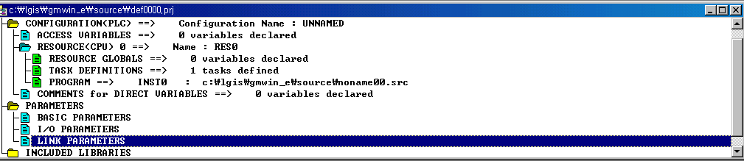
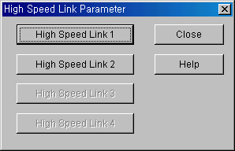

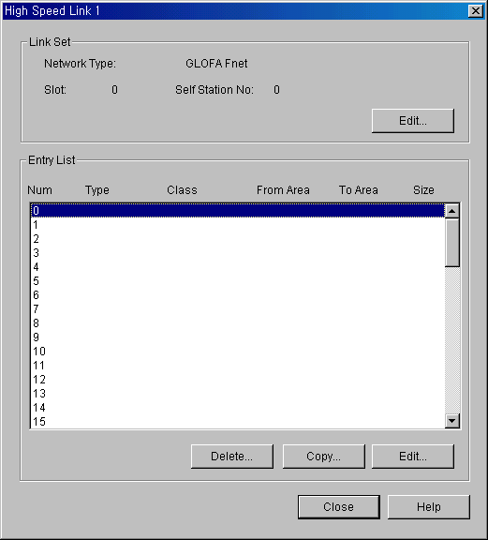
Click here for
Setting a self-station
Select High Speed Link 1
(In case of using two Fnet module
in a main base, high speed link 1
and 2 will be set)

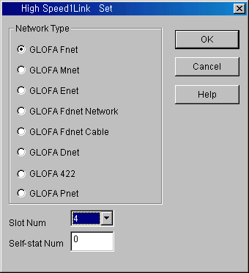

Select slot no. Fnet module
mounted and self station number

3) High Speed Link Parameter for sending (Station 0 → All other station)

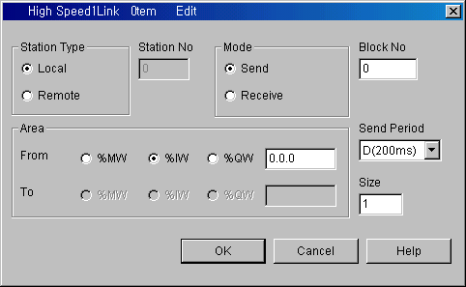
In case of CPU Link, Select Local
In case of Remote Link, Select Remote
Head addres to be sent
(%IW0.0.0 is sent to
all other stations)
In case that two or more
sending area is used,
Each sending must have a
different Block No..

♣ Point

- Block No
This is set to transmit and receive many data of several area from one station, and distinguishes data of many
block each other.
Station number and block number configured from transmission station is transmitted with transmission data.
Block number and station number should be set for all of Tx/Rx station.
Because storing the data in Receive Area can be made if the block No. is the same with other station No. of
high Speed link Receiving parameter.
Transmission block number can be set up to 32 and receive block number also can be set up to 32 for one
station, so max. of each Tx/Rx block number is limited to 34. In this time, the same block No. setting with
same station No. is impossible.

- Tx/Rx Period
High speed link executes transmission and receive at that time when PLC program is finished by the
parameter which user previously configured.
If scan time of PLC program is short(within several ms), communication module transmits data according to
program scan, and the increase of communication quantity with this causes reduction of communication efficiency.
To prevent this, user can set communication period from 20ms to 10sec.
Tx/Rx period means transmission period if selected block is set to transmission, and this means data receive
checking period of selected block if it is set to receive.
Transmission period determines data transmission period.
For example, if transmission data is set to 200ms(standard value), it will be transmitted every 200ms.
If scan time of PLC program is longer than transmission period previously set, it will be transmitted when program
scan is finished, and transmission period will be the same as scan time of PLC program.

4) High Speed Link Parameter for receiving (Station 1 → Station 0/Self Station)

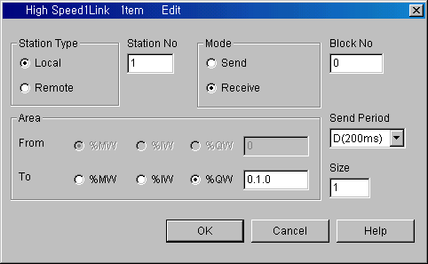
Head addres to be stored
(Data from station 1 is
stored in %QW0.1.0)
Other station’s no.
from which data is
received
Other station’s (St.1)
block no.

5) High Speed Link Parameter for receiving (Station 2 → Station 0/Self Station)

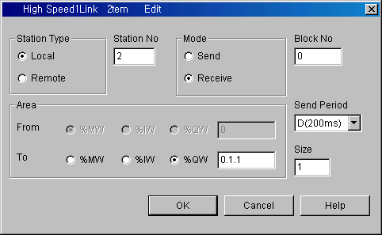
Head addres to be stored
(Data from station 2 is
stored in %QW0.1.1)
Other station’s no.
from which data is
received
Other station’s (St.2)
block no.

4.4-2 Link Parameter of Station 1

1) Connect GMWin to Station 1
2) Select ‘Link Parameter’ in parameter menu of GMWin

Click here for
Setting a self-station
Select High Speed Link 1
(In case of using two Fnet module
in a main base, high speed link 1
and 2 will be set)

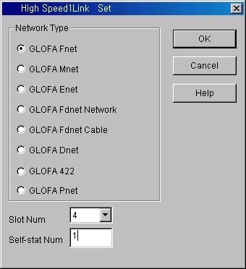
Select slot no. Fnet module
mounted and self station number

3) High Speed Link Parameter for sending (Station 1 → All other station)

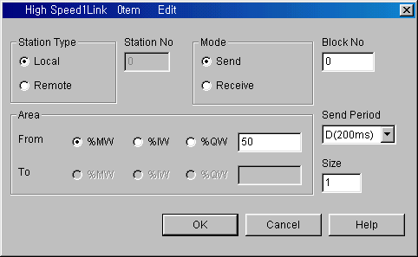

In case of CPU Link, Select Local
In case of Remote Link, Select Remote
Head addres to be sent
(%MW50 is sent to
all other stations)
In case that two or more
sending area is used,
Each sending must have a
different Block No..

4) High Speed Link Parameter for receiving (Station 0 → Station 1/Self station)

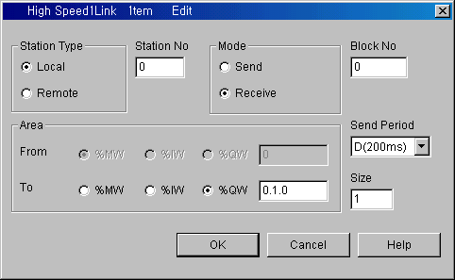
Head addres to be stored
(Data from station 0 is
stored in %QW0.1.0)
Other station’s no.
from which data is
received
Other station’s (St.0)
block no.

5) High Speed Link Parameter for receiving (Station 2 → Station 1/Self station)

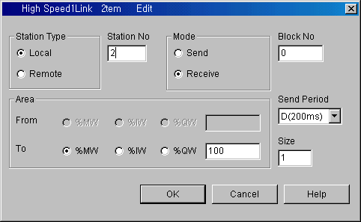
Head addres to be stored
(Data from station 2 is
stored in %MW100)
Other station’s no.
from which data is
received
Other station’s (St.2)
block no.

4.4-3 Link Parameter of Station 2

1) Connect GMWin to Station 2
2) Select ‘Link Parameter’ in parameter menu of GMWin

Click here for
Setting a self-station
Select High Speed Link 1
(In case of using two Fnet module
in a main base, high speed link 1
and 2 will be set)

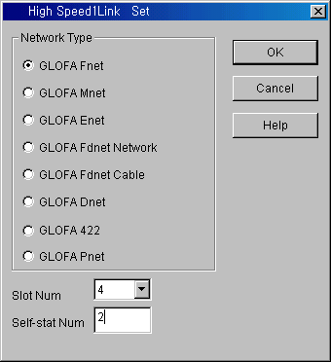
Select slot no. Fnet module
mounted and self station number

3) High Speed Link Parameter for sending (Station 2 → All other station)
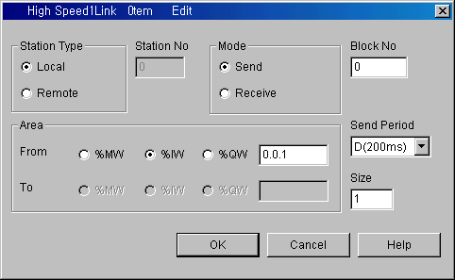

In case of CPU Link, Select Local
In case of Remote Link, Select Remote
Head addres to be sent
(%IW0.0.1 is sent to
all other stations)
In case that two or more
sending area is used,
Each sending must have a
different Block No..

4) High Speed Link Parameter for receiving (Station 0 → Station 2/Self station)

Head addres to be stored
(Data from station 0 is
stored in %QW0.1.0)
Other station’s no.
from which data is
received
Other station’s (St.0)
block no.

4.4-4 Parameter Download & Link Enable

- After parameter writing, high speed link is maintained to the stop status.
- To start communication, user must set link enable for each station
- Link enable setting is possible in the stop mode only. and if high speed link enable setting is
started, high speed link is performed regardless of PLC operation mode
- Parameter and link enable information are preserved, even if power is off due to battery back-up
in PLC CPU.
CPU Mode | Parameter downloading | Link enable setting | High speed link operation | Remark
PLC RUN | × | × | ○ | Only if high speed link enable, it is operated.
PLC STOP | ○ | ○ | ○ | Only if high speed link enable, it is operated.
PLC PAUSE | × | × | ○ | Only if high speed link enable, it is operated.
PLC DEBUG | × | × | ○ | Only if high speed link enable, it is operated.

- ‘Link Enable’ procedure is as belows
- Connect GMWin to the station 0
- Switch CPU mode to ‘STOP’
- Select ‘Online – Link enable’ in the memu
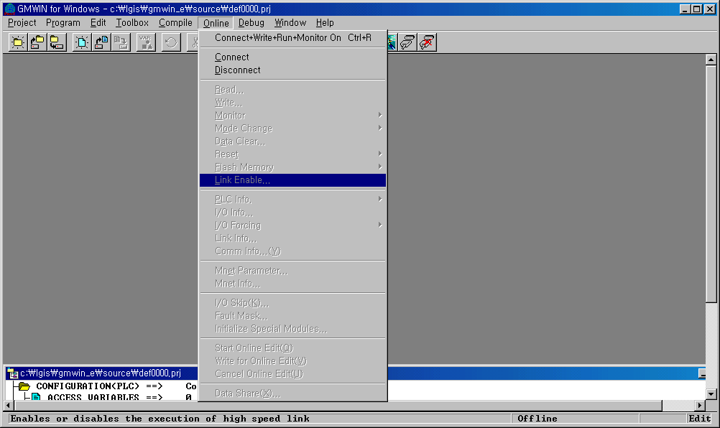

3) Set Link Enable for High Speed Link 1 (HS Link 1)

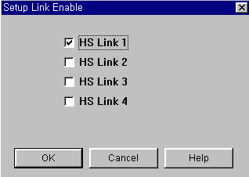
♣ Setting Link Parameter (for Master K)

- Operating and concept of Fnet system for Master K is the same as that of GLOFA
- Software(KGLWin) operation is different only for Link Parameter setting.
- Link parameter setting procedure is as below
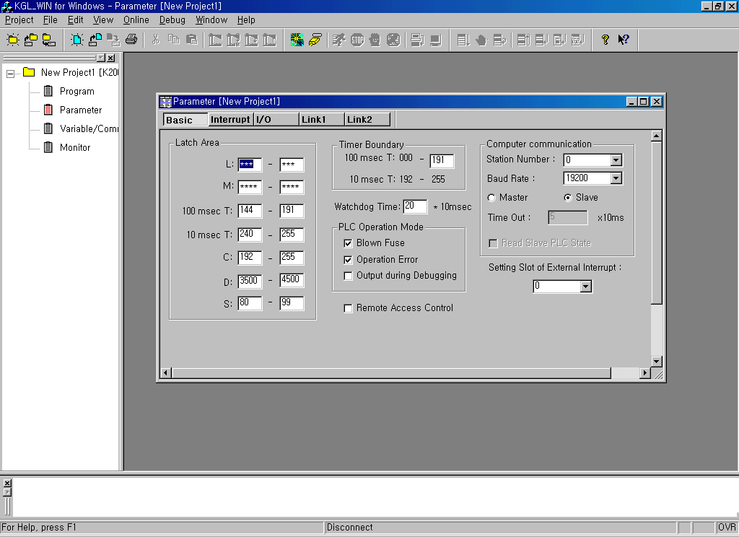
1) Clink ‘Parameter’ in the project menu.

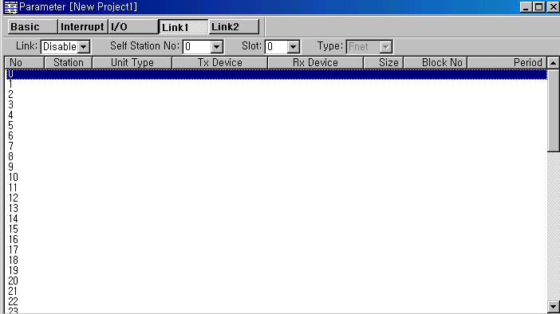
2) Select ‘Link 1’ (In case of using two Fnet module in a main base, Link 1 and 2 will be set)

Select slot no. Fnet module
mounted and self station number
Link Enable setting

3) Click the first link in link parameter setting window.

- In case of send (Sned data to all other stations)
In case that two or more sending area is used,
Each sending must have a different Block No..

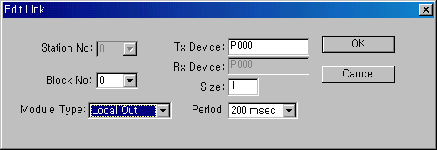

Head addres to be sent
(P000 is sent to all other stations)
Send / Receive setting
- Local Out : Send to Local (CPU) station
- Local In : Receive from Local (CPU) station
- Remote Out : Send to Remote(I/O) station
- Remote In : Receive from Remote(I/O) station

- In case of receive (Receive data from one station designated)
In case that two or more sending area is used,
Each sending must have a different Block No..

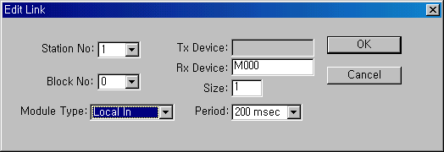

Send / Receive setting
- Local Out : Send to Local (CPU) station
- Local In : Receive from Local (CPU) station
- Remote Out : Send to Remote(I/O) station
- Remote In : Receive from Remote(I/O) station
Head addres to be sent
(M000 is sent to all other stations)

5. Example of Remote Link System

5-1. System Configuration
Fnet (1Mbps, Max 750m, Twisted pair cable)

I
16
I
32
Q
16
Q
32
•••
I
32
Q
16
•••

Station No. 0 (Master)
Station No. 1 (Remote)
Station No. 2 (Remote)

Fnet Master Module
GLOFA : G3L-FUEA, G4L-FUEA, G6L-FUEA
Master K : K7F-FUEA, K4F-FUEA, K3F-FUEA

Fnet Slave Module
GLOFA : G3L-RBEA, G4L-RBEA, G6L-RBEA
Master K : K7F-RBEA, K4F-RBEA, K3F-RBEA

5-2. Example Data Flow

Station No. 0 (Master)

%MW4
~%MW5
%MW2
~%MW3
%MW1
%MW0
%IW0.6.0
~%IW0.6.1
%QW0.7.0

Block 0
Block 1
Block 2
Block 3
Block 4
Block 5

%QW0.3.0
~%QW0.3.1
%IW0.2.0
~%IW0.2.1
%QW0.1.0
%IW0.0.0
%IW0.0.0
~%IW0.0.1
%QW0.1.0

I
16
I
32
Q
16
Q
32
•••
Station No. 1 (Remote)
I
32
Q
16
•••
Station No. 2 (Remote)

5-3. Link Address Mapping (GLOFA)
 | Station 1 |  |  |  | Station 2
Slot No. | 0 | 1 | 2 | 3 | 0 | 1
In / Out | Input 16 | Output 16 | Input 32 | Output 32 | Input 32 | Output 16
Block No. | 0 | 1 | 2 | 3 | 4 | 5
Remote  Address | %IW0.0.0 | %QW0.1.0 | %IW0.2.0  ~%IW0.2.1 | %QW0.3.0  ~%QW0.3.1 | %IW0.0.0  ~%IW0.0.1 | %QW0.1.0
Master  Address | %MW0  (%MX0  ~%MX15) | %MW1  (%MX16  ~%MX31) | %MW2  ~%MW3  (%MX32  ~%MX63) | %MW4  ~%MW5  (%MX64  ~%MX95) | %IW0.6.0  ~%IW0.6.1 | %QW0.7.0

- Remote address means just real in/out position and size then these address matched to
master address.
- When programming on master side for controlling remote I/O, master address matched remote
address will be used.
- In this example, slot 6 and 7 of master regard as being empty (not occupied by any module)
- Each sending and receiving should have a different block number.

5-4. Link Parameter (GLOFA)
- Setting for Station 1
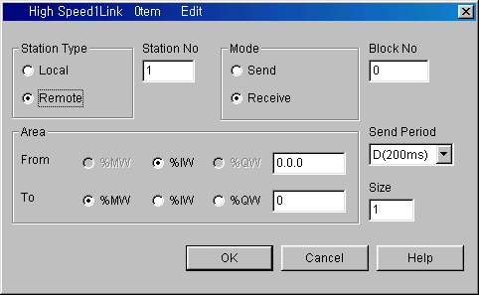
Master Head Address
Remote Station
Input Head Address
Remote Station No.

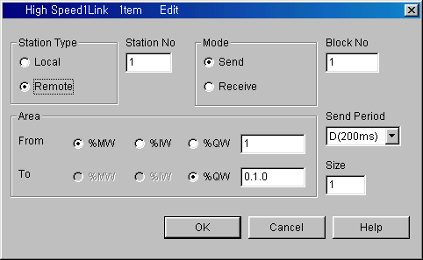
Master Head Address
Remote Station
Output Head Address

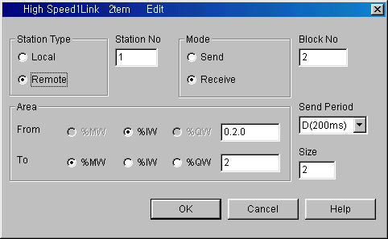

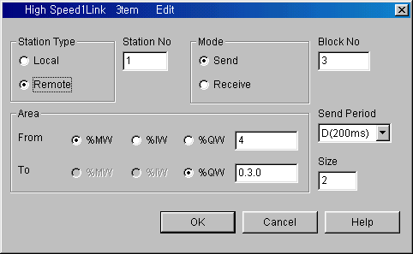

- Setting for Station 2

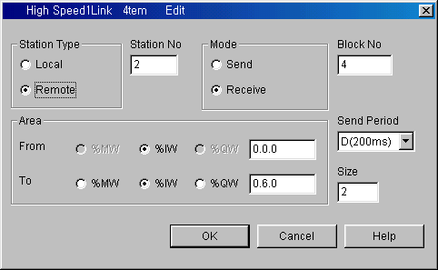
Remote Station
Input Head Address
Master Head Address
(This area should be
not occupied by any
other module)

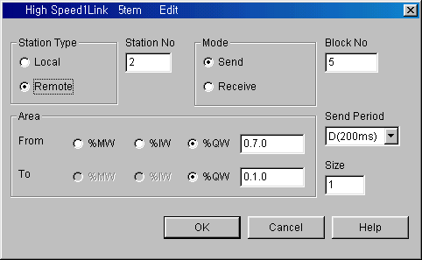
Master Head Address
(This area should be
not occupied by any
other module)
Remote Station
Output Head Address

3) Link Parameter setting completed
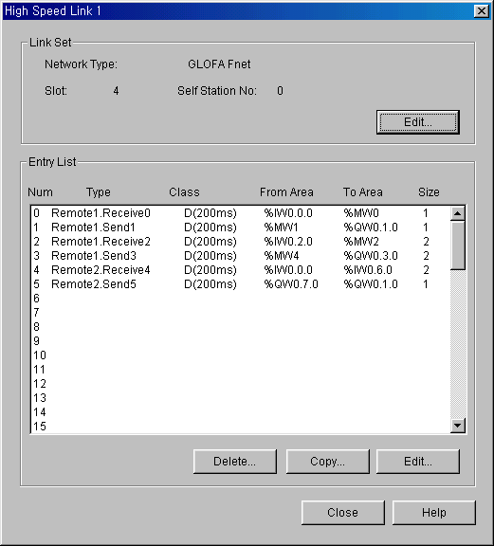

5-5. Downloading Link parameter and Link enable

1) Connect GMWin to GLOFA then download parameter.
2) Select ‘On line – Link Enable’ on the GMWin menu.
3) Select ‘HS Link 1’.

