1. Features

- GLOFA Etherent system supports International Standard Specification. (IEEE 802.3)
- GLOFA Etherent system supports International Standard Protocol. (TCP, IP, UDP, ARP)
- GLOFA Etherent system supports International Standard Cable Specification.
- 10 Base 5
- 10 Base 2
- 10 Base T
- Various Communication Service
- Dedicated Protocol Service (Port 2004)
- Function Block Service (User Defined)
- High Speed Link Service (Port 2006)
- GMWin Service (Port 2002)
- The Maximum Number of Connection is 16. (Dedicated Protocol Service + FB Service)
- By using Frame Editor, Easy Programming for Communication with other equipment is
possible.
- Max. 4 Modules can be installed in main base

# Caution
Ethernet Module requires . . . . .
• GLOFA PLC GMWIN Program Tool : Ver 3.0 or higher
• GLOFA GM1/2 CPU : Ver 1.2 or higher
• GLOFA GM3 CPU : Ver 1.8 or higher

2. Specification

2-1 Performance Specification

 |  | Specification
 |  | 10 Base 5 | 10 Base 2 | 10 Base T
Trans.  Spec. | Transmission Speed | 10Mbps
Trans.  Spec. | Transmission Method | Baseband
Trans.  Spec. | Max. Distance | 2500m | 925m | -
Trans.  Spec. | Max. Distance  (Segment) | 500m | 185m | 100m  (Node↔HUB)
Trans.  Spec. | Max. Nodes | 100/Segment | 30/Segment | Dependant to HHB
Trans.  Spec. | Min. Distance  Between Nodes | 2.5m | 0.5m | -
Trans.  Spec. | Max Protocol Size | 1500 Byte
Trans.  Spec. | Access Method | CSMA/CD
Trans.  Spec. | Frame Error Check | CRC 16 = X¹⁵ + X¹⁴ + X¹³+ .... + X² + X + 1
Basic  Spec. | DC 5V, Internal  Consumption Current | 530Ma
Basic  Spec. | Dimension | 250H x 35W x 140.7D
Basic  Spec. | Mass | 460g

2-2 Names of Parts

1) Front Part
LED Diaplay
10 Base T Connector
10 Base 5 Connector
External Power
Supply Terminal
& Display
(DC.12V,
In case of
10 Base 5 only)
Mode Select Switch
0: Run (On Line)
1: Test Mode 1
2: Test Mode 2
No | Display | Description
0 | RUN | Power & Module Initializing is normal
1 | CPU I/F RUN | Exchange(CPU↔Module) is Normal
2 | FB -SERVICE | Turns on during execution FB Service
3 | HS-SERVICE | Turns on during execution High  Speed Link Service
4 | GMWIN -  SERVICE | Turns on during execution GMWin  Service
5 | GLOFA -  SERVICE | Turns on during execution dedicated  Protocol Service
6 | FTP-  SERVICE | Turns on during execution FTP Service  (Not support yet)
7 | H/W -ERROR | Occurring Fatal Hardware Error
8 | -- | Not Used
9 | -- | Not Used
10 | 10BASE5 Enable | 10 Base 5 Enable & Ready
11 | 10BASE2 Enable | 10 Base 2 Enable & Ready
12 | 10BASE-T  LINK | 10 Base T Connected
13 | 10BASE-T  PLRTY | Pority 10 Base T
14 | TX | Turns on during Transmitting
15 | RX | Turns on during receiving

10 Base 2 Connector
3. System Configuration

3-1. 10 Base 5

Transceiver
Transceiver
Terminator

■ ■
Transceiver Cable (Max. 50m)

Segment (Max. 500m)

3-2. 10 Base 2
T-Type Connector (BNC Connector & Terminator)
BNC Cable

Segment (Max. 185m)

3-3. 10 Base T
HUB
UTP/STP Cable
UTP/STP Cable
Max. 100m

4. Communication Service

4-1. Dedicated Protocol Service
1. Concept
1) This service make other nodes enable reading / writing information and data memory
in PLC CPU directly by using dedicated protocols built in PLC Ethernet module.
(G3L-EUEA / G4L-EUEA).
2) CPU control function (stop/pause/run) and PLC Program up/down loading is also possible
by this service.
3) TCP Port 2004 is assigned for this service and user cannot change this port no.
4) This service is mainly used for communicating between GLOFA PLC and computer.

2. Operation Flow

GM4 CPU
G4L-EUEA
①Connection Request
Port
2004
⑤Search &
Exchange
②Connection complete
Data
Memory
Internal
Memory
③Command
COMM
⑥Response

④
Application
User Program
(Visual C++,
MMI Package)
Communication
Processor
- ~ ② TCP Connection is established by other node’s(computer) connection request signal
to TCP port 2004.
- Other node sends the command frame created by user application software to Internal memory of PLC Ethernet module via TCP port 2004.
- Communication Processor of Ethernet module analyze and checks command frame.
- Datas requested by other node are exchanged between Ethernet module and PLC CPU.
- Ethernet module sends the response frame to other node.

4-2. Function Block (FB) Service
1. Concept
- Function Block service is used when the other node has a different protocol form from
GOLFA ethernet module and user intend to communicate with other node by using
other node’s protocol.
- Data frame can be easily created by frame editor tool and that frame file can be used
with Function Block in user’s PLC program.
3) This service is mainly used for communicating between GLOFA PLC and other ethernet
device which has an opened protocol format.

2. Operation Flow

GM4 CPU
G4L-EUEA
①Connection Request
②Connection complete
Internal
Memory
- Connection
Request
④Command
Function Block
E_CONN
COMM
③Command
⑤Response
Function Block
TCP_SEND
⑥Response
COMM
Application
User Program
Function Block
TCP_RCV

- ~ ② TCP Connection is established by execution of ‘E_CONN’ function block in PLC user
program.
③ By using ‘TCP_SEND’ function block, PLC CPU sends the command frame created by
frame editor tool to Ethernet module.
④ Ethernet module sends the command frame to other node via TCP port (Auto assigned)
⑤ Other node sends the response frame requested to Ethernet module.
- By using ‘TCP_RCV’ fuction block, PLC CPU receives the response frame from
Ethernet module

4-3. High Speed Link Service
- Concept
- High speed link service transmits data specified by link parameter to other nodes
cyclically.
- By just setting link parameter, All nodes can share data memory simply
- TCP Port 2006 is assigned for this service and user cannot change this port no.
- This service is mainly used for communicating between GLOFA PLCs.
- This service has the same concept as High speed link of F-NET.

4. Operation Procedure

Ethernet Parameter Setting

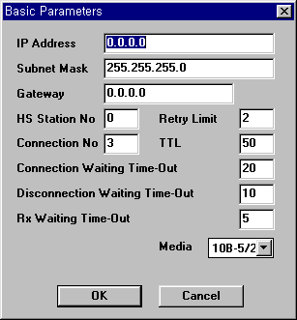
1.Common Basic
Setting
- IP Address
- Subnet mask
- Gateway .etc

FB Service
Dedicated Service
HS Link Service
2. Communication Frame
Creation by using
Frame Editor

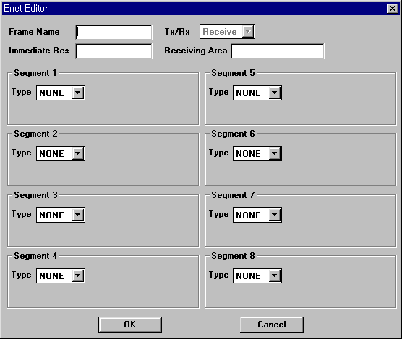

Down Loading Ethernet Parameter

2. High Speed Link
Parameter setting
by using GMWin
3. Making the program
by using Function Block
& Frame file
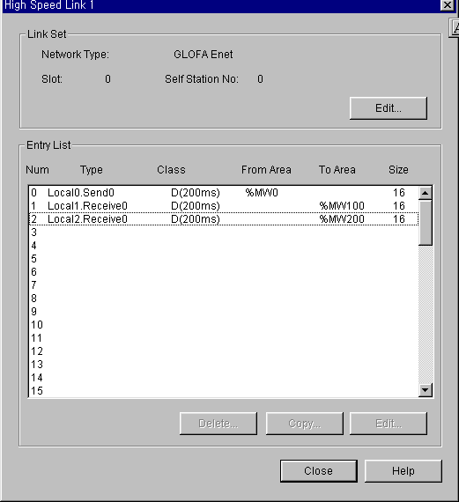
E_CONN
TCP_SEND

Down Loading
Ladder Program & Parameter

5. Example (Dedicated Protocol Service)

5-1. Example Overview
By using GLOFA’s dedicated protocol, IBM PC reads data memory (MW100)
In the PLC CPU and displays results on the monitor screen.

5-2. System Configuration

IBM Compatible
Computer
GM4 CPU / G4L-EUEA
Command

HUB
Response

UTP Cable

5-3. Test Environment

 | Computer | GLOFA
CPU | Pentium 133 | GM4 CPU
Ethernet Module | 3C509 (3COM) | G4L-EUEA
Cable | 10 Base T | 10 Base T
O/S | Windows95 | -
Development Language | MS Visual Basic | -
Protocol | TCP/IP (Microsoft) | TCP/IP
IP Address | 165.243.93.1 | 165.243.93.2
Port No | 2000 | 2004 (Fixed)
Client / Server | Client | Server
Communication Service | GLOFA Dedicated Protocol Service

5-4. Setting Ethernet Basic Parameter
- Ethernet frame editor tool is consist of two part, Basic parameter and Frame list.
- In part of basic parameter, the parameter related Ethernet is decided
- In case of dedicated protocol service, frame list is not required to be set.
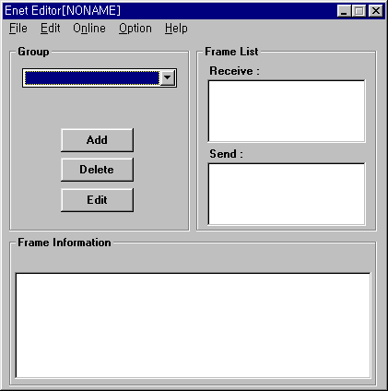
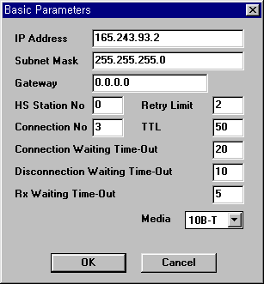

- IP Address : Sets IP Address of Ethernet module(G3L-EUEA/G4L-EUEA)
- Subnet Mask : This parameter means whether GLOFA (EUEA) and other node
are placed in the same network or not.
(255.255.255.0 means two node are placed in the same network)
- Gateway : In case that GLOFA (EUEA) and other node communicate via gateway,
sets IP Address of that gateway.
- HS Station No. : Sets High speed link station no. (available only in case of HS service)
- Connection No (Channel No) : Sets the number of TCP connection will be used for
Dedicated service.
Ethernet Module (IP Address)

Connection established

Port No
Connection No
- Connection Waiting Time out : If connection request signal is not received from other
node within the time to be set, an error occurs (available only in case of FB service)

- Disconnection Waiting Time out : If ACK signal to disconnection request of GLOFA
PLC Is not received from other node within the time to be set, GLOFA(EUEA) close
that connection.
- RX Waiting Time out : If command is not received form other node within the time to be
set, GLOFA(EUEA) close the connection. (available only in case of Dedicated Protocol
service)
- Retry Limit : Sets the number of retry

5-5. Computer Application Software (Sample software developed by visual basic)
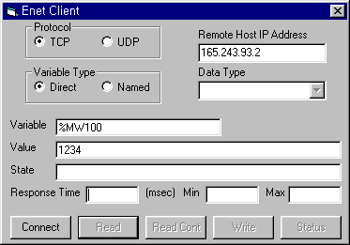
IP Address of GM4 (G4L-EUEA)
Variable Address to be monitored
- Set the IP Address of GM4 and variable address to be monitored.
- Click ‘ Connect ‘ and then ‘ Read ’ or ‘ Read Cont ’
- Value of variable(%MW100), current response time and minimum/maximum response time
will be displayed.

6. Example (FB Service)

6-1. Example Overview
By using Function Block and frame editor tool, GLOFA GM4 reads data memory
of MELSEC A2U (D100 ~ D102, 3words)

6-2. System Configuration

GM4 CPU / G4L-EUEA
A2U CPU / AJ71E71-S3
Command

Response
HUB
UTP Cable

Response(0)
Response(1)
Response(2)
D100
D101
D102

6-3. Test Environment

 | MELSEC | GLOFA
CPU | A2U CPU | GM4 CPU
Ethernet Module | AJ71E71-S3 | G4L-EUEA
Cable | 10 Base T | 10 Base T
Protocol | TCP/IP | TCP/IP
IP Address | 165.243.93.3 | 165.243.93.2
Port No | 3000 | 2004 (Fixed)
Client / Server | Server | Client
Communication Service | GLOFA FB Service

6-4. Setting Ethernet Basic Parameter
- Basic Ethernet Parameter is the same as case of Dedicated Service.

6-5. Frame Editing (Other node’s protocol editing)
- AJ71E71-S3’s (MELSEC Ethernet module) Protocol frame (Command/Response format)
can be easily created by frame editor tool and that frame will be used with Function Block
in GLOFA PLC program.
- AJ71E71-S3’s command and response format is as below

- Command Frame Format (GM4→A2U, Hexadecimal code)
01
Read
Request

1 Byte
FF
Self
Station

1 Byte
0A
Waiting
Time

1 Byte
64000000
Head
Address(100)

4 Byte
00
Null

1 Byte
2044
Memory
Type(D)

2 Byte
03
Number

1 Byte
00
Null

1 Byte

D100 ~ D102

- Response Frame Format (A2U→GM4, Hexadecimal code)
81
Read
Response

1 Byte
00
Error
Code

1 Byte
1234
Data

2 Byte
5678
Data

2 Byte
90AB
Data

2 Byte

3) Execute frame editor and create AJ71E71-S3’s command / response frame.
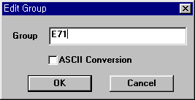
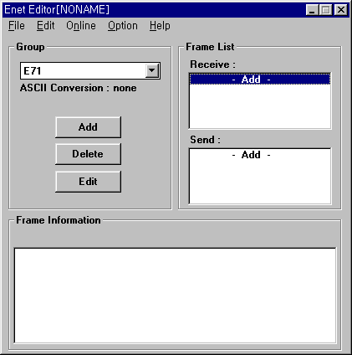
Group name will be used as a element of
Connection method in function block (E_CONN)
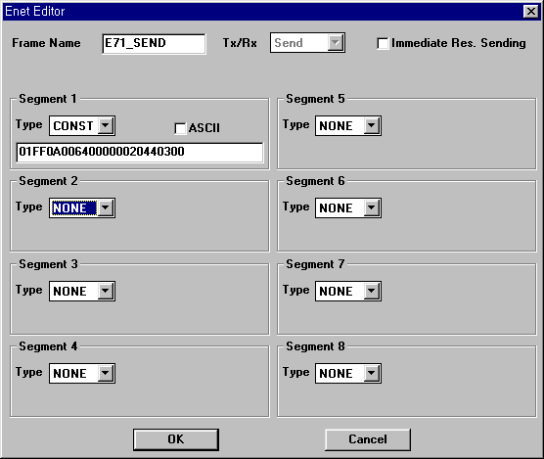
Frame name will be used in function
block (TCP_SEND)

Send Frame Editing

01
Read
Request
FF
Self
Station
0A
Waiting
Time
64000000
Head
Address(100)
00
Null
2044
Memory
Type(D)
03
Number
00
Null
AJ71E71-S3’s
Command frame

♧Point !
Command / Response Frame can be devided as some segment by frame editor.
User need to optimize frame structre by this segmentation, Some parts as constant string,
the other parts as variable.
For example, two cases below has a same result.

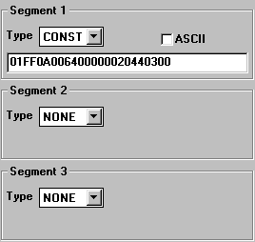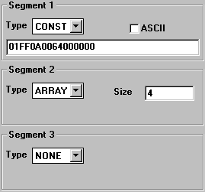 Case 1 (All constant string) Case 2 (Constant string + Array Variable)
16# 2044
16# 0300
Array (0)
Array (1)
MOVE
In the unit
Of Byte

Frame name will be used in function
block (TCP_RCV)

Receive Frame Editing
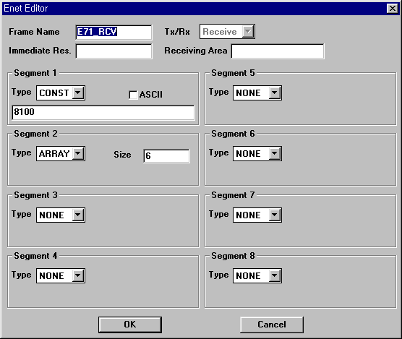
6 Byte

81
Read
Response

00
Error
Code

1234
Data
(D100)
5678
Data
(D101)
9ABC
Data
(D102)
AJ71E71-S3’s
Response frame

6-6. PLC Programming (Function Block Programming)
- It is required to insert ‘Communication Library’ (COMMUNI.4FB) to GMWin
before function block programming.
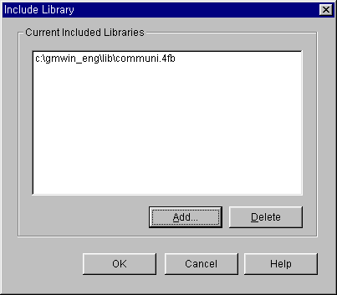

- Function Block

E_CONN | Description
E_CONN  EN NDR  NET_NO ERR  IP ADDR. STATUS  SD PORT CH_EN  METHOD  CH_NO.  BOOL  USINT  STRING  UINT  STRING  USINT  BOOL  BOOL  USINT  BOOL | <Input>  - EN : During on status, executes Continuously  - NET No. : Slot no. module installed in.  - IP ADDR. : IP Address of other node. (Active Conn.)  - SD PORT : Port no. of other node. (Active Conn.)  - METHOD *: Frame group name and Mode  - CH_ NO. : Channel no. (0 ~ 15) = Connection no.
<Output>
- NDR : Turns on when FB is executed normally.
- ERR : Turns on when FB is executed abnormally
- STATUS : Detail error code
- CH_EN : Turns on when connection is established
normally
* METHOD : XXX_YYY
XXX = Group name configured by frame editor.
YYY = Connection (channel) mode (TCP_ACTIVE, TCP_PASSIVE, TCP_SELECT)

TCP_SEND | Description
TCP_SEND  REQ NDR  NET NO. ERR  CH_NO. STATUS  FRAME  ARR_CNT  DATA  BOOL  USINT  USINT  STRING  UINT  ARRAY  BOOL  BOOL  USINT | <Input>  - REQ : When input condition changes 0 to 1, (rising  edge), executes 1 time  - NET NO. : Slot no. module installed in.  - CH_ NO. : Channel no. (0 ~ 15) = Connection no.  - FRAME : Send frame name configured by frame  editor  - ARR_CNT : Number of array variable to be sent  - DATA : Array variable
<Output>
- NDR : Turns on when FB is executed normally.
- ERR : Turns on when FB is executed abnormally
- STATUS : Detail error code

TCP_RCV | Description
TCP_RCV  REQ NDR  NET NO. ERR  CH_NO. STATUS  FRAME RCV_LEN  DATA_LEN  DATA  BOOL  USINT  USINT  STRING  UINT  ARRAY  BOOL  BOOL  USINT | <Input>  - REQ : When input condition changes 0 to 1, (rising  edge), executes 1 time  - NET NO. : Slot no. module installed in.  - CH_ NO. : Channel no. (0 ~ 15) = Connection no.  - FRAME : Receive frame name configured by frame  editor  - DATA_LEN : Number of array variable that FB  receives  - DATA : Array variable
<Output>
- NDR : Turns on when FB is executed normally.
- ERR : Turns on when FB is executed abnormally
- STATUS : Detail error code
- RCV_LEN : Number of array variable to be
received

3) Programming

