1.Features
- GLOFA DeviceNet module (G4L-DUEA, G6L-DUEA, GOL-DSQA, GOL-DSIA)
supports ODVA (Open DeviceNet Vendor Association) standard specification.
- Max. 63 slave station (Max 2048 points) can be controlled 1 master module.
- Station no(Mac Address) and transmission speed (baudrate) can be selected
by switch on module
- Various slave that provided by other maker can be connected to GLOFA DeviceNet
master module (G4L-DUEA / G6L-DUEA)
- Digital I/O
- Actuator
- Limit Switch
- Photo Sensor
- Inverter
- Position Controller
- A/D, D/A Converter
- GLOFA DeviceNet slave module (GOL-DSQA, GOL-DSIA) can be connected to
master module that provided by other maker
- Max. 2 master module can be installed in main base

# Caution
GLOFA DeiveNet system requires …..
- GLOFA GMWin : Ver. 3.3 or higher
- GLOFA GM4 CPU : Ver 2.3 or higher
- GLOFA GM6 CPU : Ver 1.3 or higher

2. Specification
2-1 Performance Specification

 | Description
Topology | Linear Bus (Power & Signal on the same network cable)
Max. no of station | 64 station
No. of points | Max. 2048 points / slave
No. of points | Max. 2048 points / master module

Transmission Speed | Distance  (Thick / Thin cable) | Drop length
Transmission Speed | Distance  (Thick / Thin cable) | 1 drop | Cumulative
125 kbps | 500 / 100m | 6m | 156m
250 kbps | 250 / 100m | 6m | 78m
500 kbps | 125 / 100m | 6m | 39m

3. System Configuration
3-1. In case that GLOFA works as master

GMWIN
GM 4 (Master)

OUT

DeviceNet

CPU

PWR
GM 6 (Slave)

OUT

DeviceNet

CPU

PWR
PMU

IN

IN

DeviceNet

OMRON

AB

Other maker’s I/O module
Inverter
GLOFA I/O module

3-2. In case that GLOFA works as slave

DeviceNet
Configurator

GMWIN
GM 4 (Slave)
GM 6 (Slave)
AB, OMRON PLC (Master)

OUT

DeviceNet

CPU

PWR

OUT

DeviceNet

CPU

PWR

OUT

DeviceNet

CPU

PWR

IN

IN

IN

DeviceNet

OMRON
AB

Other maker’s I/O module
GLOFA I/O module
Inverter
4. Name of Parts

4-1. G4L-DUEA

G4L-DUEA
MODE
ADDRESS
10
1

G4L-DUEA
MS
NS
LED Display
7-Seg. | Display status of module

LED Lamp
MS | Display I/F status of module
NS | Display network status of module

Station no. setting switch

Mode setting switch (Baudrate, Master/Slave)

Connector

4-2. G6L-DUEA

MS NS
G6L-DUEA
MODE

ADDRESS

10

1

G6L-DUEA
LED Lamp
MS | Display I/F status of module
NS | Display network status of module

Station no. setting switch

Mode setting switch (Baudrate, Master/Slave)

Connector

※Mode Setting

Module | Switch | Setting |  | Master  / Slave
Module | Switch | SW1 | SW2 | Master  / Slave
G4L-DUEA  4 3 2 1  ON  G6L-DUEA |  | OFF | OFF | Master
G4L-DUEA  4 3 2 1  ON  G6L-DUEA |  | ON | OFF | Slave  (Server)

Module | Switch | Setting |  | Baudrate
Module | Switch | SW3 | SW4 | Baudrate
G4L-DUEA  4 3 2 1  ON  G6L-DUEA |  | OFF | OFF | 125 kbps
G4L-DUEA  4 3 2 1  ON  G6L-DUEA |  | ON | OFF | 250 kbps
G4L-DUEA  4 3 2 1  ON  G6L-DUEA |  | OFF | ON | 500 kbps
G4L-DUEA  4 3 2 1  ON  G6L-DUEA |  | ON | ON | 500 kbps

4-3. G0L-DSQA


x 1
PWR
NS
MODE
On
Off
ADDRESS
MS
NC 0 1 2 3
COM1 4 5 6 7 COM2
NC 8 9 10 11
COM3 12 13 14 15
COM4
24V
24G
INPUT
DC 24V
✶   

x 10
G0L-DSQA

✶ Station no. switch | 0 ~ 63 (Decimal display)
×10 | 10 unit
×1 | 1 unit
✴ LED Display | Communication status display
PWR | Power status
MS | Interface status
NS | Network status
→ Mode switch | Baudrate setting
1:Off 2:Off | 125 kbyte
1:On 2:Off | 250 kbyte
1:On/Off 2:On | 500 kbyte
✵ LED Display | Out put display
G0L-DSQA | 16points

 Connector | 5-PIN connector
CON1 | DeviceNet connector

 Terminal Block
G0L-DSQA | 0 ~ 15 | Output terminal block
G0L-DSQA | COM1 ~ COM4 | Common (4Point Common)
G0L-DSQA | NC
G0L-DSQA | 24V | +24VDC IN
G0L-DSQA | 24G | -24VDC IN

4-4. G0L-DSIA

x 1
PWR
NS
MODE
On
Off
ADDRESS
MS
NC 0 2 4 6
COM1 8 10 12 14 COM2
NC 1 3 5 7
. 9 11 13 15
.
24V
24G
INPUT
DC 24V
✶   

x 10
G0L-DSIA

✶ Station no. switch | 0 ~ 63 (Decimal display)
×10 | 10 unit
×1 | 1 unit
✴ LED Display | Communication status display
PWR | Power status
MS | Interface status
NS | Network status
→ Mode switch | Baudrate setting
1:Off 2:Off | 125 kbyte
1:On 2:Off | 250 kbyte
1:On/Off 2:On | 500 kbyte
✵ LED Display | Input display
G0L-DSQA | 16points

 Connector | 5-PIN connector
CON1 | DeviceNet connector

 Terminal Block
G0L-DSQA | 0 ~ 15 | Input terminal block
G0L-DSQA | COM1 ~ COM4 | Common (4Point Common)
G0L-DSQA | NC
G0L-DSQA | 24V | +24VDC IN
G0L-DSQA | 24G | -24VDC IN

5. Example
5-1. System Configuration

IN

DeviceNet
Out 16
Out 16
Ethernet
GM4 CPU
PWR
High speed link
Parameter
00 Station
(Master)

High speed link
Parameter

TAB (6 Port)

03 Station
(Slave)

DeviceNet
Out 16
Out 16
GM6 CPU
PWR

IN
G0L-DSQA

AB Flex I/O
(1794-ADN / 1794-0816 / 1794-1816)
01 Station
(Slave)
02 Station
(Slave)

5-2. Test Data Flow

DeviceNet
Out 16
Out 16
Ethernet
GM4 CPU
PWR
00 Station
(Master)

IN
%MW0
%MW2
%QW0.2.0
%MW1
%QW0.3.0
%QW0.1.0

%MW0

DeviceNet

IN
Out 16
Out 16
GM6 CPU
PWR
G0L-DSQA

01 Station
(Slave)
02 Station
(Slave)
03 Station
(Slave)

5-3 High Speed Link Parameter (Master Station / GM4)
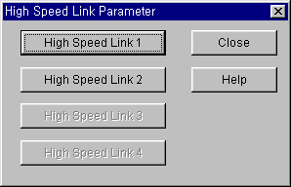
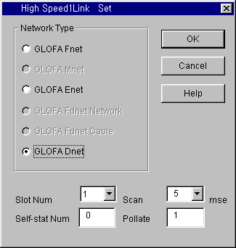

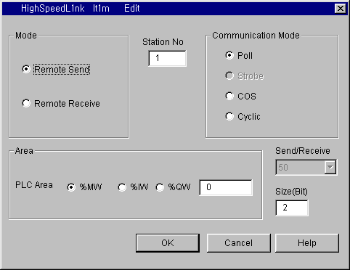
Only
Available
Not support
yet

In the unit of Byte
Master → Slave 1 (Remote)
Master PLC’s Area

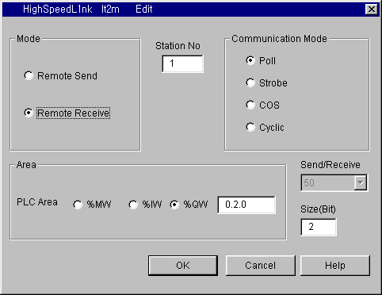

Slave 1 (Remote) → Master
Master PLC’s Area
In the unit of Byte
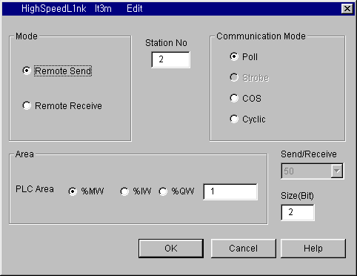

Master → Slave 2 (Remote)

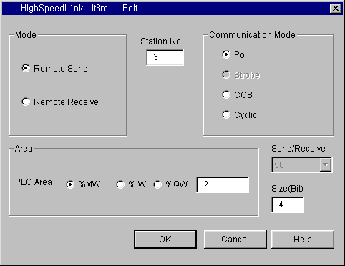

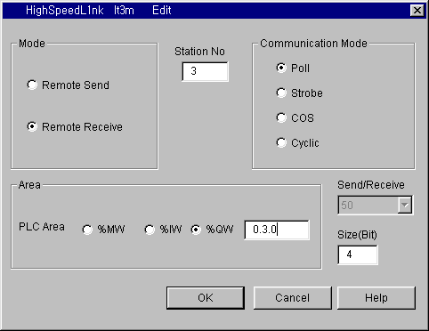
Even if AB Flex I/O (1794-ADN / 1794-0816 / 1794-1816) has 16points input and output, this slave
module occupies 32points (4bytes) input and output.

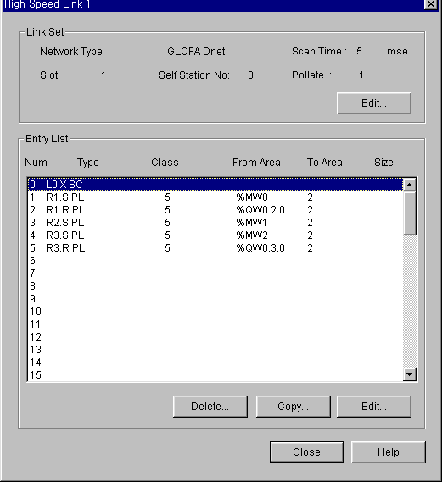

5-4 High Speed Link Parameter (Slave Station / GM6)
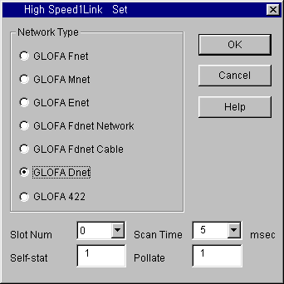

In case of setting the parameter at slave station,
This station No. means Self station no. (Station no. of GM6)
Slave 1 (Remote) → Master

