1. Features

- Supports RS-232C and RS-422/485 channels and they can operate as independent
(stand-alone)mode or concurrent(interlocking) mode.

- Supports various communication speed (baud rate) from 300bps to 57,600bps (RS-422)

- Supports a multi-drop function that maximum 32 station can be joined into a network

- A frame editor software that are based on MS-Windows 95/98 is provided. User can write
an user-defined protocol for communication with other manufacturer’s PLCs.

- With a modem communication function, it can control a remote PLC by dedicated protocol, or
user-defined protocol.

- In a main base board, multiple Cnet modules can be mounted.
(GM6 / K200S : 2 modules, GM4 / K300S : 4 modules, GM3 / K1000S : 8 modules)

2. Specification

2-1 Performance Specification

CPU |  |  | GM1/2/3  (K1000S) | GM4  (K300S) | GM6  (K200S) |  | GM7  (K80S)
Communication  Module |  |  | G3L-CUEA | G4L-CUEA | G6L-CUEB  G6L-CUEC | CPU  Built in | G7L-CUEB  G7L-CUEC | CPU  Built in
Interface |  |  | RS-232C  RS-422/485 |  | RS-232C  RS-422/485 | RS-232C | RS-232C  RS-422/485 | RS-232C
Channel Operation  (Valid only for 2ports) |  |  | Independent / Concurrent  Selectable |  | -
Comm.  Service | Dedicated  Protocol |  | ●
Comm.  Service | User Defined  Protocol |  | ● |  |  | Ｘ | ●
Comm.  Service | AB DF1 |  | ○  (Works only as slave) |  |  | Ｘ | Ｘ
Comm.  Service | Modbus |  | ○  (Works only as slave) |  |  | Ｘ | ●  (Master/Slave Selectable)
Modem  Communication |  |  | Available through RS-232C Port
Data  Structure |  | Data Bit | 7 or 8
 |  | Stop Bit | 1 or 2
 |  | Parity | Even, Odd, None
Transmit  Speed |  | RS-232C | 300 / 600 / 1200 / 2400 / 4800 / 9600 / 19200 / 38400bps
 |  | RS-422/  485 | 300 / 600 / 1200 / 2400 / 4800 / 9600 / 19200 / 38400 / 57600bps
Transmit  Distance |  | RS-232C | 15m (Max)
 |  | RS-422/  485 | 500m (Max)
Connection |  | RS-232C | 1:1
 |  | RS-422/  485 | 1:N (N = Slave Station, Max 32)

2-2 Parts Name and Description

2-2-1 G3L-CUEA

①
②
③
④
⑤
G3L-CUEA
MODE
RS-232C
RUN/BPS
TX/BPS
RX/BPS
ACK/DATA-BIT
NAK/PARITY
ERR/EVEN-ODD
MODEM/STOP-BIT
SYS-RUN
RS-422
DISPLAY
RDA
RDB
SDA
SDB
SG
FG
RS-232C
RS-422
RUN/BPS
TX/BPS
RX/BPS
ACK/DATA-BIT
NAK/PARITY
ERR/EVEN-ODD
RS-485/STOP-BIT
SYS-RUN
No. | Name | Contents
① | LED displaying section | Indication of operating status of G3L-CUEA
② | Display switch | Switch for indication of  parameter and station  number
③ | Mode switch | Setting of operation  Mode
④ | Connector  RS-232C | Connector RS-232C for  connection with external  devices
⑤ | Connector  RS-422/485 | Connector RS-422/485 for  connection with external  devices

①

②

③

④

⑤
2-2-2 G4L-CUEA

No. | Name | Contents
① | LED displaying section | Indication of operating status of G4L-CUEA
② | Display switch | Switch for indication of parameter and station number
③ | Mode switch | Setting of operation mode
④ | Connector  RS-232C | Connector RS-232C for connection with external devices
⑤ | Connector  RS-422/485 | Connector RS-422/485 for connection with external devices

③
④
②
⑤
①

G4L-CUEA
MODE
RS-422
RS-232C
DISPLAY
RS-232C
RS422
RDA
RDB
SDA
SDB
SG
FG
RUN/BPS
TX/BPS
RX/BPS
ACK/DATA
NAK/PARITY
ERR/EVEN-ODD
MODEM/STOP
SYS-RUN

RUN/BPS
TX/BPS
RX/BPS
ACK/DATA
NAK/PARITY
ERR/EVEN-ODD
RS-485/STOP
SYS-RUN

2-2-3 G6L-CUEB

②
③
①
MODE
RUNNAK
TX COM-ERROR
RX MODEM
ACKSYS-RUN/ERR
G6L-CUEB
RS-232C
No | Name | Contents
① | LED displaying section | Indication of operating  status of G6L-CUEB
② | Mode switch | Setting of operation mode
③ | Connector  RS-232C | Connector RS-232C for connection with external devices

2-2-4 G6L-CUEC

No | Name | Contents
① | LED displaying section | Indication of operating status of G6L-CUEC
② | Mode switch | Setting of operation mode
③ | Connector  RS-422/485 | Connector RS-232C for connection with external devices

②
③
①
RS-422/485
SDA
SG
SDB
RDA
RDB
FG
MODE
RUNNAK
TXCOM-ERROR
RXRS-485
ACKSYS-RUN/ERR
G6L-CUEC

2-2-5 G7L-CUEC


②
①
③
GLOFA
G7L-CUEC
PROGRAMMABLE
LOGIC
CONTROLLER
PWR
RXD
TXD
No | Name | Contents
① | RS-422/485 Interface | RS-422/485 Connector for connection with  external devices
② | LED Display | TX, RX, Power Display LED
③ | Expansion Connector | Expansion Connector for connection with  Other Special Module (A/D, HSC …)

2-3 Communication Mode Setting

2-3-1 Off Line mode switching (Switching by H/W switch)
The operation mode of Cnet module is set by a rotary switch at the front panel of the module. The Cnet
module will read the switch status and set the operation mode when the power is supplied. To change
the operation mode of Cnet module, therefore, make sure to cycle the power of Cnet module after
mode switch setting.
1) In case of G3L-CUEA / G4L-CUEA
Mode switch | Switch position | Operation mode |  | Remarks
Mode switch | Switch position | RS-232C | RS-422 | Remarks
5  6  7  9  8  4  3  2  1  0 | 0 | User-defined | User-defined | Concurrent mode  (Interlocking mode) ¹⁾
5  6  7  9  8  4  3  2  1  0 | 1 | Dedicated | Dedicated | Concurrent mode  (Interlocking mode) ¹⁾
5  6  7  9  8  4  3  2  1  0 | 2 | User-defined | User-defined | Independent mode  (Stand-alone mode)
5  6  7  9  8  4  3  2  1  0 | 3 | Dedicated | Dedicated | Independent mode  (Stand-alone mode)
5  6  7  9  8  4  3  2  1  0 | 4 | User-defined | Dedicated | Independent mode  (Stand-alone mode) ²⁾
5  6  7  9  8  4  3  2  1  0 | 5 | Dedicated | User-defined | Independent mode  (Stand-alone mode) ²⁾
5  6  7  9  8  4  3  2  1  0 | 6 | Loader I/F | User-defined | Independent mode  (Stand-alone mode) ²⁾
5  6  7  9  8  4  3  2  1  0 | 7 | Loader I/F | Dedicated | Independent mode  (Stand-alone mode) ²⁾
5  6  7  9  8  4  3  2  1  0 | 8 | Loop-back | Loop-back | Self-diagnosis
5  6  7  9  8  4  3  2  1  0 | 8 | Flash memory write |  | Press the ‘display’ button at the power-on
5  6  7  9  8  4  3  2  1  0 | 9 | On-line |  | On-line mode change
2) In case of G6L-CUEB / G6L-CUEC
Mode switch | Switch position | Operation mode | Remarks
5  6  7  9  8  4  3  2  1  0 | 0 | User-defined
5  6  7  9  8  4  3  2  1  0 | 1 | Dedicated
5  6  7  9  8  4  3  2  1  0 | 2 | Loader I/F
5  6  7  9  8  4  3  2  1  0 | 3 | Loop-back
5  6  7  9  8  4  3  2  1  0 | 4 | Reserved | Not used
5  6  7  9  8  4  3  2  1  0 | 5 | Reserved | Not used
5  6  7  9  8  4  3  2  1  0 | 6 | Reserved | Not used
5  6  7  9  8  4  3  2  1  0 | 7 | Reserved | Not used
5  6  7  9  8  4  3  2  1  0 | 8 | Flash memory write | Cnet v2.0 or later
5  6  7  9  8  4  3  2  1  0 | 9 | On-line | On-line mode change
♣Point !
1.In the interlocking mode, the RS-232C channel operates as main channel and the RS-422
channel operates as the data path. The data structure of RS-422 channel is set as that of
RS-232C channel.
2.In stand-alone mode, RS-232C and RS-422 channel can operates in different operation modes.

2-3-2 On Line mode switching (Switching by S/W)
Operation mode can be switched by software(Cnet Frame Editor Ver. 2.0)
For use this function, rotatry switch of Cnet module should be placed on ‘9’
Library mode(Modbus/AB DF1 Service) can be selected in Online mode only.

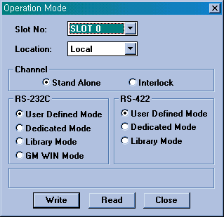

3. System Configuration and Cabling

3-1 RS-232C

3-1-1 Connection between Cnet Module (G3L-CUEA, G4L-CUEA, G6L-CUEA)
and External Device

GLOFA/ MKS PLC
(G3L-CUEA/G4L-CUEA/
G6L-CUEA)

RS-232C Interface
External Device
(IBM Compatible PC
& Others)

1) In case that external device uses CD signal (Use handshake function)
Cnet (9-pin) |  | Pin connection and signal direction | External device (9-pin)
Pin No. | Name | Pin connection and signal direction | Pin No. | Name
1 | CD |  | 1 | CD
2 | RxD |  | 2 | RxD
3 | TxD |  | 3 | TxD
4 | DTR |  | 4 | DTR
5 | SG |  | 5 | SG
6 | DSR |  | 6 | DSR
7 | RTS |  | 7 | RTS
8 | CTS |  | 8 | CTS
9 | RI |  | 9 | RI

2) In case that external device doesn’t uses CD signal (No handshake function)
Cnet (9-pin) |  | Pin connection and signal direction | External device (9-pin)
Pin No. | Name | Pin connection and signal direction | Pin No. | Name
1 | CD |  | 1 | CD
2 | RxD |  | 2 | RxD
3 | TxD |  | 3 | TxD
4 | DTR |  | 4 | DTR
5 | SG |  | 5 | SG
6 | DSR |  | 6 | DSR
7 | RTS |  | 7 | RTS
8 | CTS |  | 8 | CTS
9 | RI |  | 9 | RI

3-1-2 Connection between Cnet Module (G3L-CUEA, G4L-CUEA, G6L-CUEA)
and Modem

External Device
(IBM Compatible PC)

RS-232C

MODEM

Public telephone line
RS-232C

MODEM

GLOFA/ MKS PLC
(GM7 / K80S)

External Device
(IBM Compatible PC)
MODEM
MODEM

Cnet (9-pin) |  | Pin connection and signal direction | Modem (25-pin)
Pin No. | Name | Pin connection and signal direction | Pin No. | Name
1 | CD |  | 8 | CD
2 | RxD |  | 3 | RxD
3 | TxD |  | 2 | TxD
4 | DTR |  | 20 | DTR
5 | SG |  | 7 | SG
6 | DSR |  | 6 | DSR
7 | RTS |  | 4 | RTS
8 | CTS |  | 5 | CTS
9 | RI |  | 22 | RI

3-1-3 Connection between Cnet Modules (G3L-CUEA, G4L-CUEA, G6L-CUEA)

GLOFA/ MKS PLC
(G3L-CUEA/G4L-CUEA/
G6L-CUEA)

RS-232C Interface

Cnet (9-pin) |  | Pin connection and signal direction | Cnet (9-pin)
Pin No. | Name | Pin connection and signal direction | Pin No. | Name
1 | CD |  | 1 | CD
2 | RxD |  | 2 | RxD
3 | TxD |  | 3 | TxD
4 | DTR |  | 4 | DTR
5 | SG |  | 5 | SG
6 | DSR |  | 6 | DSR
7 | RTS |  | 7 | RTS
8 | CTS |  | 8 | CTS
9 | RI |  | 9 | RI

3-1-4 Connection between GM6(K200S)/GM7(K80S) CPU Port (Cnet Built in)
and External Device

GLOFA/ MKS PLC
(GM6 / K200S)

External Device
(IBM Compatible PC
& Others)

GLOFA/ MKS PLC
(GM7 / K80S)

External Device
(IBM Compatible PC
& Others)

CPU (9-pin) |  | Pin connection and signal direction | External device (9-pin)
Pin No. | Name | Pin connection and signal direction | Pin No. | Name
1 | CD |  | 1 | CD
2 | RxD |  | 2 | RxD
3 | TxD |  | 3 | TxD
4 | DTR |  | 4 | DTR
5 | SG |  | 5 | SG
6 | DSR |  | 6 | DSR
7 | RTS |  | 7 | RTS
8 | CTS |  | 8 | CTS
9 | RI |  | 9 | RI

3-1-5 Connection between GM6(K200S)/GM7(K80S) CPU Port (Cnet Built in)
and PMU

GLOFA/ MKS PLC
(GM7 / K80S)
GLOFA/ MKS PLC
(GM6 / K200S)
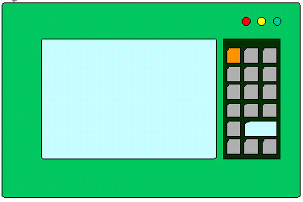
PMU

PMU

CPU (9-pin) |  | Pin connection and signal direction | PMU (9-pin)
Pin No. | Name | Pin connection and signal direction | Pin No. | Name
1 | CD |  | 1 | CD
2 | RxD |  | 2 | RxD
3 | TxD |  | 3 | TxD
4 | DTR |  | 4 | DTR
5 | SG |  | 5 | SG
6 | DSR |  | 6 | DSR
7 | RTS |  | 7 | RTS
8 | CTS |  | 8 | CTS
9 | RI |  | 9 | RI

3-1-6 Connection Between GM7(K80S)CPUs (Cnet Built in)

GLOFA/ MKS PLC
(GM7 / K80S)
GLOFA/ MKS PLC
(GM7 / K80S)

CPU (9-pin) |  | Pin connection and signal direction | CPU (9-pin)
Pin No. | Name | Pin connection and signal direction | Pin No. | Name
1 | CD |  | 1 | CD
2 | RxD |  | 2 | RxD
3 | TxD |  | 3 | TxD
4 | DTR |  | 4 | DTR
5 | SG |  | 5 | SG
6 | DSR |  | 6 | DSR
7 | RTS |  | 7 | RTS
8 | CTS |  | 8 | CTS
9 | RI |  | 9 | RI

♠Point !!!
Using Loader function and Cnet synchronously (GM7/K80S)
- In case of using built in Cnet

“Built-in Cnet” Dip switch should be ‘ON’

External Device
(IBM Compatible PC
& Others)
GLOFA/ MKS PLC
(GM7 / K80S)
Connection#1 (RS232C/Cnet)
Connection#2 (RS232C/Loader)
Loader(GMWIN/KGLWIN) or
Touch Screen(PMU)

Connection#1 (RS232C/Cnet)
CPU (9-pin) |  | Pin connection and signal direction | External device (9-pin)
Pin No. | Name | Pin connection and signal direction | Pin No. | Name
1 | CD |  | 1 | CD
2 | RxD |  | 2 | RxD
3 | TxD |  | 3 | TxD
4 | DTR |  | 4 | DTR
5 | SG |  | 5 | SG
6 | DSR |  | 6 | DSR
7 | RTS |  | 7 | RTS
8 | CTS |  | 8 | CTS
9 | RI |  | 9 | RI

Connection#2 (RS232C/Loader)
CPU (9-pin) |  | Pin connection and signal direction | External device (9-pin)
Pin No. | Name | Pin connection and signal direction | Pin No. | Name
1 | CD |  | 1 | CD
2 | RxD |  | 2 | RxD
3 | TxD |  | 3 | TxD
4 | DTR |  | 4 | DTR
5 | SG |  | 5 | SG
6 | DSR |  | 6 | DSR
7 | RTS |  | 7 | RTS
8 | CTS |  | 8 | CTS
9 | RI |  | 9 | RI
- In case of using option module(G7L-CUEB)

“Built-in Cnet” Dip switch should be ‘OFF’

External Device
(IBM Compatible PC
& Others)
GM7 / K80S
(G7L-CUEB)
Connection#2 (RS232C/Loader)
Connection#1 (RS232C/Cnet)
Loader(GMWIN/KGLWIN) or
Touch Screen(PMU)
Connection#1 (RS232C/Cnet) : In case of no handshake fuction
Cnet (9-pin) |  | Pin connection and signal direction | External device (9-pin)
Pin No. | Name | Pin connection and signal direction | Pin No. | Name
1 | CD |  | 1 | CD
2 | RxD |  | 2 | RxD
3 | TxD |  | 3 | TxD
4 | DTR |  | 4 | DTR
5 | SG |  | 5 | SG
6 | DSR |  | 6 | DSR
7 | RTS |  | 7 | RTS
8 | CTS |  | 8 | CTS
9 | RI |  | 9 | RI

Connection#2 (RS232C/Loader)
CPU (9-pin) |  | Pin connection and signal direction | External device (9-pin)
Pin No. | Name | Pin connection and signal direction | Pin No. | Name
1 | CD |  | 1 | CD
2 | RxD |  | 2 | RxD
3 | TxD |  | 3 | TxD
4 | DTR |  | 4 | DTR
5 | SG |  | 5 | SG
6 | DSR |  | 6 | DSR
7 | RTS |  | 7 | RTS
8 | CTS |  | 8 | CTS
9 | RI |  | 9 | RI

3-2 RS-422/485

3-2-1 1 : 1Connection
1) In Case of G3L-CUEA / G4L-CUEA / G6L-CUEA

External Device
(IBM Compatible PC
& Others)

RS-422/485 Interface

GLOFA/ MKS PLC
(G3L-CUEA/G4L-CUEA/
G6L-CUEA)

RS-422/485 Interface

⊙RS-422 Connection ⊙RS-485 Connection
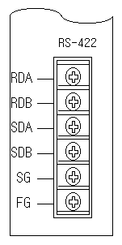

♣Point !
When communicate via RS-422 or RS-485 channel, terminal resistors should be added at the ends of network wiring. The terminal resistor prevents a distortion of signal caused from reflected wave of cable. The terminal resistor should have the same resistance with the characteristic impedance of cable. If you use the recommended cable or equivalent, please connect two 120Ω, 1/2W resistors at the ends of network.

2) In Case of G7L-CUEC

GM7 / K80S
(G7L-CUEC)
External Device
(IBM Compatible PC
& Others)

RS-422/485 Interface

GM7 / K80S
(G7L-CUEC)
GM7 / K80S
(G7L-CUEC)

RS-422/485 Interface

⊙RS-422 Connection ⊙RS-485 Connection
RXA
RXB
TXA
TXB
·
SG
·
RXA
RXB
TXA
TXB
·
SG
·
RXA
RXB
TXA
TXB
·
SG
·
RXA
RXB
TXA
TXB
·
SG
·

3-2-2 Multidrop(1:N) Connection
1) In Case of G3L-CUEA / G4L-CUEA / G6L-CUEA
Station 0
Station 1
Station N
External Device
(IBM Compatible PC
& Others)

RS-422/485 Interface

⊙RS-422 Connection
External Device
(IBM Compatible PC
& Others)
Station 0
Station 1
Station N

⊙RS-485 Connection
External Device
(IBM Compatible PC
& Others)
Station 0
Station 1
Station N

2) In Case of G7L-CUEC

GM7 / K80S
(G7L-CUEC)
GM7 / K80S
(G7L-CUEC)
GM7 / K80S
(G7L-CUEC)
Station 1
Station 2
Station N

External Device
(IBM Compatible PC
& Others)

RS-422/485 Interface

GM7 / K80S
(G7L-CUEC)
GM7 / K80S
(G7L-CUEC)
GM7 / K80S
(G7L-CUEC)
Station 0
Station 1
Station N
Station 2

GM7 / K80S
(G7L-CUEC)

⊙RS-422 Connection
RXA
RXB
TXA
TXB
·
SG
·
RXA
RXB
TXA
TXB
·
SG
·
RXA
RXB
TXA
TXB
·
SG
·
RXA
RXB
TXA
TXB
·
SG
·

⊙RS-485 Connection

RXA
RXB
TXA
TXB
·
SG
·
RXA
RXB
TXA
TXB
·
SG
·
RXA
RXB
TXA
TXB
·
SG
·
RXA
RXB
TXA
TXB
·
SG
·

4. Communication Service

CPU |  | GM1/2/3  (K1000S) | GM4  (K300S) | GM6  (K200S) |  | GM7  (K80S)
Communication  Module |  | G3L-CUEA | G4L-CUEA | G6L-CUEB  G6L-CUEC | CPU  Built in | G7L-CUEB  G7L-CUEC | CPU  Built in
Dedicated  Service  (PLC↔  Ex.Device) | Master &  Slave | Slave
Dedicated  Service  (PLC↔  Ex.Device) | S/W Tool | Cnet Editor |  |  | GMWin or KGLWin
Dedicated  Service  (PLC↔  Ex.Device) | Parameter | Basic Parameter |  |  | Comm. Parameter
Dedicated  Service  (PLC↔  Ex.Device) | PLC Prog. | Not required
Dedicated  Service  (PLC↔  PLC) | Master &  Slave | Master/Slave (One station works as a master, the other one works as a slave)
Dedicated  Service  (PLC↔  PLC) | S/W Tool | Cnet Editor |  |  | GMWin or KGLWin
Dedicated  Service  (PLC↔  PLC) | Parameter | Basic Parameter |  |  | HS Link  (RS485/422  Only) | Comm. Parameter
Dedicated  Service  (PLC↔  PLC) | PLC Prog. | Master : GM_RD/GM_WR(GLOFA)  READ/WRITE(Master K)  Slave : Not required. |  |  | Not required | Not required
User  Define  Service  (PLC↔  Ex.Device) | Master &  Slave | Master |  |  | Not support | Master
User  Define  Service  (PLC↔  Ex.Device) | S/W Tool | Cnet Editor |  |  | Not support | GMWin or KGLWin
User  Define  Service  (PLC↔  Ex.Device) | Parameter | Basic Parameter & Frame Editing |  |  | Not support | Comm. Parameter
User  Define  Service  (PLC↔  Ex.Device) | PLC Prog. | SND_MSG/RCV_MSG(GLOFA)  SND/RCV(Master K) |  |  | Not support | SND_MSG
Library  Service  (Modbus) | Master &  Slave | Slave |  |  | Not support | Master/Slave
Library  Service  (Modbus) | S/W Tool | Cnet Editor |  |  | Not support | GMWin or KGLWin
Library  Service  (Modbus) | Parameter | Library Downloading |  |  | Not support | Comm. Parameter
Library  Service  (Modbus) | PLC Prog. | Not required |  |  | Not support
Library  Service  (AB DF1) | Master &  Slave | Slave |  |  | Not support
Library  Service  (AB DF1) | S/W Tool | Cnet Editor |  |  | Not support
Library  Service  (AB DF1) | Parameter | Library Downloading |  |  | Not support
Library  Service  (AB DF1) | PLC Prog. | Not required |  |  | Not support

4-1. Dedicated Protocol Service
4-1-1 Introduction
Cnet module includes a dedicated protocol for communication with external devices.
It enables that an external device reads/writes data from/to PLC CPU through Cnet module if the external
device send a data frame complying with the dedicated protocol.
- During this service Cnet module works as only a slave for external device, so any PLC program
to related with communication is not required.
2) RS-232C and RS-422 channels can communicate independently or concurrently according to mode
setting.
3) Multi-drop network is available by assigning a station number to Cnet modules.
(Max. 32 station can be connected.)
4) By using dedicated Function Block(GM_RD, GM_WR) or Instruction(READ, WRITE), communication
can be executed easily between GLOFA(Master K) PLCs. (Cnet Ver.2.0 or higher)

4-1-2 Operation Flow

GM/MKS
CPU
CUEA
③Access
Datas
requested
Data
Memory
RS-
232C
①Command(Request)
COMM
Internal
Memory

④Response
RS-
422
Application
User Program
(Visual C++,
MMI Package)
②
Communication
Processor
- External device(PC, MMI etc…) sends the command frame created by user application software
to PLC Cnet module via RS-232C or 422/485 port.
- Communication Processor of Cnet module analyze and checks command frame.
- Datas requested by external device are exchanged between Cnet module and PLC CPU.
- Cnet module sends the response frame to external device.

4-1-3 Dedicated Protocol Frame Structure
4-1-3-1 Basic structure

- Request frame (External device → Cnet module)
Header  (ENQ) | Station number | Command | Command type | Structured data area | Tail  (EOT) | Error check  (BCC)

- ACK Response Frame (Cnet Module → External device)
Header  (ACK) | Station number | Command | Command type | Structured data area or Null | Tail  (ETX) | Error check  (BCC)

- NAK Response Frame (Cnet Module → External device)
Header  (NAK) | Station number | Command | Command type | Error code (ASCII 4 bytes) | Tail  (ETX) | Error check  (BCC)

4-1-3-2 Command & Command type

 |  | Command | Type | Description
 |  | Command | Type | GLOFA | Master K
Read | Single | r (R) | SS | Read a single Bit / Byte  Word / Double word  from PLC | Read a single Bit / Word  from PLC
Read | Continuous | r (R) | SB | Read multiple Byte  Word / Double word  From PLC  (Bit signal is not available) | Read multiple Words  from PLC  (Bit signal is not available)
Write | Single | w (W) | SS | Write a single Bit / Byte  Word / Double word to  PLC | Write a single Bit / Word  To PLC
Write | Continuous | w (W) | SB | Write multiple Byte  Word / Double word to  PLC  (Bit signal is not available) | Write multiple Words  to PLC  (Bit signal is not available)

4-1-3-3 Device Memory Expression

%
M
W
0
1
2

3
Device Address number
Data type (X,B,W,D)
Device type
Start of data

 | Item | Memory Expression |  |  |  | Remarks
 | Item | Bit | Byte | Word | Double | Remarks
GLOFA | Input | %IX0.0.0~ | %IB0.0.0~ | %IW0.0.0~ | %ID0.0.0~ | Read / Write
GLOFA | Output | %QX0.0.0~ | %QB0.0.0~ | %QW0.0.0~ | %QD0.0.0~ | Read / Write
GLOFA | Internal Memory | %MX000~ | %MB000~ | %MW000~ | %MD000~ | Read / Write
Master K | Input & Output | %PX000~ | - | %PW000~ | - | Read / Write
Master K | Internal Relay | %MX000~ | - | %MW000~ | - | Read / Write
Master K | Keep Relay | %KX000~ | - | %KW000~ | - | Read / Write
Master K | Special Relay | %FX000~ | - | %FW000~ | - | Read Only
Master K | Timer | %TX000~ | - | %TW000~ | - | Read / Write
Master K | Counter | %CX000~ | - | %CW000~ | - | Read / Write
Master K | Data Register | - | - | %DW000~ | - | Read / Write

♣Point !
- The CPU doesn’t care capital or small letter in frame except main command. For example,
‘%MW100’ and ‘%mw100’ have same meaning. However, if the main command is written in small
letter, the BCC check will be executed.
- When read or write a bit, the last digit of address should be a capital letter.
Example) %mx001f ( X )
%mx001F ( O )
- In the above examples, device numbers are consist of 4 digits and it is the recommended
format of MASTER-K series. However, 2 ~ 8 digits are allowed to express a device number.
Example) %MX01 = %MX001 = … = %MX0000001 = %MX00000001
%DW31 = %DW031 = … = %DW0000031 = %DW00000031

4-1-3-4 Read continuous device memory (RSB Command)
1) Request Format (External Device → Cnet Module)
Format name | Header | Station number | Command | type | Length of device definition | Head Device  To be accessed | Number of data | Tail | Frame check
Frame example | ENQ | h10 | R (r) | SB | h06 | %MW100 | h02 | EOT | BCC
ASCII value | h05 | h3130 | h52 (h72) | h5342 | h3036 | h254D57313030 | h3032 | h04

Structured Data Area

2) ACK Response Format (Cnet Module → External Device)
Format name | Header | Station number | Command | type | Block *  Number | Number of data | Data | Tail | Frame check
Frame example | ACK | h10 | R (r) | SB | 01 | h04 | h12345678 | ETX | BCC
ASCII value | h06 | h3130 | h52 (h72) | h5342 | H3031 | h3034 | h3132333435363738 | h03

Structured Data Area

3) NAK Response Format (Cnet Module → External Device)
Format name | Header | Station number | Command | type | Error code (Hex 2 byte) | Tail | Frame check
Frame example | NAK | h10 | R (r) | SB | h2232 | ETX | BCC
ASCII  value | h15 | h3130 | h52 (h72) | h5342 | h32323332 | h03

- Station number, command, and type are same as the request format.
- BCC : When the command is small character (r), the lower byte of summation from ENQ to EOT is
converted into ASCII format and added to frame as BCC check.
- Length of device definition : It indicates that the device definition include ‘%’ occupies how many bytes
after converted to ASCII code (1byte = 2 ASCII codes). The available range is h01 ~ h10
( ASCII format : h3031 ~ h3130 )
For Example : %MW000 = h06, %PW0000 = h07
- Device definition : It indicates an actual address to be read. It should be consist of ‘%’, device type
(capital or small letter), and numbers only.
- Number of data (in the Request) : It indicates that how many bits/bytes/words/double words will be read
from the start address. The unit of this value is dependant on Device memory(Variable) type
The range is h01 ~ h3C (1 ~ 60).
- Number of data (in the Response) : It indicates the size of datas received in the unit of Byte.
- Block Number of ACK Response is only available for GLOFA CPU and always set to “01”.
4-1-4 Dedicated Function Block(GLOFA) & Instruction(Master K)
- This function block and instruction is only available for communication between GLOFA’s Cnet
Modules or Master K’s Cnet modules
- When you want to communicate with multi-stations for RS-422 Channel, you should make a program to
be communicated in order. (this is to prevent data collision error)
- Reading/Writing is available up to 110 bytes

4-1-4-1 Function Block (for GM1/2/3/4/6)
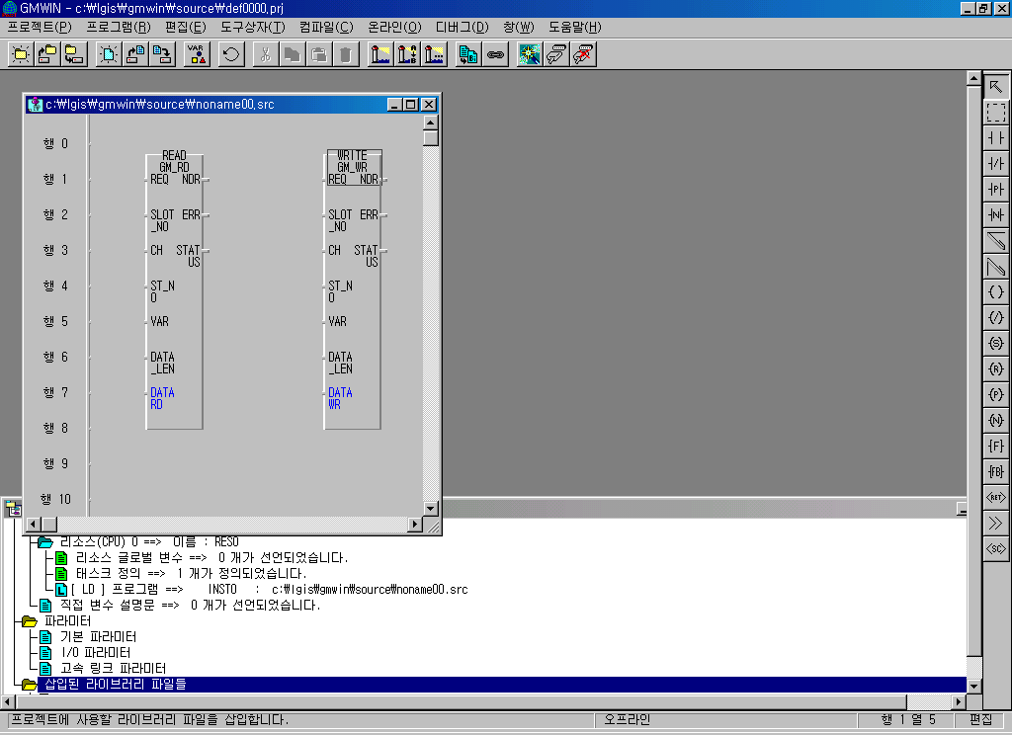
GM_RD : This function block is used for reading data
of other station.
GM_WR : This function block is used for writing data
of other station.
 | I/O |  | Description
Input | REQ | BOOL | Function block begins in rising edge (0→ 1)
Input | SLOT_NO | USINT | Cnet slot no. of self station
Input | CH | UDINT | Communication channel select ( 0 : RS232C / 1 : RS422 )
Input | ST_NO | UDINT | Station no. of other PLC to communicate with function block (0~31)
Input | VAR | STRING | Memory area of other PLC station to write or read data using function block.  Input type should be string using ‘ ‘. And direct variables as byte type.  ex) ‘%MB100’, ‘%QB20’, ‘%IB50’…..
Input | DATA_LEN | USINT | Length of data(byte unit) to read/write (Max. 110 bytes)
Input | DATA_WR | USINT  ARRAY | Start address of Local PLC which has data to be written to other PLC  (defines Direct variable as byte type)
Input | DATA_RD | USINT  ARRAY | Start address of Local PLC to save read data from other PLC  (defines Direct variable as byte type )
Output | NDR | BOOL | When this function operates properly, it will be On and keep On condition  until next function block’s call.
Output | ERR | BOOL | When the result of this function does not operate well, it will be On and  keep On condition until next function block’s call.
Output | STATUS | USINT | ERR : 1 → error code, NDR : 1 → ‘0’

4-1-4-1 Instruction (for K1000S/300S/200S)
READ : This instruction is used
for reading data of other station.
WRITE : This instruction is used
for writing data of other station.
READ sl st D S n SS

WRITE sl st D S n SS

 | Description
sl | Slot number on which the Cnet module is mounted
st | Station number of other station and communication channel (4words)  Ex) In case that ‘D000’ is designated  - D000~D001 (2words) : Station number of other station to accessed  - D002~D003 (2words) : Channel selection (0:RS-232C, 1:RS-422/485)
D | Head Device address of self-station at which read data is stored (in case of ‘READ’)  Head Device address of self-station at which write data is stored (in case of ‘WRITE’)
S | Head Device address of other station to be read (in case of ‘READ’)  Head Device address of other station to be written (in case of ‘WRITE’)
n | Numbers of word to be read
SS | Device at which the communication status is stored

Instructions |  | Available Device |  |  |  |  |  |  |  |  |  |  | Steps
 |  | M | P | K | L | F | T | C | S | D | #D | Integer | Steps
READ | sl |  |  |  |  |  |  |  |  |  |  | O | 13
READ | St | O | O | O | O | O | O | O |  | O | O |  | 13
READ | D | O | O | O | O* |  | O | O |  | O | O |  | 13
READ | S | O | O | O | O | O | O | O |  | O | O |  | 13
READ | n |  |  |  |  |  |  |  |  | O |  | O | 13
READ | SS | O | O | O | O* |  | O | O |  | O | O |  | 13

4-2. User Defined Protocol Service (FB Service)
4-2-1 Introduction
User defined protocol service is used when the external device has a different protocol form from
Cnet module and user intend to communicate with external devices by using their own protocol.
- During this service Cnet module works as a master for external device, so PLC program which
sends/receives communication frame is required.
- Communication frame can be easily created by frame editor tool and that frame file can be used
with Function Block in user’s PLC program.
- This service is mainly used for communicating between PLC and other device which has RS-232C
or RS-422/485 port and opened protocol format.

4-2-2 Operation Flow

GM/MKS
CPU
CUEA
External Device
②Requested(Command)
RS-
232C
Internal
Memory
Function Block
[ SND ]
①Request
COMM
RS-
422
③Response
④Response
COMM
Function Block
[ RCV ]
Application
User Program

- By using function block(GLOFA CPU : SND_MSG) or instruction(Mater K : SND) PLC CPU sends
the command frame created by frame editor tool to Cnet module.
② Cnet module sends the command frame to external device via RS-232C or RS-422/485 port.
③ External device sends the response frame requested to Cnet module.
④ By using function block(GLOFA CPU : RCV_MSG) or instruction(Master K : RCV) PLC CPU receives
the response frame from Cnet module

4-2-3 Function Block & Instruction

4-2-3-1 Function Block (GLOFA CPU)
1) SND_MSG (Send Message)
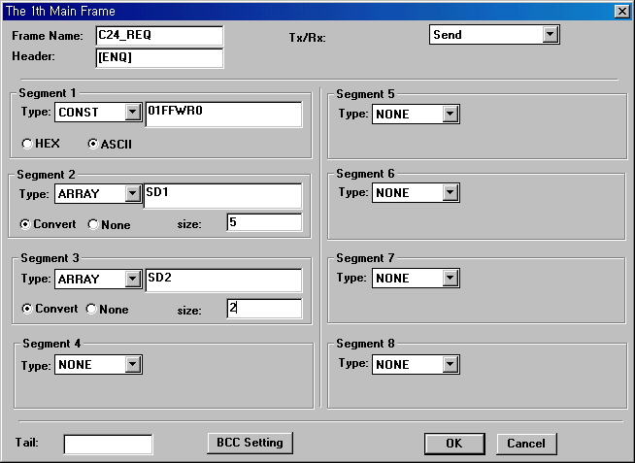
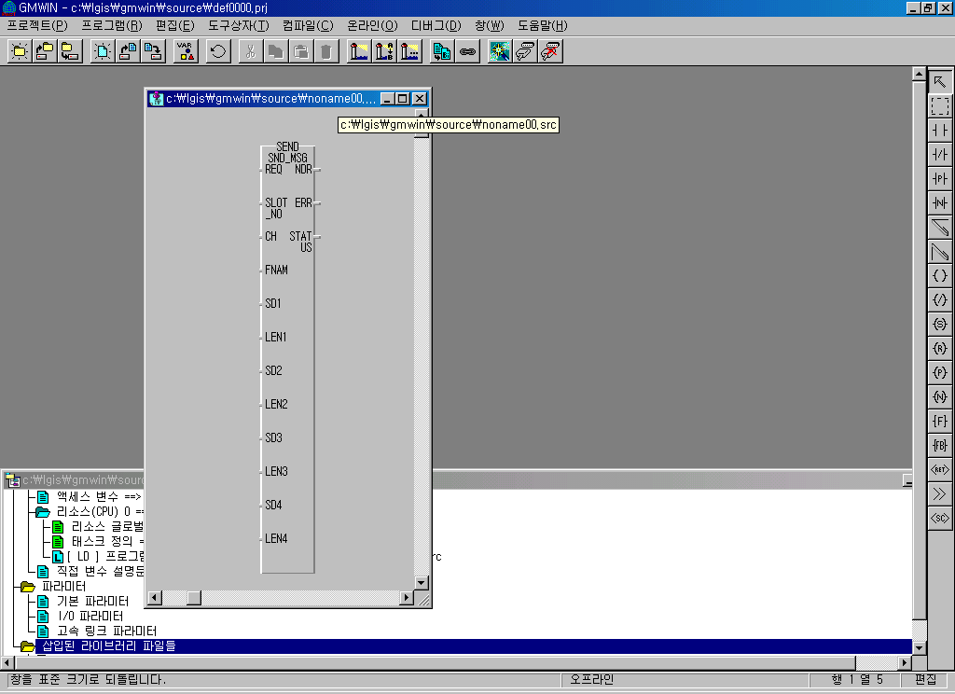

Input |  | Output
REQ  (Bool) | When input condition changes 0 to  1, (rising edge), executes 1 time | NDR  (Bool) | Turns on when FB is executed  normally.
SLOT_NO  (Sint) | Slot No. at which Cnet Module is  In mounted | ERR  (Bool) | Turns on when FB is executed  abnormally
CH  (Usint) | 0 : RS-232C  1 : RS-422/485 | STATUS  (Usint) | Detail error code  (0 is Normal status)
FNAM  (String) | Send frame name configured by  frame editor
SD n  n=1,2,3,4  (Usint  Array) | Array Variable to be sent  (Even if all field (SD1~SD4) is not  Used, must be filled by dummy  Array variables)
LEN n  n=1,2,3,4  (Usint) | Number of Array Variable to be  Sent

2) RCV_MSG (Receive Message)
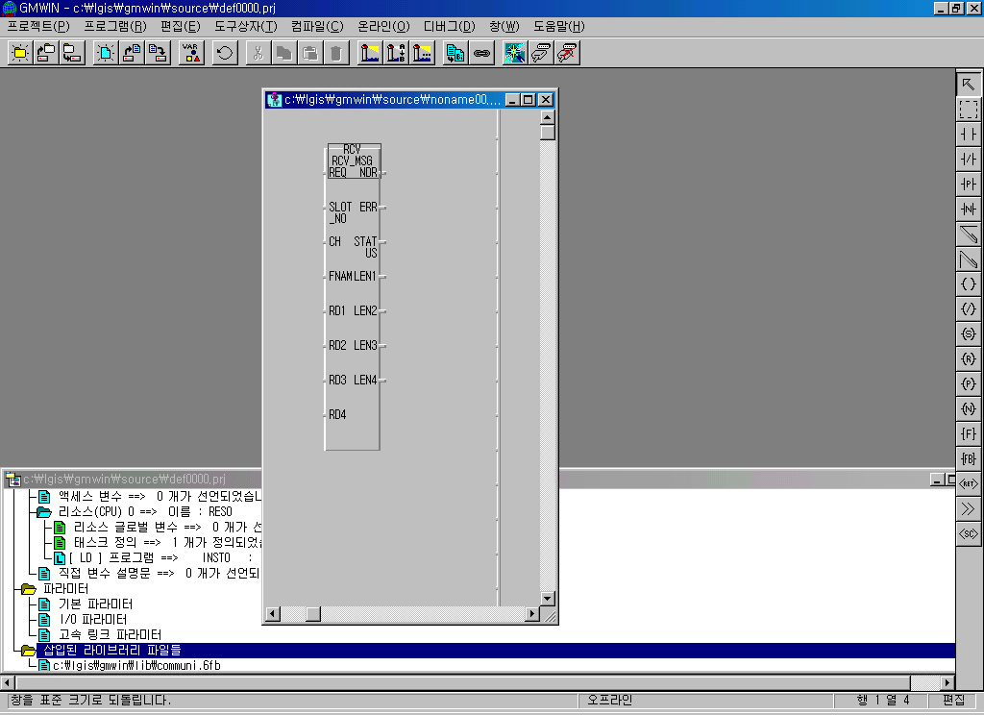
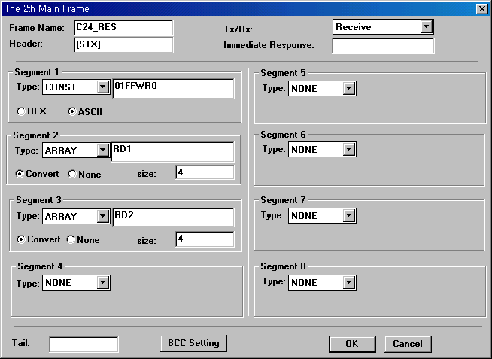

Input |  | Output
REQ  (Bool) | When input condition changes 0 to  1, (rising edge), executes 1 time | NDR  (Bool) | Turns on when FB is executed  normally.
SLOT_NO  (Sint) | Slot No. at which Cnet Module is  In mounted | ERR  (Bool) | Turns on when FB is executed  abnormally
CH  (Usint) | 0 : RS-232C  1 : RS-422/485 | STATUS  (Usint) | Detail error code  (0 is Normal status)
FNAM  (String) | Receive frame name configured by  frame editor | LEN n  n=1,2,3,4  (Usint) | Displays the byte number of datas  To be received
RD n  n=1,2,3,4  (Usint  Array) | Array Variable to be stored  (Even if all field (RD1~RD4) is not  Used, must be filled by dummy  Array variables)

4-2-3-2 Instruction (Master K CPU)
1) SND
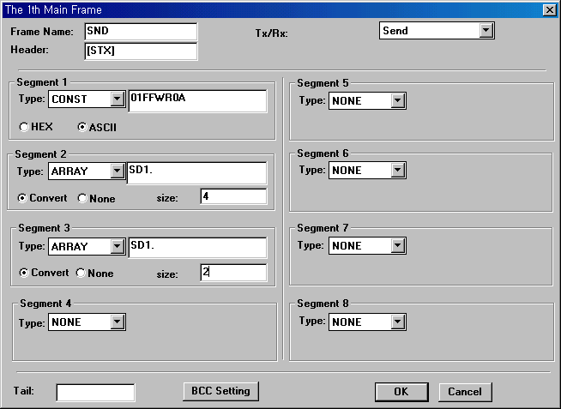
SND sl Fnam snd n SS

 | Description
sl  A B  C D | Slot number of Cnet module mounted & Type of channel (RS232C or RS422)  - Lower 8 bits (CD) : Slot No. of Cnet module mounted  - Higher 8 bits (AB) : Type of channel (h00 : RS232C, h01 : RS422)
Fnam | Send frame name configured by frame editor (8words, ASCII Code)
snd | Start address of device that stores source data to be sent
n | Numbers of byte to be sent
SS | Device at which the communication status is stored

2) RCV
RCV sl Fnam rcv n SS
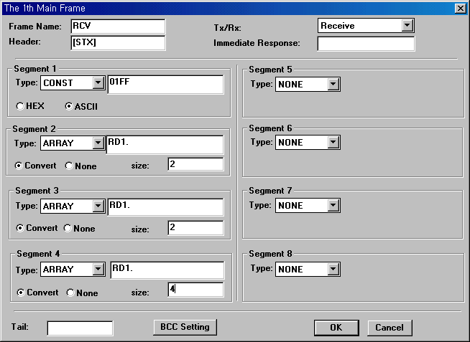

 | Description
sl  A B  C D | Slot number of Cnet module is mounted & Type of channel (RS232C or RS422)  - Lower 8 bits (CD) : Slot No. of Cnet module mounted  - Higher 8 bits (AB) : Type of channel (h00 : RS232C, h01 : RS422)
Fnam | Receive frame name configured by frame editor (8words, ASCII Code)
rcv | Start address of device that stores source data to be received
n | Numbers of byte to be received
SS | Device at which the communication status is stored

4-3. Library Service (Modbus / AB DF1 Service)

4-3-1 Introduction
To communicate with other manufacturer’s PLC without writing an user-defined frame, the ‘Library service’
Is added to the Cnet module v2.0.
In the library mode, the Cnet module will communicate with other manufacturer’s device according to the
library downloaded to the Cnet module, and no frame setting is required. (Set basic parameters only)
The frame editor includes two libraries for AB DF1(AB Asynchronous Full Duplex) and Modbus.
With these libraries, the Cnet module can operate as a ‘Slave(Server)’ or ‘Master(Client)’ station.

CPU |  | GM1/2/3  (K1000S) | GM4  (K300S) | GM6  (K200S) |  | GM7  (K80S)
Communication  Module |  | G3L-CUEA | G4L-CUEA | G6L-CUEB  G6L-CUEC | CPU  Built in | G7L-CUEB  G7L-CUEC | CPU  Built in
Modbus | Master | Ｘ |  |  | Ｘ | ●
Modbus | Slave | ● |  |  | Ｘ | ●
AB DF1 | Master | Ｘ |  |  | Ｘ | Ｘ
AB DF1 | Slave | ● |  |  | Ｘ | Ｘ
Library |  | Ab34.lib  Modbus6.lib |  | Ab6.lib  modbus6.lib | - | Library Download is not  required

4-3-2 Library Download
① Set the Cnet module to ‘Flash memory write mode’ with the mode selection switch.
② the LED of Cnet module will blink with 1 second period.
③ Run the frame editor and connect to the Cnet module. Then, select File – Open Lib in menu.
④ Select a library file to be downloaded as following figure
⑤ select Online – Flash Memory – Write in the menu. Type the slot number at which the Cnet module
is mounted, and press ‘Write’ button.
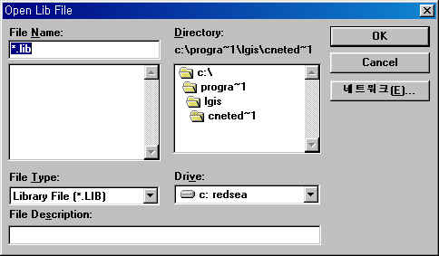
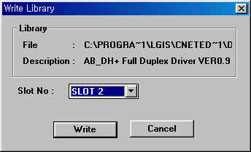
Network

5. Operation Procedure

User Defined Service
Dedicated Service
Library Service
(AB DF1 / MODUBUS)

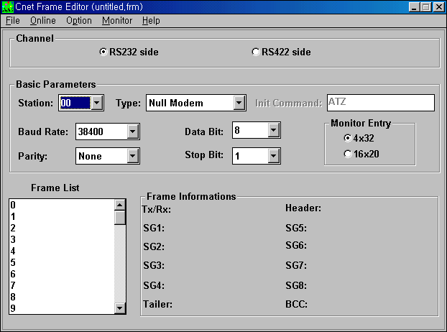
1. Basic Parameter Setting
1. Basic Parameter Setting
1. Basic Parameter Setting
Down Loading Cnet Parameter
2. Communication Frame
Editing
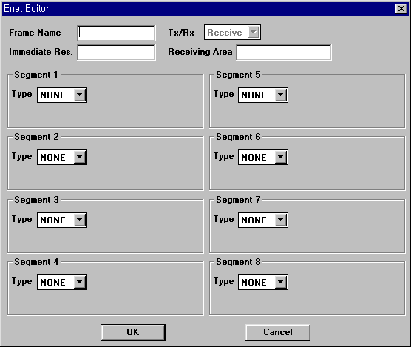
Down Loading Cnet Parameter
Down Loading Cnet Parameter
Network
2. Library Selecting

3. Making the program
by using Function Block
& Frame file
2. Making the program
by using Function Block
or Instruction (Only for
Communication between
Cnet modules)

SND_MSG
RCV_MSG
GM_RD
GM_WR
Writing Lib. to
Flash Memory

3. Mode selecting by using
Cnet frame editor (On line
Mode switching)

4. Mode selecting by using
rotary switch of Cnet module
4. Mode selecting by using
rotary switch of Cnet module
5
6
7
9
8
4
3
2
1
0
5
6
7
9
8
4
3
2
1
0

Down Loading Ladder Program
& Cycle the power of Cnet module

6. Example

6-1 Dedicated protocol service (GM6 / K200S ↔ IBM PC)

6-1-1. Example Overview
By using Cnet dedicated protocol, IBM PC reads data memory In the PLC CPU and displays
results on the monitor screen.

6-1-2. System Configuration

IBM Compatible
Computer
GM6 CPU & G6L-CUEA
K200S CPU & G6L-CUEA
Command

Response
RS-232C Interface

6-1-3. Test Environment

 | Computer | GM6 / K200S
CPU | Pentium 133 | GM6 CPU / K200S CPU
Communication Module | COM1 Port | G6L-CUEA
Cable | RS-232C | RS-232C
O/S | Windows95 | -
Development Language | MS Visual Basic | -
Station number | - | 0
Mode Switch | - | 1 (RS-232C Dedicated)
Client / Server | Client (Master) | Server (Slave)
Communication Service | Cnet Dedicated Protocol Service
RS-232C Spec. | 9600bps, Data 8bit, Stop 1bit, None pariry

6-1-4. Setting Cnet Basic Parameter
- Cnet frame editor tool is consist of two part, Basic parameter and Frame list.
- In part of basic parameter, the parameter related Cnet is decided
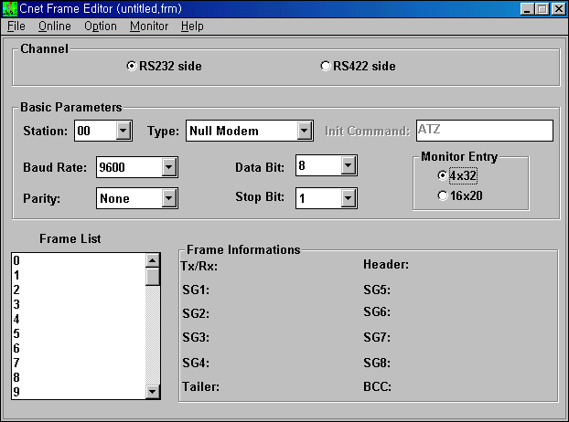
- In case of dedicated protocol service, frame list is not required to be set.

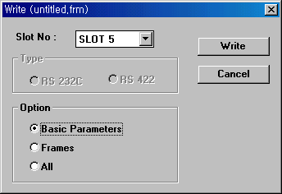
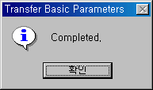

6-1-5. Computer Application Sample Software (Developed by visual basic)
- Set COM Port, Baudrate, Parity, Data Bit, Stop Bit (These parameter values must be same as the
Value of the Cnet basic parameter set by frame editor)
2) Set Request frame (00RSB06%DW10005)
3) Click ‘OPEN’ button.
4) Click ‘SEND’ button.
5) Response will be displayed on ‘Rx’ menu.
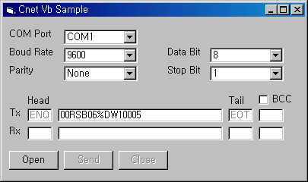

6-3 Dedicated protocol service (K200S ↔ K200S)

6-3-1. Example Overview
By using Cnet dedicated protocol, K200S(Master) reads data memory(D100 ~ D104) of K200S(Slave)
CPU and stores that value in D200 ~ D204.

6-3-2 System Configuration

Command
Station 0 (Master)
Station 1 (Slave)

Response

RS-232C Interface
K200S CPU &
G6L-CUEA
K200S CPU &
G6L-CUEA

Data Value (2words)
P001 (P010~P01F)
P002 (P020~P02F)
D100
D101

6-3-3. Test Environment

 | K200S | K200S
CPU | K200S CPU | K200S CPU
Communication Module | G6L-CUEA | G6L-CUEA
Cable | RS-232C | RS-232C
Programming (Instruction) | READ / WRITE | Not required
Station number | 0 | 1
Mode Switch | 1 (RS-232C Dedicated) | 1 (RS-232C Dedicated)
Client / Server | Client (Master) | Server (Slave)
Communication Service | Cnet Dedicated Protocol Service
RS-232C Spec. | 9600bps, Data 8bit, Stop 1bit, None pariry

6-3-4. Setting Cnet Basic Parameter
1) Station 0

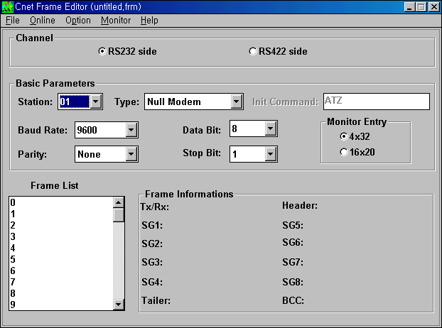
2) Station 1

6-3-5. PLC Programming (Station 0)
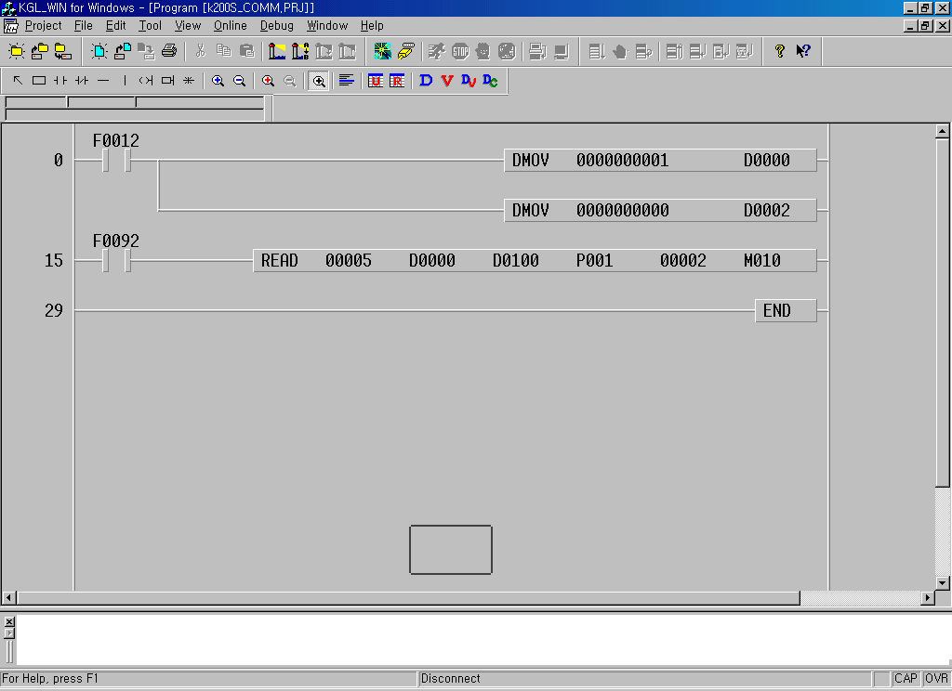
Station No. of slave (2words) : 1

Comm. status
Channel (2words) : 0 (RS-232C)

Slot No. : 5
Channel & Station No. of slave
Master(self) station’s head area to be stored : D100
Number of word to be read : 2
Slave station’s head area to be read : P001 (P010~P01F)

6-4 Dedicated protocol service (GM6 ↔ GM6)

6-4-1. Example Overview
By using Cnet dedicated protocol, GM6(Master) reads data memory(%MB100 ~ %MB103) of GM6(Slave)
CPU and stores that value in %MB0 ~ %MB3.

6-4-2 System Configuration

Command
Station 0 (Master)
Station 1 (Slave)

Response

RS-232C Interface
GM6 CPU &
G6L-CUEA
GM6 CPU &
G6L-CUEA
%MB0
%MB1
%MB2
%MB3
%MB100
%MB101
%MB102
%MB103
Data Value (2words)

6-4-3. Test Environment

 | GM6 | GM6
CPU | GM6 CPU | GM6 CPU
Communication Module | G6L-CUEA (Slot 5) | G6L-CUEA (Slot 5)
Cable | RS-232C | RS-232C
Programming (Instruction) | GM_RD | Not required
Station number | 0 | 1
Mode Switch | 1 (RS-232C Dedicated) | 1 (RS-232C Dedicated)
Client / Server | Client (Master) | Server (Slave)
Communication Service | Cnet Dedicated Protocol Service
RS-232C Spec. | 9600bps, Data 8bit, Stop 1bit, None pariry

6-4-4. Setting Cnet Basic Parameter
1) Station 0

2) Station 1

6-4-5. PLC Programming (Station 0)
1) Library Inserting
- Select “Project → Library insert” on GMWin menu.
- Click Add then select “communi.6fb”

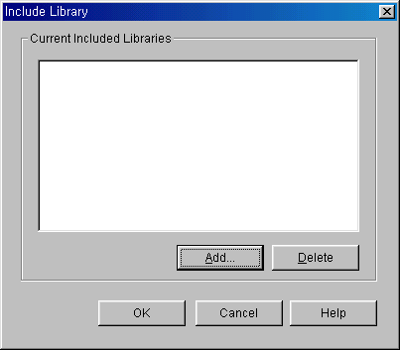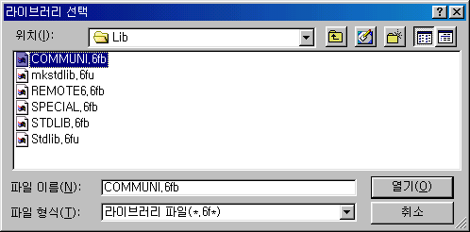

2) Programming

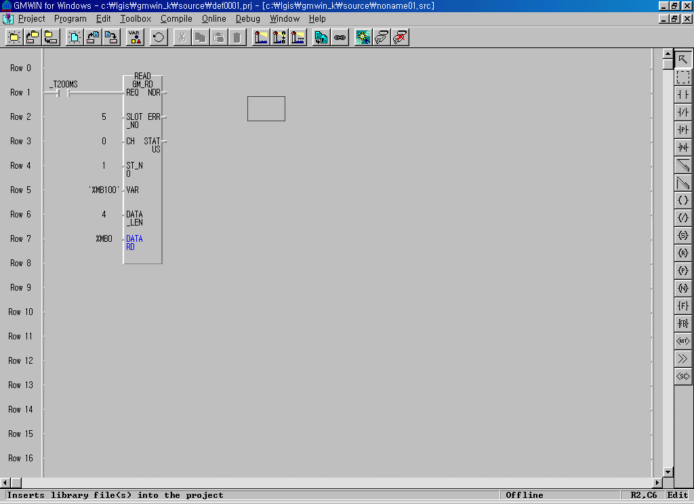
6-5 Dedicated protocol service (GM7 ↔ GM7)

6-5-1. Example Overview
By using Cnet dedicated protocol, GM7(Master) reads data memory(%IW0.0.0) & write data memory
(%QW0.0.0) of GM7(Slave)
By setting parameter only, communication is executed easily (Ladder program is not required)

6-5-2 System Configuration

GLOFA/ MKS PLC
(GM7 / K80S)
GLOFA/ MKS PLC
(GM7 / K80S)

Command
Response

RS-232C Interface
%IW0.0.0
%QW0.0.0
%IQ0.0.0
%IW0.0.0

6-5-3. Test Environment

 | GM7 | GM7
CPU | GM7 CPU | GM7 CPU
Communication Module | CPU Built in | CPU Built in
Cable | RS-232C | RS-232C
Programming (Instruction) | Not required | Not required
Station number | 0 | 1
Mode Switch | Not available | Not available
Client / Server | Client (Master) | Server (Slave)
Communication Service | Cnet Dedicated Protocol Service
RS-232C Spec. | 9600bps, Data 8bit, Stop 1bit, None pariry

6-5-4. Communication Parameter

6-5-4-1. Station 0 (Master)
1) Double click ‘communication parameter’ in the parameter menu.
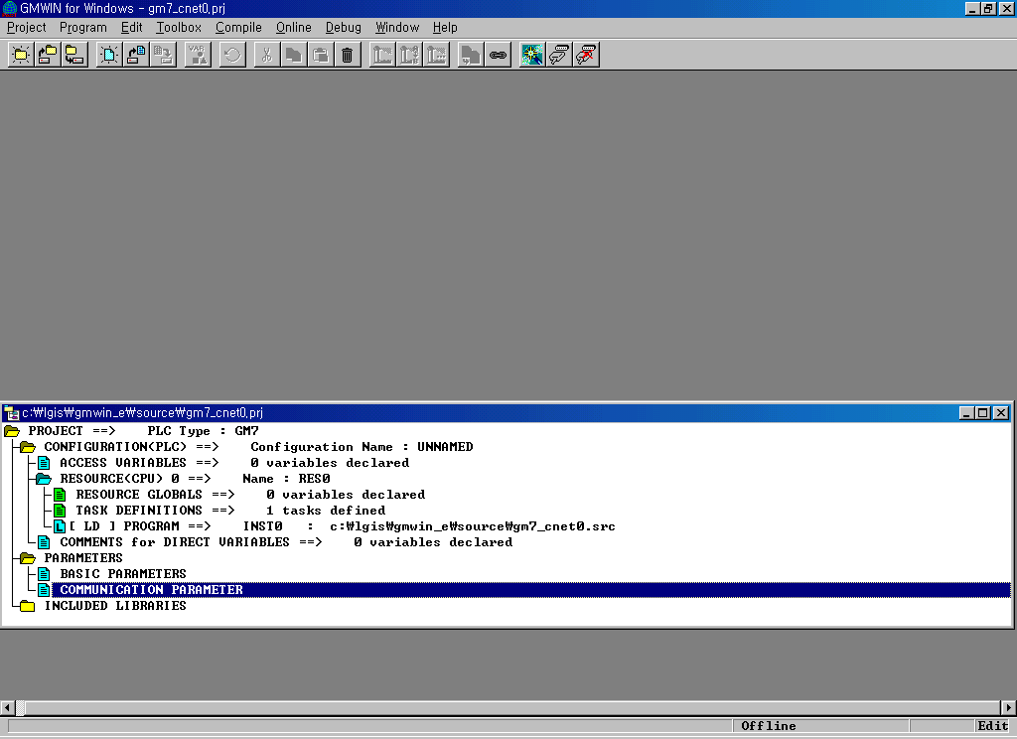
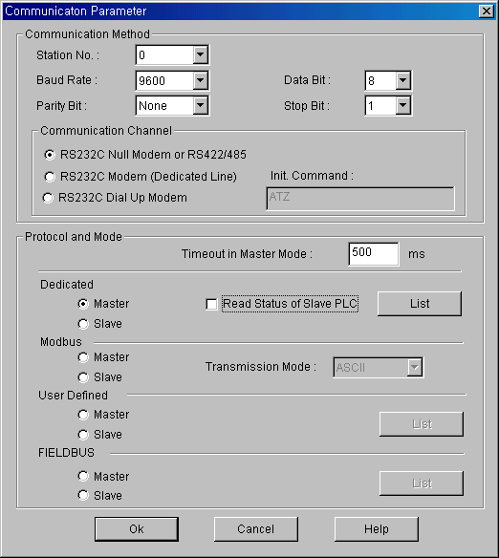

2) Set basic parameters (Baudrate, Station No. Parity, Data bit, Stop bit )

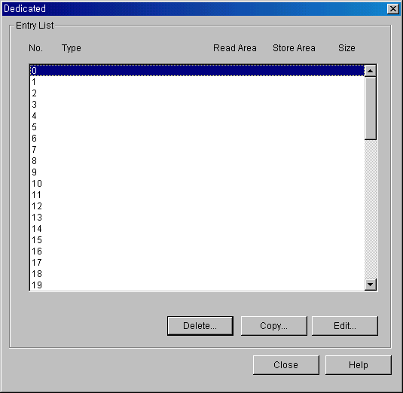
3) Click ‘LIST’ button in the dedicated menu.

4) Click the first line and edit send parameter
Slave station no.
to be accessed
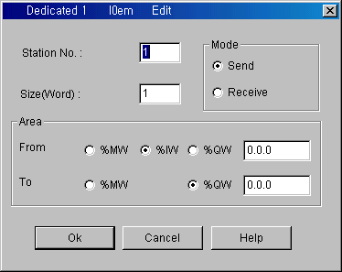
Head address of
Slave station
Head address of
Master(self) station
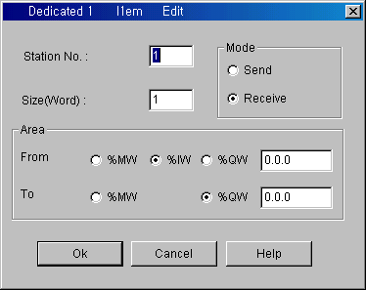
5) Click the second line and edit receive parameter
Slave station no.
to be accessed
Head address of
Slave station
Head address of
Master(self) station

6) Connect and download parameter
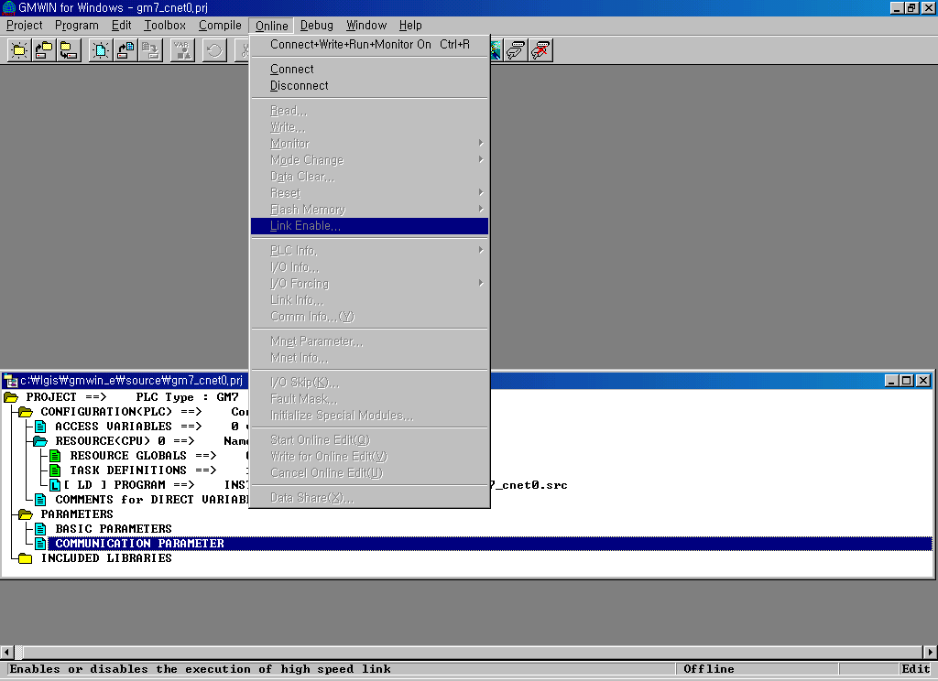
7) Click ‘Link Enable’ in the on-line menu

6-5-4-2. Station 1 (Slave)
1) Double click ‘communication parameter’ in the parameter menu.
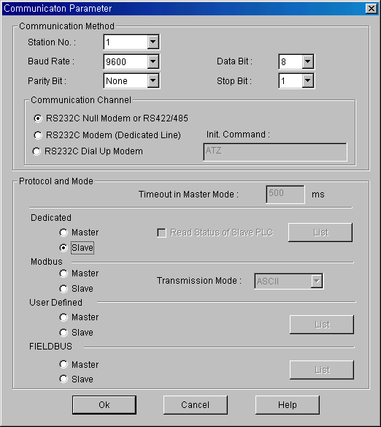

2) Set basic parameters (Baudrate, Station No. Parity, Data bit, Stop bit )
3) Connect and download parameter

4) Click ‘Link Enable’ in the on-line menu

6-6 User defined protocol service (GM6 / K200S ↔ Mitsubishi PLC)

6-6-1. Example Overview
By using ‘User defined protocol service’, GM6 / K200S reads data memory of Mitsubishi Melsec
A2U (D000 ~ D002, 3words)

6-6-2. System Configuration
A2U CPU / AJ71UC24
K200S CPU & G6L-CUEC
GM6 CPU & G6L-CUEA
Command

Response

RS-422/485 Interface

D200 / RCV_DATA(0~1)
D201 / RCV_DATA(2~3)
D202 / RCV_DATA(4~6)
D000
D001
D002

6-6-3. Test Environment

 | K200S | Mitsubishi
CPU | GM6 CPU / K200S CPU | A2U CPU
Communication Module | G6L-CUEA (Slot 5) | AJ71UC24
Cable | RS-422 | RS-422
Programming (Instruction) | SND / RCV | Not required
Station number | 0 | 1
Mode Switch | 0 (RS-422 User defined) | 5 (RS-422 Dedicated)
Client / Server | Client (Master) | Server (Slave)
Communication Service | Cnet User defined Protocol Service
RS-232C Spec. | 9600bps, Data 8bit, Stop 1bit, None pariry

6-6-4. Setting Cnet Basic Parameter
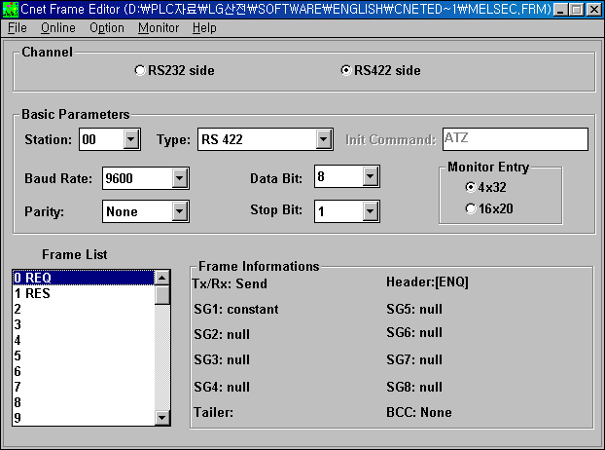

6-6-5. Communication Frame Editing
- AJ71UC24’s (MELSEC Serial communication module) Protocol frame (Command/Response format)
can be easily created by frame editor tool and that frame will be used with instruction in PLC program.
- AJ71UC24’s request(command) and response format is as below

1) Request Format (Cnet module → AJ71UC24) : ASCII Code
01
Station
Number

2 Byte
FF
Self
Station

2 Byte
WR
Command
(Word
read)

2 Byte
D0000
Head
Address

5 Byte
0
Waiting
Time

1 Byte
03
Number

2 Byte
D000 ~ D002
ENQ
Header

1 Byte

2) Response Format (AJ71UC24 → Cnet module) : ASCII Code
STX
Header

1 Byte
01
Station
Number

2 Byte
1234
Data

2 Byte
5678
Data

2 Byte
90AB
Data

2 Byte
FF
Self
Station

2 Byte
ETX
Tail

1 Byte

6-6-5-1. Send Frame editing
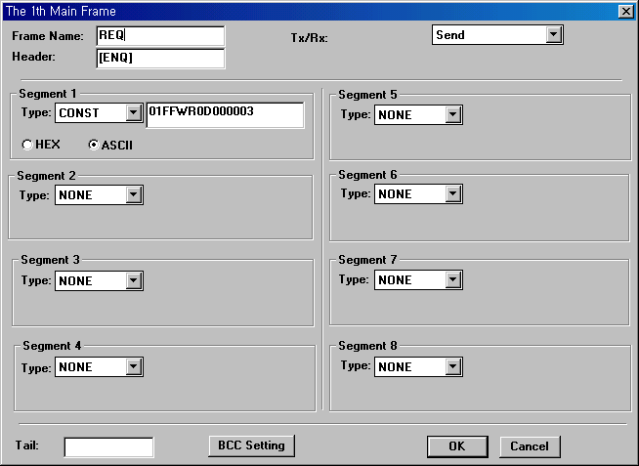
Frame name will be used in instruction (SND)

♧Point !
Command / Response Frame can be divided as some segment by frame editor.
User need to optimize frame structure by this segmentation, Some parts as constant string,
the other parts as variable.
For example, two cases below has a same result.
Case 1 (All constant string) Case 2 (Constant string + Variable)
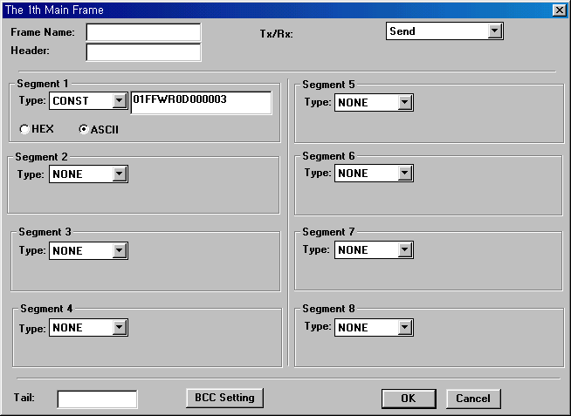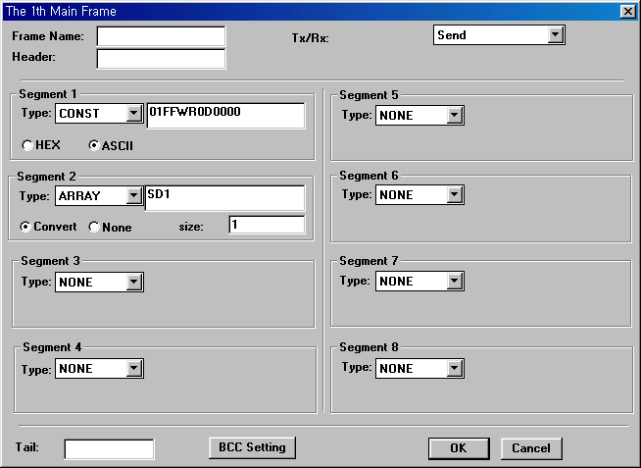
In the unit
Of Byte
SD1. Is fixed name
User can not change this Name
In case of GLOFA : SD1
In case of MKS : SD1.

H03
SD1.
Moved by Ladder Program

6-6-5-2. Receive Frame editing
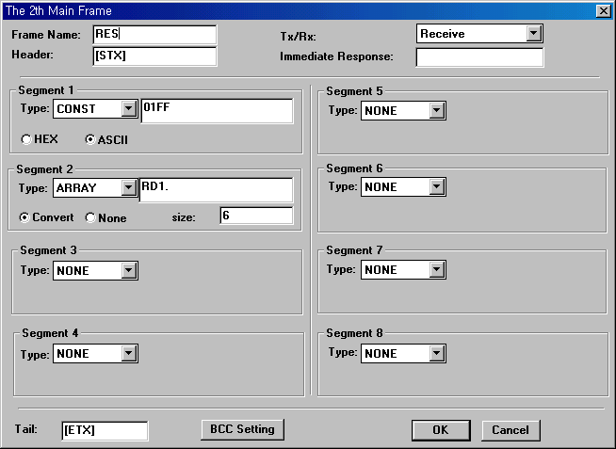
Frame name will be used in instruction (SND)
In the unit
Of Byte
Note !!!
In case of GLOFA : RD1
In case of MKS : RD1.
STX
Header

1 Byte
01
Station
Number

2 Byte
1234
Data

2 Byte
5678
Data

2 Byte
90AB
Data

2 Byte
FF
Self
Station

2 Byte
ETX
Tail

1 Byte
Variable area : 6 Bytes
Fixed area

6-6-6. PLC Programming (for GLOFA)

Recive Frame name designated in frame editor
This value is string type, so ‘ must be attached
(‘RES‘)

Send Frame name designated in frame editor.
This value is string type, so ‘ must be attached
(‘REQ‘)

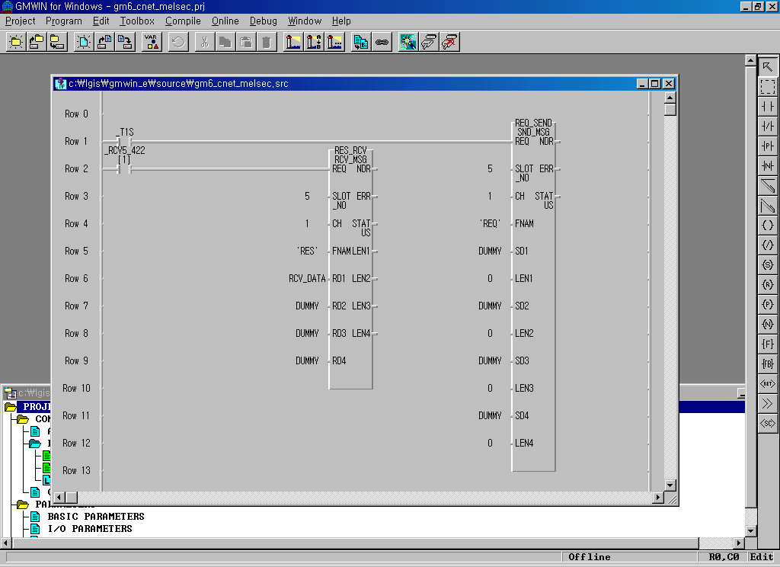

Array variable(USINT type) in which received
data is stored.
(this array must have more than 6 component
to store 3 words)
In this example, this area is not required.
But this area must be filled by dummy variable.

Receive complete flag
- If the frame agreed with the frame downloaded to Cnet module is received, Cnet modules lets
the flag ‘ON’ Indicating that the receiving is completed successfully
Flag Name | Item | Description
_RCVn_232[ i ]  _RCVn_422[ i ] | n (0~7) | Select slot number of Cnet
_RCVn_232[ i ]  _RCVn_422[ i ] | 232 | RS-232C
_RCVn_232[ i ]  _RCVn_422[ i ] | 422 | RS-422 / 485
_RCVn_232[ i ]  _RCVn_422[ i ] | i | Entry number of receive frame designated by frame editor.

6-6-7. PLC Programming (for Master K)
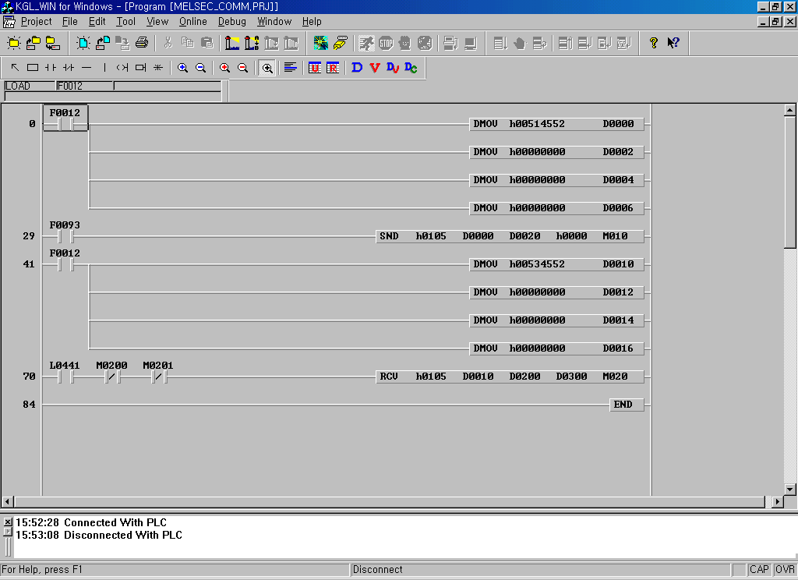
①
②
③
④
⑤
① Store the name of send frame in D000 ~ D007 as ASCII Code (8words)
D007 |  | D006 |  | D005 |  | D004 |  | D003 |  | D002 |  | D001 |  | D000
0 | 0 | 0 | 0 | 0 | 0 | 0 | 0 | 0 | 0 | 0 | 0 | 0 | Q  H51 | E  H45 | R  H52
② [ SND H0105 D000 D0020 H0000 M010 ]
- H0105 : Channel & slot no. (01 = RS-422, 05 = slot no.)
- D0000 : Frame name set by frame editor (‘REQ’)
- D0020 : Start address of sending data to ‘SD1.’ designated by frame editor.
In this case, there is not ‘SD1.’ field in the frame (all constant string). So this device becomes
Dummy area.
- H0000 : Byte number of sending data to ‘SD1.’ Designated by frame editor
In this case, there is not ‘SD1.’ field in the frame (all constant string). So this value becomes
0 (zero)
- M010 : Communication status (M0100 ~ M010F)
Error Code (M108 ~ M10F, 8bits) | Not Used (M102 ~ M107, 6bits) | M101 | M100
Error bit (Turns on when an error occurs during communication)
Done bit (Turns on during 1scan when instruction is executed normally)
③ Store the name of receive frame in D010 ~ D017 as ASCII Code (8words)
D017 |  | D016 |  | D015 |  | D014 |  | D013 |  | D012 |  | D011 |  | D010
0 | 0 | 0 | 0 | 0 | 0 | 0 | 0 | 0 | 0 | 0 | 0 | 0 | S  H53 | E  H45 | R  H52

④ [ RCV H0105 D0010 D0200 D0300 M020 ]
- H0105 : Channel & slot no. (01 = RS-422, 05 = slot no.)
- D0010 : Frame name set by frame editor (‘RES’)
- D0200 : Start address of receiving data from ‘RD1.’ designated by frame editor.
- HD300 : Byte number of data received from ‘RD1.’ Designated by frame editor )
- M020 : Communication status (M0200 ~ M020F)
Error Code (M208 ~ M20F, 8bits) | Not Used (M202 ~ M207, 6bits) | M201 | M200
Error bit (Turns on when an error occurs during communication)
Done bit (Turns on during 1scan when instruction is executed normally)
⑤ Receive Flag (L0441) : Turns on per 1scan automatically when the frame is received
- This flag is a kind of special relay. User can not change value & address of this flag.
Slot (Cnet) | Channel | Frame No. | Receive Flag
0 Slot  (L0000 ~ L007F) | RS-232C  (L0000 ~ L003F) | Frame No.0 | L0000
0 Slot  (L0000 ~ L007F) | RS-232C  (L0000 ~ L003F) | Frame No.1 | L0001
0 Slot  (L0000 ~ L007F) | RS-232C  (L0000 ~ L003F) | Frame No.2 | L0002
0 Slot  (L0000 ~ L007F) | RS-232C  (L0000 ~ L003F) | Frame No.63 | L003F
0 Slot  (L0000 ~ L007F) | RS-422/485  (L0040 ~ L007F) | Frame No.0 | L0040
0 Slot  (L0000 ~ L007F) | RS-422/485  (L0040 ~ L007F) | Frame No.1 | L0041
0 Slot  (L0000 ~ L007F) | RS-422/485  (L0040 ~ L007F) | Frame No.2 | L0042
0 Slot  (L0000 ~ L007F) | RS-422/485  (L0040 ~ L007F) | Frame No.63 | L007F
1 Slot  (L0080 ~ L015F) | RS-232C  (L0080 ~ L011F)
1 Slot  (L0080 ~ L015F) | RS-422/485  (L0120 ~ L015F)
5 Slot  (L0080 ~ L015F) | RS-232C  (L0400 ~ L043F)
5 Slot  (L0080 ~ L015F) | RS-422/485  (L0440 ~ L047F) | Frame No.0 | L0440
5 Slot  (L0080 ~ L015F) | RS-422/485  (L0440 ~ L047F) | Frame No.1 | L0441
5 Slot  (L0080 ~ L015F) | RS-422/485  (L0440 ~ L047F) | Frame No.2 | L0442
5 Slot  (L0080 ~ L015F) | RS-422/485  (L0440 ~ L047F) | Frame No.63 | L047F

6-7 User defined service (GM7 ↔ Mitsubishi PLC)

6-7-1. Example Overview
By using ‘User defined protocol service’, GM7 reads data memory of Mitsubishi Melsec
A2U (D000 ~ D002, 3words)

6-7-2. System Configuration
A2U CPU / AJ71UC24
Command
GM7 & G7L-CUEC

Response

RS-422/485 Interface

%MB0~%MB1
%MB2~%MB3
%MB4~%MB5
D000
D001
D002

6-7-3. Test Environment

 | GM7 | Mitsubishi
CPU | GM7 CPU | A2U CPU
Communication Module | G7L-CUEC | AJ71UC24
Cable | RS-422 | RS-422
Programming (Instruction) | SND_MSG | Not required
Station number | 0 | 1
Mode Switch | Selected by parameter | 5 (RS-422 Dedicated)
Client / Server | Client (Master) | Server (Slave)
Communication Service | Cnet User defined Protocol Service
RS-232C Spec. | 9600bps, Data 8bit, Stop 1bit, None pariry

6-7-4. Communication parameter setting

1) Double Click ‘Communication Parameter’ in the parameter menu.
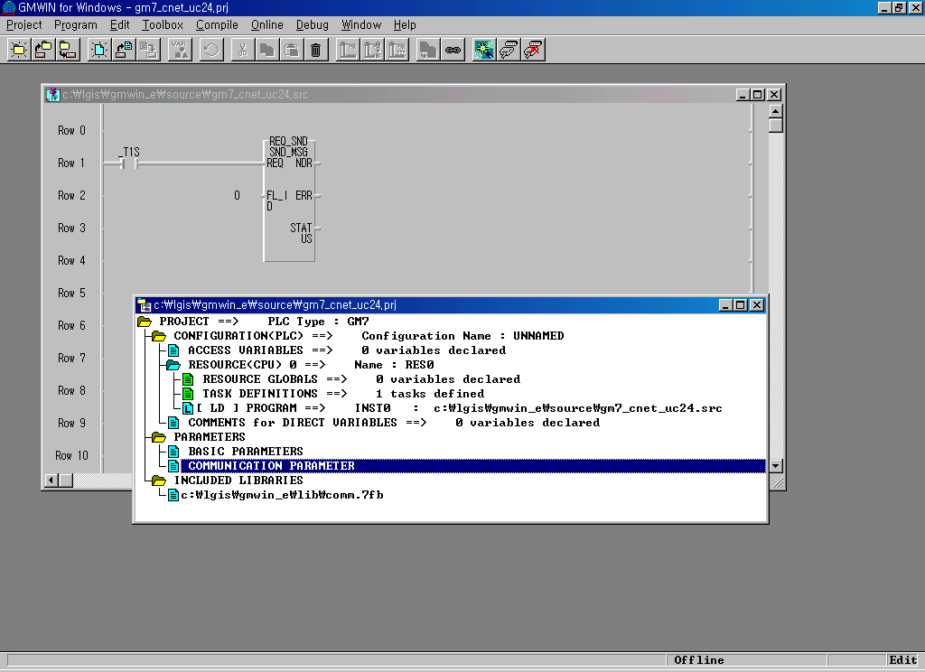

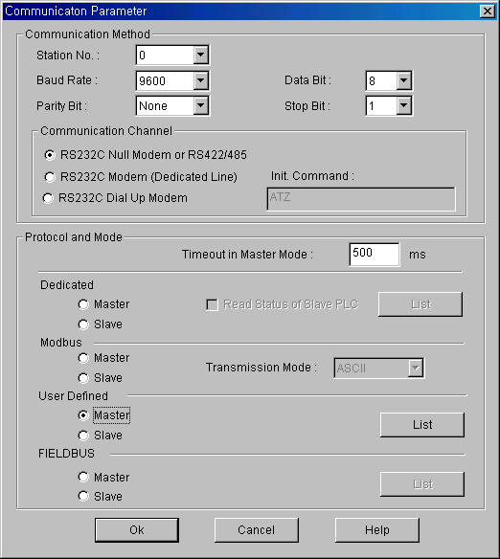
Buadrate (9600bps)
Parity (None)
Data (8bit), Stop(1bit)
User Defined
Master mode

- Click the ‘List’ button for Frame editing
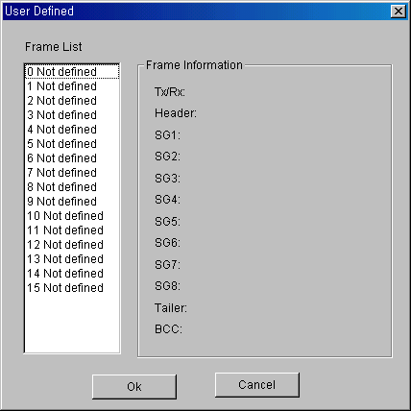
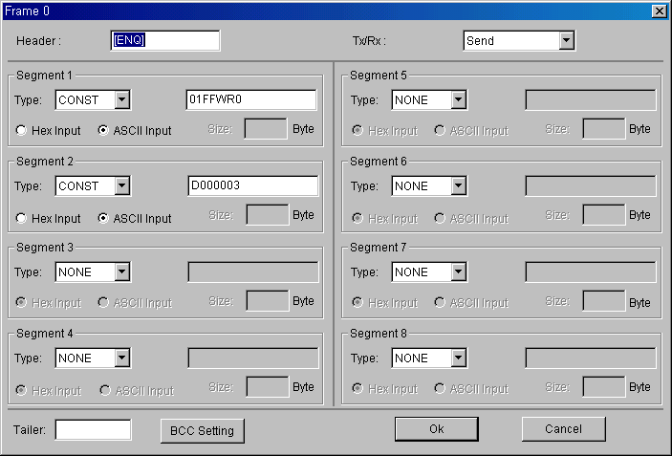
- Send (Request) frame editing
Maximum character of
Each constant area is
10 character.

01
Station
Number

2 Byte
FF
Self
Station

2 Byte
WR
Command
(Word
read)

2 Byte
D0000
Head
Address

5 Byte
0
Waiting
Time

1 Byte
03
Number

2 Byte
D000 ~ D002
ENQ
Header

1 Byte

4) Receive (Response) frame editing
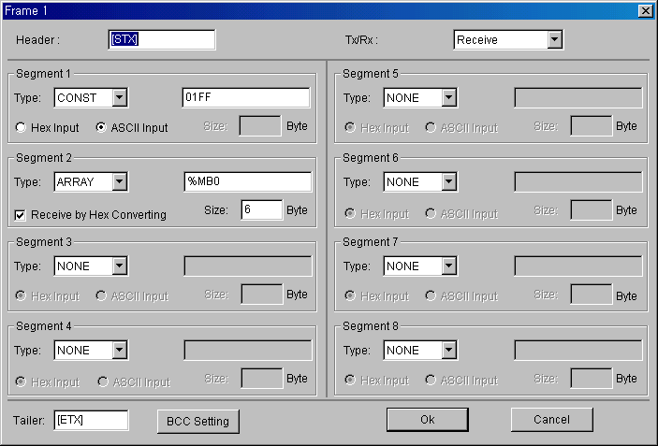

Variable area : 6 Bytes
Fixed area
STX
Header

1 Byte
01
Station
Number

2 Byte
1234
Data
(D000)

2 Byte
5678
Data
(D001)

2 Byte
90AB
Data
(D002)

2 Byte
FF
Self
Station

2 Byte
ETX
Tail

1 Byte

%MB4 = 16#90
%MB5 = 16#AB

%MB2 = 16#56
%MB3 = 16#78

%MB0 = 16#12
%MB1 = 16#34

6-7-5. Programming

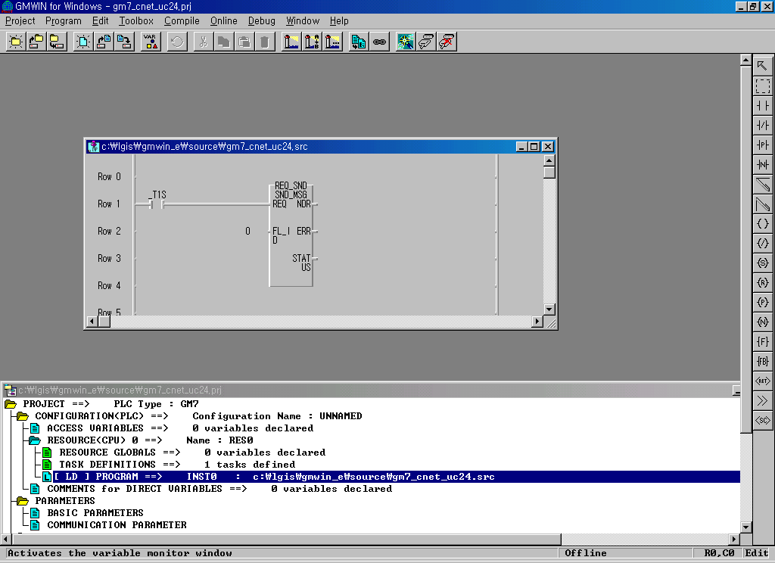
Send frame entry number designated by comm. parameter

6-7-6. Link Enabling
1) Connect and download parameter and program
2) Click ‘Link Enable’ in the on-line menu

6-8 Library service / Modbus (K200S / GM6 ↔ IBM PC)

6-8-1. Example Overview
By using Modbus protocol, IBM PC reads/write data memory In the PLC CPU and displays
results on the monitor screen.

6-8-2. System Configuration

IBM Compatible
Computer
K200S / GM6 CPU
& G6L-CUEA
Command

Response
RS-232C Interface

6-8-3. Test Environment

 | Computer | K200S / GM6
CPU | Pentium 133 | K200S / GM6 CPU
Communication Module | COM1 Port | G6L-CUEA
Cable | RS-232C | RS-232C
O/S | Windows98 | -
Development Language | MS Visual Basic | -
Station number | - | 1
Mode Switch | - | 9 (On line switching mode)
Client / Server | Client (Master) | Server (Slave)
Communication Service | Modbus RTU Protocol Service
RS-232C Spec. | 9600bps, Data 8bit, Stop 1bit, None pariry

6-8-4. Setting Cnet Basic Parameter
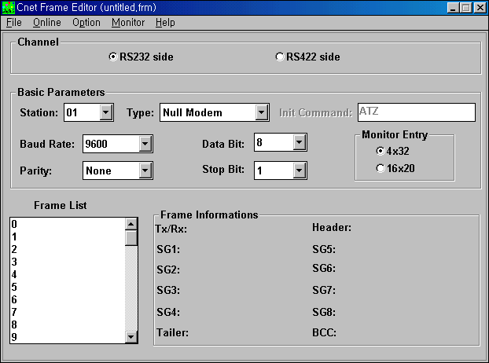

Frame editing is not rquired
Modbus Station No.

6-8-5. Writing library (Modbus driver) to flash memory

- Set the Cnet module to ‘Flash memory write mode’(Mode 8) with the mode selection switch.
- RUN LED of Cnet module will blink with 1 second period
- Run the frame editor and connect to the Cnet module.
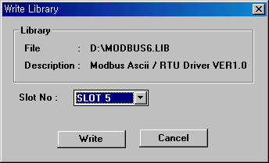
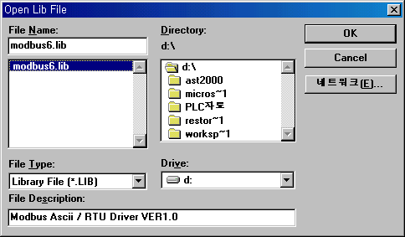
- Select ‘modbus6.lib’(Modbus driver for GM6/K200S) in Open Lib menu

- select Online – Flash Memory – Write in the menu, then type the slot number at which the Cnet
module is mounted, and press ‘Write’ button.
- Set the Cnet module to ‘On-line mode’(Mode 9) with the mode selection switch and cycle Cnet
Module power.
- Run the frame editor and connect to the Cnet module, then select ‘Library mode’ in on line change
Menu.
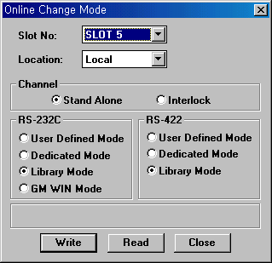

6-8-6. Address Map
1) GM1/2/3/4/6 (K1000S/300S/200S)
- Modbus device (Modicon PLC Device) can be corresponded to the M(%M) area only.
- In case of bit device, M0000 ~ M0007 (%M0 ~ %M7) can not be correspond to Modicon Address.
- In case of word device, M000 (%MW0) can not be correspond to Modicon Address.

Bit / Word | Modicon  Address | GLOFA  Address | Master K  Address | Remarks
Bit | □ 0008 | %M8 | M 0008 | Raead / Write
Bit | □ 0009 | %M9 | M 0009 | Raead / Write
Bit | □ 0010 | %M10 | M 000A | Raead / Write
Bit | □ 0011 | %M11 | M 000B | Raead / Write
Bit | □ 0012 | %M12 | M 000C | Raead / Write
Bit | □ 3071 | %M3071 | M 191F | Raead / Write
Bit | □ 3072 | %M3072 | Not available | Raead / Write
Bit | □ 9999 | %M9999 | Not available | Raead / Write
Word | ■ 0001 | %MW1 | M 001 | Read / Write
Word | ■ 0002 | %MW2 | M 002 | Read / Write
Word | ■ 0003 | %MW3 | M 003 | Read / Write
Word | ■ 0004 | %MW4 | M 004 | Read / Write
Word | ■ 0005 | %MW5 | M 005 | Read / Write
Word | ■ 0006 | %MW6 | M 006 | Read / Write
Word | ■ 0191 | %M191 | M 191 | Read / Write
Word |  |  | Not available | Read / Write
Word | ■ 4999 | %MW4999 | Not available | Read / Write
Word | ■ 5000 | Not available | Not available | Read / Write
Word | ■ 9999 | Not available | Not available | Read / Write
□: Identifier of Modicon device ( 0=Input, 1=Coil )
■: Identifier of Modicon device ( 3=Input register, 4=Holding register )
2) GM7 (K80S)
- In case of K80S, Modbus device (Modicon PLC Device) can be corresponded to all type & range of
device memory.
- In case of GM7, Modbus device (Modicon PLC Device) can be corresponded to %M area only.

Bit / Word | Modicon  Head Address | GLOFA  Head Address | Master K  Head Address | Remarks
Bit | □ 0001 ~ | %M000 ~ | P 0000 ~ | Raead / Write
Bit | □ 4097 ~ | %M4096 ~ | M 0000 ~ | Raead / Write
Bit | □ 8193 ~ | %M8192 ~ | L 0000 ~ | Raead / Write
Bit | □ 12289 ~ | Not available | K 0000 ~ | Raead / Write
Bit | □ 16385 ~ | Not available | F 0000 ~ | Raead / Write
Bit | □ 20481 ~ | Not available | T 0000 ~ | Raead / Write
Bit | □ 24577 ~ | Not available | C 0000 ~ | Raead / Write
Word | ■ 0001 ~ | %MW0 ~ | P 000 ~ | Read / Write
Word | ■ 4097 ~ | Not available | M 000 ~ | Read / Write
Word | ■ 8193 ~ | Not available | L 000 ~ | Read / Write
Word | ■ 12289 ~ | Not available | K 000 ~ | Read / Write
Word | ■ 16385 ~ | Not available | F 000 ~ | Read / Write
Word | ■ 20481 ~ | Not available | T 000 ~ | Read / Write
Word | ■ 24577 ~ | Not available | C 000 ~ | Read / Write
Word | ■ 28673 ~ | Not available | S 000 ~ | Read / Write
Word | ■ 32769 ~ | Not available | D 000 ~ | Read / Write
□: Identifier of Modicon device ( 0=Input, 1=Coil )
■: Identifier of Modicon device ( 3=Input register, 4=Holding register )

6-8-7. Computer Application Software (Modbus simulator)
- Run modbus.exe
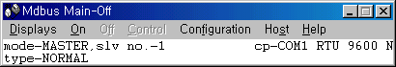
2) Click ‘configuration’ on menu bar
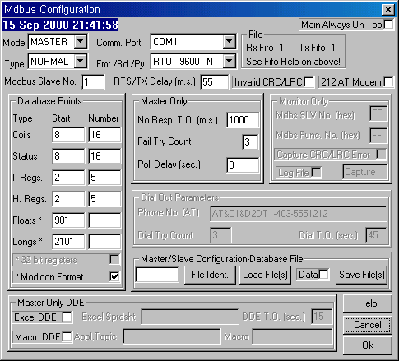
Slave station No. (Station No. of Cnet)

Protocol (RTU), Buadrate (9600bps), Parity (None)
Head address(word) to be read and number
- M002 ~ M006 (%MW2 ~ %MW6)
Head address(Bit) to be read and number
- M0008 ~ M0017 (%M8 ~ %M23)

3) Click ‘ON’ on menu bar (Communication is started)
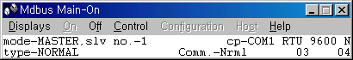
4) Select ‘Display – Coils’ on menu bar
M0008 is ON
M000A is ON
M000B is ON
M000D is ON
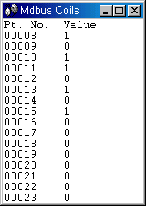
M000F is ON
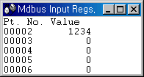
5) Select ‘Display – Input register’ on menu bar
Value of M002(word) is 1234

