6. Modbus Communication

6.1 Overview of Modbus Communication

Smart I/O module communication supports modbus through GM3/4/6/7 master module.
(G3L-CUEA/G4L-CUEA/G6L-CUEC/G7L-CUEC)
This supports ASCII mode that communicates using ASCII (American Standard Code for Information Interchange) data and RTU (Remote Terminal Unit) mode that uses HEX data and the function code used in the modbus is supported by the Function Block and only function code 01, 02, 03, 04, 05, 06, 15, 16 are supported.

6.2 Communication Specifications

    - ASCII Mode
- This communicates using ASCII data.
2) Each frame uses ‘:(Colon) : H3A)’ for the header, CRLF(Carriage Return-Line Feed) : HOD HOA) for the tale.
3) Max. 1second interval between Characters is allowed.
4) It uses LRC to check the error.
5) Frame structure (ASCII data)

Classification | Header | Station no. | Function code | Data | LRC | Tale (CR LF)
Size | 1 byte | 2 byte | 2 byte | n byte | 2 byte | 2 byte

6.2.2 RTU Mode
1) It uses HEX data to communicate.
2) There is no header and tale and it starts from station no.(Address) and ends the frame with CRC.
3) It has min. 3.5 Character Time Interval between frames.
4) When exceeding more than 1.5 Character Time between Character, please disregard the corresponding frame.
5) It uses 16 bit CRC to check the error.
6) Frame structure (HEX data)

Classification | Station no. | Function code | Data | CRC
Size | 1 byte | 1 byte | n byte | 2 byte

Remark
- The size to compose one letter (character) is called ‘1 character’, that is, 1 character is 8bits = 1byte.
- 1 character time means the time to take when sending 1 character.
Ex.1) 1 character time calculation in communication speed 2,400 bps
2,400 bps is the speed that takes 1 second to send 2,400 bits. When sending 1 bit, 1(sec)÷2,400(bit) = 0.41(ms).
Thus, 1 character time is 0.41(ms)×8(bit) = 3.28(ms).
In case of 584, 984A/B/X, the internal processing performs the frame classification using the interval more than 1sec without LRC.

6.2.3 Station no.(Address) Area
- Smart I/O series supports 0 ~ 31.
2) Station 0 uses Broadcast address. Broadcast address is the station no. the salve device except self station no. recognizes and responds, and it does not support in Smart I/O series.

6.2.4 Function Code Area
1) In Smart I/O series, it supports Modicon function code 01, 02, 03, 04, 05, 06, 15, 16 only.
2) When the response format is Confirm+ (ACK response), the same function code is used.
3) When the response format is Confirm- (NCK response), set the 8th bit of function code as ‘1’ and return.

6.2.5 Data Area
1) It transmits the data using ASCII (ASCII mode) data or HEX (RTU mode).
2) The data structure is changed according to each function code.
3) Response frame uses the data area as response data or error code.

    - Error Check (LRC Check/CRC Check) Area
1) LRC (Longitudinal Redundancy Check) : this is used in ASCII mode and takes the 2’s complement from the sum of frame except the header/the tale and carries out the ASCII conversion.
2) CRC (Cyclical Redundancy Check) : this is used in RTU mode and uses 2 bytes of CRC check regulations.

    - Function Code Type and Memory Mapping

Code | Function code name | Modicon PLC  Data address | Smart I/O Mapping | Remarks
01 | Read output contact status  (Read Coil Status) | 0XXXX(bit-output) | %QX0~%QX31 | Bit read
02 | Read input contact status  (Read Input Status) | 1XXXX(bit-input) | %IX0~%IX31 | Bit read
03 | Read output registers  (Read Holding Registers) | 4XXXX(word-output) | %QW0~%QW3 | Bit read
04 | Read input register  (Read Input Registers) | 3XXXX(word-input) | %IW0~%IW3 | Word read
05 | Write output contact 1 bit  (Force Single Coil) | 0XXXX(bit-output) | %QX0~%QX31 | Bit write
06 | Write output register 1 word  (Preset Single Register) | 4XXXX(word-output) | %QW0~%QW3 | Word write
15 | Write output contact continuously  (Force Multiple Coils) | 0XXXX(bit-output) | %QX0~%QX31 | Bit write
16 | Write output register continuously  (Preset Multiple Register) | 4XXXX(word-output) | %QW0~%QW3 | Word write

6.3 Cable Specifications

6.3.1. Cable Specifications.
In case of Modbus communication using RS-422 channel, it is required to use Twist Pair Cable for RS-422 considering communication distance and communication speed. The table below shows the specification of recommended cable. In case of using other cables, it is required to use the cable suitable for the following characteristics.

Twist Pair Cable Specification
1) Electric Characteristic
Test Items |  | Unit |  | Characteristics | Test condition
Conductor resistance |  | Ω/km |  | Less than 59 | Normal temp.
Voltage-resistance(DC) |  | V/1min |  | 500V 1 min resist | In air
Insulation resistance |  | MΩ-km |  | More than 1,000 | Normal temp.
Capacitance |  | Pf/M |  | Less than 45 | 1kHz
Characteristics impedance |  | Ω |  | 120 ± 12 | 10MHz
Maker |  | LG Cable Co. LIREV-AMESB(2P X 22AWG D/0.254 TA)
2) Appearance Characteristic
Items |  |  |  | Single Wire
Conductor | No. of core wire |  | Pair | 2
Conductor | Spec. |  | AWG | 22
Conductor | Composition |  | NO./mm | 1/0.643
Conductor | Outside diameter |  | Mm | 0.643
Insulator | Thickness |  | Mm | 0.59
Insulator | Outside diameter |  | Mm | 1.94

6.3.4 Structure of Cable

Conductor
Insulator
Grounding wire
Braided material
Sheath material
Al/Myler tape

6.4 Cabling Diagram

6.4.1 Cabling Diagram for Modbus Smart I/O

GnL-CUEA
Termination
Resistor
(110Ω, 1/2W)

Connector for
Modbus Smart I/O
Tx+
Rx+
Tx-
Rx-
RDA
Termination
Resistor
(120Ω, 1/2W)
Tx+
Rx+
Tx-
Rx-
R
RDB
R
R
SDB
Tx+
Rx+
Tx-
Rx-
R
SDA
SG

Max. 500m.
Max. 32 Stations. (Include Master module).

Available Master Module Table for Modbus Smart I/O when LG PLC is used as master.
CPU | Communication Module
GMR/1/2/3 | G3L-CUEA
GM5 | G4L-CUEA
GM6 | G6L-CUEC
GM7 | G7L-CUEC

6.4.2 Pin assignment for Modbus Smart I/O

1  2  3  4  5  6  7  8  9  Male Type | PIN spec. | Smart I/O (9-PIN)
1  2  3  4  5  6  7  8  9  Male Type | 1 | Reserved(OS Upgrade)
1  2  3  4  5  6  7  8  9  Male Type | 2 | Reserved(OS Upgrade)
1  2  3  4  5  6  7  8  9  Male Type | 3 | RX-
1  2  3  4  5  6  7  8  9  Male Type | 4 | RX+
1  2  3  4  5  6  7  8  9  Male Type | 5 | GND
1  2  3  4  5  6  7  8  9  Male Type | 6 | Reserved
1  2  3  4  5  6  7  8  9  Male Type | 7 | Reserved
1  2  3  4  5  6  7  8  9  Male Type | 8 | TX-
1  2  3  4  5  6  7  8  9  Male Type | 9 | : TX+

6.5 Function Block for Modbus Communication

Because Modbus communication with RS-422 communication is one of various RS-422 applications. So, LG PLC GLOFA-GM series is used for master module of Modbus Smart I/O, Function Block for modbus communication is required.
To use Function Block, Library must be added to project. If GM3/4/6 is used, Modbus.xFB and Communi.xFB libraries are required, and GM7 is used, Communi.7FB library is required.
The steps adding library will be explained programming part of this chapter.

6.5.1 Function Blocks for GM3/4/6

1) RTU_RD
Item | IN / OUT | Type | Description
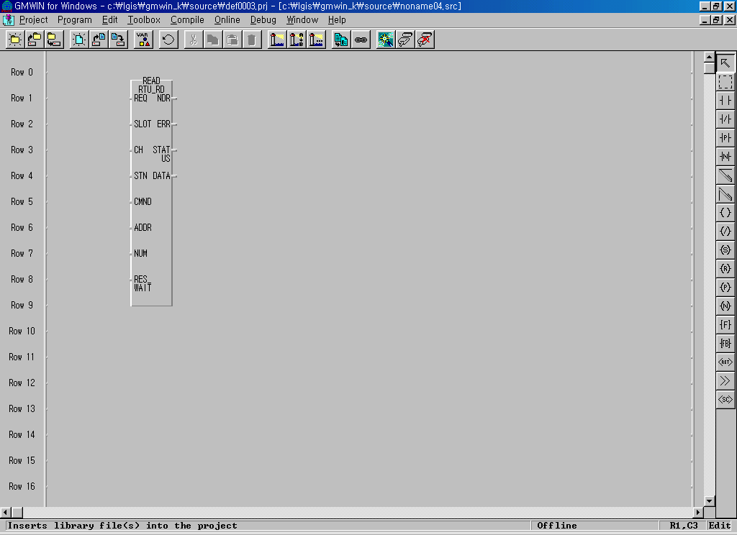 | REQ | BOOL | Function Block execution condition (Rising edge action)  - When changing from 0 to 1, one time executed.
 | SLOT | USINT | Cnet module slot no. (0 ~ 7)
 | CH | USINT | Channel setting (0 : RS-232C, 1 : RS-422/485)
 | STN | USINT | Other station no. setting (0 ~ 32)
 | CMND | USINT | Modbus Command (1 ~4)  1 : Read coil status (Bit)  2 : Read input status (Bit)  3 : Read holding register (Word)  4 : Read input register (Word)
 | ADDR | INT | Leading address of other station to Read (1 ~ 9999)
 | NUM | USINT | Data number to Read (1 ~ 64)
 | RES_WAIT | TIME | Response wait time  (after the setting wait time, eceive the response data from Cnet module of CPU.)
 | NDR | BOOL | After completing the normal communication, 1Scan ‘ON’.
 | ERR | BOOL | When communication error occurs, 1Scan ‘ON’.
 | STATUS | USINT | Communication status code (Error code)  0 : normal, if not 0, : Error code
 | DATA | USINT  ARRY  (256) | Receiving data storage area
  Array [0] : High Byte of first word
  Array [1] : Low Byte of first word
  Array [2] : High Byte of second word
  Array [3] : Low Byte of second word
  …

① Function
This is the Function Block that is executed by selecting function code 01, 02, 03, 04 from modbus protocol communication and used for Bit/Word Read. Function code 01 executes output contact status (Coil Status) Data Read and function code 02 executes input contact status (Input Status) Data Read. Function code 03 executes output register (Holding Registers) Data Read and function code 04 executes input register(Input Registers) Data Read.

② Error
Output the error code from output STATUS. For further information, please refer to error code.

Remark
Response Wait Time setting

1) After the setting wait time, receive the response data from Cnet module of CPU.
2) If the response does not reach from other station within the setting time, error (code 74 or code 10) occurs. This Function Block acts in Cnet function ‘User definition Protocol Mode’.
3) Response Wait Time shall be set considering Read/Write data number, transmission speed (Baudrate), the response speed of other station etc.
4) When setting, please refer to the table below and if error occurs, extend the setting time.

Classification | 1 ~ 16 word | 17 ~ 32 word | 33 ~ 48 word | 49 ~ 64 word
4800 bps | 150ms | 250ms | 330ms | 400ms
9600 bps | 100ms | 180ms | 230ms | 280ms
19200 bps | 80ms | 150ms | 180ms | 230ms

2) RTU_WR
Item | IN / OUT | Type | Description
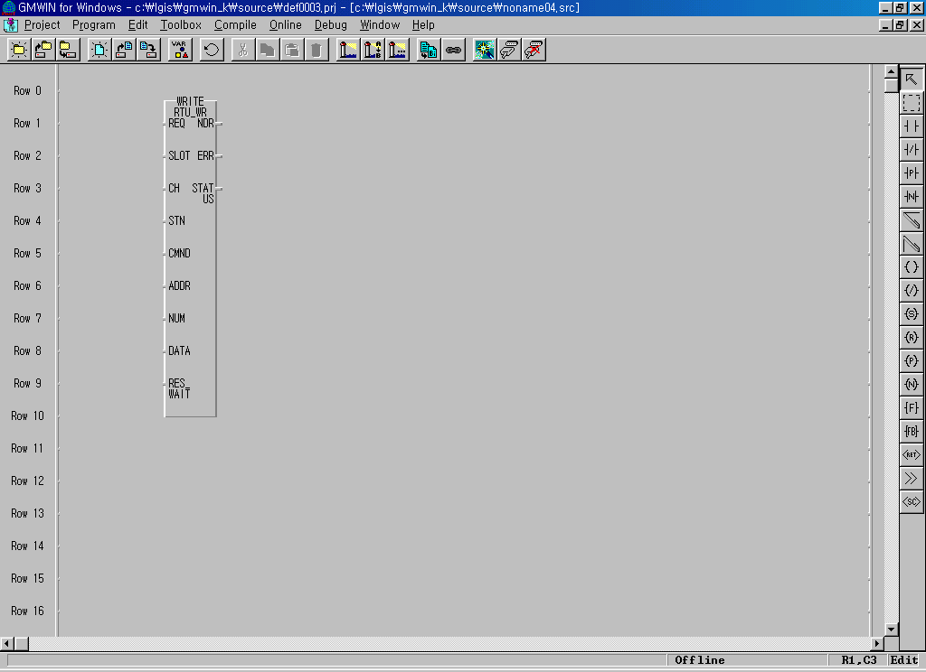 | REQ | BOOL | Function Block execution condition (Rising edge action)  - When changing from 0 to 1, one time executed.
 | SLOT | USINT | Cnet module slot no. (0 ~ 7)
 | CH | USINT | Channel setting (0 : RS-232C, 1 : RS-422/485)
 | STN | USINT | Other station no. setting (0 ~ 32)
 | CMND | USINT | Modbus Command (15 ~ 16)  15 : Force Multiple coils(Bit)  16 : Preset Multiple register (Word)
 | ADDR | INT | Leading address to Write (1 ~ 9999)
 | NUM | USINT | Data number to Write (1 ~ 64)
 | RES_WAIT | TIME | Response wait time  (after the setting wait time, receive the response data from Cnet module of CPU.)
 | NDR | BOOL | After completion of the normal communication, 1Scan ‘ON’.
 | ERR | BOOL | When communication error occurs, 1Scan ‘ON’.
 | STATUS | USINT | Communication status code (Error code)  0 : normal, if not 0, : Error code
 | DATA | USINT  ARRY  (256) | Self station data storage area to Write
  Array [0] : High Byte of first word
  Array [1] : Low Byte of first word
  Array [2] : High Byte of second word
  Array [3] : Low Byte of second word
  …

① Function
This is the Function Block to execute by selecting function code 15 and 16 from modbus protocol communication and used for Continuous 1 bit Write (function code 15), Continuous 1 word Write (function code 16). Function code 15 performs 1 bit Data Write to output contact (Coil) continuously and function code 16 performs 1 word Data Write to output register (Holding Registers) continuously.

② Error
Output the error code to output STATUS. For further information, please refer to the error code.

3) Error code table
Status  code  (Dec) | Description | Solution | Remarks
0 | Normal | No error
1 | Illegal command  (When the master requires the command that the Slave does not support.) | After confirming the command available to support by the Slave, modify the command on FB. | The error  returned from the  Slave
2 | Illegal address  (When the Master requires the address that the Slave does not support.) | After confirming the address available to support by the Slave, modify the address on FB. | The error  returned from the  Slave
3 | Illegal data value  (When the Master requires the data of the range that the Slave does not support.) | After confirming the data range available to support by the Slave, modify the data on FB. | The error  returned from the  Slave
4 | Slave device failure  (The unrecoverable error occurs while performing the Master requirements in the Slave.) | Check the Slave station status. | The error  returned from the  Slave
6 | Slave device busy | After waiting for the regular time, Master | The error  returned from the  Slave
10 | Receiving Frame CRC error | 1. After confirming the receiving frame status, extend the Response Wait Time.  2. Check the Cable and Noise status. | Function  Block internal error
16 | Cnet module I/F error  (No Cnet module in the designated slot.) | Check the slot no. designated on FB. | Function  Block internal error
64 | Channel (232c/422) stop | RUN the Cnet module.  (power reinput) | Function  Block internal error
74 | Time out error | 1. Check the basic parameter (station no./speed etc.)  2. Check the Slave station status (power etc.)  3. Check the Cable status and connecton | Function  Block internal error
115 | Communication mode error | Check if Cnet user definition | Function  Block internal error

Remark
1) This Function Block acts in Cnet function ‘User Definition Protocol Mode’.
2) Basic parameter (Baudrate, Data bit, Stop bit, Parity check, Station No. etc.) shall be set in Cnet editor and the frame editing is not needed.
3) This supports Modbus RTU Protocol. (scheduled to support ASCII Protocol later)
4) Cnet module requirements to use this Function Block are as follows.
  - Cnet module version : more than v2.0 (available to verify in GMWIN)
  - Cnet module Flash Rom OS version : more than v1.01 (available to verify in Cnet Editor)
  - Modbus.Nfb (Modbus Function Block file, N=3,4,6) needed.

6.5.2 Function Blocks for GM3/4/6

1) MOD0102
Function Block | Description
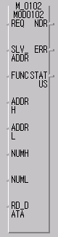 | Input
 | REQ | : When 1(rising edge), Function Block execution
 | SLV_ADDR | : Slave station no. input
 | FUNC | : Function code input  It supports function code 01 and 02.
 | ADDRH | : High address of starting address to read in the Slave station.
 | ADDRL | : Low address of starting address to read in the Slave station.
 | NUMH | : High address of data size to read from the starting address to read in the Slave station.
 | NUML | : Low address of data size to read from the starting address to read in the Slave station.
 | Output
 | RD_DATA | : Variable name to save the Read data.(Array number should be declared as equal to or greater than the data size.)
 | NDR | : If executing without error, output 1 and maintain 1 until calling next Function Block.
 | ERR | : When error occurs, output 1 and maintain 1 until calling next Function Block.
 | STATUS | : When error occurs, output the error code.

① Function
This is the Function Block to execute by selecting function code 01 and 02 from modbus protocol communication and used for Bit Read. Function code 01 performs output contact status (Coil status) data Read and function code 02 performs input contact status (Input Status) data Read.

② Error
Output the error code to the Output STATUS. For further information, please refer to the error code.

2) MOD0304
Function Block | Description
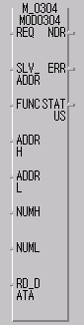 | Input
 | REQ | : When 1(rising edge), Function Block execution
 | SLV_ADDR | : Slave station no. input
 | FUNC | : Function code input  It supports function code 03 and 04.
 | ADDRH | : High address of starting address to read in the Slave station.
 | ADDRL | : Low address of starting address to read in the Slave station.
 | NUMH | : High address of data size to read from the starting address to read in the Slave station.
 | NUML | : Low address of data size to read from the starting address to read in the Slave station.
 | Output
 | RD_DATA | : Variable name to save the Read data. (Array number should be declared as equal to or greater than the data size.)
 | NDR | : If executing without error, output 1 and maintain 1 until calling next Function Block.
 | ERR | : When error occurs, output 1 and maintain 1 until calling next Function Block.
 | STATUS | : When error occurs, output the error code.

① Function
This is the Function Block to execute by selecting function code 03 and 04 from modbus protocol communication and used for Word Read. Function code 03 performs output register (Holding Registers) data Read and function code 04 performs input register (Input Registers) data Read.

② Error
Hold the error code to the Output STATUS. For further information, please refer to the error code.

3) MOD0506

Function Block | Description
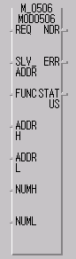 | Input
 | REQ | : When 1(rising edge), Function Block execution
 | SLV_ADDR | : Slave station address input
 | FUNC | : Function code input  It supports function code 05 and 06.
 | ADDRH | : High address among start address to write in the Slave station.
 | ADDRL | : Low address among start address to write in the Slave station.
 | NUMH | : High address among data to write in the Slave station.
 | NUML | : Low address among data to write in the Slave station.
 | Output
 | NDR | : If executing without error, output 1 and maintain 1 until calling next Function Block.
 | ERR | : When error occurs, output 1 and maintain 1 until calling next Function Block.
 | STATUS | : When error occurs, output the error code.

① Function
This is the Function Block to execute by selecting function code 05 and 06 from modbus protocol communication and used for 1Bit Write (function code 05) and 1Word Write (function code 06). Function code 05 performs 1Bit data Write for output contact (Coil) and if setting 255 (or HFF) for input NUMH of Function Block or 0 (or H00) for input NUML, write ‘1’ for output contact and if setting 0 (or H00) for input NUMH or 0 (or H00) for NUML, write ‘0’ for output contact. Function code 06 performs 1 word data write in output register.

② Error
Output the error code to the output STATUS. Further information, please refer to Error code.

4) MOD1516
Function Block | Description
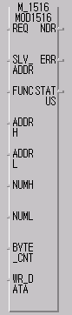 | Input
 | REQ | : When 1(rising edge), Function Block execution
 | SLV_ADDR | : Slave station address input
 | FUNC | : Function code input  It supports function code 15 and 16.
 | ADDRH | : High address among starting address to write in the Slave station.
 | ADDRL | : Low address among starting address to write in the Slave station.
 | NUMH | : High address of data size to write in the Slave station.
 | NUML | : Low address of data size to write in the Slave station.
 | BYTE_CNT | : Byte size of data to write in the Slave station.
 | WR_DATA | : Variable name to save the data to write. (It should be declared as equal to or greater than the data size.)
 | Output
 | NDR | : If executing without error, output 1 and maintain 1 until calling next Function Block.
 | ERR | : When error occurs, output 1 and maintain 1 until calling next Function Block.
 | STATUS | : When error occurs, output the error code.

① Function
This is the Function Block to execute by selecting function code 15 and 16 from modbus protocol communication and used for Continuous 1Bit Write (function code 15) and Continuous 1Word Write (function code 16). Function code 15 performs 1Bit Data Write for output contact (Coil) by 1 byte continuously and Function code 16 performs 1 Word Data Write for output register (Holding Registers) continuously.

② Error
Output the error code to the output STATUS. For further information, please refer to Error Code.

5) Error code

CODE | Error type | Meaning
01 | Illegal Function | Function code input error to the Function Block
02 | Illegal Address | The area to read/write in the slave exceeds the allowed range.
03 | Illegal Data Value | The data value to read/write in the Slave is not allowed.
04 | Slave Device Failure | Slave error status
05 | Acknowledge | This is a kind of response code that the Slave sends to the master to prevent the time of the master when it takes a time for the processing of demand command. In the master, it indicates the error code and wait for the regular time without demanding again.
06 | Slave Device Busy | The error caused by long processing time of the slave. Master must demand again.
07 | Time Out | The error occurred when exceeding the setting time of the communication parameter while communication.
08 | Number Error | The error occurred when data is ‘0’ or more than 256byte, when data size is greater than array size, and when number and BYTE_CNT is different.
09 | Parameter Error | Parameter setting error (mode, master/slave)
10 | Station Error | The error occurred when the station no. set in self station and input parameter of function is the same.

6.6 Communication Example.

6.6.1 System Configuration

In GM base, the communication module (G3/4L-CUEA, G6L-CUEC) is installed for slot 0, Input 32 points for slot 1, and Output 32 points for slot 2, respectively.

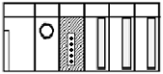
Station # 2
GPL-D22A
(Input 16 points)
Station # 3
GPL-TR4A
(Output 32 points)

Station # 1
G6L-CUEC

I/O configuration and Sending/receiving flow table
Data Flow | PLC Address | Size
PLC ← Smart I/O # 1 | %MW110 | 2 bytes
PLC → Smart I/O # 2 | %MW100 | 4 bytes
PLC ← Smart I/O # 3 | %MW111 | 2 bytes
PLC → Smart I/O # 3 | %MW102 | 2 bytes

Overview of Working steps.
- Station number allocation and communication cable connection.
- Make the data sending/receiving map same type of the above table.
- Execute GMWIN and edit user program. Before editing user program, some library must be added to project file.
- Execute ‘compile’ and ‘make’ from compile menu.
- Write compiled project to PLC.
- Change the mode to RUN from online menu.
- If the error occurs, repeat the above from 1.

4.5.3 Steps to edit Modbus communication Program.
1. Execute GMWIN and compose Project. – Refer to Ch. 3.
2. Add necessary libraries to Project.
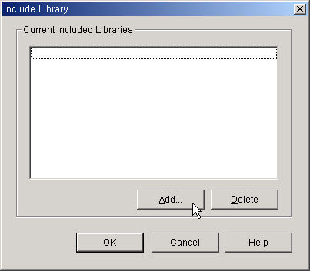
1) Click “Insert Library” from Project Menu and Include Library window will appear.

2) Click “Add…” button and Library Selection window will appear.
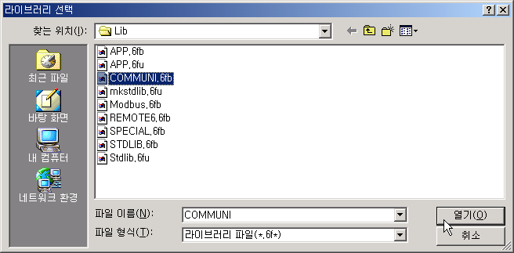

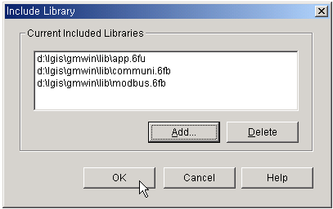3) The three libraries(Communi.xFB, Modbus.xFB, and App.xFU) must be added for GM3/4/6 and two libraries(Comm.7FB, App.7FU) is required for GM7.

4) Included Libraries can be seen on project window.
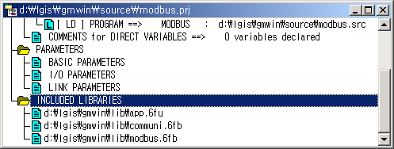

5) Edit user program as follow.
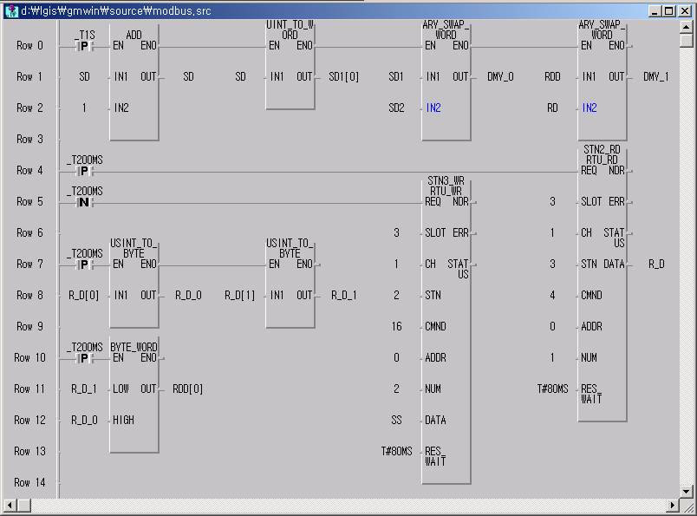
①
②
③

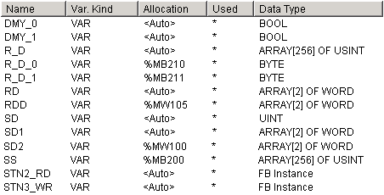

Program and Local Variables

6) Explanation of program
① When data is transmitting with RS-422 module, the order of data is exchanged by byte. So, before send the data and after receive data, the order of data must be exchanged artificially to communicate original data.
A
B
C
D
0
15
A
B
C
D
0
15
A
B
C
D
0
15
PLC data
Transferring data
Smart I/O data
ARY_SWAP_WORD

② Communication performed by byte whose data type is USINT. Convert the type of received data USINT to BYTE and compose one word data by composing two bytes data.
③ Communication is performed. Because only one communication function execute on the same time, the condition to perform communication functions must set interlocking.

3. Communication Parameter of Communication module srtting.
Before downloading project to PLC, the parameter of communication module must be set.
To set the parameter of communication module, Frame editor for Cnet is required.

- Hardware Setting – Cnet Communication module has some modes, user defined mode, dedicated mode, GMWIN mode etc. To perform Modbus communication via RS-422 port, RS-422 port must be set to user defined mode. The mode of communication module can be changed by changing mode select switch which located at front side of module.
Mode Switch of G3L-CUEA / G4L-CUEA
Mode switch | Switch position | Operation mode |  | Remarks
Mode switch | Switch position | RS-232C | RS-422 | Remarks
5  6  7  9  8  4  3  2  1  0 | 0 | User defined | User defined | Interlocking mode
5  6  7  9  8  4  3  2  1  0 | 1 | Dedicated | Dedicated | Interlocking mode
5  6  7  9  8  4  3  2  1  0 | 2 | User defined | User defined | Stand-alone mode
5  6  7  9  8  4  3  2  1  0 | 3 | Dedicated | Dedicated | Stand-alone mode
5  6  7  9  8  4  3  2  1  0 | 4 | User defined | Dedicated | Stand-alone mode
5  6  7  9  8  4  3  2  1  0 | 5 | Dedicated | User defined | Stand-alone mode
5  6  7  9  8  4  3  2  1  0 | 6 | GMWIN | User defined | Stand-alone mode
5  6  7  9  8  4  3  2  1  0 | 7 | GMWIN | Dedicated | Stand-alone mode
5  6  7  9  8  4  3  2  1  0 | 8 | Loop-back | Loop-back | Self-test
5  6  7  9  8  4  3  2  1  0 | 8 | Flash memory write |  | Off and On with display S/W pushed
5  6  7  9  8  4  3  2  1  0 | 9 | On-line |  | On-line mode setting
Mode Switch of G6L-CUEC
Mode switch | Switch position | Operation mode | Remarks
5  6  7  9  8  4  3  2  1  0 | 0 | User defined
5  6  7  9  8  4  3  2  1  0 | 1 | Dedicated
5  6  7  9  8  4  3  2  1  0 | 2 | -
5  6  7  9  8  4  3  2  1  0 | 3 | Loop-back
5  6  7  9  8  4  3  2  1  0 | 4 | -
5  6  7  9  8  4  3  2  1  0 | 5 | -
5  6  7  9  8  4  3  2  1  0 | 6 | -
5  6  7  9  8  4  3  2  1  0 | 7 | -
5  6  7  9  8  4  3  2  1  0 | 8 | Flash memory write | Over than Cnet v2.0
5  6  7  9  8  4  3  2  1  0 | 9 | On-line | On-line mode setting
Modbus communication is available.

- Basic parameter setting with Frame editor for Cnet.
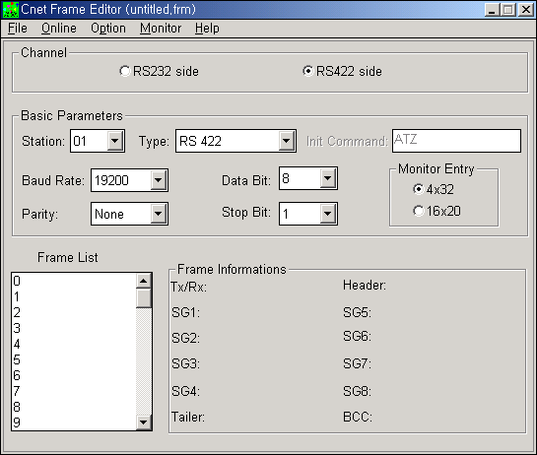
① Basic Parameters of Cnet.

  - Channel – Select RS422 channel.
  - Stations – Not to select 00 is recommended.
  - Type – must be set RS422.
  - Baud Rate – Recommended 9600 or 19200.

② Downloading Parameter – Click “Connect” from Online menu and click “Write” again Online menu.
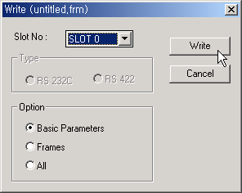

- Slot No – Slot number where Cnet module is installed
- Option – Select Basic Parameter
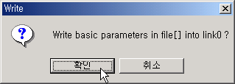

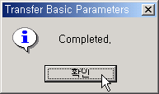

③ Change Run/Stop
After downloading basic parameter, click “Change Run/Stop” from Online menu to execute communication.
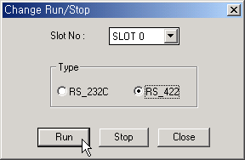

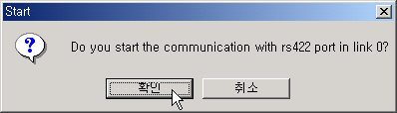

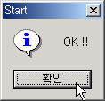

④ Disconnect – After click OK button of above screen, RUN (00) and SYS-RUN(07) LED will turn on.
Then disconnect by clicking “Disconnect” from Online menu to download the project file with GMWIN.

4. Downloading Project and Run the CPU
After setting communication parameter by Frame editor, Project must be downloaded.
Click “Connect + Write + Run + Monitor On” from Online menu.
When Modbus is used, Enabling High Speed Link is needless.

