5. DeviceNet Communication

5.1 Overview of Dnet Communication

DeviceNet was born to meet the demand to replace the high-cost analog 4~20mA standard with simple digital standard and is the communication link to connect various kinds of industrial devices such as limit switch, photo electronic sensor, motor controller, inverter, barcode reader, panel display etc. to the network. The characteristics is low cost, simple installation, excellent compatibility with other maker’s device as well as outstanding application in the network application such as Master/Slave, Multiple Master, Peer-to-Peer etc. As DeviceNet uses CAN (Controller Area Network) protocol as it is and system response time is short, and the reliability is high, the production cost shall be low as we can use CAN chip with low cost.

5.2 Communication Specifications

Items |  | Performance Specification
Communication speed |  | 125/250/500kbps
Communication distance (Thick)^{[*1]} |  | 500/250/100m
Max. drop  length | 125 kbps | 6m(max. extension 156m)
Max. drop  length | 250 kbps | 6m(max. extension 78m)
Max. drop  length | 500 kbps | 6m(max. extension 39m)
Data packet |  | 0~8 Byte
Network structure |  | Trunk/drop line  Power in the same network/signal cable
Bus method^{[*2]} |  | Multi slave/ multi casting  Peer-to-Peer method  Poll, Strobe, COS/Cyclic method
Max. node number |  | Max. 64 MAC ID/MAC Identifier  32 I/O per node (max. 2,048 I/O)
System type |  | Node insertion and removal in the status of voltage ON.
Action voltage |  | DC 24V
Diagnosis function |  | The duplicate station check /bad station monitor /CRC error Check

5.3 Cable Specifications

5.3.1. Cable Specifications.

Type name | Class 2 Thick/Thin Cable
Maker | Allen-Bradley | Trunk/ drop  Simultaneous use
Cable type | Round | Trunk/ drop  Simultaneous use
Rated output voltage | 30V/100VA | Trunk/ drop  Simultaneous use
Max. allowable current | 100VA/24V or 4A | Trunk/ drop  Simultaneous use
External diameter | 12.2mm/6.9mm | Trunk/ drop  Simultaneous use
Number of core wire | 5 cores | Trunk/ drop  Simultaneous use

Class 2 Thick Cable |  | Class 2 Thin Cable
Spool Size |  | Spool Size
50m |  | 50m
150m |  | 150m
300m |  | 300m
500m |  | 600m

5.3.2 Cable Signal Name
Smart I/O Dnet I/F module cable have 5 cores as follows. It is composed of Twist pair cable for DC 24V power supply, twist pair cable for signal cable, shield cable etc. and both Thick and Thin cable are available for trunk/drop line.

Cble color | Signal name | Description
While | CAN_H | Signal cable
Blue | CAN_L | Signal cable
Bare | Drain | Shield cable
Black | V- | Power cable
Red | V+ | Power cable

5.3.3 Max. transmission distance by Cable types

Transmission speed | Max. distance
Transmission speed | Thick cable | Thin cable
125kbps | 500m | 100m
250kbps | 250m | 100m
500kbps | 100m | 100m
5.3.4 Structure of Cable

Insulation covering
-Thick: Green
-Thin: Yellow
Mylar Tape
Copper-film covered shield
Signal cable
(Blue/White)
-18AWG 19X30(Thick)
-24AWG 19X36(Thin)
DC Power cable
-15AWG 19X28(Thick)
-22AWG 19X34(Thin)
Shielded cable

5.3.5 Structure of Connector

Red
White
Black
Blue
Shield

5.4 Cabling Diagram

5.4.1 Multi-drop type Cabling Diagram
R:Red W:White
S:Shield BU:Blue
BK:Black
GnL-DUEA
Max. 500m.
Max. 64 Stations/Segment. (Include Master module).
R
W
S
BU
BK
R
W
S
BU
BK
R
W
S
BU
BK
DC 24V
Connector for DeviceNet

5.5 Communication Example.

5.5.1 Overview

DeviceNet Smart I/O module has the following characteristics.

1) The real time control is available to communicate various I/O machine that is the lowest in the network system.
- One master module can control 63 slave module and max. 2,084 points I/O control is available.
- Network installation is flexible as multi drop and T branch connection is available.
- Available to connect the master module of LGIS and various slave module of other maker.
- Available to configure the system with the slave module of LGIS and other maker’s master module.
- Available to set station number (MAC Address) with hardware. (0 ~ 63 stations).
- The communication speed is set automatically according to the master setting.
- Available to install 2 master modules in GLOFA-GM4 and GM6.
- Available to communicate by High Speed Link parameter setting.
- Available to connect with various slave I/O.
- Supports Poll, Cos, Cyclic, Strobe method as communication method.

5.5.2 System Configuration

In GMn base, the communication module (GnL-DUEA) is installed for slot 0, Input 32 points for slot 1, and Output 32 points for slot 2, respectively.

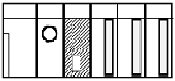
Trunk line
Termination
Resistor
Drop line
Termination
Resistor
Station # 1
GPL-D22A
(Input 16 points)
Station # 2
GPL-TR4A
(Output 32 points)
Station # 3
GPL-DT4A
(Hybride)

Station # 0
GnL-DUEA

I/O configuration and Sending/receiving flow table
Data Flow | PLC Address | Size
PLC ← Smart I/O # 1 | %MW110 | 2 bytes
PLC → Smart I/O # 2 | %MW100 | 4 bytes
PLC ← Smart I/O # 3 | %MW111 | 2 bytes
PLC → Smart I/O # 3 | %MW102 | 2 bytes

Overview of Working steps.
- Station number allocation and communication cable connection.
- Execute GMWIN and edit user program.
- Make the data sending/receiving map same type of the above table.
- Set communication Parameter in GMWIN High Speed Link parameter setting item.
- Execute ‘compile’ and ‘make’ from compile menu.
- Execute program and parameter write from online menu.
- Select ‘Link Enable set’ from online menu and set the High Speed Link Enable that corresponds to the setting number.
- Change the mode to RUN from online menu.
- If the error occurs, repeat the above from 1.

4.5.3 Steps to setup high speed link parameter with Dnet
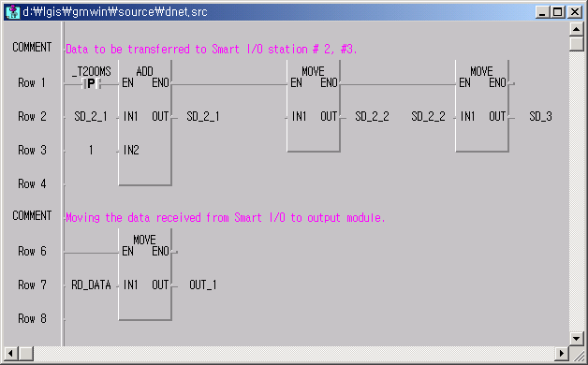
1. Execute GMWIN and compose Project and edit user Program. – Refer to Ch. 3.

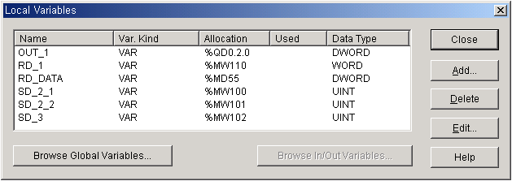Program for DeviceNet

Local Variables
2. Setting High Speed Parameter.
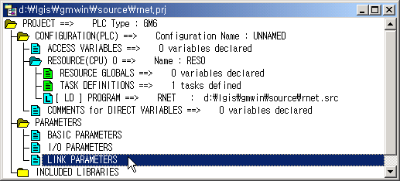
1) Double click “Link Parameters” on Project window

2) Select High Speed Link number.
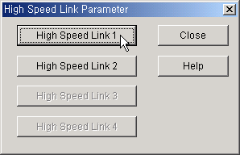

Available number of High Speed Link
CPU |  | Available number of High Speed Link
GMR/1/2/3 |  | 4
GM4 | CPUA | 2
GM4 | CPUB/C | 4
GM6 |  | 2
GM7 |  | 1

3) Master Module setting.
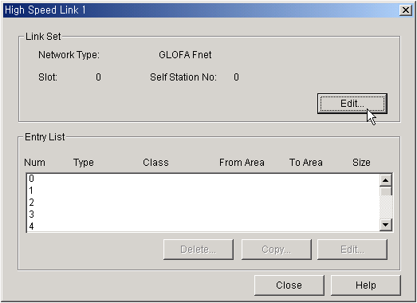
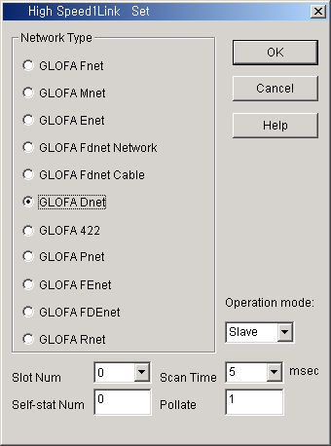
DeviceNet Master module has 2 modes, Master and Slave.
It operates as Master module, the mode doesn’t matter.

Classification | Description
Network type | This is to set the communication module type by ‘GLOFA Dnet’
Slot Num. | Select the slot number where Dnet module is installed. The choice is 0~7.
Self station Num. | Enter the self-station no. that is set in the station number switch, located the front side of communication module. It is available to set 0~63 by decimal number but it is not allowed to use duplicate station no. because the self station no. is the unique number to distinguish communication modules in a network system.
Scan time | This is the scan delay time (msec) to delay to next scan after Dnet I/F module scanned the slave module all.
Poll rate | This is the rate that Dnet I/F module scans the salve module. That is, if the value is ‘2’, this means that after scanning Dnet I/F module twice, ‘poll’ shall be executed once for the module of station number set in the parameter.

4) When basic DeviceNet parameter setting is completed, 0th parameter will be created automatically. This 0th parameter is closely connected to scan.
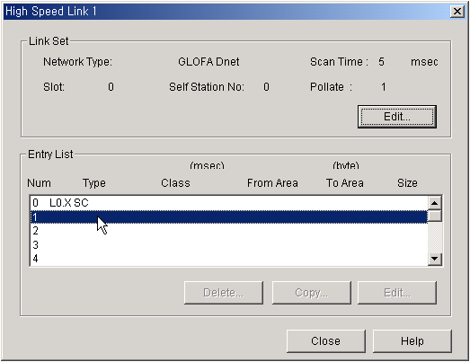Double click 1st row of entry list to set 1st parameter which reads the input data of .

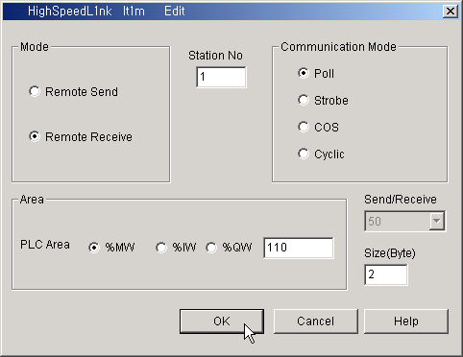
5) The 1st parameter setting. (PLC ← Smart I/O # 1)
②

①

- When Remote Send is selected, the data of selected area will be transferred from PLC to Smart I/O, station numbered Station No. While Remote Receive is selected, the data will be transferred from the Smart I/O, station numbered Station No and stored at the designated memory address of CPU.
② The DeviceNet master module at present supports Only Poll mode. Sooner or later the rest type will be support.

6) The 2nd parameter setting. (PLC → Smart I/O # 2)
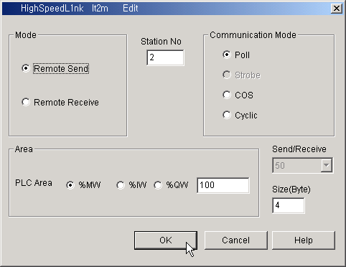

7) The 3rd parameter setting. (PLC → Smart I/O # 3)
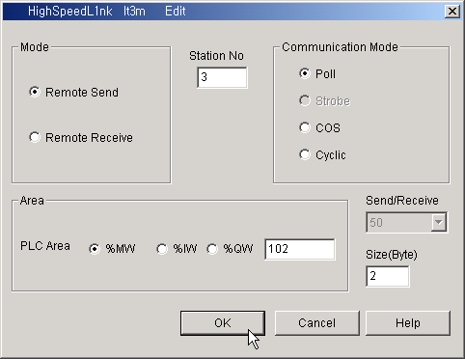

8) The 4th parameter setting. (PLC ← Smart I/O # 3)
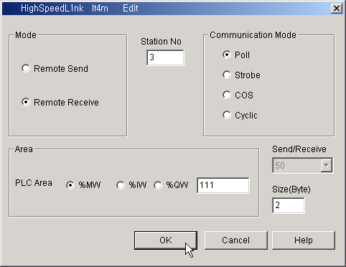

9) The total parameter Entry list.
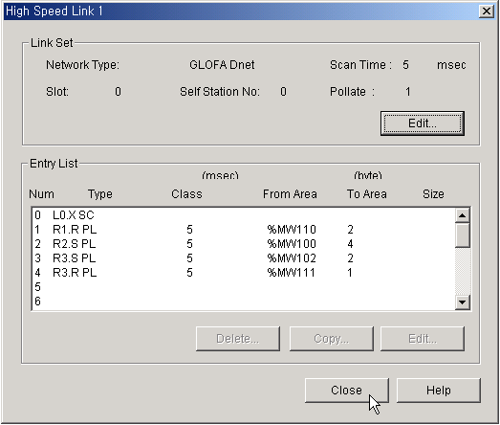

3. Compiling, downloading project to PLC and Enabling High Speed Link. – Refer to Ch. 3.

