4. Profibus-DP Communication

4.1 Overview of Pnet Communication

Profibus is the open type field bus that the manufacturer selects independently to apply and manufacture (Vendor-independence) and that is used widely for processing automation. DP among them is the most frequently used Communication profile and the network suitable for FA environment of Field Level and also is suitable for master-slave communication between master automation machine and distribution slave I/O machine. It is designed to install with low cost and DP is the most suitable item to replace the existing system such as 4~20mA or Hart system together with 24V parallel signal transmission to the production automation system.

Smart I/O module communication supports Profibus-DP through GM3/4/6 master module.
(G3L-PUEA/ G3L-PUEB/G4L-PUEA/ G4L-PUEB/G6L-PUEA/ G6L-PUEB)
For further information for Profibus-DP, please refer to ‘Korea Profibus Association’s homepage’.

4.2 Communication Specifications

Classification | G3/4/6L-PUEA | G3/4/6L-PUEB
Module type | Master
Network type | Profibus-DP
Standard | EN 50170 / DIN 19245
Media Access | Logical Token Ring
Communication method | RS-485(Electric)
Topology | Bus
Modulation method | NRZ
Communication cable | Shielded Twisted Pair
Communication distance | 1200 m (9.6k ~187kbps)
Communication distance | 400 m (500kbps)
Communication distance | 200 m (1.5 Mbps)
Communication distance | 100 m (3M ~ 12Mbps)
Max. Node/network | 126 Station
Max. Node/segment | 32 Station
Max. I/O data | 1kbytes | 7kbytes
Communication parameter setting | Parameter setting by using GMWIN High Speed Link parameter and SyCon-PB
Configuration Tool | SyCon-PB
Configuration port | RS-232C Configuration Port support

4.3 Cable Specifications

1. Cable Specifications.

Classification | Twisted Pair
AWG | 22
Type | BC-Bare Copper
Insulation | PE-Polyethylen
Insulation strength | 0.035 (Inch)
Shield | Aluminum Foil-  Polyester Tape/Braid Shield
Capacitance | 8500㎊/ft
Characteristic impedance | 150Ω
Number of core wire | 2 Core
Maker | Belden

2. Structure Diagram

Conductor
Insulator
Al Foil
Grounding Wire
Braid Shield

4.4 Cabling Diagram

GnL-PUEA
A1
A2
B1
B2
A1
A2
B1
B2
A1
A2
B1
B2
Connector for Pnet Smart I/O
Max. 1200m.
Max. 32 Stations/Segment. (Include Master module).
Max. 126 Stations/Network. (when repeater is used.)
ON
OFF
COMM CONN
CONFIGCONN
ON
OFF
Dip switch must be located ON side at termination. The others must be located OFF side.

4.5 Communication Example.

4.5.1 Overview

Profibus-DP Master module is available to set as the following function.

1) Supports only High Speed Link communication.
2) Uses parameter setting in GMWIN/KGLWIN and Configuration Tool(LGIS provided Tool: SyCon).
3) Sets only sending/receiving area from GMWIN/KGLWIN highs speed link parameter setting.
4) Sending/receiving data shall be saved continuously from the setting area and sent. (This is similar to the continued MAP of MASTER-K.)
5) Uses SyCon to set sending/receiving number and slave area per slave station and uses Configuration Port to dselfload as master module.
6) Sending/receiving number per slave station is set as byte unit.(set in SyCon)
7) Sending/receiving number is available up to 512bytes/3,584bytes respectively according to the type of Daughter board
8) Communication begins through GMWIN/KGLWIN High Speed Link enable set.

4.5.2 Operation by High Speed Link

1) If Master module is the product of LGIS (G3/4/6L-PUEA, G3/4/6L-PUEB), it configures Profibus Network using SyCon.
2) It dselfloads Profibus Network Configuration as master module.
3) It sets High Speed Link parameter of master in GMWIN and dselfloads it.
4) It performs High Speed Link enable set.
5) If using other maker’s product as Master, it configures Profibus Network using Configuration Tool of the corresponding product.

4.5.3 System Configuration

In GMn base, the communication module (GnL-PUEA) is installed for slot 0, Input 32 points for slot 1, and Output 32 points for slot 2, respectively.

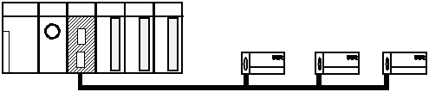
Station #2
GPL-TR4A
(Output 32 point)
Station #1
GPL-D22A
(Input 16 point)
Station #3
GPL-DT4A
(Hybride)
Station #0
GnL-PUEA
(Master)
The dip switch on PCB must be located ON side
Configuration Port.
Communication Port.
The dip switch on PCB must be located ON side

I/O configuration and Sending/receiving flow table
Data Flow | PLC Address | Size
PLC ← Smart I/O | %MW1000 | 4 bytes
PLC → Smart I/O | %MW1010 | 6 bytes

The size of communication data is the total sum of data to be send/received in byte.
The size of receiving (PLC ← Smart I/O) data is the sum of data from station #1, 2bytes, and station #3, 2bytes. And the size of sending (PLC → Smart I/O) data is the sum of data to be transferred to station #2, 4bytes, and station #3, 2bytes.

Overview of Working steps.
- Station number allocation and communication cable connection.
- Execute GMWIN and edit user program.
- Make the data sending/receiving map same type of the above table.
- Set communication Parameter in GMWIN High Speed Link parameter setting item.
- Execute ‘compile’ and ‘make’ from compile menu.
- Execute program and parameter write from online menu.
- Execute SyCon and set Profibus parameter and download to Profibus communication module.
- Select ‘Link Enable set’ from online menu and set the High Speed Link Enable that corresponds to the setting number.
- Change the mode to RUN from online menu.
- If the error occurs, repeat the above from 1.

4.5.4 Steps to setup high speed link parameter with Rnet
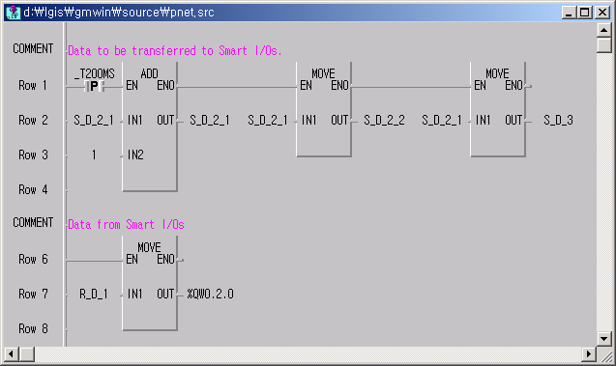
1. Execute GMWIN and compose Project and edit user Program. – Refer to Ch. 3.

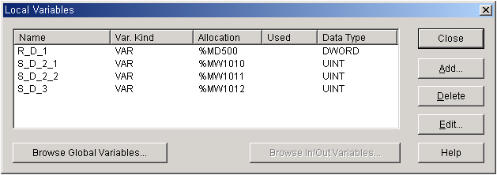Program for Pnet

Local Variables

2. Setting High Speed Parameter.
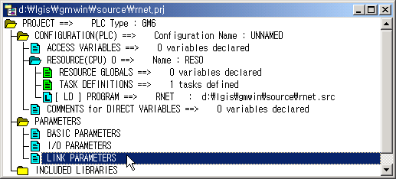
1) Double click “Link Parameters” on Project window

2) Select High Speed Link number.
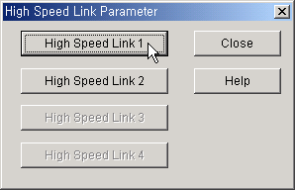

Available number of High Speed Link
CPU |  | Available number of High Speed Link
GMR/1/2/3 |  | 4
GM4 | CPUA | 2
GM4 | CPUB/C | 4
GM6 |  | 2
GM7 |  | 1

3) Master Module setting.
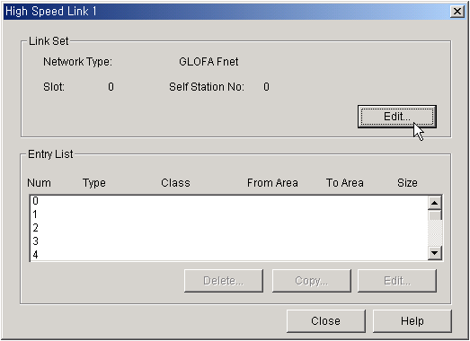
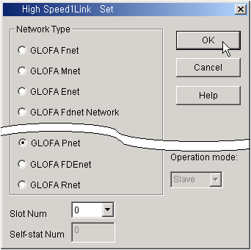
Select Network type GLOFA Pnet
Select Slot number No.

4) Double click 0th row of entry list to set 0th parameter.
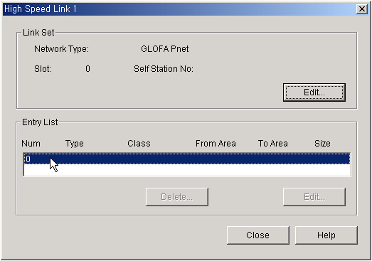

5) The 0th parameter setting.
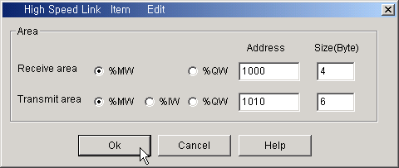
①
②
③

① Receive area is the data memory of PLC where the received data will be stored.
② Transmit area is the data memory of PLC where the data to be sent is stored.
③ The size of communication data is the total sum of data to be send/received in byte.

 | PLC | Data flow | Smart I/O | Size(bytes)
Receive area | %MW1000 | ← | %IW0.0.0 of # 1 | 2 | Total 4bytes Receive
Receive area | %MW1001 | ← | %IW0.0.0 of # 3 | 2 | Total 4bytes Receive
Transmit area | %MW1010 | → | %QW0.0.0 of # 2 | 2 | Total 6bytes Transmit
Transmit area | %MW1011 | → | %QW0.0.1 of # 2 | 2 | Total 6bytes Transmit
Transmit area | %MW1012 | → | %QW0.0.0 of # 3 | 2 | Total 6bytes Transmit

6) Total parameter.
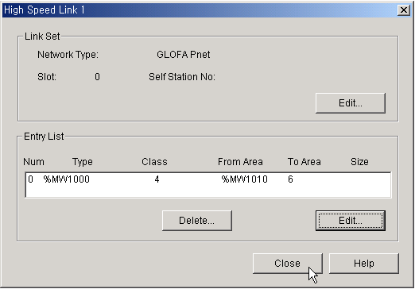

3. Compiling, downloading project to PLC and Enabling High Speed Link. – Refer to Ch. 3.
4. Profibus parameter setting using Sycon.

If Profibus module provided by LGIS (G3/4/6L-PUEA, G3/4/6L-PUEB) is used as master module, it is required to configure Profibus Network using SyCon and download the information to the corresponding master module. As Profibus Network Configuration Tool is different from each master module maker, if the master module provided by LGIS (G3/4/6L-PUEA, G3/4/6L-PUEB) is used, SyCon is available.
LGIS provides SyCon with Profibus master module or by internet homepage of LGIS. (www.lgis.com)

1) Execute SyCon
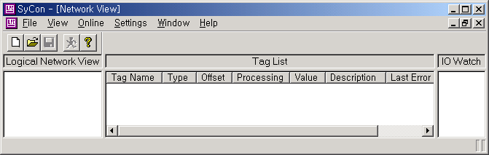

The initial screen of SyCon

2) Click New from File menu to make new file.
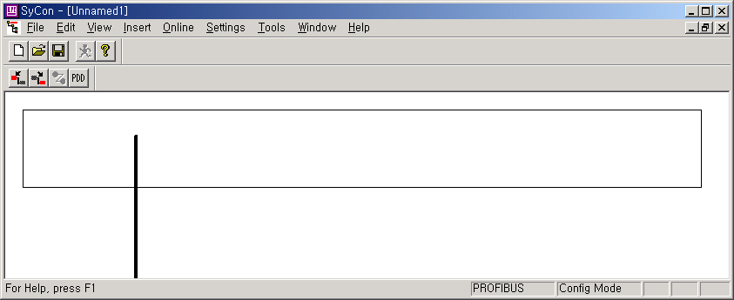

Insert Slave from PDD file

Insert Slave Module
Insert Master Module

3) Insertion Master module. – Click “Insert Master module” icon ( ) and click again on setting window and Master module selecting window will appear.
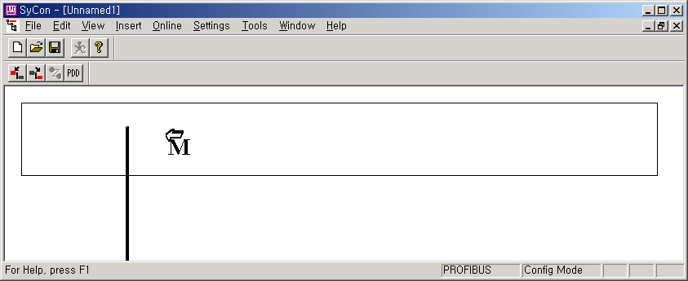

4) Select master module and click Add button. Then the master module name of left side will be copied to right side.
If G3/4/6L-PUEA is used, select COM-DPM/PKV20-DPM, and G3/4/6L-PUEB is used, select COM-PB/PKV20-PB.

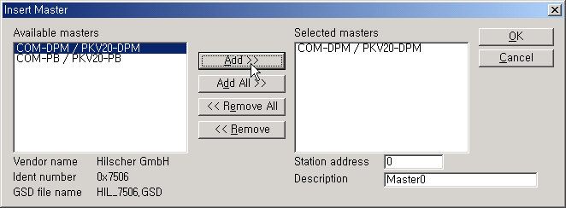

Master module is added to new file

5) Insertion Slave module. – Click “Insert Slave module” icon ( ) and click again on setting window and Slave module selecting window will appear.
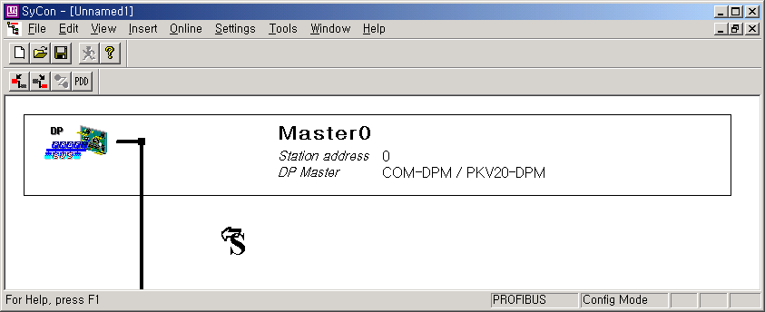

Add Slave module
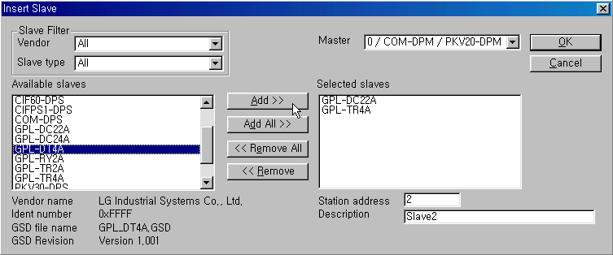

Slave module selecting window
Slave Module Selection Table
Smart I/O | Slave | Smart I/O | Slave
GPL-D22A | GPL-DC22A | GPL-TR2A | GPL-TR2A
GPL-D24A | GPL-DC24A | GPL-TR4A | GPL-TR4A
GPL-DT4A | GPL-DT4A | GPL-RY2A | GPL-RY2A
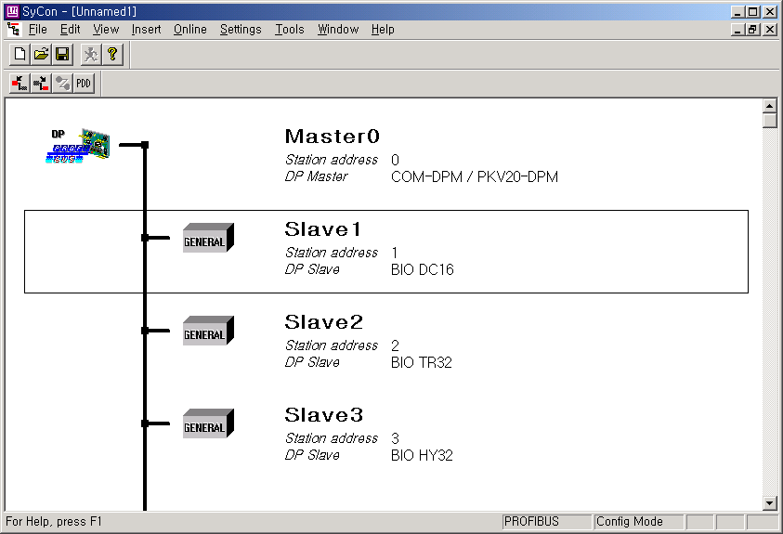

Slave module is added to new file

6) Master module setting.-Double click master module to set up the master module. Then master module setting window will appear.
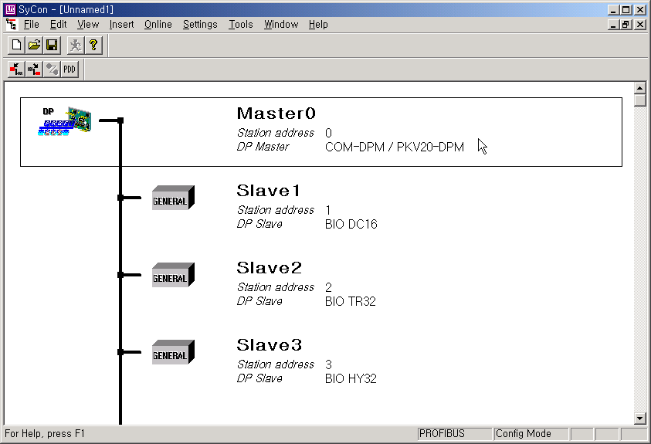
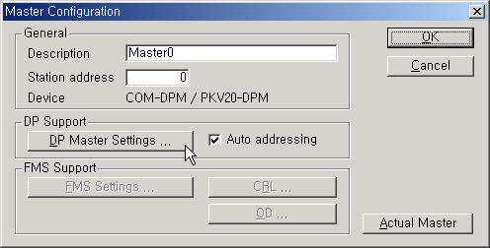
Double Click

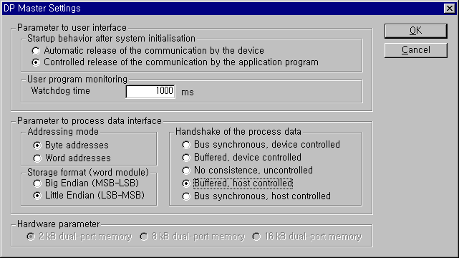
Select “Controlled release of the communication by the application program”
Select “Byte addresses” and Little Endian (LSB-MSB)”
Select “Buffered, host controlled”

7) Slave module configuration. – Slave configuration can be seen or changed by double clicking slave module.
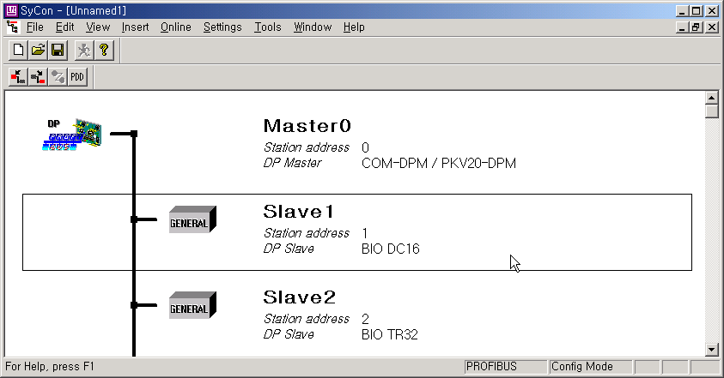

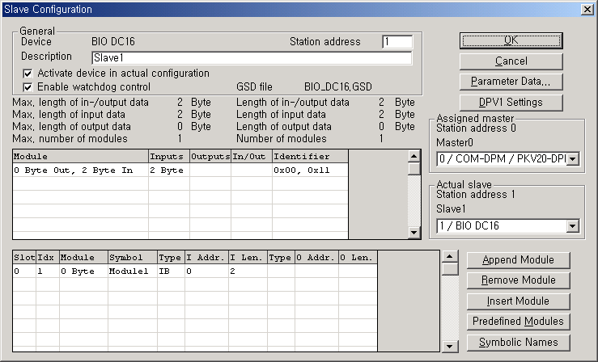

Slave module configuration
8) Bus Parameter Setting

Bus parameter setting is the setting about Profibus-DP network. Select “Settings/Bus Parameter...” from the menu. Optimize field contains “Standard” and “user definition” setting and speed setting (Baud rate) contains 9.6kbps ~ 12Mbps setting. Basically, Baud rate is set as 1.5Mbps and Optimize is set as ‘standard’.
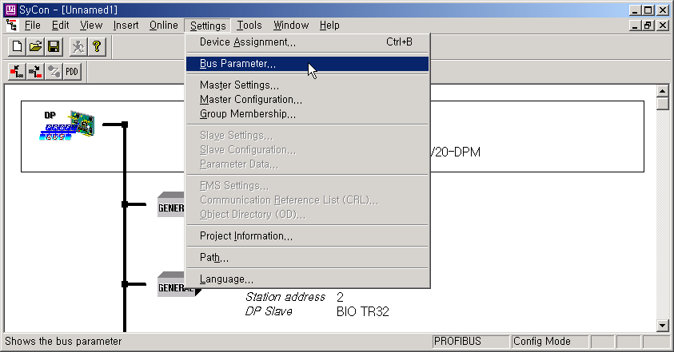

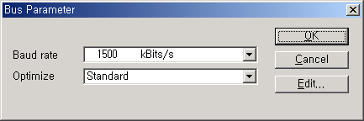

Bus Parameter

Bus Parameter Selection Table
Total cable length | Baud rate
1200 m | 9.6k ~187kbps
400 m | 500kbps
200 m | 1.5 Mbps
100 m | 3M ~ 12Mbps

Remark
- Communication speed is related to transmission distance.
- When using 12Mbps, you should use the connector only for 12Mbps and exclusive cable.
- When using 12Mbps, min. Distance between stations shall be set as more than 1m.
- When using 12Mbps, if the communication is cut off (especially, the station far from master), search the proper end resistance value and set it random.
9) Downloading the configuration.
When “Online/Download” from the menu is clicked, ‘download’ begins to run. While downloading is running, all LED shall be OFF and only “READY”LED shall be blinking. After download, all LED show its appropriate function. If you carry out ‘download’ in the status that the communication between the current master and slave is open, the warning window with the message “if the download is done during the bus operation, the communication between the master and the slaves is stopped.” will appear. After confirming if there is a problem by communication cutoff, click “Yes(Y)” button and ‘download’ will run normally.
Downloading configuration cable is same as project downloading cable.

Before download the configuration, rectangular cursor of SyCon must be located Master module.

① Before download communication parameter between PC and PUEA module must be set. To set communication parameter click Device Assignment from Setting menu.
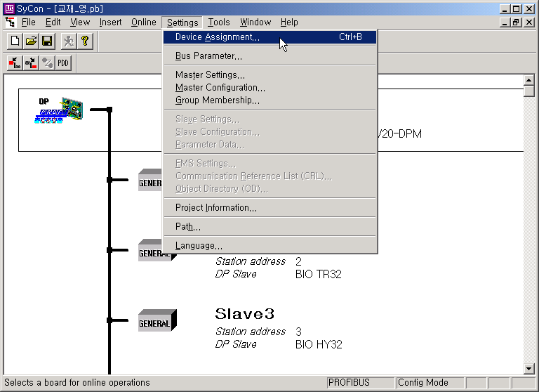
Before clicking “Download” from Online menu, rectangular cursor of SyCon must be located Master module.

② Click “Connect COMx” button

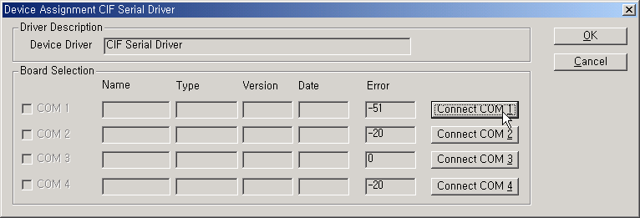

③ When “Connect COM1” button is clicked and the window changed to following picture, then COM1 port is available communication port. Check COM 1 and click OK. If “Connect COM1” button is clicked and the window does not changed to following picture, then try again with “Connect COM2” button.
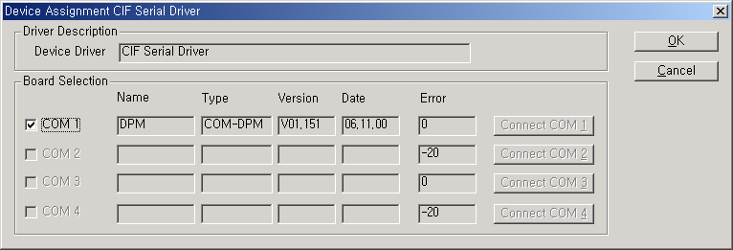

④ Click “Download” from Online menu. When ‘Download’ is clicked from Online menu while the communication between the current master and slave is open, the warning window with the message “if the download is done during the bus operation, the communication between the master and the slaves is stopped.” will appear. After confirming if there is a problem by communication cutoff, click “Yes(Y)” button and ‘download’ will run normally.

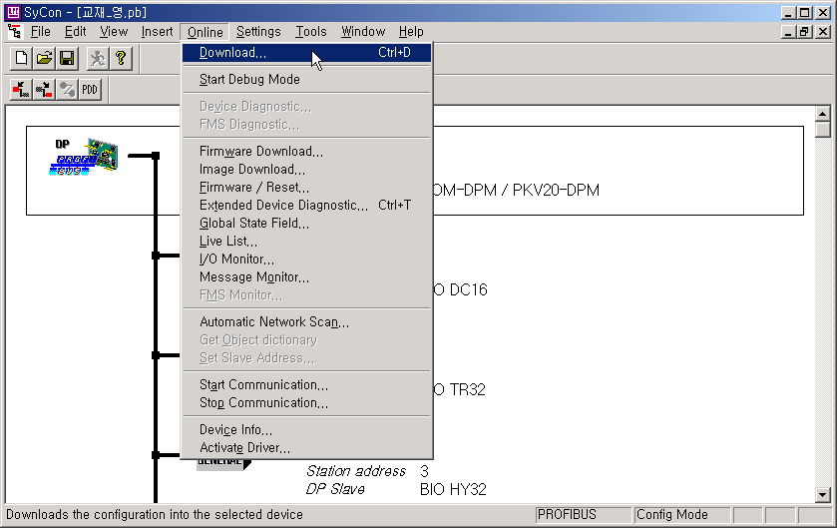

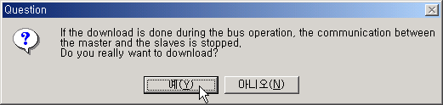

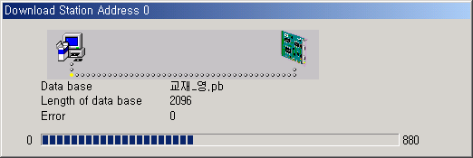

⑤ Start Communication – To enable communication, click “Start Communication from Online menu.
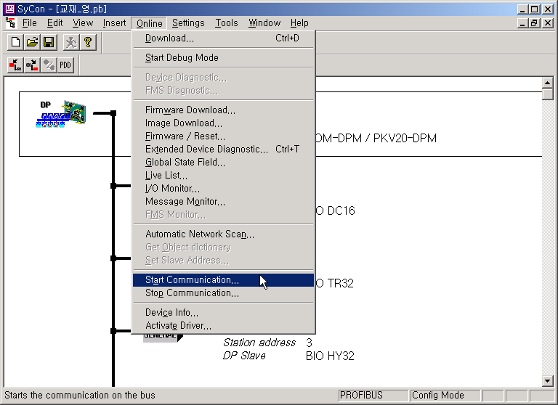

5. Monitoring Network Status using SyCon.

It is possible to monitor the status of network and communication. In addition, debugging is performed automatically errors of software configurations.

To perform debugging, click “Start Debug Mode” from Online menu.
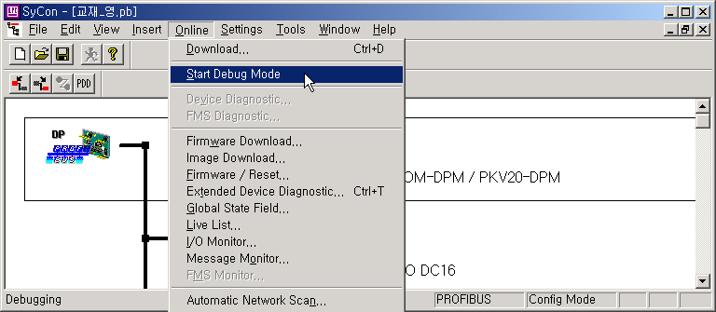

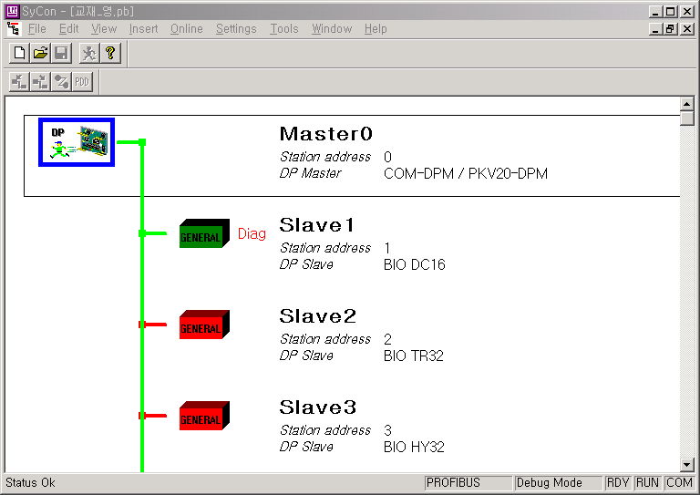
The color of line and module which operates normally changes to green.
The color of line and module which operates abnormally changes to red.

