3. Rnet Communication

3.1 Overview of Rnet Communication

The major characteristics of Rnet network are the cost saving of installation/maintenance, diversification of system configuration, easy maintenance and repair, easy system change.
This network supports the electrical network (twisted pair cable) that is cost effective and easy to install for the diversification of configuration.
Rnet module can be used in common for GLOFA series and MASTER-K series and applied diversely according to the system application.

In Rnet version V1.0, GLOFA Rnet and MASTER-K Rnet module can be in common.

Type | Rnet V1.0 | Remarks
Master  (RMM) | G3L-RUEA | GM3/K1000S Rnet (electric)
Master  (RMM) | G4L-RUEA | GM4/K300S Rnet (electric)
Master  (RMM) | G6L-RUEA | GM6/K200S Rnet (electric)
Master  (RMM) | G7L-RUEA | GM7/K80S Rnet (electric)

3.2 Communication Specifications

Remote I/O module transmission specification (master standard)

Items |  | Specification
Transmission speed |  | 1Mbps (Rnet module common)
Encoding method |  | Manchester Biphase-L
Electric | Transmission distance  (per segment) | Max. 750m
Electric | Transmission distance  (when using the repeater) | Max. 750m * (6 repeaters + 1)  = 5.25km
Electric | Transmission wire | Twisted pair shield cable
Max. no of station number |  | Master + slave = 64 stations  (at least one master should be connected.)
Max. protocol size |  | 256 bytes
Access type of Communication |  | Circulated Token Passing
Communication method |  | Connection Oriented service  Connectionless service
Frame error check |  | CRC 16 = X¹⁵ + X¹⁴ + X¹³+ .... + X² + X + 1

3.3 Cable Specifications

• Twist Pair Cable
Cable Description
Product name |  | Low Capacitance Lan Interface Cable
Type name |  | LIREV-AMESB
Specification |  | 2*0.64 mm (GS 92-3032,22 AWG)
Maker |  | LG Cable
Electric characteristics
Items |  | Unit |  | Characteristics | Test condition
Conductor resistance |  | Ω/km |  | Less than 59 | Normal temp.
Voltage-resistance(DC) |  | V/min |  | 500V 1 min resist | In air
Insulation resistance |  | MEGA Ω-km |  | More than 1,000 | Normal temp.
Capacitance |  | pF/m |  | Less than 45 | 1 kHz
Characteristic impedance |  | Ω |  | 120 ± 12 | 10MHz
Appearance characteristics
Conductor | No. of core wire |  | CORE | 2
Conductor | Spec. |  | AWG | 18
Conductor | Composition |  | NO./mm | 1/1.0
Conductor | Outside diameter |  | mm | 1.0
Insulator | Thickness |  | mm | 0.9
Insulator | Outside diameter |  | mm | 2.8

● Structure Diagram

Insulator
Conductor
Grounding wire

3.4 Cabling Diagram

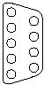
GnL-RUEA
Tx1
Tx2
Rx1
Rx2
6
7
6
7
Tx1
Tx2
Rx1
Rx2
Tx1
Tx2
Rx1
Rx2
R
R
Termination
Resistor
(110Ω, 1/2W)
Termination
Resistor
(110Ω, 1/2W)
Connector for Rnet Smart I/O
Max. 750M/Segment. (Max.5.25Km when repeater is used.)
Max. 32 Stations/Segment. (Include Master module)
Max. 64 Stations/Network. (when repeater is used.)

3.5 Communication Example

3.5.1 Overview

The method to program in RNET communication module is supposed to enable to communicate with Smart I/O module through High Speed Link service, which communicate periodically.

High Speed Link
The High Speed Link service through Rnet communication module is available to use all the existing function and carry out the communication by simple parameter setting. The parameter shall be set in GMWIN for GLOFA series and in KGLWIN for MASTER-K series.

max. High Speed Link point per communication model (Rnet master standard)
Classification |  | Max. communi- cation point | Max. sending point | Max. block no. | Max. point per block
RNET  Communication module | G3L-RUEA | 3,840 words | 1,920 words | 64 (0-63) | 60 words
RNET  Communication module | G4L-RUEA | 3,840 words | 1,920 words | 64 (0-63) | 60 words
RNET  Communication module | G6L-RUEA | 3,840 words | 1,920 words | 64 (0-63) | 60 words
RNET  Communication module | G7L-RUEA | 3,840 words | 1,920 words | 64 (0-63) | 60 words

Communication setting when communicating with Smart I/O module
HS link block setting |  | Sending/ Receiving period | Address area |  | HS link information
Sending | Receiving | Sending/ Receiving period | Input module | Output module | HS link information
32 | 32 | 20ms ~ 10s | %IW | %QW | Ref.7.3.2

3.5.2 System Configuration
In GMn base, the communication module (GnL-RUEA) is installed for slot 0, Input 32 points for slot 1, and Output 32 points for slot 2, respectively.

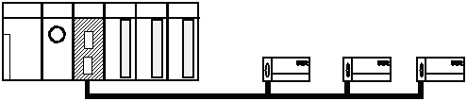
Station #2
GRL-TR4A
(Output 32 point)
Station #1
GRL-D22A
(Input 16 point)
Station #3
GRL-DT4A
(Hybride)
Station #0
GnL-RUEA
(Master)
Termination Resistor
Must be installed.
(120Ω, 1/2 W)
Termination Resistor
Must be installed.
(120Ω, 1/2 W)

I/O configuration and Sending/receiving flow table
Data Flow | PLC Address | Smart I/O address | Block no. | Size
PLC ← Station # 1 | %QW0.2.0 | %IW0.0.0 | 0 | 1
PLC → Station # 2 | %IW0.1.0 | %QW0.0.0 | 1 | 2
PLC ← Station # 3 | %QW0.2.1 | %IW0.0.0 | 2 | 1
PLC → Station # 3 | %IW0.1.0 | %QW0.0.0 | 3 | 1

Working steps.
- Station number allocation and communication cable connection.
- Execute GMWIN and edit user program.
- Make the data sending/receiving map same type of the above table.
- Set communication Parameter in GMWIN High Speed Link parameter setting item.
- Execute ‘compile’ and ‘make’ from compile menu.
- Execute program and parameter write from online menu.
- Select ‘Link Enable set’ from online menu and set the High Speed Link Enable that corresponds to the setting number.
- Change the mode to RUN from online menu.
- Start ‘monitor’ from online menu and check if RUN-LINK is ON without error in the High Speed Link monitor.
- If the error occurs, repeat the above from 1.

Remarks
- In case of Smart I/O, if 32 points are installed for one module, max. link point is available to use up to 2,016 words for 63 stations.
For further information, please refer to ‘Chapter 4. Communication Programming’ of Smart I/O manual.

3.5.3 Steps to setup high speed link parameter with Rnet
1. Execute GMWIN and compose Project and edit user Program.
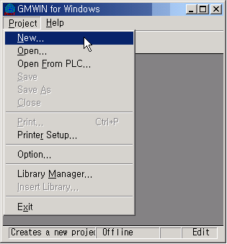
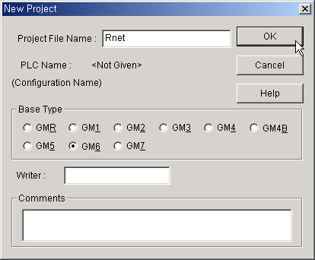
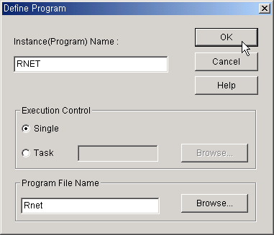
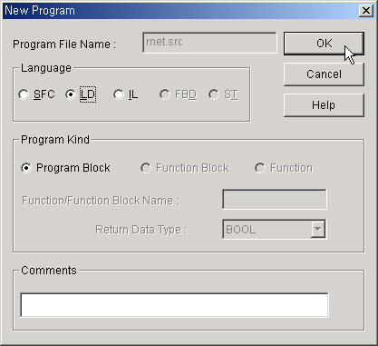
Define Project
Define Program
Program Characteristic
Type Project file name
Select CPU type
Type Program instance name
Type Program file name
Select programming Language
Select Program type.
The 1st program after composing project is fixed to Program Block

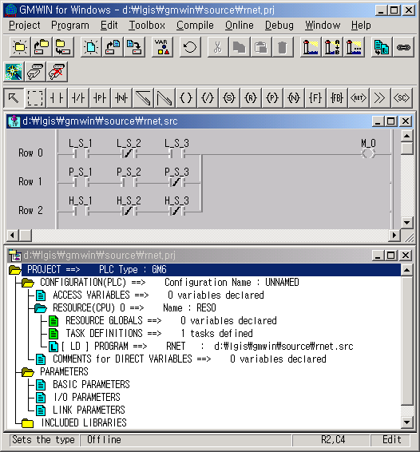
Menu Bar
Icons
Tool Bar
Program window
Project window
Status Bar

GMWIN Screen

2. Setting High Speed Parameter.
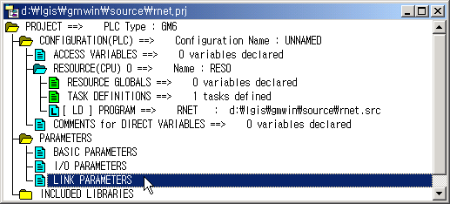
1) Double click “Link Parameters” on Project window

2) Select High Speed Link number.
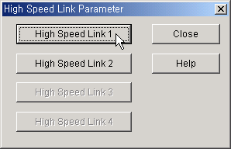

Available number of High Speed Link
CPU |  | Available number of High Speed Link
GMR/1/2/3 |  | 4
GM4 | CPUA | 2
GM4 | CPUB/C | 4
GM6 |  | 2
GM7 |  | 1

3) Master Module setting.
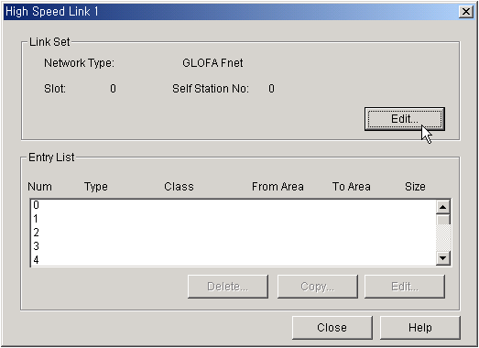
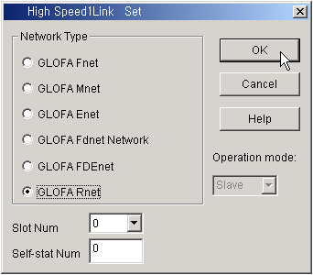
Select Slot number and Self station No.
Select Network type GLOFA Rnet

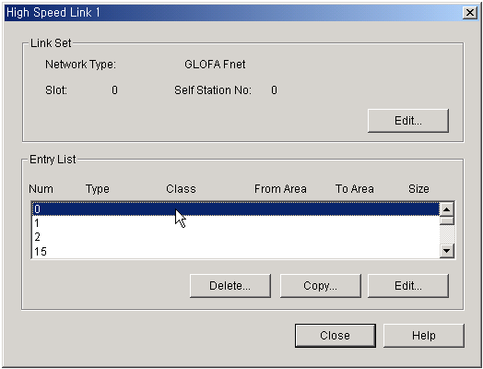4) Double click 0th row of entry list to set 0th parameter.

5) The 0th parameter setting. (PLC ← Smart I/O #1:%QW0.2.0 ← %IW0.0.0, 1Word)
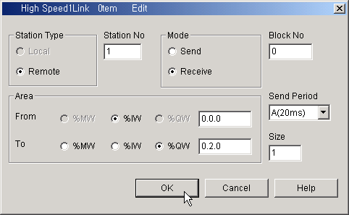
①
②
③
④

⑥
⑤
⑦

① Station type is fixed to Remote when Network type is selected to GLOFA Rnet at Link set
② Station No. of communication partner. Station No. of Smart I/O to communicate with 0th parameter.
③ Select mode. When Send is selected, the data transfer from PLC to Smart I/O, and Receive is selected data transfer from Smart I/O to PLC
④ The ID of Data block to be transferred. The block number must be different each parameters.
⑤ Area
Mode
Area
 | Send | Receive
From | Smart I/O Input module address. | PLC data memory address where received data are stored.
To | PLC data memory address where data to be send are stored. | Smart I/O Output module address.
⑥ The period of communication. 20ms is best choice for Rnet
⑦ The number of Word to be transferred.

6) The 1st parameter setting. (PLC → Smart I/O #2:%IW0.1.1 → %QW0.0.0, 2Word)
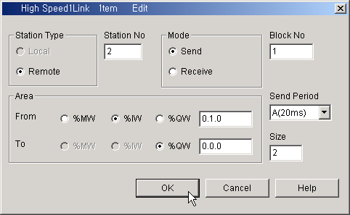

7) The 2nd parameter setting. (PLC ← Smart I/O #3:%QW0.2.1 ←%IW0.0.0, 1Word)
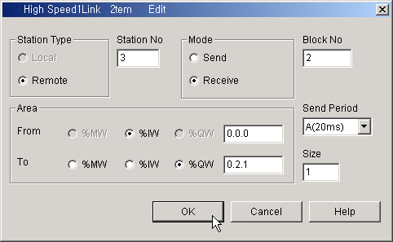

8) The 3rd parameter setting. (PLC → Smart I/O #3, 1Word)
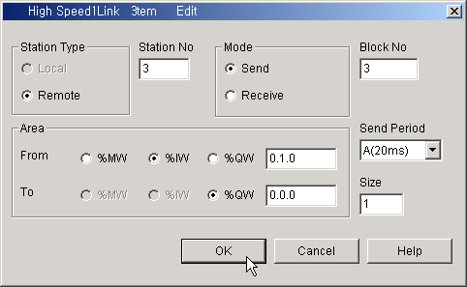

9) Total parameter.
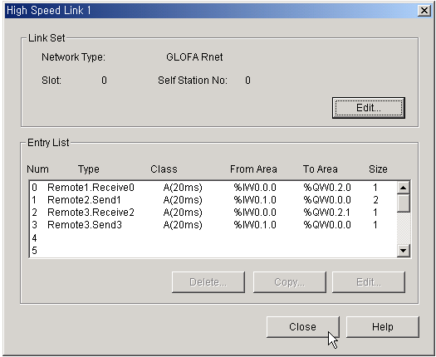

3. Compiling and download project to PLC.
After editing user program and setting parameters compiling, downloading and enabling high speed link must be performed to communicate high speed link via communication module.
Working steps.
1) Compiling the project.
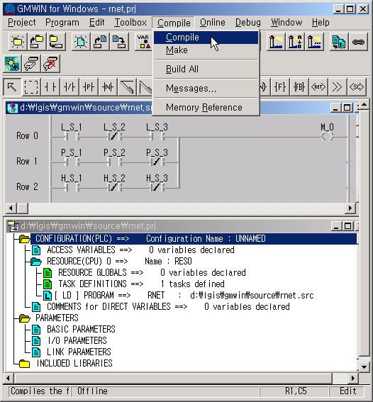
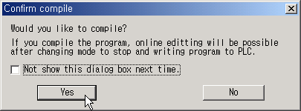
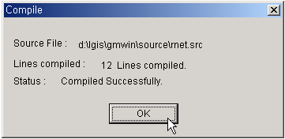

2) Making the project.

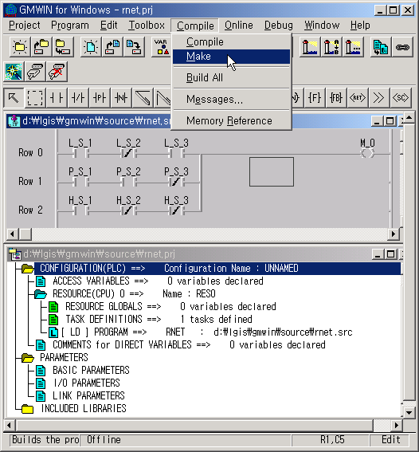
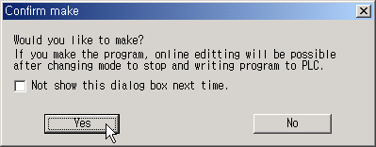
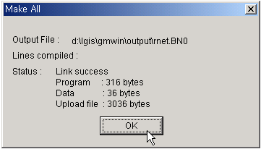

After making a project “project file name.BN0” file will be made by compiler of GMWIN.
Compiling and making a project will be performed simultaneously when “Build All” is clicked in Compile menu.

3) Downloading the project.
① To download a project to PLC, downloading cable must be connected between PC and PLC
Cabling diagram follows below.
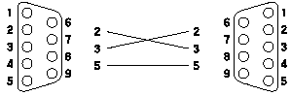
PC side
D-sub 9pins, Female
PLC side
D-sub 9pins, Male

② Connect GMWIN and PLC by Clicking Connect item in Online menu.
③ Download the project by clicking Write menu in Online menu. While downloading a project, the mode of PLC will be changed to STOP mode automatically if mode switch is located REMOTE mode. If mode switch is located RUN mode, mode switch must be changed to STOP mode by hand
④ When complete downloading a project, the mode of CPU must be changed to RUN mode. This can be done by GMWIN or by hand.
※ Above Compiling, making and downloading a project steps can be performed automatically by clicking ( ) icon or “Connect + Write + Run + Monitor ON” item in Online menu. In this case the mode switch of CPU must be located REMOTE mode.
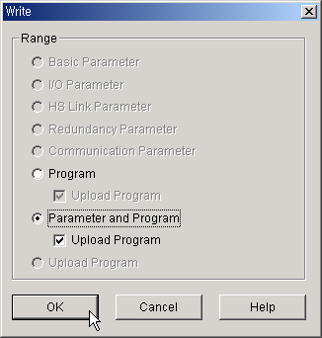
Upload Program must be checked to enable read program from PLC

Downloading options

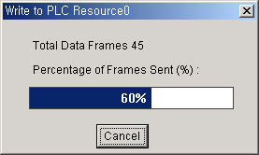

Downloading Execute program

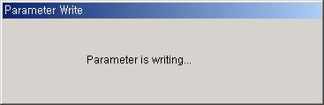

Downloading Parameter

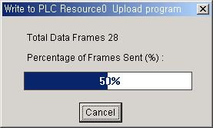

Downloading Parameter

3. Enabling High Speed Link.
1) Confirm if the CPU is running.

CPU
RUN
STOP
The CPU is running when Green LED turn on

The CPU stop when Red LED turn on.
The CPU has some error when Red LED is flickering

2) Click Link Enable item in Online menu.
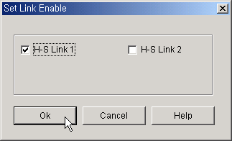
Check High Speed Link number which is identical with the number set in High Speed Link Parameter.

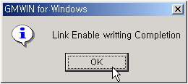

When OK button is clicked, communication between Master module and Smart I/O will start.

4. Monitoring High Speed Link Information.

It is possible to monitor the current High Speed Link status by using ‘monitor’ function after the GMWIN online connection. There are two kinds of methods to monitor :by selecting ‘variable monitor’ from monitor menu and by high speed parameter monitor.

- Variable monitor

‘Variable monitor’ is the function to monitor the necessary items by using the GMWIN flag monitor function and the order to monitor is as follows.

① Confirm if PLC and PC is connected and Monitor is On from online menu.
② Select Variable monitor from online monitor items.
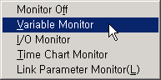

③ Select the High Speed Link information flag you want to monitor directly one by one from Variable, Flag list screen and register. (As _HSxSTATE[n], _HSxERR[n], _HSxMOD[n],_HSxTRX[n] is ARRAY flag, the user enters the registration no. of parameter that he wants to monitor directly).

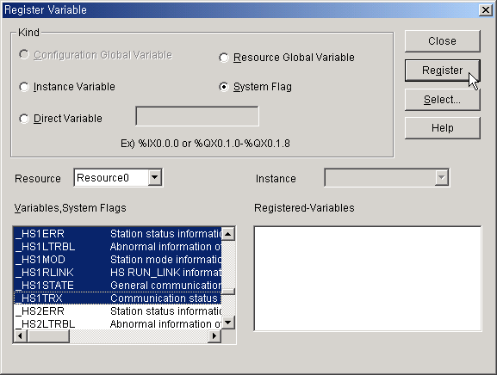

④ Input the start and end number of parameter to be monitored.
This number is identical with Entry List number in High Speed Link setting window.
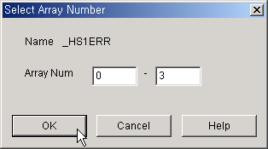

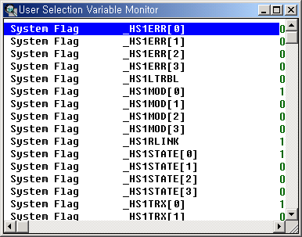

2) High speed parameter monitor

This is the function to monitor the High Speed Link communication status from the menu as below. Select ‘link parameter’ item from monitor menu of GMWIN online connection.

① Confirm if PLC and PC is connected and Monitor is On from online menu.
② Select Link Parameter Monitor from online monitor items and select high speed link number.
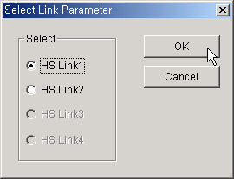
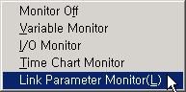

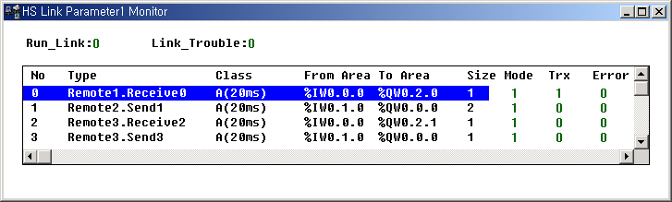

Link parameter monitor shows the general information for RUN-LINK, LINK-TROUBLE on the top screen as below and the individual information such as mode (action mode), communication (sending/receiving status), error on the setting parameter items.

