8. Programming(GLOFA-GM)

8.1 The basic rules for program

- All of the positioning function block must not be executed more than one at the same time except for
“POSP_CRD” and “POSP_SRD”, if not a error will be occurred (error code : “10”)
- If the positioning data type is “ABS” or use teaching function then must register “POSP_ORG” or
“POSP_FLT” function block and execute it before executing “POSP_AST”,”POSP _TEA” ”POSP_
_VLT” Function block
3) The instance name of function block must be given different from other function block
4) It is recommand that the same name of function block, relate to positioning function, isn’t be register
in program more than once

*Remark : The difference between a Instance name of function block and a name of function block
- A instance name of function block is a name given name by user when regist a function
Into Program as to user’ define
- A Name of function block is a orgin name of function block given by GMWIN maker
(LGIS) (ex : “POPA_AST”,”POPA_ORG”…..)

8.2 A sample program for positioning

8.2.1 Training kit system configuration

1.Positioning module is mounted at ”slot 7” on the basic base
2.The movement length of positioning kit is 0 ~ 400mm
3.The pitch of ball screw is 5mm
4.The distance per a rotation of shaft is 5mm
5.Feed back pulse form encoder to servo driver is 4000 per a rotation
6. Electric gear ratio is 1: 1.25(CMX/CDV)
7. It has not deceleration gear
8. The moving distance per a pulses 1μm
The moving distance per a pulse
= ((The distance per a rotation of shaft)/( The number of pulse for a rotation of the shaft)) *
(Electric gear ratio) *(deceleration gear ratio)
= ( ( 5mm) / (4000) )* ( 1 / 1.25 ) * ( 1 ) = 1μm

♦Program 1(Single)

1. Condition
- Push the input switch (%I0.0.0) then the pointer of the training kit returns to the origin point and stop
At that point ( Operation velocity : high speed – 20Kpps / low speed – 3kpps )
- Push the input switch (%I0.0.1) then the pointer of the training kit moves to 150mm and stop at that point(Operation velocity : 40kpps )
- Push the input switch(%I0.0.1) again then the pointer of the training kit moves to 300mm and stop
at that point( Operation velocity : 20kpps )
- Push the input switch(%I0.0.1) once more then the pointer of training kit moves to 400mm and stop
at that point( Operation velocity : 15kpps )
- The input switch(%I0.0.2) is use for “error reset”
- The input switch(%I0.0.3) is use for “ clear the pulse out inhibit”

2. Operation time chart
Origin point
( 0mm)
First stop
(150mm)
Second stop
( 300mm)
Third stop
( 400mm)
Velocity
(40kpps)
Velocity
(20kpps)
Velocity
(15kpps)

3. Solution
1) Position parameter

(1) Basic parameter
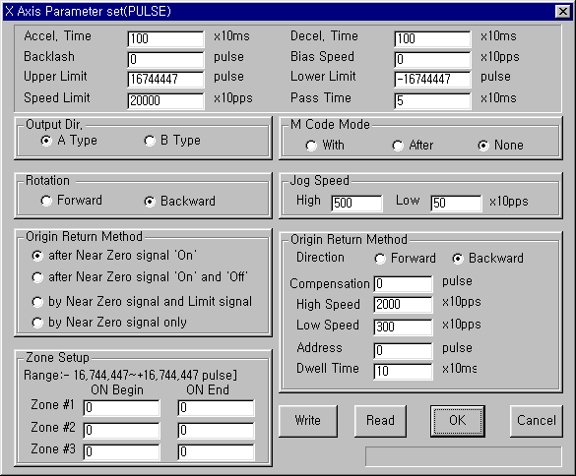

(2) Data parameter
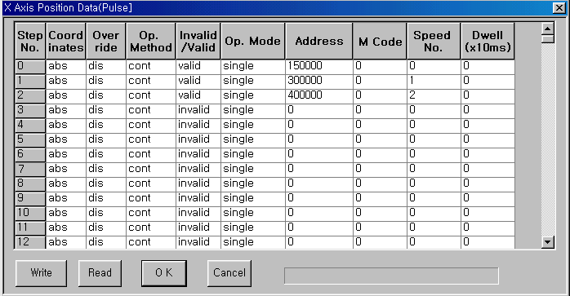

(3) Speed parameter
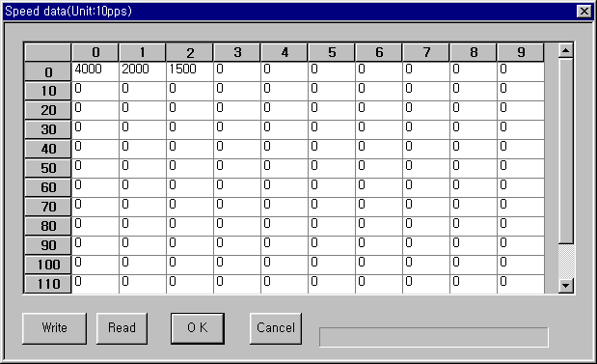

2) Position program

(1) Program
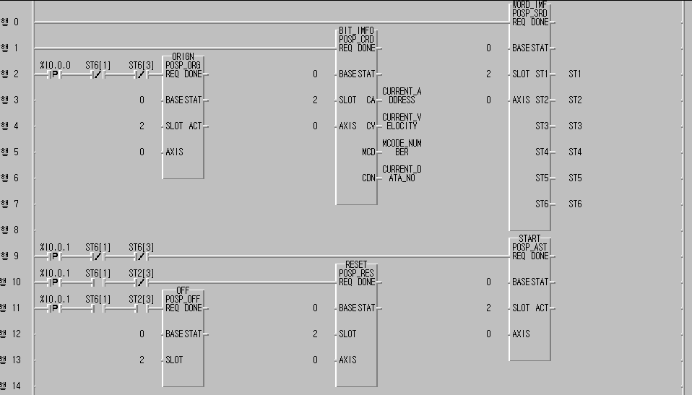

(2) Variable
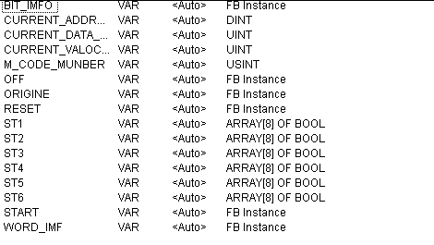

♦ Program 2(Auto)

1. Condition
(1) Push the input switch (%I0.0.0) then the pointer of the training kit returns to the origin point and stop
at that point ( Operation velocity : high speed – 20kpps / low speed – 3kpps )
(2) Push the input switch (%I0.0.1) then the pointer of the training kit moves to 150mm and stop at that
point( Operation velocity : 40kpps )
(3) After 3sec since the point was stopped at first point it restarts automatically to the second stop point and
stop at 300mm ( Operation velocity : 20kpps )
(4) After 3sec since the point was stopped at second point it restarts automatically to the third stop point
and stop at 400mm ( Operation velocity : 15kpps )
(5) The input switch(%I0.0.2) is use for “error reset”
(6) The input switch(%I0.0.3) is use for “ clear the pulse out inhibit”

2. Solution
All the position parameter and program same to solution of program 1 except for position data parameter

1) Data parameter
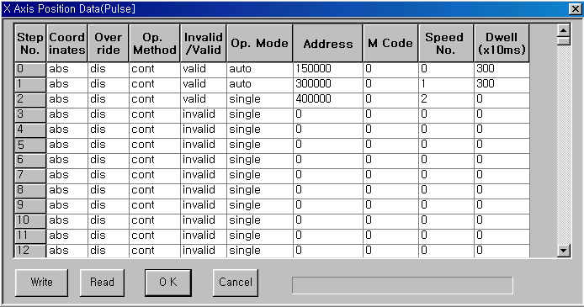

♦ Program 3 (Repeat)

1. Condition
- Push the input switch (%I0.0.0) then the pointer of the training kit returns to the origin point and
stop ( Operation velocity : high speed – 20kpps / low speed – 3kpps )
(2) Push the input switch (%I0.0.1) then the pointer of the training kit moves to 150mm(Operation
velocity : 40kpps ) and stop at that point for 1sec and restarts to the second position( Target
address : 300mm / Operation velocity : 20kpps ) and stop at that option for 1sec then returns to
the start option(Target address : 0mm / Operation velocity : 20kpps )

2. Operation time chart
Repeat
Repeat
Repeat

Velocity
(40kpps)
Velocity
(20kpps)
Velocity
(15kpps)

Origin point
( 0mm)
First stop
(150mm)
Second stop
( 300mm)

3. Solution
All the position parameter and program same to solution of program 1 except for opsition data parameter

1) Data parameter
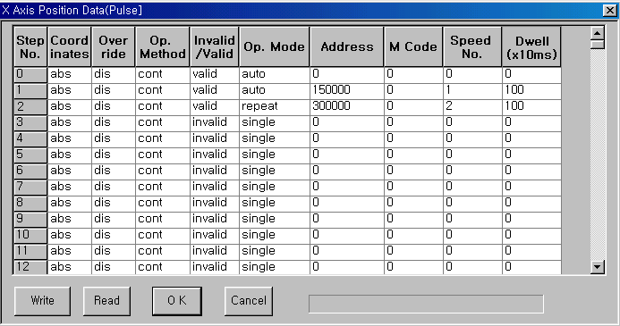

♦ Program 4 (Position teaching / Velocity teaching)

1. Condition
(1) Push the input switch (%I0.0.0) then the pointer of the training kit returns to the origin point and
stop ( Operation velocity : high speed – 20kpps / low speed – 3kpps )
(2) Teaching the target address and operating velocity with data number by using PMU
✶ Input the first target address, operating velocity, data number and press set tag
✴ Input the second target address, operating velocity, data number and press set tag
→ Input the third target address, operating velocity, data number and press set tag
(3) Push the input switch (%I0.0.1) then the pointer move to the first point as to defined on the PMU
(4) Push the input switch (%I0.0.1) again then the pointer move to the second point as to defined on the
PMU
(5) Push the input switch (%I0.0.1) once more then the pointer move to the third point as to defined
on the PMU

2. Operation time chart
Origin point
( 0mm)
First stop

Second stop

Third stop

First data
Second data
Third data

3. Solution
The basic position parameter is same to solution of program 1
1) Data parameter
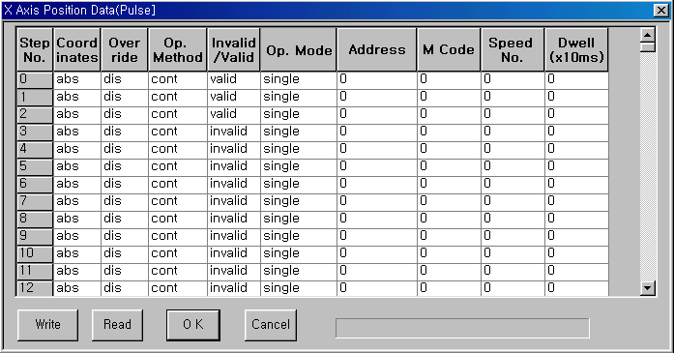

3) Program
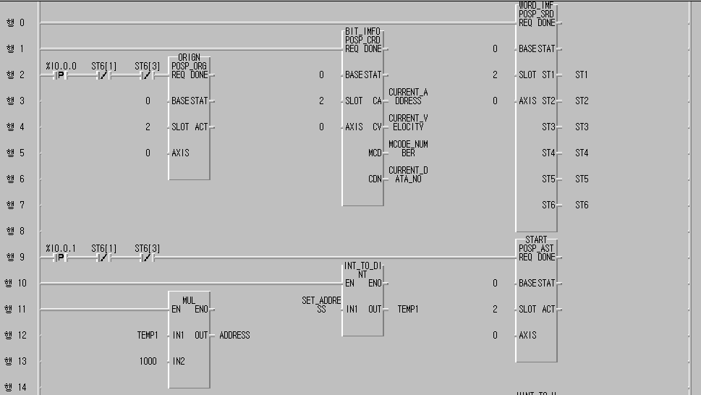

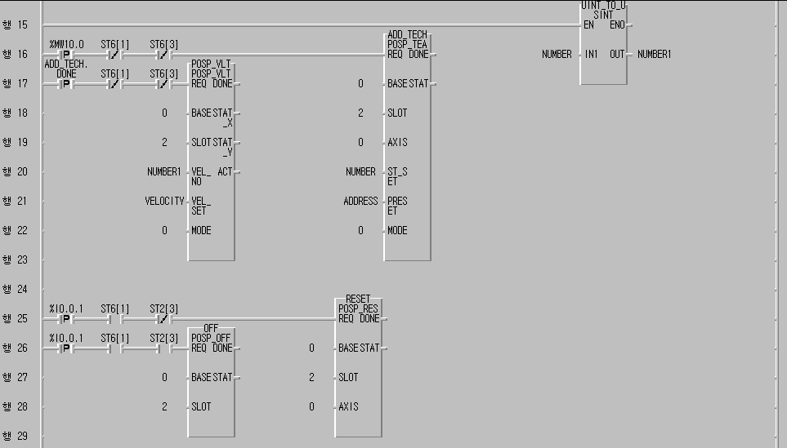

(4) Variable
