Chapter 7. Programming(MASTRE-K)
At this chapter, various programs for using a positioning module are presented.

Remarks
The sequence program presented at the chapter is G6F-POPA arrayed on slot no.2 of a base I/O unless specified otherwise, representing I/O contact point number. When it is located on other slot, change I/O contact point no. before proceeding with
consulting.
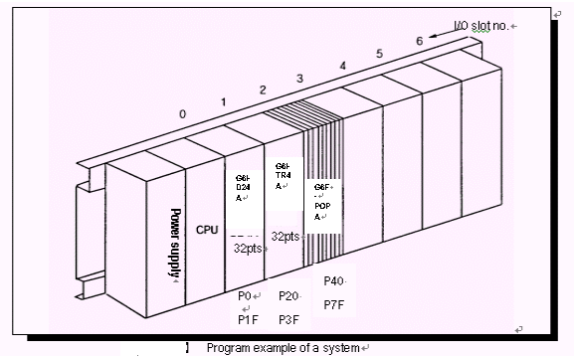

Fig. 6.1 shows example program of a system presented at 8.2.2 ~ 8.2.4. I/O contact points of K3F-POPA are P040 ~ P07F. Use GET/PUT commands to let CPU and K3F-POPA read/write common from/to RAM data.

Ex.) P 0 4 A
Contact point no.
I/O word no.

7.1 Data communication between a positioning module and CPU
Exchanges 2 types of information by large.
• Bit unit information →Input P040 ~ P04F (positioning module status), Output P050 ~ P05F (contact point P control of a positioning module)
• Word unit information → Data sent/received in a bulk up to the maximum 50 words by 1 word unit (16 bits)
EMBED Word.Picture.8 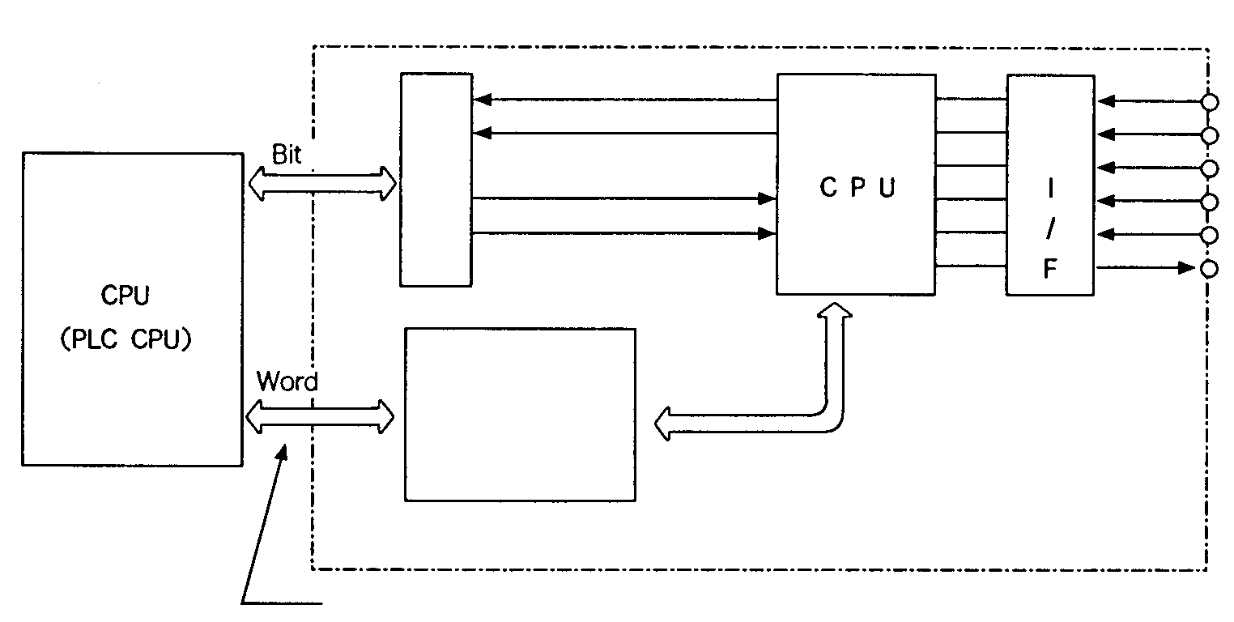
Access with PUT, PUTP, GET and GETP commands
data
data
Common
RAM
Input
Output
Positioning module
Exte-
rnal
Upper L/S
Lower L/S
Emergency stop
Zero-point L/S
Z-phase
Pulse string
【Fig. 7.2】 Structure of a positioning module

7.1.1 I/O signal communication (Bit data)
As a signal exchanged between PLC CPU and a positioning module, I/O signal is used for bit-unit signal. I/O signal discussed here is a unique and separate signal of a positioning module and used with PLC. Input signal is contact point P status and output signal is contact point P control.

♣Input signal
CPU
K3F-POPA
Input signal used as a sequence program, is an input signal for CPU from a positioning module, of which source is a positioning module.
Error
In operation
It is used as a contact point in a program. For example, the followings are available:
① Error signal
Positioning complete
Inching complete
On when error occurs during operation
Speed teaching
complete
(Normal: off, Error: on)
② In-operation signal
A signal which informs positioning in progress for CPU
Input signal of a positioning module

♣Output signal
SET, RST or OUT used as a sequence program are output signals to a positioning module from CPU and of which source is used as program coil or a contact point at CPU.
CPU
G6F-POPA
Changing emergency stop
Start position no
① Positioning start control
Set floating zero point
Disable output prohibition
A control that initiates a positioning module to find the next position no. and continue to operate.
Position teaching
Speed teaching
② Zeroing control
A control which commands zeroing and continue to operate.
Inching

【Fig. 7.4】 Output of a positioning module

7.1.2 Word data communication
Word data are exchanged by 16-bit unit. Therefore, there is common RAM for data storage in a positioning module.
EMBED Word.Picture.8 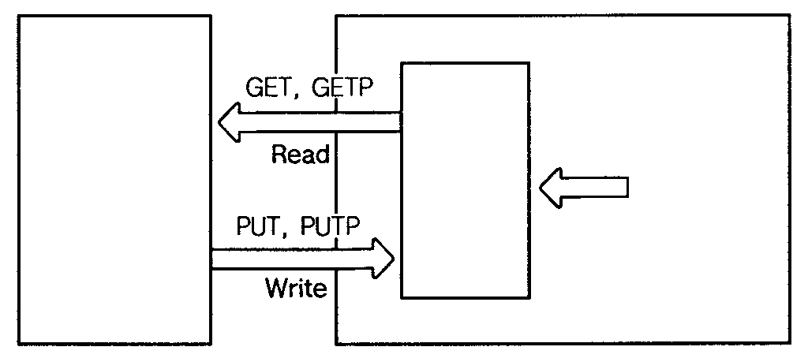
Value of code MStatus No. 1AlarmErrorValue of current speedCommon RAM commendPosition teaching Position noSpeed teaching Speed noSpeed teaching Speed value
0
1
2
↓
6
7
↓
13
14
Read and write is enabled in CPU
Common
RAM
Position module Address
CPU
【Fig. 7.5】 Common RAM

Common RAM reads status information from CPU using GET or GETP commands and writes controls and data using PUT, PUTP commands.
EMBED Word.Picture.8 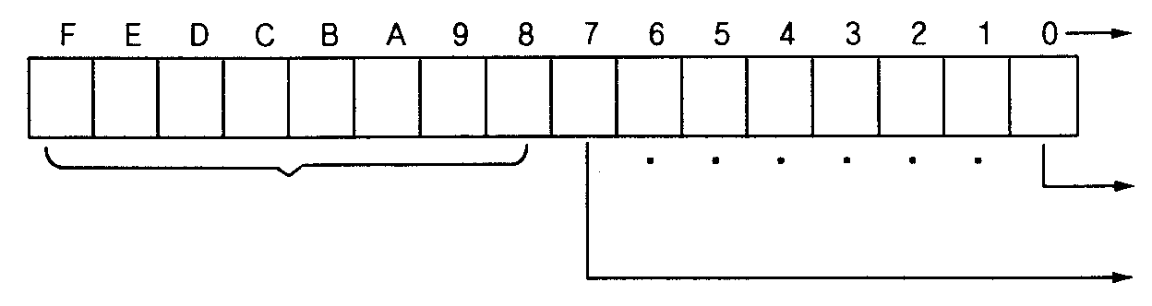
Code value of M ( 0~255)
Upper limit
Zone #3
X-axis :
Address 0
Bit no
【Fig. 7.6】 Example of common RAM

(3) Cautions for Read and Write programs
ⓐThere is a read-only area depending on the address of common RAM.
Status area of common RAM is a read-only address.
ⓑDo never write in this area. If it is written in the area by mistake, common RAM data may be damaged and malfunctioning because a positioning module always writes.
(Read-only address X-axis: Address 0~5, Y-axis: Address 50~55)
ⓒDo never read or write in areas other than common RAM address areas.
Since addresses beyond the range can be being used for operating system, normal operation may not be guaranteed.
Always write the 2 words at a time for the current position address (X-axis: address 9, 10, Y-axis: address 59, 60).

7.2 Programming for positioning programs

7.2.2 Basic rules for programming
- Always run only one control at a time (can not run more than two controls at a time).
- Do not issue another control while a control is being executed (In-operation signal on).
- After contact point P control is on, turn it off after receiving contact point P control complete
signal (P(n)7 signal).
- After common RAM control is on, turn it off after receiving contact point P control complete
signal (P(n)7 signal).

* After power is on, complete zeroing first and then proceed with execution of other controls. Otherwise, error 76 occurs if in ABS operation. This error indicates that operation control has been entered while zero point has not been decided and data type is ABS, and run floating zero point at a software package (PosPack.exe) and operate to clear this.

■Program example
G6F-POPA is mounted on slot no.2 , DC input 32 and Tr output 32 points modules module are mounted on slot no.0, 1
- Example of contact point P control program

【Positioning start control (X-axis)】

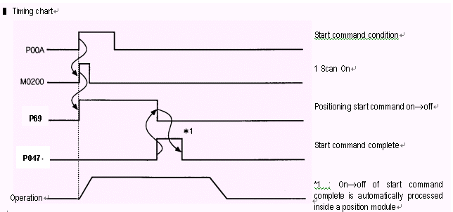

■ Example of zeroing program
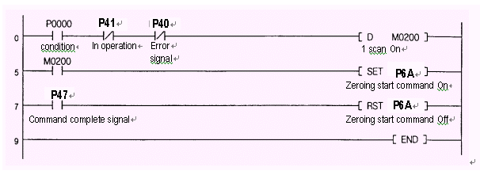

]

■ Example of JOG operating program

4) Example of starting position no. change program
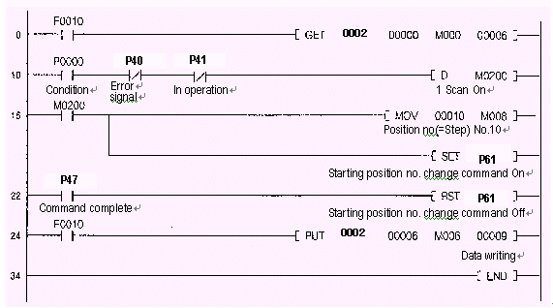

5) Set a floating zero point

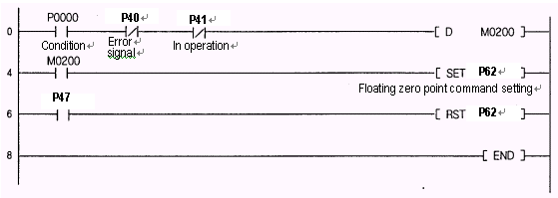

6) Enable output.
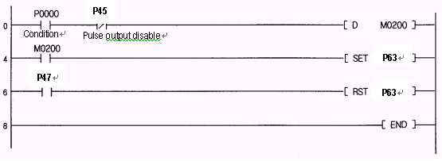

7) Overriding
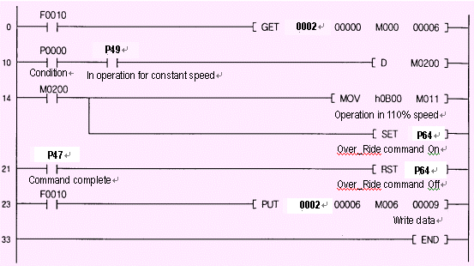

P64
0002
P47
P64

8) Reset error
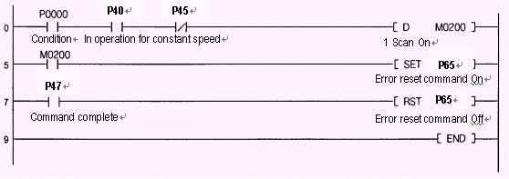

9) Turn code M off
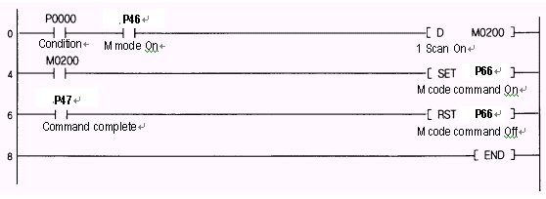

10) Change speed.
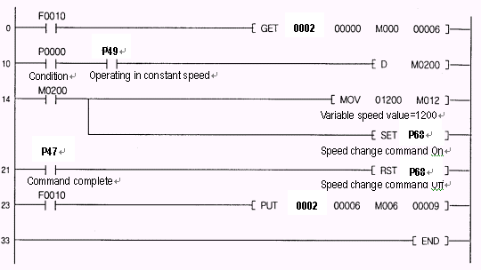

11) Position teaching
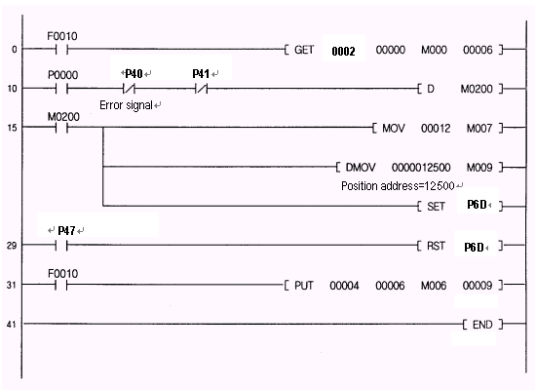

12) Speed teaching
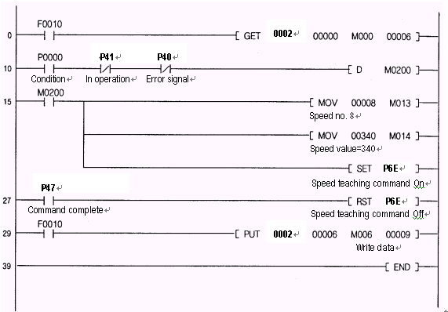

13) Inching
