Chapter5. SPECIFICATION (MASTER-K)

Common memory stores communication data between positioning module and PLC CPU on it.

5.1 COMMON MEMORY

5.1.1 Common memory structure

▣ Memory structure of G6F-POPA
Address (Decimal) |  | Description
X-Axis  Status | Y-axis
0 | 50 | Status 1 | Code M value
1 | 51 | Error
2 | 52 | Current speed value
3 | 53 | Current position no.
4 | 54 | Current position address (Lower)
5 | 55 | Current position address (Upper)
6 | 56 | Common RAM instruction
7 | 57 | Position teaching position no.
8 | 58 | Starting position no.
9 | 59 | Preset position address (Lower)
10 | 60 | Preset position address (Upper)
11 | 61 | Override distance in percentage | Inching distance
12  Instruction  And data | 62 | Variable speed value
13 | 63 | Speed teaching speed no.
14 | 64 | Speed-teaching speed value
15 | 65 | Position address teaching mode  ( 0 : RAM teaching / 1 : ROM teaching )
16 | 66 | Position speed teaching mode  ( 0: RAM teaching / 1 : ROM teaching )
17 | 67 | Acceleration time( 0 ~999 )
18 | 68 | Deceleration time( 0~999 )
19 | 69 | M code mode  ( 0: with / 1: after / 2: none)
20 | 70 | Hi speed of JOG operation( 1~20,000)
21 | 71 | Hi speed of returning zero point

•Status 1

BIT 8: Upper limit
BIT 9: Lower limit
BIT A: Emergency stop
BIT B: On JOG operation
BIT C: On compensation
BIT D: ZONE #1
BIT E: ZONE #2
BIT F: ZONE #3
BIT 7: ZONE #3

•Common RAM instructions

BIT 0: RTP
BIT 1: NEXT MOVE
BIT 2: MPG permission
BIT 3: JOG (LOW/HIGH)
BIT 4: JOG/Inching (FWD/RVS)
BIT 5: Preset current value
BIT 6~F: Unused

5.2 Status descriptions

- G6F-POPA
F E D C B A 9 8 7 6 5 4 3 2 1 0
X-axis : address 0
Y-axis : address 50
Bit No.

Upper limit
Lower limit
Emergency stop
On JOG operation
On Compensation operation
Zone #1
Zone #2
Zone #3

•Upper/lower limit
(a) Turns on if stroke upper/lower limit is exceeded.
(b) Pulse output is disabled.
(c) After enabling pulse output, set the limit off during manual positioning (JOG operation).

•Emergency stop
(a) Turns on if operation is stopped by external or internal emergency stop signal, from
then pulse output is disabled.
(b) Pulse output is enabled and all the error status is reset by pulse enable output
instruction.

•JOG operation
(a) Turns on during low-speed or high-speed JOG operation.

•On compensation
(a) Turns on during back lash or zero point compensation.

•ZONE #1, 2, 3
(a) Turns on if a machine enters ZONE #1, 2 or 3 set in a parameter.

•Code M value
(a) Code M values (0~255) set in position data are displayed.
(b) Since code M values are displayed at bits 0~7, there exists a difference between the value in the position data and the value monitored.

Ex.) If a position data value is “15”, the monitored value appears as h000F or 15

Error

F E D C B A 9 8 7 6 5 4 3 2 1 0
X-axis : address 1
Y-axis : address 51

•Error
- This positioning module CPU error is a critical failure and user may
not proceed.

Current speed value

F E D C B A 9 8 7 6 5 4 3 2 1 0
X-axis : address 2
Y-axis : address 52
0 ~ 200,000
Current position No.
•Displays the current speed of operation.

F E D C B A 9 8 7 6 5 4 3 2 1 0
X-axis : address 3
Y-axis : address 53
0 ~ 299
•Displays the current position no. (step no.).

Current position address

F E D C B A 9 8 7 6 5 4 3 2 1 0
X-axis : address 4
Y-axis : address 54
(Lower)

(Upper)
X-axis : address 5
Y-axis : address 55
•Displays the current position address (-16,744,447 ~ +16,744,447).

5.2.1 Instructions and Data descriptions

Common RAM instructions

F E D C B A 9 8 7 6 5 4 3 2 1 0
X-axis : address 6
Y-axis : address 56
Unused
RTP
NEXT MOVE
PARAMETER SETTING
JOG (Low/High)
JOG/Inching(Forward/reverse)
Current value Preset

•RTP
An instruction that returns a machine to the previous position after JOG or inching operations.

•Next move
An instruction that changes the current operation speed to the speed of the next position (=step) in continuous operation mode. (On: 1, Off: 0)
The instruction is executed only at constant speed.

• PARAMETER SETTING
Change positioning parameter without pospack

•JOG (Low/High)
Decides low speed (Off: 0) or high speed (On: 1) during JOG operation.

•JOG/Inching (Forward/Reverse)
Decides forward rotation (Off: 0) or reverse rotation (On: 1) during JOG or inching operations.

•Preset current value
An instruction that changes the current position address. It writes the position address value at address 9, 10 (X-axis), and 59, 60 (Y-axis), and then turns on.

Position-teaching position No.

F E D C B A 9 8 7 6 5 4 3 2 1 0
X-axis : address 7
Y-axis : address 57
0 ~ 299

•Position-teaching position no.
The data that specifies a position no. during position teaching, are manipulated with position teaching by position teaching instruction along with address 9, 10 (X-axis) and 59, 60 (Y-axis).

Start position No.

F E D C B A 9 8 7 6 5 4 3 2 1 0
X-axis : address 8
Y-axis : address 58
0 ~ 299

•Starting position no.
A value of the position no. (step no.) where operation starts.

Preset position address

F E D C B A 9 8 7 6 5 4 3 2 1 0
X-axis : address 9
Y-axis : address 59
(Lower)

(Upper)
X-axis : address 10
Y-axis : address 60

•Preset position address
Preset position address is the data that the current position address is changed to upon execution of preset current value instruction, and the data that the position address of the step no. specified by position-teaching position no. is changed to upon execution of position teaching instruction.

Override quantity in percentage
Inching quantity

F E D C B A 9 8 7 6 5 4 3 2 1 0
X-axis : address 11
Y-axis : address 61
1 ~ 15 | 1 ~ 99

•Override quantity
An operation speed changes from 1 to 15 (10~150%). A speed magnitude in percentage (h0100~h0F00) for the operation speed in speed data.

•Inching quantity
A travelling distance (1~99) when inching instruction is executed.

Variable speed value

F E D C B A 9 8 7 6 5 4 3 2 1 0
X-axis : address 12
Y-axis : address 62
1 ~ 20,000

•Variable speed value
A speed value randomly selected during operation.
Speed change instruction should be issued at constant speed.

Speed-teaching speed No.

F E D C B A 9 8 7 6 5 4 3 2 1 0
1 ~ 127
X-axis : address 13

•Speed-teaching speed no.
The speed no. to be changed by speed teaching.

Speed-teaching speed value

F E D C B A 9 8 7 6 5 4 3 2 1 0
1 ~ 20,000
X-axis : address 14

•Speed-teaching speed value
The speed data (= value) to be changed by speed teaching

▣ What is position teaching?
Position teaching is a function that changes a position address in position data.
Ex.) Position teach with a position address of step No. 3 at X-axis for 1234.

Step | Method | Override | - - | Position address | Code M
0  1  2  3  4 | Absolute  Absolute  Incremental  Absolute  Absolute | - -  - -  - -  - -  - - | - -  - -  - -  - -  - - | -  -  -  1 2 3 4  - | - -  - -  - -  - -  - -

┼

┼
Position-teaching instruction (Contact point P instruction)

•Program

* In case of the above program, G6F-POPA has been mounted on slot no. 0 of a base.

HINT

X-axis position data

Positioning-teaching position

Address 7
“ 3 “
“ 1 2 3 4 “

Preset position address

Address 9

Address 10

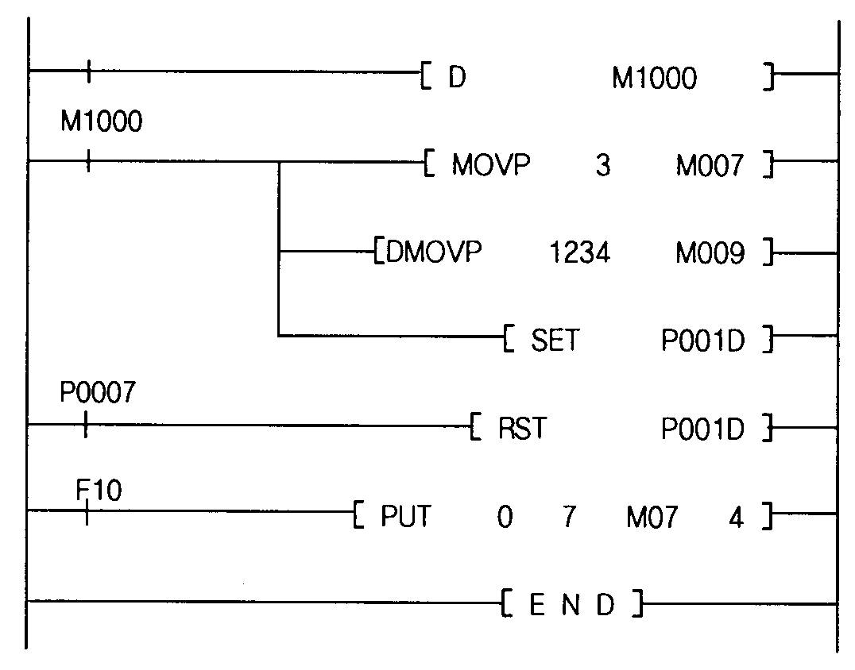
Point-teaching condition
1 Scan On

Position-teaching position No. =3
Position-teaching instruction On

preset position address = 1 2 3 4

Instruction complete
Position-teaching instruction Off

Always On
Write data in common memory

▣ What is speed teaching?
Speed teaching is a function that changes a speed data (= speed value).
Ex.) Speed teaching with a speed value of speed data No. 2 for 450.

No. | Speed value
0  1  2  3  ∫ | 5000  0  450  0  ∫

┼

┼
Position-teaching instruction (Contact point P instruction)

•Program

* In case of the above program, G6F-POPA has been mounted on slot no. 0 of a base.

HINT

Speed data

2
450

Speed-teaching speed

Address 14
“ 2 “

Speed-teaching speed value

Address 15
“ 450 “

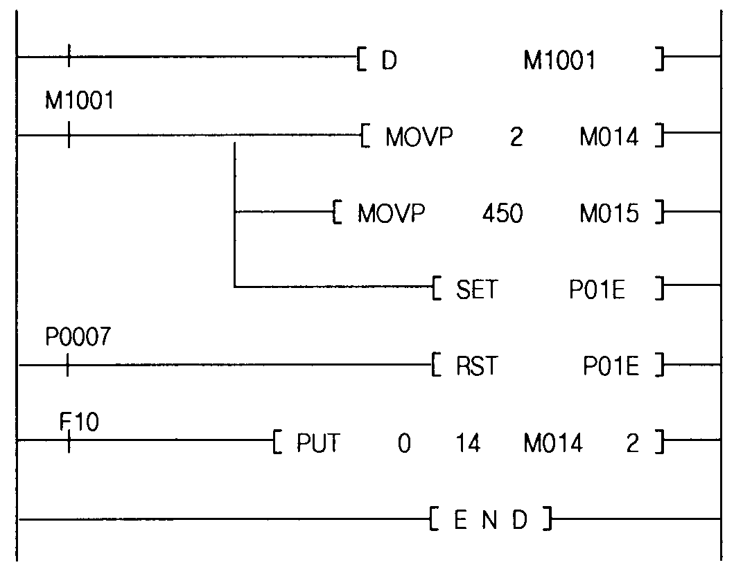
Speed-teaching condition
1 Scan On

Speed-teaching speed No. = 2

Speed-teaching speed value = 450

Speed-teaching instruction On

Instruction complete
Speed-teaching instruction Off

Write data in common memory

5.3 I/O Signals for Interface with PLC CPU

The module uses I/O for data communication with PLC CPU. Their description and functionality are presented here. The following is for the case when I/O word no. of the module = n.

5.3.1 Descriptions on I/O signals

•I/O signals (64 points)
Input: positioning module status
PLC CPU ← positioning module
* Y-axis
P(n+1)0 …………………. Error
P(n+1)1 ………………… On operation
P(n+1)2 ………………… Positioning complete
P(n+1)3 ………………… Zeroing complete
P(n+1)4 ………………… Zero point not decided
P(n+1)5 ………………… Pulse output disabled
P(n+1)6 ………………… Code M on
P(n+1)7 ………………… Instruction complete
P(n+1)8 ………………… At deceleration stop and complete
P(n+1)9 ………………… At constant speed
P(n+1)A ………………… Zeroing
P(n+1)B ………………… Positioning
P(n+1)C ………………… On interpolation operation
P(n+1)D ………………… Position teaching complete
P(n+1)E ………………… Speed teaching complete
P(n+1)F ………………… Inching complete
* X-axis
P(n)0 …………………. Error
P(n)1 ………………… On operation
P(n)2 ………………… Positioning complete
P(n)3 ………………… Zeroing complete
P(n)4 ………………… Zero point not decided
P(n)5 ………………… Pulse output disabled
P(n)6 ………………… Code M on
P(n)7 ………………… Instruction complete
P(n)8 ………………… At deceleration stop and complete
P(n)9 ………………… At constant speed
P(n)A ………………… Zeroing
P(n)B ………………… Positioning
P(n)C ………………… On interpolation operation
P(n)D ………………… Position teaching complete
P(n)E ………………… Speed teaching complete
P(n)F ………………… Inching complete

Output: an instruction for positioning module
(= contact point P instruction)
PLC CPU → positioning module
* X-axis
P(n+2)0 …………………. Emergency stop
P(n+2)1 ………………… Starting no. change
P(n+2)2 ………………… Set floating zero point
P(n+2)3 ………………… Output enabled
P(n+2)4 ………………… Override
P(n+2)5 ………………… Error reset
P(n+2)6 ………………… Code M off
P(n+2)7 ………………… Stop deceleration
P(n+2)8 ………………… Interpolation
P(n+2)9 ………………… Start positioning
P(n+2)A ………………… Start zeroing
P(n+2)B ………………… Change speed
P(n+2)C ………………… JOG operation
P(n+2)D ………………… Position teaching
P(n+2)E ………………… Speed teaching
P(n+2)F ………………… Inching
* Y-axis
P(n+3)0 …………………. Emergency stop
P(n+3)1 ………………… Starting no. change
P(n+3)2 ………………… Set floating zero point
P(n+3)3 ………………… Output enabled
P(n+3)4 ………………… Override
P(n+3)5 ………………… Error reset
P(n+3)6 ………………… Code M off
P(n+3)7 ………………… Stop deceleration
P(n+3)8 ………………… - -
P(n+3)9 ………………… Start positioning
P(n+3)A ………………… Start zeroing
P(n+3)B ………………… Change speed
P(n+3)C ………………… JOG operation
P(n+3)D ………………… Position teaching
P(n+3)E ………………… Speed teaching
P(n+3)F ………………… Inching

5.3.2 Function
1) Input
Input signal is status information of positioning module, which is transferred to PLC CPU from the module.

①Error
•Turns on when alarm or error occurs.
•Turns off when error is reset or output is enabled.

②In operation
•Turns on when start positioning, and off when it is done.
•Turns on/off at a time for both axes X and Y during interpolation operation.
•Turns on during inching or JOG operation.
•Dwell time also turns on.

③Positioning complete
•Turns off by start positioning or start zeroing instructions.
•Turns on during single operation, repetition complete opertion, zeroing complete and constant speed operation with positioning after dwell time passes by.
•Turns off at deceleration or emergency stop.
•Turns on during single operation, constant speed operation with positioning and
repetition complete operation.
•Turns on/off at both axes X and Y during interpolation.
•Turns off in between independent operation and continuous operation.

④Zeroing complete
•Turns on after dwell time passes by and zero point compensation distance is transferred, which follows start zeroing instruction.
•Turns off by all other instruction signals.

⑤Zero point not decided
•Turns off when floating zero point is set and zeroing is complete.
•Keeps on if zero point is not decided.

⑥Pulse output disabled
•Turns on at emergency stop, overrun occurring at upper/lower limits and operation out
of switch limits.
•Turns off by enable output instruction.

⑦Code M on
•Generates code M value by dividing into With and After modes during positioning and turns on when it is in the range of 1~255.
•Turns on after dwell time passes by in single/repeated operation and single/constant speed operation modes.
•Turns on at the setting point in continuous mode.
•Turns off by code M off signal.

 Instruction complete
•A signal which turns on and informs PLC CPU of that, when common RAM instruction and contact point P instruction (positioning module output contact point instruction) turn on, the instructions can be formally accepted and executed by positioning module.
•Turns immediately off if the common RAM instruction and the contact point P
instruction turn off.
•Do not use the signal during JOG operation or MPG permission.

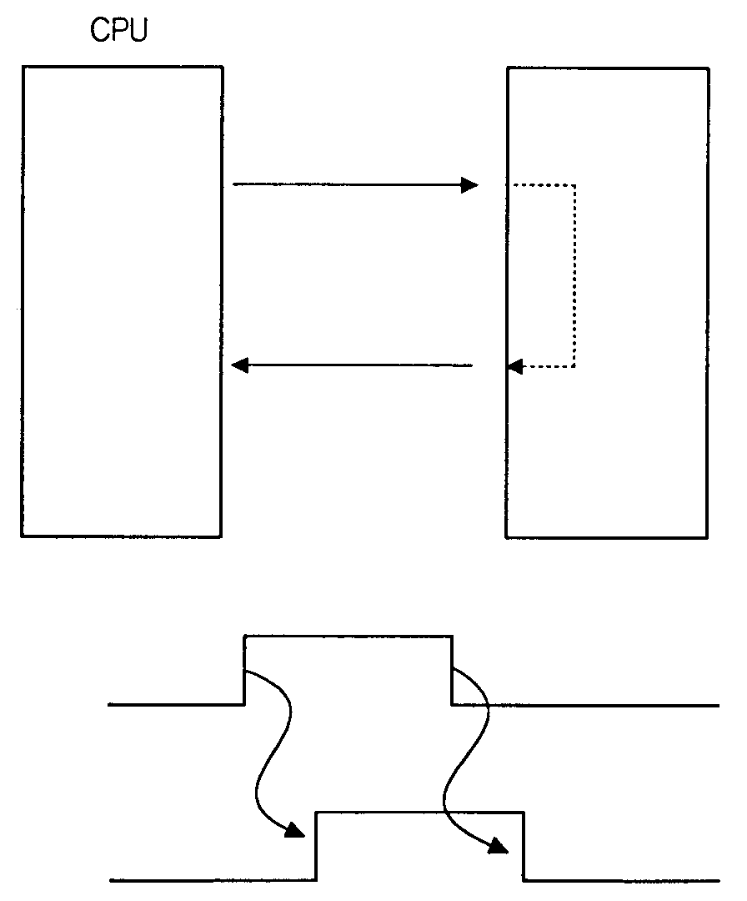

Positioning module

Instruction

Instruction taken and execution

Instruction complete

CPU Instruction
Positioning module
instruction complete

HINT
•If an instruction signal turns on, the instruction should be set off.
•CPU can not assign to positioning module more than two instructions at a time. It must assign only a single instruction at a time and give out the next one when the instruction is completed.
Wrong Ex.):Start positioning instruction + JOG instruction (X), Inching
instruction + Preset current value instruction (X),
Starting point no. change instruction + Error reset instruction (X),….and so on.

⑨At deceleration stop and complete
•Keeps on from the time of deceleration stop instruction till the stop.
•Turns off upon positioning start, zeroing start and JOG and inching instruction.

⑩At constant speed
•Turns on for constant speed operation and off otherwise.

⑪Zeroing
•Turns on upon start zeroing instruction and off when the instruction is completed.

⑫On interpolation operation
•Turns on upon interpolation instruction and off when positioning is completed.

⑬Position teaching complete
•Turns on when position teaching is completed.
•Turns off upon start positioning instruction, zeroing instruction and JOG operation.

⑭Speed teaching complete
•Turns on when speed teaching is completed.
•Turns off upon start positioning instruction, zeroing instruction and JOG operation.

⑮Inching complete
•Turns on when inching is completed.
•Turns off upon start positioning instruction, zeroing instruction and JOG operation.

2) Output
•Output signal is a contact point P instruction transferred to positioning module from PLC CPU.

①Emergency stop
•An emergency stop linked to the external connector of positioning module is called
external emergency stop, and an emergency stop by contact point P is called
internal emergency stop.
•Internal emergency stop should be issued when external emergency stop signal is
wired in normal condition (N.C.).
•If this instruction is executed, output is disabled.

②Starting position no. change
•This is a convenient function by which user may jump to a certain position no.
( = step).
•If a position no. value to jump to is stored at address 8 (X-axis) and 58 (Y-axis) and the instruction is set on, operation continues at the stored position no. (= step) upon start positioning instruction.

③Set floating zero point
•While zeroing searches for a base point for a system in a mechanical sense, the set
floating zero point instruction is used to locate a base point as for software approach
in index table with circular movement or a system that does not require a
mechanical base point.
•Set floating zero point instruction changes the current position to a zero point
address set as in a parameter.

④Enable output
•The function enables output disabled by upper/lower limit overrun, emergency stop
or switch limit.

⑤Override
•The function changes operating speed in the range of 10~ 150%.
•Since the changed speed value is a upper byte of address 11 (X-axis), 61 (Y-axis), it should be displayed in the range of h0100 ~ hF00.
•h0100 = 10%, h0200 = 20%,…, h0F00 = 150%

⑥Error reset
•An instruction that resets alarm status.

⑦Code M off
•An instruction that sets code M signal off

⑧Deceleration stop
•This pauses positioning and zeroing operations internally.
•The rest part of positioning operation continues as a new start instruction.
•For Incremental position moving, move as much as the travelling distance.
•For Absolute position moving, move as much as the left distance.

⑨Interpolation
•Starts linear interpolation.
•A target speed, dwell time and other controls are decided with a basis of X-axis.
•Arrays of position data at X- and Y-axes should be configured as the same.
•Override instruction is not allowed.
•Bias speed is always regarded as “0”.
•Operation mode is decided with X-axis as a basis.
•Interpolation is not executed and an error is generated in modes other than single operation, repetition complete operation and independent operation.
•It always stops upon abnormal stoppage.
•A signal is process for any of X- and Y-axes at deceleration stop, EOM stop and positioning stop.
•A target speed is processed with a speed value at X-axis as a master axis and reduced speed is calculated as in the following for processing:
Speed of master axis x reduced distance
Reduced speed =
Distance of master axis

The basic operation format of interpolation is shown at Fig. 5.1.

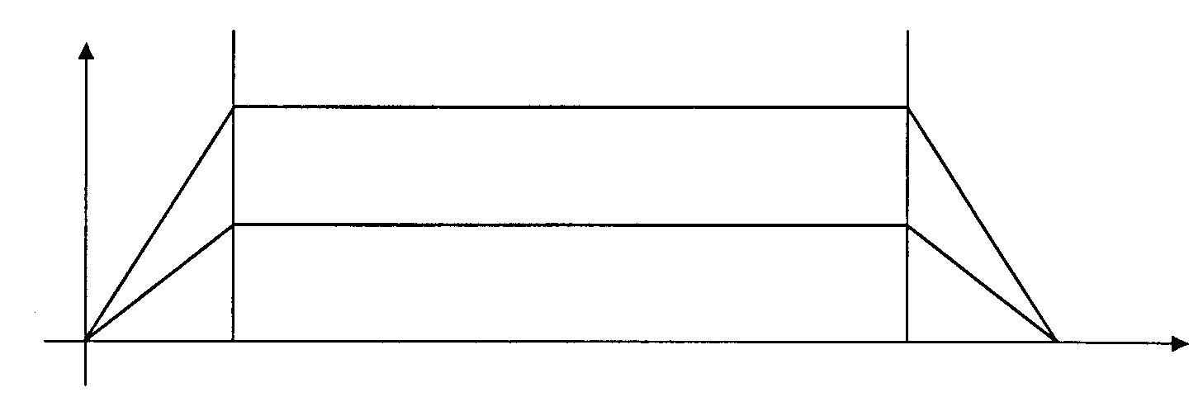
Y-axis
X-axis
X-axis
Y-axis
Speed

Position
【Fig. 5.1】

Stop deceleration instruction is allowed on interpolation and stop formats, when instructions are initiated, are as in the below.

•Deceleration stop

Speed
Position
X-axis
Y-axis

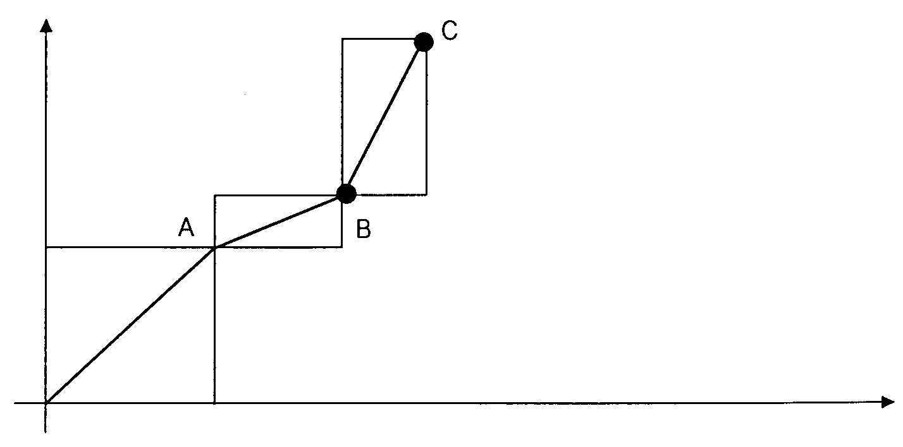
X-axis speed : 100 PPS
Increment operation
0 10 20 22

•Operation example of interpolation

a) Since traveling distances are the same for operation to the point A, they are
calculated by formula No. 1 with X- axis as a master axis like in the below:

100 x 10
Speed Y = = 100 [PPS]
10
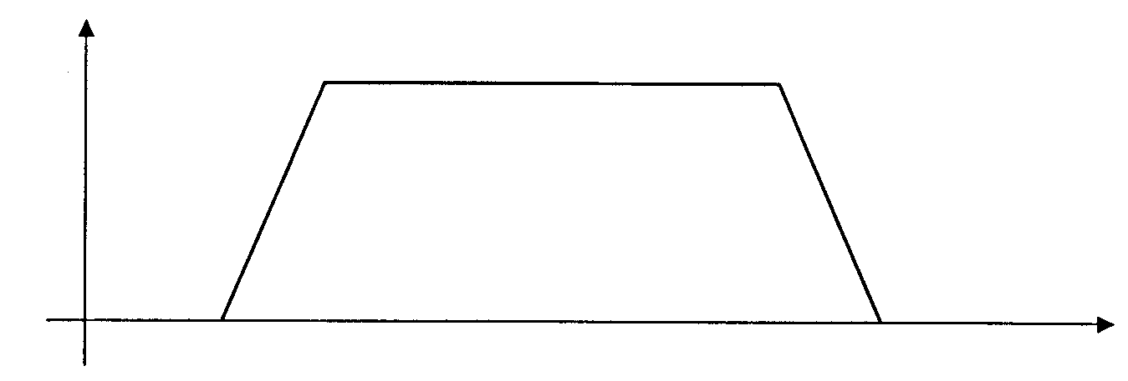
Speed
X(Y)-axis

X-axis

b) For operation to the point B, the following formula yields the result with Y-axis as
a slave axis.
100 x 2
Speed Y = = 20 [PPS]
10
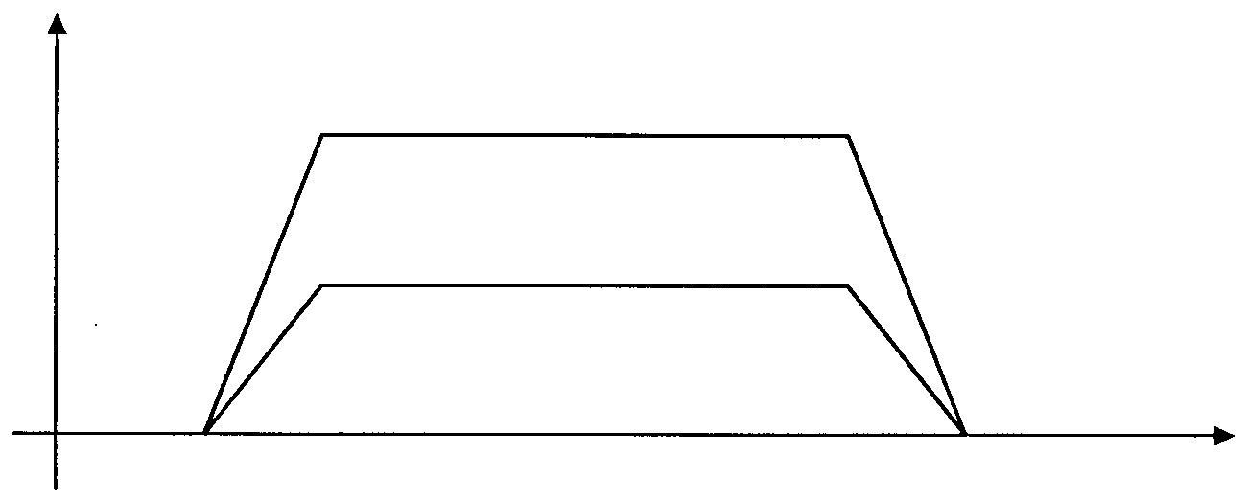
X-axis
Speed
100

20
Y-axis

b) For operation to the point C, the following formula yields the result with X-axis as a
slave axis.

100 x 2
Speed X = = 20 [PPS]
10
Speed
Y-axis
100

20
X-axis
X-axis

* A triangular format or a unit functional format may be obtained even during interpolation according the setting data of X- and Y-axes as explained for single operation mode.

⑩Start positioning
•A machine operates to a position address of the current position no. according to the position data and then stops.
•In single mode, the instruction is executed for each position no. incremented whenever the instruction is output.
•In independent (automatic), continuous modes, it is executed till the last independent, continuous operation with a single instruction.

⑪Start zeroing
•The initial instruction in machine operation, which commands a machine to locate a mechanical zero point.
•There are two methods depending on the configuration of zero point limit switch.
•When it stops by zero point signal, the address set in a parameter becomes a zero point.

⑫Change speed
•A function that changes a speed by user in the range of 10~200 KPPS during
operation.
•Speed value is in the range of 1~20,000 and a machine is operating at its actual

speed of 10~200,000 PPS.
•The speed value to be changed are stored at address 12 (X-axis), 62 (Y-axis).
•Since acceleration/deceleration time is not applied during speed change, a rapid speed change, when a step motor is used, may cause separation of motor parts.
•Speed change is allowed only at constant speed.

⑬JOG operation
•An instruction signal that initiates forward rotation (common RAM instruction bit 4 off) or reverse rotation (common RAM bit 4 on) of JOG at high speed (common RAM instruction bit 3 on) or low speed (common RAM instruction bit 3 off) as specified in a parameter.
The high speed should be set slower than the low speed. (Manual operation)

⑭Position teaching
•An instruction that changes a position address of position data to a random value.
•The position no. (= step) and the position address value to be changed are stored
at common RAM address 7 at X-axis (57 for Y-axis) and address 9~10 at X-axis
(59~60 for Y-axis) respectively and then position teaching is set on.

⑮Speed teaching
•A function that a speed value of speed data can be changed.
•The speed no. and the speed data (or value) to be changed are stored at
common RAM address 13 and 14 at X-axis respectively and then the instruction is
set on.

⑮Inching
•An instruction that outputs the pulse amounts (1~99) as specified by user.
•Speed is fixed as 1 KPPS. (Manual operation)
•It is convenient to make a delicate movement that can not be achieved by JOG.

