Chapter 1. OPERATION OUTLINE

1.1 Operation Outline

1.1.1 Positioning System

Positioning system with PLC has two different methods
One is use with servo motor and the other is use with stepping motor

(1) Positioning system operations by the servo motor (Pulse output type)

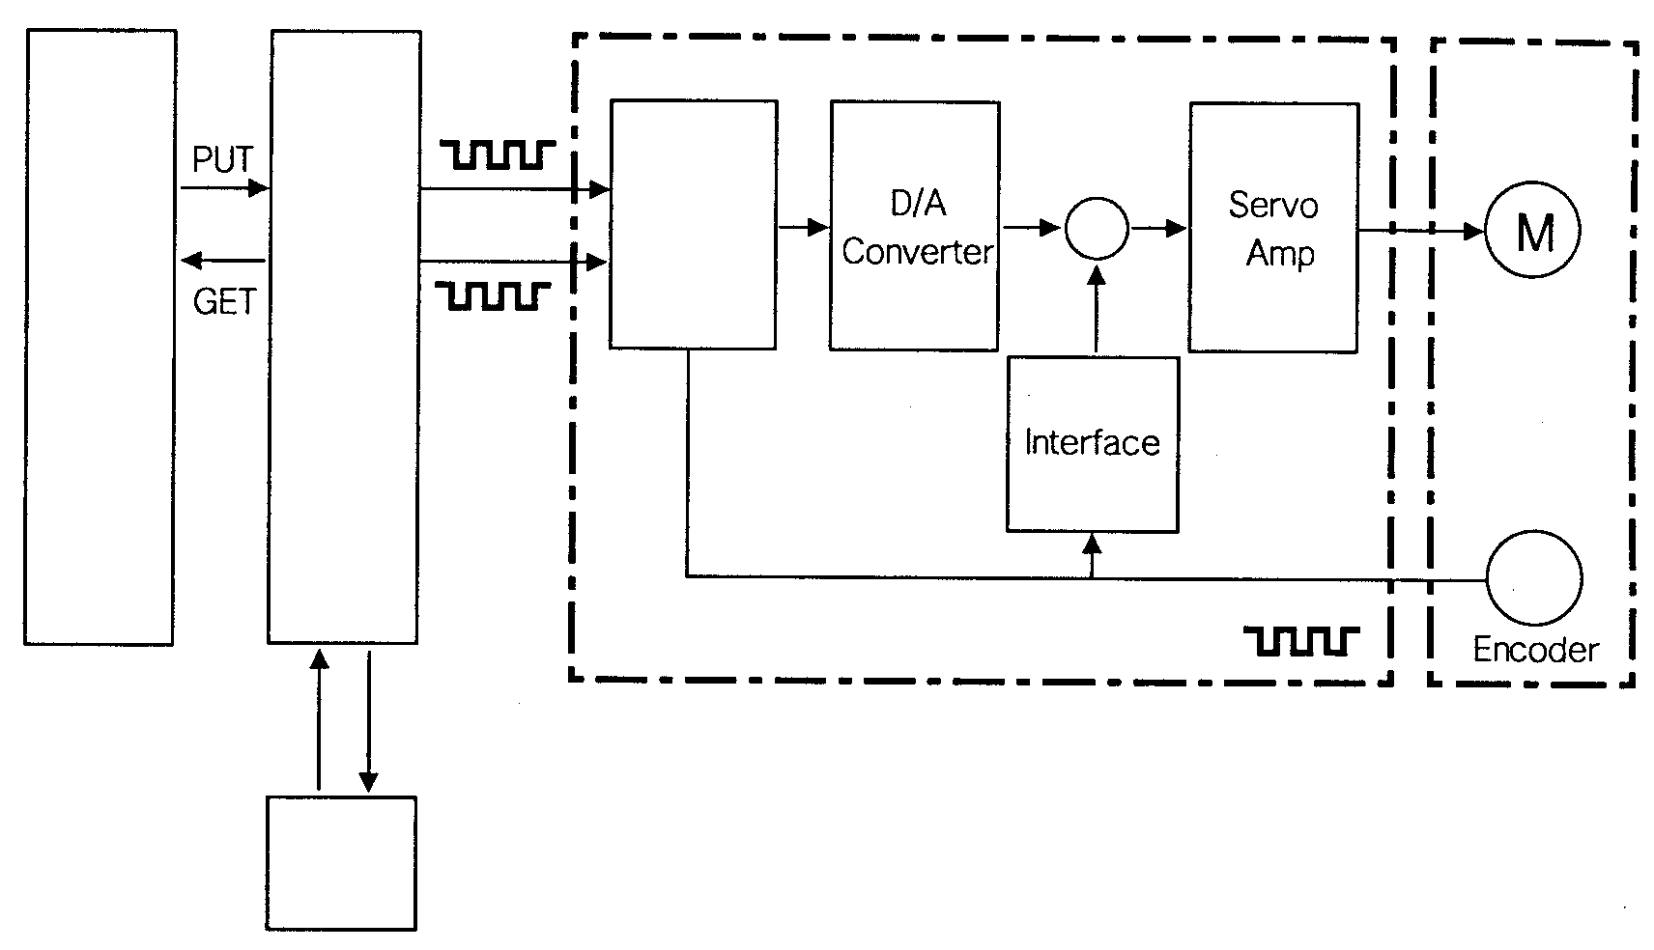

PLC
(CPU)
Positioning Module
Drive Unit
Forward rotation Pulse string
Servo Motor

Deviation counter
Sequence
Program
Setting Data

Reverse rotation Pulse string

Feed Back Pulse String

Write, Read (Parameter, Positioning data, Speed data)

Peripheral
devices

Personal Computer

[Fig 1.1] Positioning System Operation Block Diagram ( Pulse Output)

● operation order
✶ The G6F-POPA output pulse string as their output data.
② the pulses are accumulated in the deviation counter.
③The D/A converter converts the stored pulses into analog voltages and they becomes speed commands, As many feedback pulses as proportional with the number of rotations of the encoder are input at the same time as the motor stars it rotation by the speed

commands from the drive unit and the deviation counter decrements the stored pulses.
The offset counter retains a constant number of the stored pulses and the motor continues to rotate.

→ When the G6F-POPA stops outputting command pulses, the stored pulses in the deviation counter start to decrease and the speed reduces. If the stored pulses are cleared out, the motor stops. That is, the number of rotations of the motor is proportional with the number of the output pulses

In addition, the speed of rotation of the motor is proportion with the pulse frequency. As shown in the Fig. 1.2, the pulse frequency increases when the motor accelerates. The frequency of the setting speed remains constant at full speed. When decelerating, the frequency decreases and the number of pulses finally reaches to 0, and when the stored pulses are cleared out the motor stops. That is, the servo motor stops with more or less delay to the command pulse. That difference time is called stop correcting time, it is the dwell time which is requested to acquire the stop accuracy.

Positioning system operations by the stepping motor.
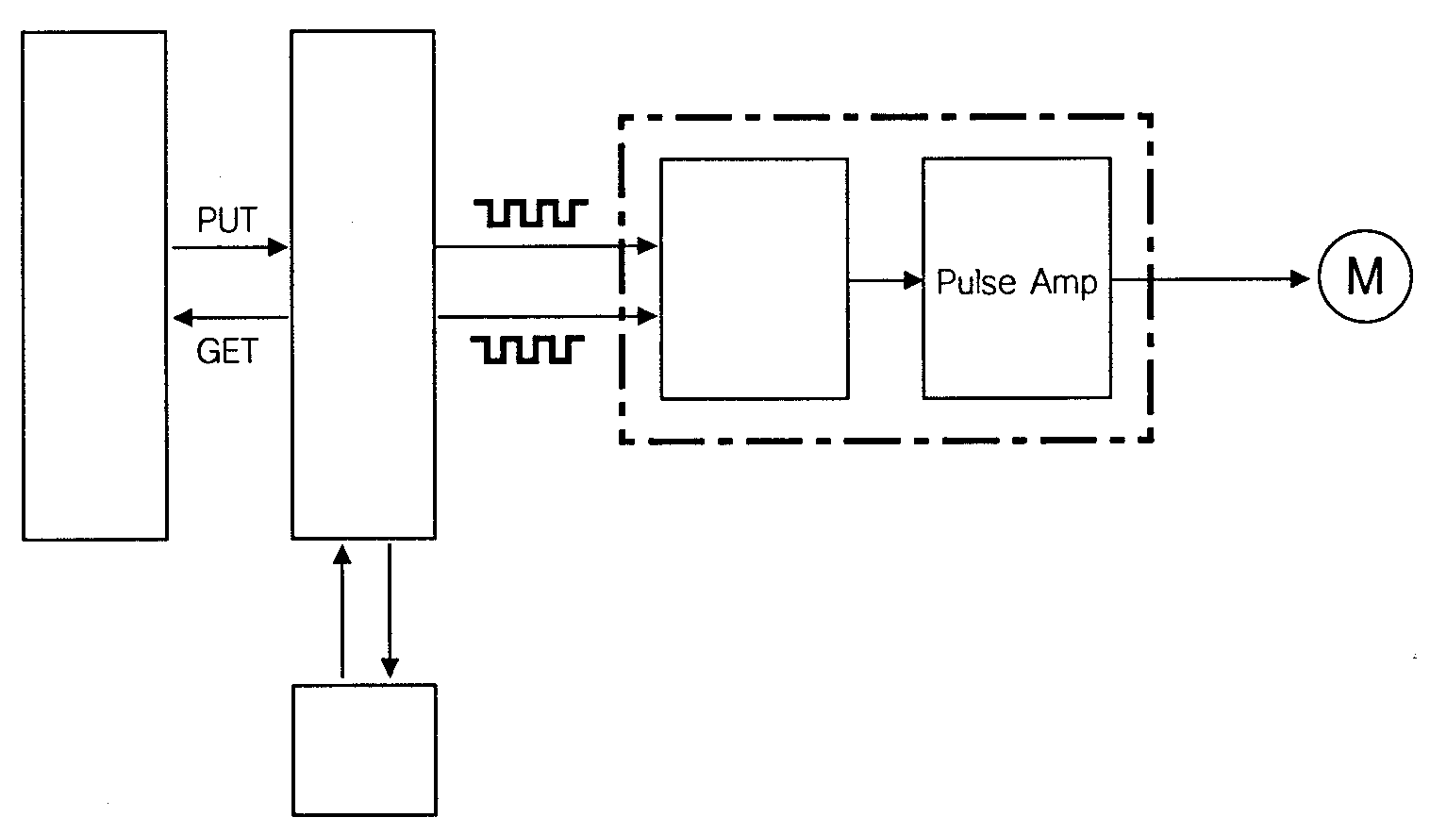
PLC
(CPU)
Positioning Module
Forward rotation Pulse string
Drive Unit
(Stepping Motor)
(Pulse Motor)
Reverse rotation Pulse string

Multi-phase Pulse generator

Write, Read (Parameter, Positioning data, Speed data)

Peripheral
computer

Personal Computer

[Fig 1.2] Positioning System Operation Block Diagram (by Stepping Motor)

✶ The G6F-POPA outputs ‘pulse string’ as their output data.

When a pulse string is output, it is converted into a multi-phase pulse by the multi-phase pulse generator. The stepping motor has inherent rotary angle which is proportional to input pulses. Pulses given to the motor are of 2-phase, 4-phase 5-phase. The multi-pulse generator distributes the pulse string into multi-phase pulses.

✴ After the conversion into multi-phase pulses, the steeping motor starts to be
driven by the AMP.

REMARK

● The main difference between servo system and stepping system
① Servo driver system takes feedback pulse from encoder and balance input pulse number and feedback
pulse number
Stepping driver system doesn’t takes feedback pulse from encoder
② Server motor is rotated by analog signal
Stepping motor is rotated by digital signal

1.2 System Configuration

The below system configuration explains us the positioning module with the K200S CPU module.

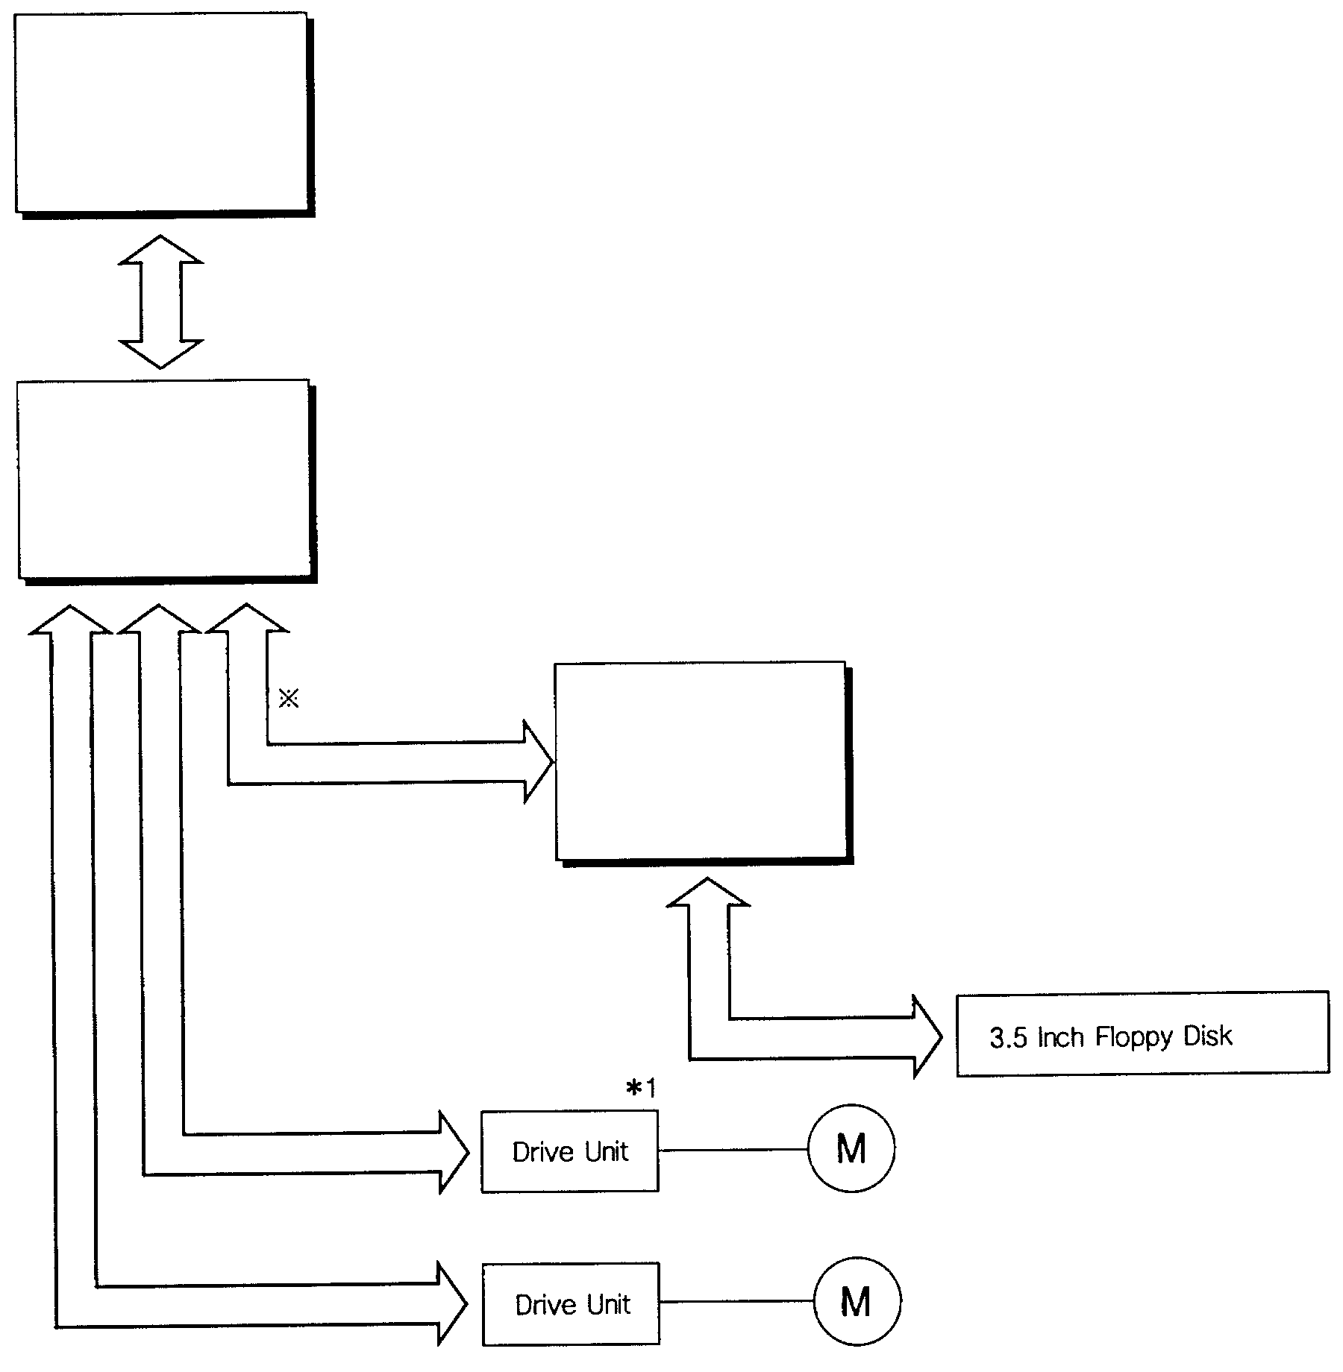
K200S

CPU
Positioning Module

Y axis X axis RS-232
□ □ □
RS-232C Cable

Personal Computer

※Setting Parameters, Positioning Data
and Speed Data

X axis

Y axis

X axis Motor

Y axis Motor

