6. Interface with GLOFA-GM

6-1. GM7/GM6/GM4←→ PMU

1) LOADER PORT IN THE CPU
2
3
4
5
6
7
8
GM7/GM6/GM4(9P)
PMU300(9P)
2
3
4
5
6
7
8
GM7/GM6/GM4(9P)
PMU200(9P)
( CONNECTION DIAGRAM )
2
3
5
2
3
5

( CONNECTION DIAGRAM )

POWER
CPU
I/O
PMU

2
3
5

LINK EDITOR SETTING
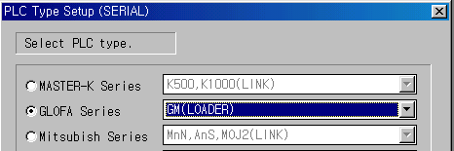

2) C-NET PORT IN THE CPU
GM7/GM6/GM4(9P)
PMU300(9P)
GM7/GM6/GM4(9P)
PMU200(9P)
4
7
5
2
3
4
5
6
7
8
4
7
5
2
3
4
5
6
7
8
( CONNECTION DIAGRAM )

4
7
5
PMU

( CONNECTION DIAGRAM )

POWER
CPU
I/O

LINK EDITOR SETTING
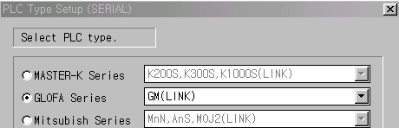

3) C-NET MODULE (G7L-CUEB, G6L-CUEB, G4L-CUEA)
C-NET Module(9P)
PMU200(9P)
PMU
C-NET Module(9P)
PMU300(9P)
1
2
3
4
5
6
7
8
2
3
4
5
6
7
8
1
2
3
4
5
6
7
8
2
3
4
5
6
7
8

( CONNECTION DIAGRAM )
( CONNECTION DIAGRAM )

POWER
CPU
I/O
C-Module

LINK EDITOR SETTING

