5. Symbol Edit

5-1 Create Symbol
When the main machine operating, you can create symbols to be called open and draw shapes, such as pen, straight lines, ovals, and rectangle on the main screen.
The maximum size for symbols is 96 * 96 with the width and height each having units of 16 dots.
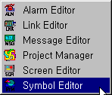
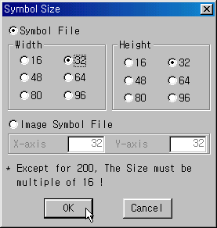

1) Edit symbol
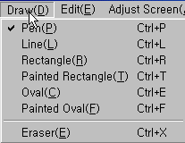

>Pen clicking the left mouse button will draw a dot. Holding the left button down and dragging the mouse draws over the area the cursor passes.
>Line A Straight is drawn from the point the left mouse button is held down to the point the button is released.
>Rectangle A Rectangle is drawn from the point the left mouse button is held down to the point the button is released.
>Painted Rectangle A colored-in Rectangle is drawn from the point the left mouse button is held down to the point the button is released.
>Oval Drawn the same way as the Rectangle but an oval is inscribed in the Rectangle.
- The point the mouse was held down and the point released becomes the corners of the circumscribed Rectangle.
>Painted Oval Drawn the same way as the oval but a colored-in oval is drawn.
>Eraser clicking the left button, or holding down the button and dragging the mouse erases the area the cursor passes.

.
- Draw any shape you wants

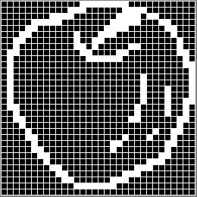

- Registrate symbol on the screen

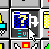
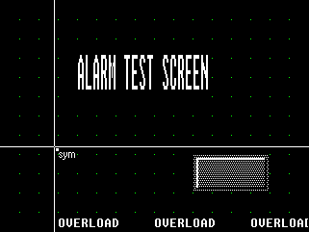

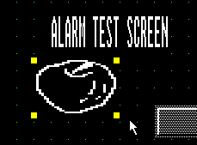
- Symbol can be resized by dragging
Adjust the symbol size

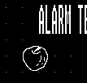

5-2 Open Bitmap File (Full size 320 * 240)

A bitmap(*.BMP) file created in paintbrush or capture in Windows can be called open and saved as a symbol. Please note that the background for paintbrush in Windows is white, and PMU background is black, thus the bitmap will appear in reverse black and white color from the original form. To change to the original form, run “Reverse” in the “Edit” menu.

Symbols with numbers after 900 is saved in image form. In PMU 300/600, the width and height
can only be multiples of 16.
- Image Sizes
PMU-200: width x height, From 16 x 16 to maximum 240 * 128 Screen size.
PMU-300: width x height, From 16 x 16 to maximum 320 * 240 Screen size (only multiples of 16)
PMU-600: width x height, From 16 x 16 to maximum 640 x 480 Screen size (only multiples of 16)

1) Create BMP symbol.

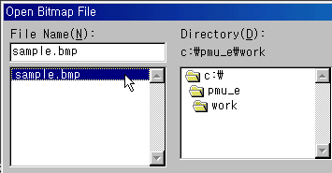
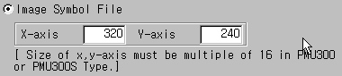
- When you open the full size bmp, you must set the size as a below shown Fig.(320*240)

- Open BMP image

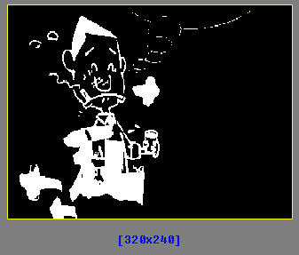
- Save the file name after 900.

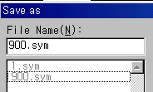

5-3 Open BMP symbol on the Screen Editor

- Open Screen editor and set the Grid as under the Fig.
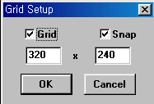

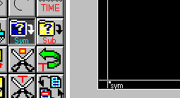

- Resistrates the Symbol left bottom of the Screen

- Choose the symbol number

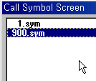
Bmp image covers the objects already made, so click one time the image and Click the send to back menu

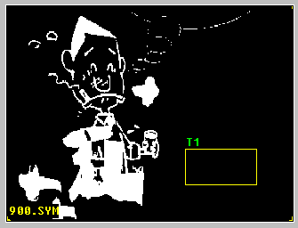
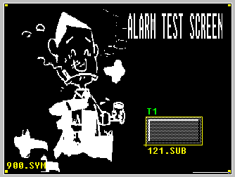

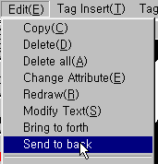

- Completed

