4. Display Alarm messege

- Create an alarm to use when the main machine is operating. An alarm file can have a maximum of 999 comment lines.

- Only one alarm file can exist per one project file.
- The recorded alarm number, system buffer, specified bit of specified buffer, alarm criteria, Attributes, color, number of characters, contents appear on the Alarm editor.

- An alarm number can range from 1 to 999, and the system buffer ranges from 0 to 1023.
- Set the Bit value from 0 to 15.

- Criteria is either 0->1 or 1->0 and the style is normal, blink, or toggle.
- The alarm that appears when the main machine is operating is saved in the internal memory. Using the special function of the Function Key Tag or Touch Key Tag can also show the alarm history. To print the alarm history, upload the alarm history file to your PC (using project manager) and print from your PC in PMU-200 and PMU-300.

4-1 Creat a Alarm File

1) Open Alarm Editor
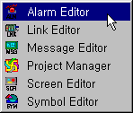

2) Edit the Alarm messege
This menu allows you to add/edit/delete cancel selected items in the Alarm Screen.
By double clicking the empty contents line and doing the same as above, additional alarm contents can be recorded.
Enter number and contents in the popped up dialogue box to record alarm contents
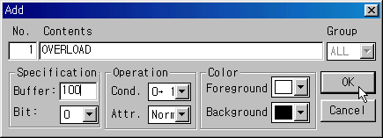
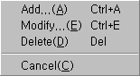

- Edit the alarm messeges as below Fig.

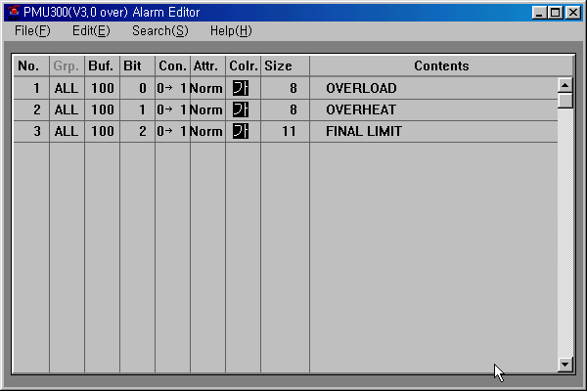

- Save and Give the File name ( any name available ex. 1.alm, test.alm..)

4-2 Make new screen and project

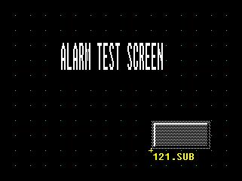

1) Make a Alarm Summary Window.
- Set touch tag function at the button as below shown Fig.s.

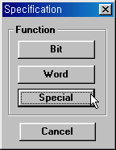
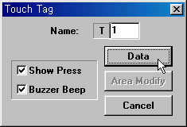

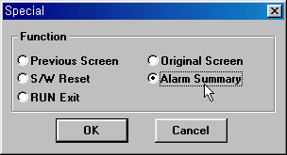
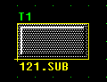

- Save and Give the file name as “1.scr”

2) Make link file
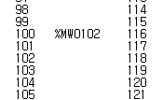

- Save and Give the file name as “200s_ld.lnk”

3) Make a Project File

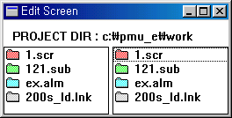

- Save and Give the file name as “test.prj”

- Download the Project file to PMU.

- Running with PLC
2 -----------7
3 -----------4
5------------5

PMU300

GM6
INBUILTED
CNET

- If PLC’s memory ‘M01000’ turns ON, Alam messege is shown below Fig.
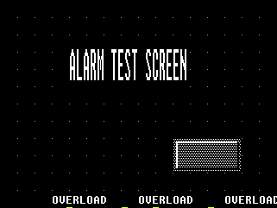

- If PLC’s memory ‘M01000’ turns ON, Second Alam messege”OVERHEAT” is appeared like a above the Fig.

Touch the button on the Screen, Alarm summary displayed

NOTE
Adjust the Scrolling Speed of alarm display in PMU300 hardware
Use the function keys or ten keys in the main unit.(* 100 msec)

Flickering Speed of Screen
Speed of alarm display
Back light OFF time
Current Date/Time
24 hours 12 hours
000 * Minute
Display Method
Initial Mode Setup / Date/Time Setup
Save
0000 – 00 – 00 00 – 00
000 * 100msec
000 * 100msec

4) Display position of alarm message in PMU300 hardware
This menu designates the display position of alarm message. Whenever user presses the keys, the display
position will be changed into upper or below position.

Initial Mode Setup / System Setup
Buzzer
Alarm Enlargement/Position
Latch Area Select
Password
Save
YesNone
UpperBelow
0000 ----- 0000
0001

