3. Display a message

PMU can display text message on screen according to the value or status of PLC devices. In this chapter, add a routine to the example program of chapter 2, that displays several different messages according to the current value of counter.

PLC C000 Current Values | Display Message
1 | Welcome to LGIS
2 | PMU Series
3 | Master-K
4 | GLOFA-GM

3-1 Create the message file

- Open the massage editor

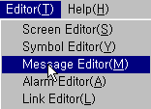

- Double-click at the position as the following figure, and input the number and contents of message.

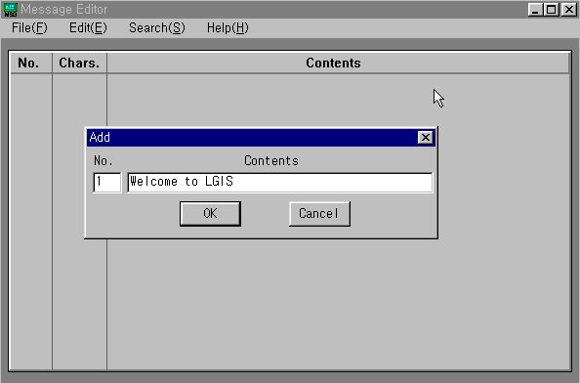

- With same methods, input all messages.

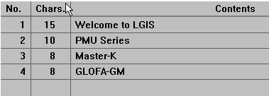
In this example, the longest message contains 15 characters.
PLC C000 Current Values | Display Message
1 | Welcome to LGIS
2 | PMU Series
3 | Master-K
4 | GLOFA-GM

- Save messages as a message file.

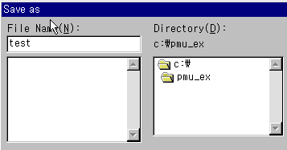
3-2 Edit the Screen (2.scr)

Open the Screen ‘2.scr’ and set the massage tag under the shown picture
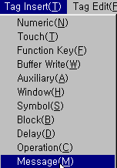
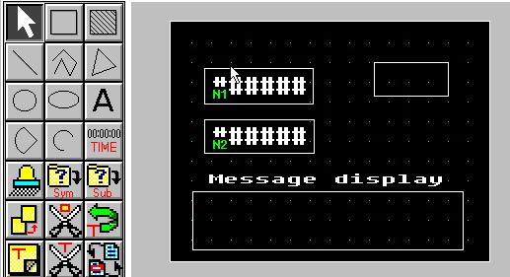

The buffer of PMU at which the current value of C0 will stored.
The numbers of character of the longest message.

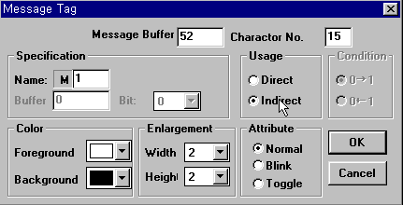

Select ‘Indirect’ when display multiple message at the same position.

★ Remark

If the ‘Usage’ item is set as ‘Direct’, set the specification and condition as followings;
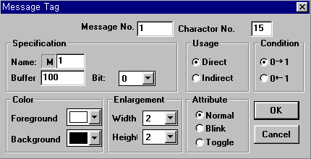

When the bit 0 of buffer 100 of PMU turns on (0 → 1), the message No.1 of TEST.MSG file (Welcome to LGIS) will displayed on screen. Then, the message No.1 will disappear when the bit 0 of buffer 100 is off (1 → 0).

3-3 Simulation

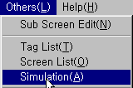
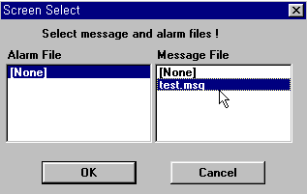
Select the message file.

※ A project can not contain two or more message, link, and alarm files.

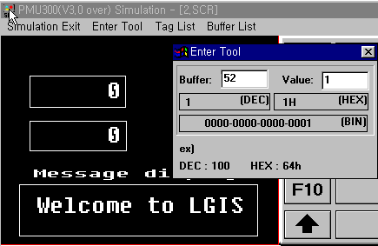
Input 52 at the ‘Buffer’ item of ‘Enter Tool’ window, and input 1 ~ 4 at the ‘Value’. Monitor the message display according the value of buffer 52.

3-4 Edit the Link file

Open the link file and link the buffer 52 with C0 of PLC as following figure.

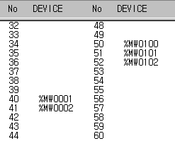

Save the link file.

3-5 Edit the Project file

Press ‘Work Dir.’ button.
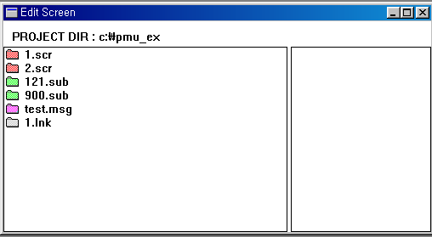
Select all edited files.

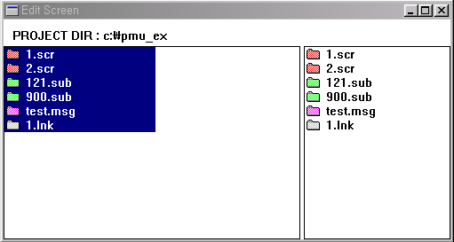

- Press the ‘Make PRJ’ button, and select the Test.prj file to overwrite.
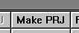
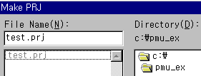

Pmu300.prj

- Transfer the Test.prj file to PMU, and monitor the displayed message with changing the counter value of C000 (1 ~ 4).

