2-7 Test of communication with PLC

- Edit the PLC program used in chapter 1 as following, and download to PLC.

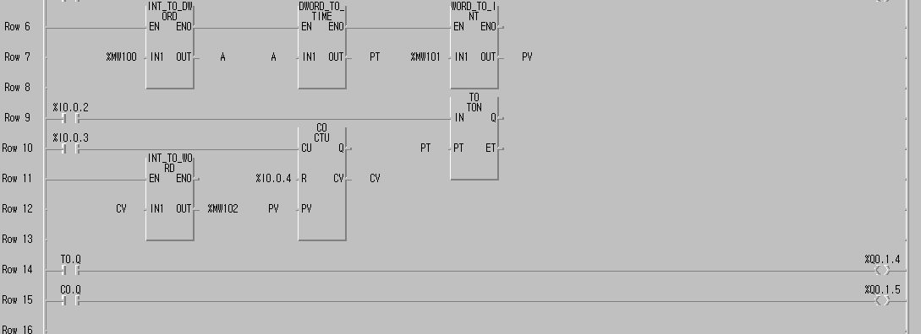

Add this part to the previous program

- Run the PMU to input numeric data, and monitor the preset value of timer and counter of PLC.

F1 Diagnosis
F2 Initial Setup
F3 Transfer
F4 Simulation
F5 Run
PMU 300 MAIN MENU

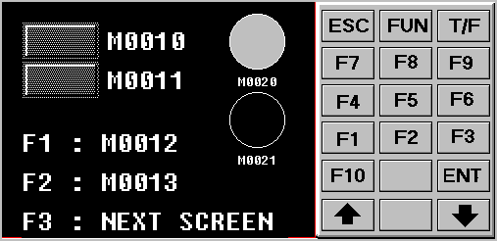

Move to
2.scr

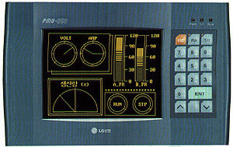
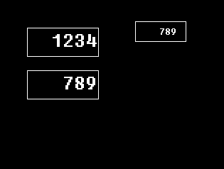

Change to
Numeric Key

