2-4 Change screen

Open the screen file ‘1.scr’ in the Screen Editor software, and register a Function Key Tag at any position of screen as following figures.

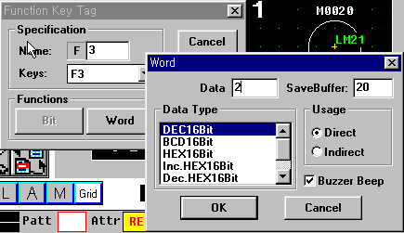
The buffer 20 contains the current screen number. To change the current screen, input the screen number to buffer 20.

2-5 Editing link file

Open the link file to be edited.
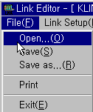

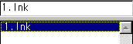

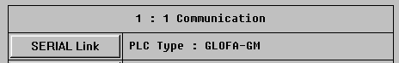

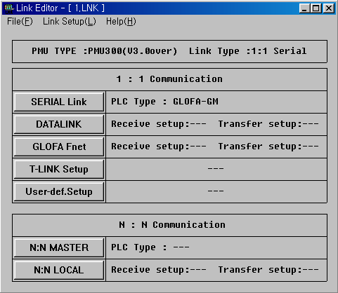

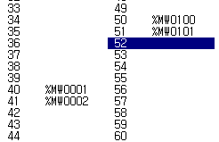

Setup the link between PMU and PLC as above figures, and save the link file.

2-6 Editing Project File

- Open the Project File to be edited.
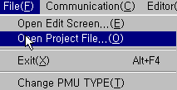
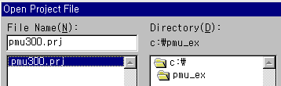

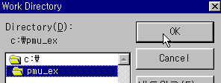
- Select the directory at which the ‘*.scr’, ‘*.sub’, and ‘*.lnk’ files.
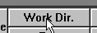

- Select all files to be contained in the project file, and press ‘Add to PRJ’ button.

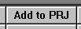
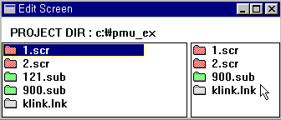
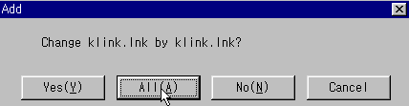

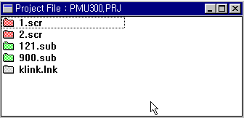

- After editing project files is finished, transfer the project file to PMU.

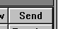

※ Refer the chapter 1 for the method of transmitting project file.

