2. Input data with Key Pad

2-1 Assign the properties of Key Pad
Turn on when use 10-key
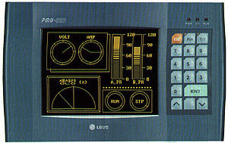

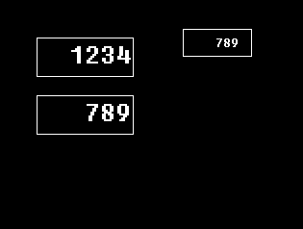
Toggle the ‘Function key’ and 10-key’ by pressing this ‘T/F’Key

- Run the Screen Editor, and press the ‘Main ←→ Sub Screen’ button as following figure.

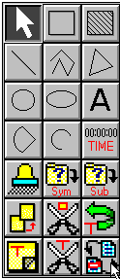
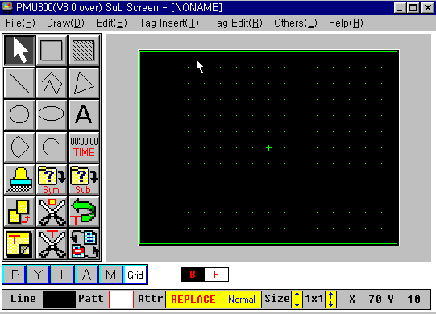

\

- Select the Key Display in sub screen, and click the mouse at the center of screen.

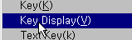

- Register the name of tag and data type as following figure.
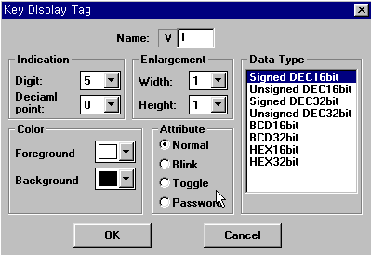

- Draw a box for tag with suitable size.

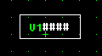

- Register a Key Tag in the box, and give the Key Attribute as ‘Enter’.

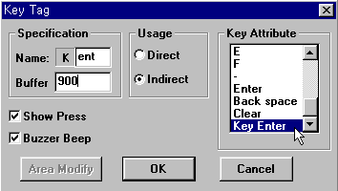
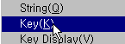

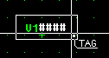

- Description of ‘Specification’ of above screen.

Buffer (900) : Any buffer after 40 can be used for this item, but the number of buffer after 900 is recommended. The value displayed at the key display tag will be stored at this buffer if the ‘Usage’ is assigned as ‘Indirect’.

Example) If the value of buffer 900 is 100, the value displayed in key display tag will be stored at buffer 100 when the ‘Enter’ key of key pad is pressed.

- Align the outer green box of sub screen to the key display tag as following figures.
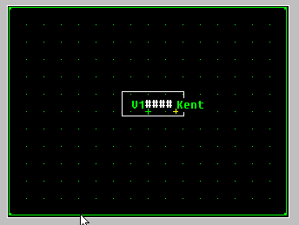
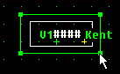

Align the green box by dragging the size adjustment point

Click the outer green box, and points for size adjustment will displayed.

- Save the sub screen as file ‘900.sub’

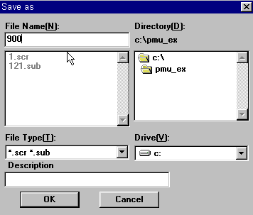

- Return to the main screen by pressing ‘Main ←→ Sub screen’ button.
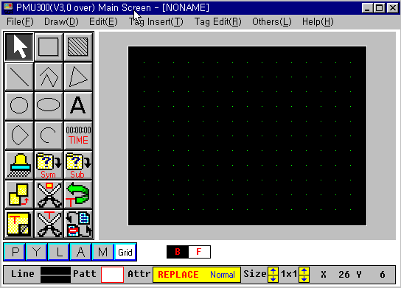
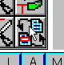

- Press the ‘Sub Screen Call’ button to register the sub screen to main screen.

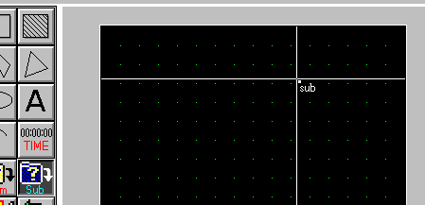

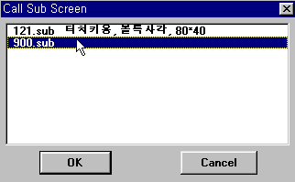
2-2 Editing Main Screen

- Register a Numeric Tag ‘N1’

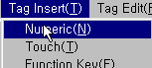
- Assign the properties of Tag ‘N1’ as following figures.
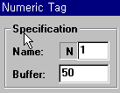
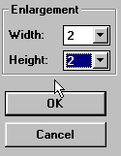

- Register the numeric tag ‘N2’ with same method.

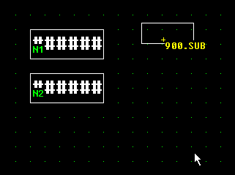

- Touch Tag registration
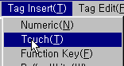
- Register a touch tag on the Numeric Tag as following figure.
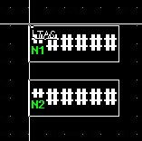

- Assign the properties of touch tag as following figure.

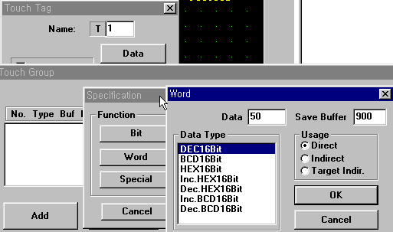
※ When the touch tag ‘T1’ is pressed, 50 will be stored at buffer 900. The ‘50’ means that an indirect buffer address, and the numeric value inputted by Key Pad will stored at buffer 50.

- Register the touch tag ‘T2’ with same method.

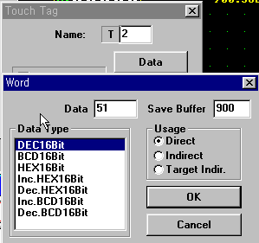
- Save the main screen as file ‘2.scr’.

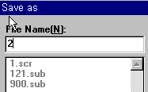

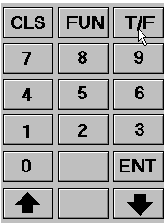
2-3 Test by simulation run

- Execute simulation, and press ‘T/F’ button to display numeric keys as the following figure.

Touch the touch tag ‘T1’.
The ‘50’ will be stored at buffer 900. It means the indirect address of destination buffer.
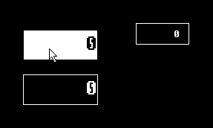

Input numeric data by Numeric Key, and press ‘Enter’.

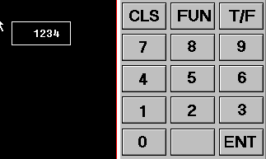

Input a numeric data to the second tag.

