1-5 Transfer project file to PMU

- Make a project file

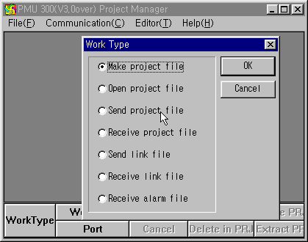
Run the Project manager software, and press the ‘Work Type’ button.

Select ‘make project file’ in the ‘Work Type’ window.

Choose a Work Directory at which the project file will be stored.

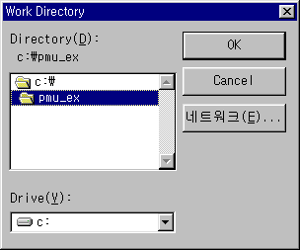

Choose all source files (.scr, .sub, .lnk, etc.) by double-click or ‘Select’ button.
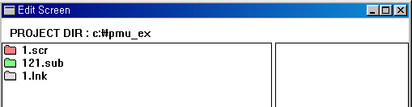

After all source files are selected, press the ‘Make PRJ’ button.

Type the name of project file, and press ‘OK’ button.

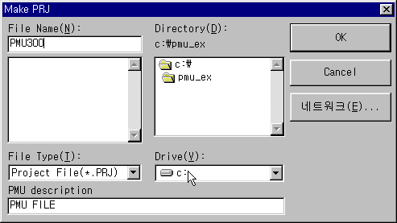

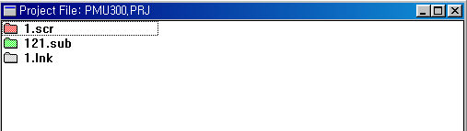

1-6 Setup the PMU300

- Power on the PMU300.
- Press ‘F2 Initial Setup’ after the following menu is displayed.

F1 Diagnosis
F2 Initial Setup
F3 Transfer
F4 Simulation
F5 Run
PMU 300 MAIN MENU

- Press ‘F1 RUN MODE SETUP’ after the following screen appeared.
F1 Run mode setup
F2 Serial Setup

F4 Date/Time Setup
Main Menu/Initial Mode Setup
F3 System Setup
F5 Memory Initialization
F6 Link Information

- Run mode setup

This mode set operation method, initial screen number, initial mode and used memory in operation.
Set Initial Operating Screen to ‘number1’ (1.scr)
Set the Power ON Mode to ‘Menu’
Press ‘Save’ button after setup is finished.
Initial Mode Setup/Run Setup
Initial Operating Screen
Power ON Mode
0001
Menu
Operation
Save

\

\
\
\

- Operating Method
- Select Operation setup in the initial mode setup or press F1 function key.
- To select the left menu (Initial Operating Screen, Power ON Mode, etc.)
- Press “↑ “ key or press touch key to be edited
Press “↓ ” key or press touch key to be edited
- ‘Initial screen number (1-999)’ means the first screen to show up in the operation mode.
A. Enter with Touch key: After touch the tag, enter the screen number for initial screen.
Then presses enter key.
Cancel : Cancel entering data
Delete : Deletes entered all numbers
← : Deletes last entered number
B. Enter with Function Key : Presses enter key after enter the screen number in the right side of the screen.
- Power ON mode
When the power of main unit gets on, a user can select direct operation or main menu.
To select the menu, use F0 to F9 keys

- Press ‘Serial Setup’ button after the screen is changed to ‘Initial Mode Setup’ screen. Press ‘Save’ button after setup is finished.
Baud rate (300-38400)
Data bit/Stop bit
Parity bit
Interface
Station number (0-31)
Initial Mode Setup / Serial Setup
Save

[19200]

7/1 7/2 8/1 8/2

None Even Odd

RS-232C RS-422

00

- Setup for transmission preparation

Press ‘Transfer’ button in the main menu, and ‘ENT’ button. At this time, ignore the password.

Designate password and press enter key to execute !
Password : [0000]
< PC ←→ Main Unit >
ENT(Execution)
Main Menu / Transfer

Baud rate: 19200 Baud rate
Data Length: 8 Bit
Stop Bit: 1 Bit
Parity Bit: None
Interface: RS-232C

- Transfer the ‘PMU300.PRJ’ file to PMU.

1) Setup the COM port
PC Serial Port(9p) PMU Serial Port(PMO-300S,9p)
2 2
3 3
5
(Cable connection for project file transmission)

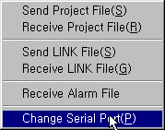

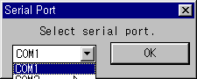

Assign the COM port to be used for transfer.

- Press the ‘Send’ button at the bottom of project manager, and press ‘Start’ button after the communication window is displayed.
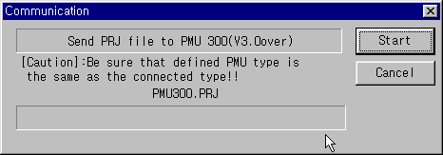
The screen when the transmission is completed normally

1-7 Operating PMU

After the transmission is completed, press any key to escape from ‘Transfer Mode’.
Press ‘F5 Run Key’ in the following main menu to enter ‘Run Mode’.

F1 Diagnosis
F2 Initial Setup
F3 Transfer
F4 Simulation
F5 Run
PMU 300 MAIN MENU

- PLC program
The following example is a simple program for check the communication status between PLC and PMU.
Input the following sequence program into the PLC, and then run the PLC.
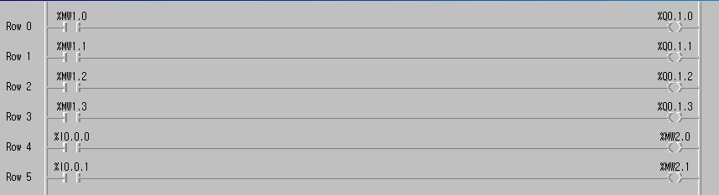

Monitor the M0010 ~ M0013 with pressing touch tag and function key of PMU. Also, monitoring the lamp tag with change the P0000 and P0001 of PLC.

