1-4 Link the PMU with PLC
- Open the link editor and select ‘Serial Link’

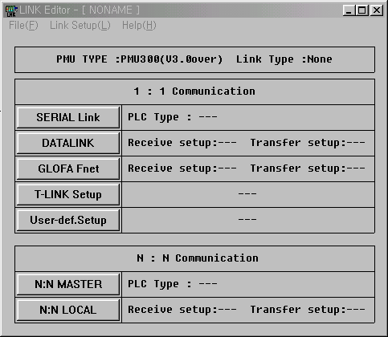

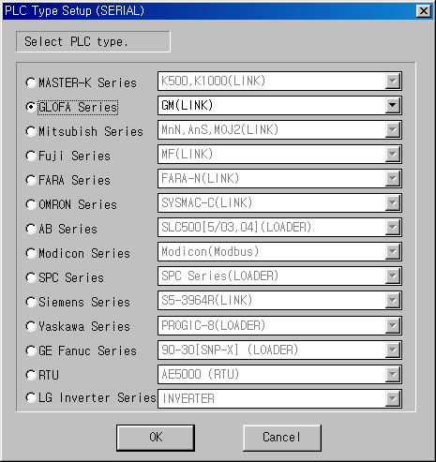

When communicate with Cnet module of GM6, GM4, GM3 (G6F-CUEB, G6F-CUEC, G4F-CUEA, G3F-CUEA) or built-in Cnet function of GM6 (GM6-CPUA, GM6-CPUB, GM6-CPUC), choose the PLC type as ‘GM(LINK)’.
In this example, assume that PMU communicate with built-in Cnet of GM6 (pin number 4, 5, 7). Therefore, select the ‘GM(LINK)’ in the PLC type selection window.

Note
※ When the PMU communicate with loader port of GM6 CPU(2, 3, 5 pins), select the PLC type as ‘GM(LOADER)’ in link editor.


- Link each buffers with PLC address as following;
Buffer 40 ~ 1023 can be linked with PLC devices. The buffer 0 ~ 39 is system area, and it is not available for user data.
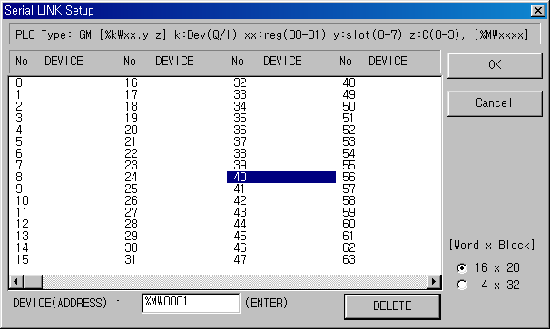

Select buffer 40 and input %MW001 to link the buffer 40 and M001 of PLC.

Link buffer 41 and %MW002 as the same way.

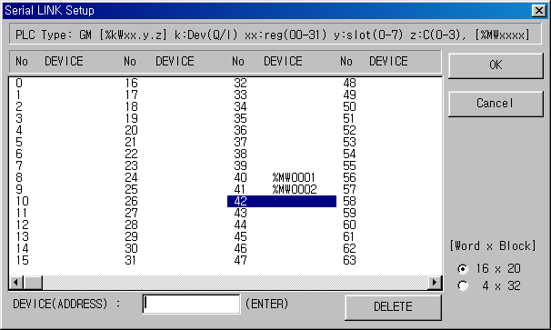

After serial LINK setup is completed. the buffer of PMU and PLC memory is matched as following;

Buffer(Word) No. | Bit Number
PMU : 40 | 15 | 14 | 13 | 12 | 11 | 10 | 9 | 8 | 7 | 6 | 5 | 4 | 3 | 2 | 1 | 0
 | ↕ | ↕ | ↕ | ↕ | ↕ | ↕ | ↕ | ↕ | ↕ | ↕ | ↕ | ↕ | ↕ | ↕ | ↕ | ↕
PLC : %MW001 | 15 | 14 | 13 | 12 | 11 | 10 | 9 | 8 | 7 | 6 | 5 | 4 | 3 | 2 | 1 | 0

%MW001.11 Or %MW1.11

When press F1 key of PMU (bit 2 of buffer 40), for example, the bit 2 of %MW001 word
(%MW001.2) of PMU will be turned on.

Now, save the setting as a file. (*.lnk) The following figure shows the ‘Save as’ message window.

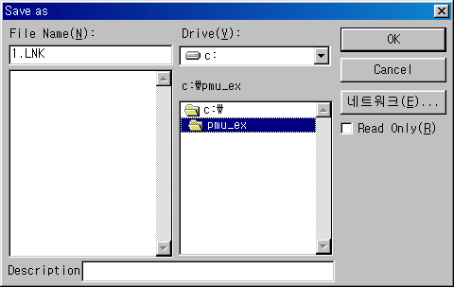

The screen of PMU after all setting is completed.
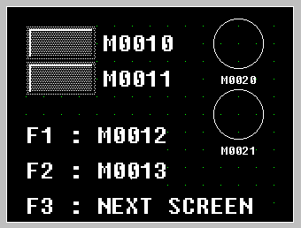
bit 0
of buffer 40
bit 1
of buffer 40

bit 2
of buffer 40

bit 3
of buffer 40

bit 0
of buffer 41

bit 1
of buffer 41

