1-3 SCREEN EDIT

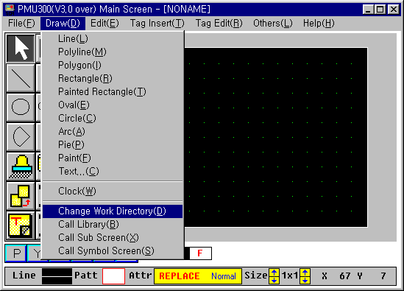
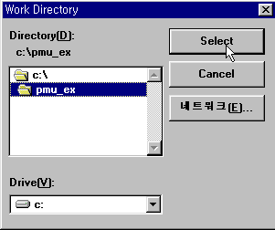
- Create a Touch Tag

- Assign the work directory at which the PMU programs (screen, etc) are stored.
Be sure to the work directory exists on the hard disk before it is selected as work directory.
In this example, use the C:\Pmu_ex as work directory.

- Select Call Library in Draw menu to insert a button.

- Select a button and click LOAD button.
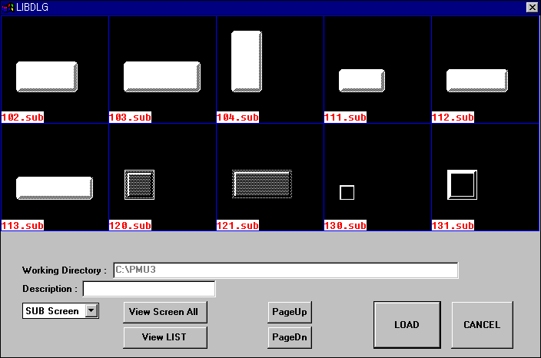

- Copy a button
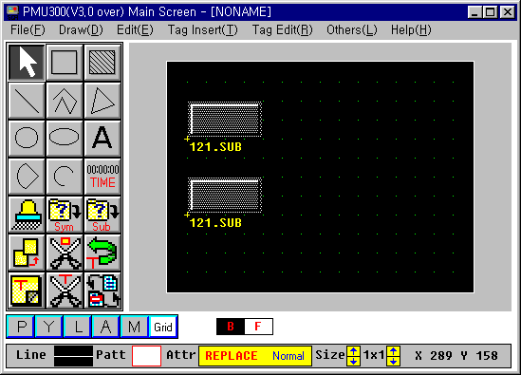
① Select the name of button to be copied (‘121.sub’), and ②select the ‘Copy’ button on the menu.
1
3
Click the name of original button, and click again at the position to be copied.
2

- Text input
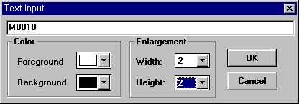
Select the ‘Text input’ icon, and input the text string after click the position at which the text is inputted. The size of character is set as following figure. (Enlargement)

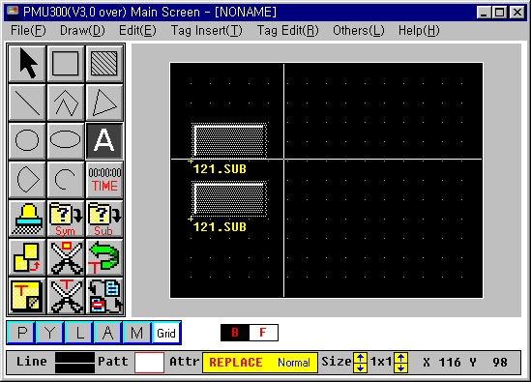

- The screen after drawing is finished

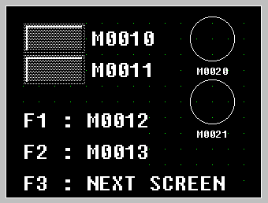
- Make a Touch Tag

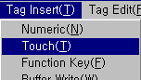Choose ‘Tag Insert – Touch’ in the menu

Point and click the cursor at the top-left of button.

The following message window will displayed. Put the data of touch tag as following.

Name : Type a name of touch tag within 4 characters. Make sure that all names are not duplicated.

Click the ‘Data’ button.
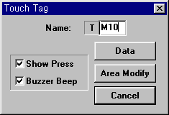
Click the ‘Add’ button after the following window is displayed. Then click the ‘bit’ at the specification window.
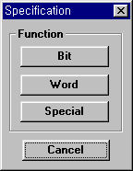
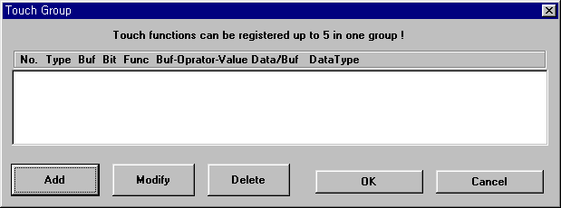

The bit 0 of buffer 40 will turn on when the Touch tag ‘M10’ is pressed.
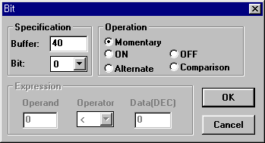
The PMU has buffer40 ~ 1023 for data exchange with external devices. Each buffer can be linked with the PLC address (word) by Link Editor software.

The touch tag area will displayed on the screen after press ‘OK’ button, and adjust the size of area by dragging the button-right of button.

Set another touch tag as the same procedure at above.

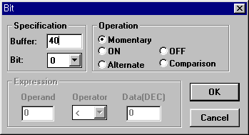
M11
1

The bit 1 of buffer 40 will be turned on when the touch tag ‘M11’ is pressed.

