1. On/Off of a bit ( TOUCH TAG, FUNCTION KEY TAG, LAMP TAG )

  - Introduction

By using the Touch / Function key of PMU, turns on / off the contacts of PLC and indicates the status on the screen of PMU.
2

Example)
3
4
1

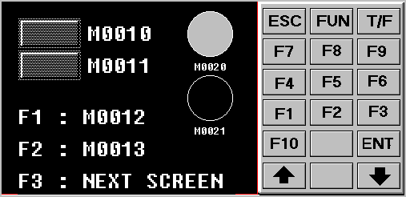

Turn on %MW1.0 bit of GM6 by touch the touch tag 1.
Turn on %MW1.1 bit of GM6 by touch the touch tag 2.
Turn on %MW1.2 bit of GM6 by pushing the F1 function key at the right side of PMU.
Turn on %MW1.3 bit of GM6 by pushing the F2 function key at the right side of PMU.

The lamp 3 will turn on when the %MW2.0 bit of PLC GM6 is turned on.
The lamp 4 will turn on when the %MW2.1 bit of PLC GM6 is turned on.

- System configuration
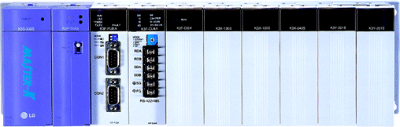

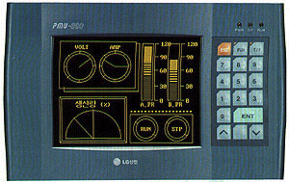

Built-in Cnet (4,5,7pin)

PMO-300S (RS232C option)
K200S CPU PMO-300S

4 2
7 3
5 5

1-2 Edit the screen of PMU

Run the Project manager software.

- Create a main screen

When you install PMU-MASTER software, 6 kinds of file managers will be created in Program group of Start menu.

- Select Project Manager in the PMU-MASTER Program group.
- Select PMU type and click OK button.
- If the ‘Work type’ windows appears, press the ‘Cancel’ button and choose ‘File – Change PMU TYPE’, and then select the PMU type.

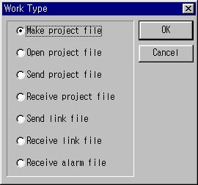

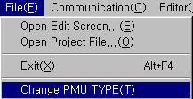

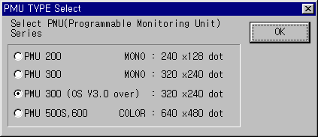

- Select Editor-Screen Editor in the full down menu to create a drawing file.

- Select Project Manager in the PMU-MASTER Program group.
- Select PMU type and click OK button.

