Chapter 6. Upload
It saves a compressed project file and source file to RAM(program area) or flash memory of PLC, and uploads a program from PLC.

Make Upload File

You can make an upload file by selecting Make Option menu.
An upload file includes project, program, function lock and user define function used in program.

- Select the Project-Option in menu. Then Option dialog box appears.
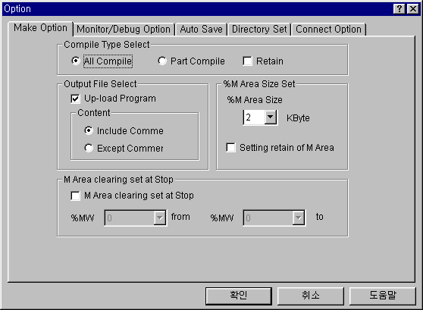
- Check the Up-load Program in Make Option dialog box, and click OK button.

- It creates the execution file for program and Upload file with selecting Compile-Make in menu
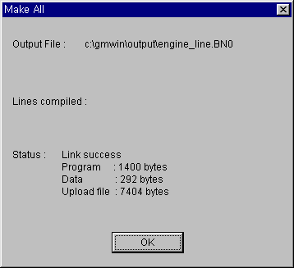

Write to PLC(Download)
Select the Upload program when writing a program to PLC.
- Select the Online-Write in menu.
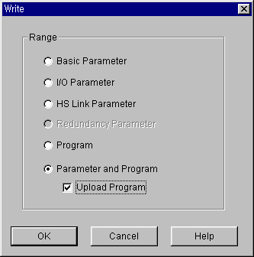
- Select the Parameter and Program, Upload Program in the Write dialog box.

According to the program size, it runs as below.

Program Size | The place to save upload program
Size of(Execution Program + Upload Program) < Size of Program RAM | It writes to RAM in CPU
Size of Program RAM < Size of (Execution Program + Upload Program) | If device has flash memory, it writes to flash memory after query to user

Read from PLC(Upload)
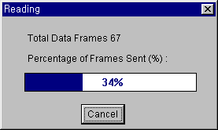
- Select the Project-Open From PLC in menu

- If a file had the same name in Source directory, the following dialog box appears.
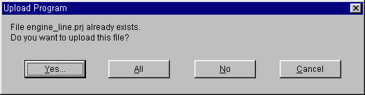

- Click “All” button to monitor and online-edit.
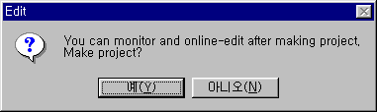
- Uploaded Project window create, then the following dialog box appears.

- Click “Yes” button to monitor and online-edit.
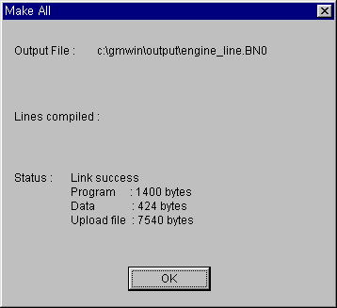
- You can monitor and online-edit after making project.

