Chapter 5. Monitoring

Monitor a Program
To monitor the operation of PLC in Run mode,
- Select Online-Connect in the pull-down menu.
- Select Monitor-Monitor On in menu.
If there is more than 2 defined instances in a program, Select Instant dialog box appears.
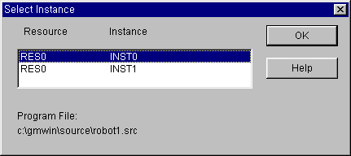
- Select an instance in the list box of Select Instance dialog box, and click OK button.

Note

To monitor in GMWIN, the program in the current window must be exactly same with a transferred program in PLC.
If you monitor the program edited after downloading to PLC, monitored data of the program may be operated differently with the real one in the window. So, if you edit the program after downloading to PLC, you must execute monitoring after creating an execution file again Compile-Make menu.
You can not edit the program in the project while execute monitoring. But you can edit the program not contain the project.

5.1.1Monitor LD
LD Monitoring basically has two functions. One is that showing the variable status, and the other is that setting or getting ON/OFF the variable value by force.

1 ) Monitor a Variable
(1) Monitor a Contact or Coil variable
You can see the ON/OFF status of variable by the change of color( ON : Red, OFF : Black)of the appropriate variable name, because the variable of contact or coil is BOOL type in Ladder Diagram. If the color of the variable name turns to be red, the variable means On status, and Off status for black one.

(2) Monitor I/O Variable for the Function or Function Block
I/O variable for the Function or Function Block is displayed as a number or string on the line
of the variable name.

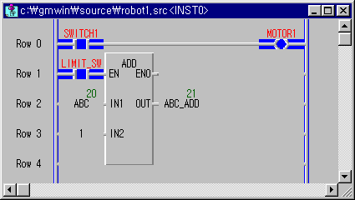

2 ) Forced Variable
This function allows you to turn the variable of contact or coil ON/OFF and set the variable for the function or function block as a desired value forcibly
- In LD Program, move the mouse to the variable that you want to set and double-click the left button of the mouse. Then Force Variable dialog box appears.
- In LD Program, move the cursor to the variable that you want to set.
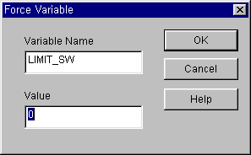
- Press Enter.

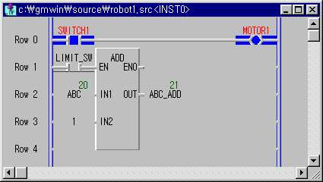
- Input ‘0’(Off) in the Value box of Force Variable dialog box and click OK button.

3 ) Forced Output I/O Variables
If Variable is I/O variable, the following dialog box appears.

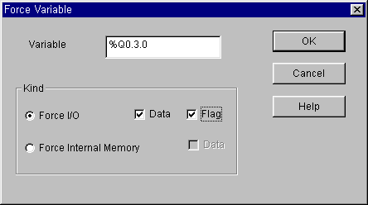
- If you want change the I/O value, select Force I/O and to set up ‘1’, select Data and Flag. In this case, Forced I/O is available under the setting of forced I/O enable. ( Refer to 7.12 ‘Forced I/O Setup and 7.13 ‘Enable I/O Forcing)
- If you want change the internal value, select Force Internal Memory and to set up ‘1’, select Data.

4 ) Monitor Array Variable
When a program monitoring starts, array variable basically monitors the first elements of array.
If array variable name is ARR, this variable displayed as ARR(0) and monitors the first element of array.
- Move the cursor on the array variable that you want to monitor.
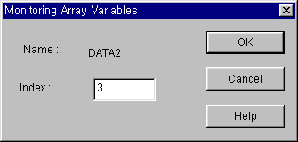
- Select the Toolbox-Select Array Subscript.
- In Monitoring Array Variables dialog box, enter the index of element that you want to monitor. Click OK button.
You can also monitor an array variable with hot key without using Monitoring Array Variables dialog box.
- Move the cursor to the array variable.
- Increase the element index with pressing Ctrl-↑ or decrease with pressing Ctrl-↓

Monitor a Variable
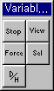
You can monitor a variable declared in a program, global variable, I, Q, M area, system flag and etc.
Monitor
Start / Stop
Forced Allocation
Data Display Form
Detail Display
Select Variable

To monitor the program the program initially,
- To call the Select Variable dialog box, select Online-Monitor-Monitor On in menu.
- Select Online-Monitor- Variable Monitor in menu.
To monitor the program,
To call the Select Variable dialog box, select Online-Monitor- Variable Monitor in menu.
Note

If GMWIN is not connected to PLC, select Connect in menu before selecting the above menu.

- In the Register Variable dialog box, select the variable that you want to monitor.
Refer to the following section for selecting variable.

Register Variable
To select the variable declared in program,global variable,I,Q,M area,system flag and etc. at the same time.
- Click ( ) in toolbox.
- Select a variable to monitor in accordance with the Register Variable dialog box.

- Select the Toolbox-Select (F5) in menu.
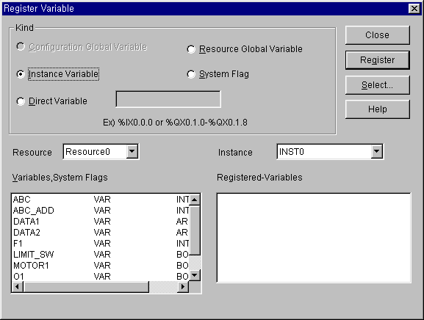
- Select a variable to monitor in accordance with the Register Variable dialog box.

1) Register Configuration Global Variable ( only available in GM1)
To register configuration global variable,
- Select the Configuration Global Variable in option button.
- Select the variables to monitor in the Variables, System Flags list box.
- Click Register button.

2) Register Resource Global Variable
To register resource variable,
- Select the Resource Global Variable in option button.
- Select the variables to monitor in the Variables, System Flags list box.
- Click Register button.

3) Register Instance Variable
To register the variable declared in the designated program,.
- Select the Instance Variable in option button.
- Select the instance in the Instance list.
- Select the variables to monitor in the Variables, System Flags list box.
- Click Register button.

4) Register Direct Variable
- Select the Direct Variable in option button.
- Enter the address of direct variable in the input text box.
- Click Register button.

5) Register System Flag
- Select the System Flag in option button.
- Select the flag to monitor in the Variables, System Flags list box.
- Click Register button.
Registered Variable will be displayed in Registered Variable list box.

6) All Select
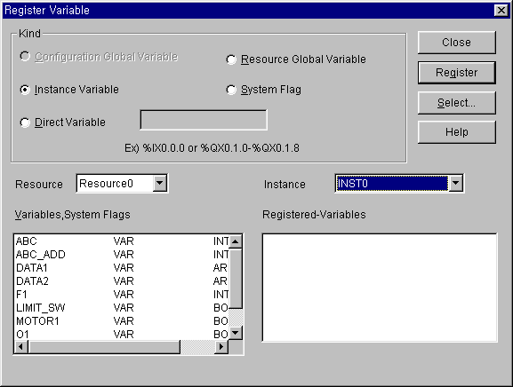
It allows you to monitor one program or the entire global variable.
- Click Select Button, and Select Variable dialog box appears.

(1) Select Configuration Global Variable
To monitor only configuration global variable,
- Select the Configuration Global Variable in option menu, and click OK button.
(2) Select Resource Global Variable
To monitor only resource global variable,
- Select the Resource Global Variable in option menu, and click OK button.
(3) Select Instance Variable
To monitor only program instant variable,
- Select the Instance Variable in option menu, and click OK button.

Start Monitoring
- Click ( ) in toolbox.
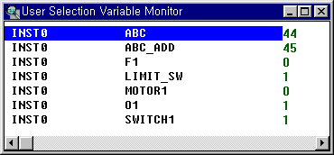
- Select Toolbox-Start (F2) in menu.

Set the View Type of Monitoring
It allows you to monitor the detail information of variable selectively.
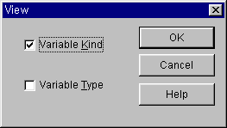
- Click ( ) in toolbox.

- In the View dialog box, select the information that you want to displayed and click OK button.

- Select Toolbox-View(F3) in pull-down menu.
- In the View dialog box, select the information that you want to displayed and click OK button.

Data Display Form
To display type of variable’s value as decimal, hexadecimal or by the variable type,

- Click ( ) in toolbox.

- Select Toolbox-Hex (F6) in menu.
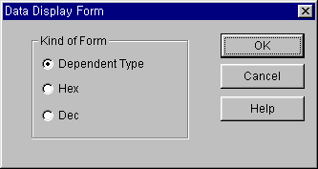
- Select display type with Kind of Form option radio box.
- Click OK button.

Forced Variable Output
To output the desired variable’s value forcibly.
- Click ( ) in toolbox. Or
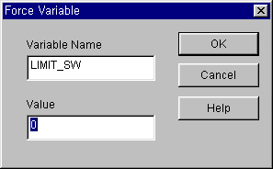
- Move the mouse on the variable to change a value, and double-click the left button of the mouse, which calls the Force Variable dialog box.

- Enter the variable’s value in the Value input text box.
- Click OK button.
- Call the Force Variable dialog box.
- Enter the variable’s value in the Value input text box.
- Click OK button.
If the type of a variable is a direct variable and Boolean type, forced I/O setting is available and you can prevent the value from being changed by program.

Note
Although you output a variable’s value forcibly, it can be changed by program.

Monitor Array Variable
Select array range to monitor the variable of array type.
(Use Select menu in monitoring of variable selected by User)
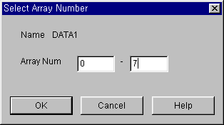
- To call the Select Array Number dialog box, move the cursor to Array Type Variable and select Toolbox-Array Number Select(F7)in menu.

- Select the array range in the Select Array Number dialog box.

I/O Monitoring
It monitors I/O modules mounted on the PLC system. First assign the base to monitor, and the I/O cards mounted on the base are displayed.
And click ( ) button in toolbox, then the PLC system starts monitoring.
Start/Stop Monitoring button in toolbox is toggled each other.
Selected base number is displayed at the left upper corner, and at the bottom of each slot the value of monitoring data is displayed as decimal scale or hexadecimal by the display type to monitor.
If you click the each contact in the I/O module with mouse, each contact are toggled into On or Off.

Toolbox for I/O Monitoring (This toolbox appears after selecting I/O monitor in Online-Monitor menu).

Select
Base
Start

To monitor the program initially,
- Select the Online-Monitor-Monitor on in menu, Online-Monitor-I/O Monitor in menu.

To monitor the program in monitoring mode,
- Select Online-Monitor-I/O Monitor in menu.

To start I/O Monitoring in monitoring mode.

- Call the Select Base dialog box by clicking ( ) button in toolbox.

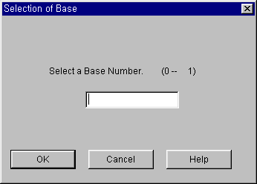
- Enter the base number to monitor in the Select Base dialog box and click OK button.
- Click ( ) in toolbox.
- Call the Select Base dialog box by selecting Toolbox-Select Base(F2) in menu.
- Enter the base number to monitor in the Select Base dialog box and click OK button.
- Select Toolbox-Start/Stop(F3) in menu.
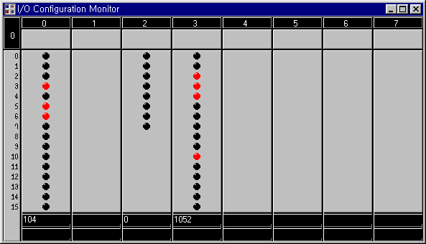
To stop the I/O monitoring,
- Click ( ) in toolbox.
- Select Toolbox-Start/Stop(F3) in menu.

