Chapter 4. Program Compile
To create an execution file.

Compile the Program that belongs to a project
Compile the program that defines as a program instance in a project.
At this time, the compiler verifies the erroe in a program and if error does not exist,
it creates an object an object file.
Object file name : Program file name. OP3 (for GM3)

Create an execution file
It links object files each other which are created by compiler.
At this time, a linker verifies the error on Global Variable, Function, Function block, and
creates one execution file.
Execution file name : Project file name. BN0
Note: In case of GM1, it is created as many as resource number.
(Project file name.BN1, Project file name.BN2, ...)

Make
It creates an execution file after compiling the only program, which needs compiling,
in the project.
- Select Compile-Make ( ) in the pull-down menu.
If an error occurs, the error message is displayed in Make dialog box and
execution file is not created.
- Click OK button in Make dialog box.

Compile
It compiles only the currently active program, and creates an object file.
- Select Compile - Compile ( ) in the pull-down menu.
If an error occurs, the error message is displayed in Compile dialog box and
object file is not created.
- Click OK button in Compile dialog box.

Note

Only compiling a program cannot make an execution file.

Build All
It creates PLC execution file after compiling all programs in the project.
- Select Compile - Build All in the pull-down menu.
If an error occurs, the error message is displayed in Build All dialog box and
execution file is not created.
- Click OK button in Build All dialog box.

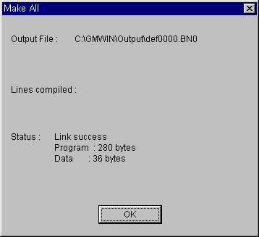

Message
It shows an error or warning message in the process of Compiling, Make and Build All.
If you double-click the message, it helps you to move directly to the occurred place of error/warning
- When an error or warning occurs in the process of Compile, Make and Build All, message window appears automatically and it shows the type and occurred place of error/ warning by list
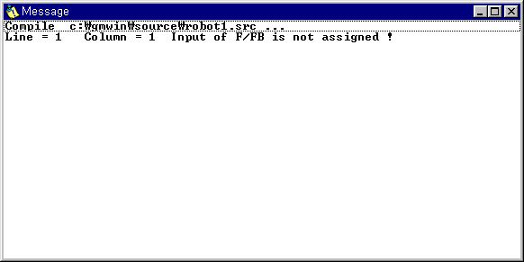
- If you double-click the each list item, the cursor moves to the occurred place of error/warning.
- If you select Compile-Message… in menu, you can repeatedly see the previous message after closing the message window.

Memory Reference
It allows you to see the global variable and direct variable at the program in project.
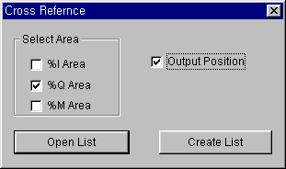
- Select Compile-Memory Reference in the pull-down menu.

- When you open the existed list, select Open List.
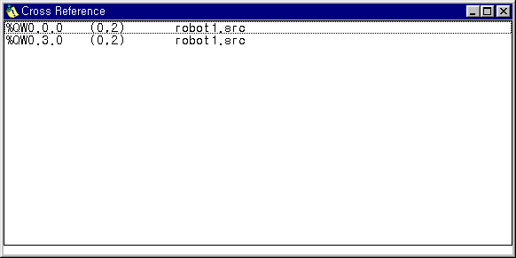
- When you create a new list, select Create List after selecting Select Area and Output Position.

