Chapter3. Edit LD

3.1 Editing Tools in LD Program
LD program creates a PLC program with a graphic symbol like coil or connects, which is used in relay logic diagram. In the below picture, ‘Rung Comment’ is the comment for the appropriate rung.
Rung is a unit of continuous line, which is connected vertically. I.e., in the below picture, a rung is from Row 1 to Row 4 and Row 5 is also a rung.

Rung Comment Function Block Function
End of Main
Program
Contact
Call Subroutine
Coil
Jump
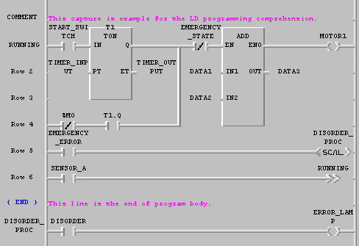
Row No.
Label
Subroutine Left Power Connecting Line Right Power

{ END } in Row 7 express the end of the main program. Error management, which is continued in the next column, is one type of sub-program and calls this subroutine in Row 1.

It is shows Tools and those names in the Toolbox.

Call subroutine
Jump
Return
Function block
Function
Coil
Vertical line
Horizontal line
Contact
Block
Toolbox for ladder program

The shape and meaning of each element is as below.
Symbol | Shortcut Key | Comments
 | F2 | Normally open contact
 | F3 | Normally closed contact
 | Shift-F1 | Positive transition-sensing contact
 | Shift-F2 | Negative transition-sensing contact
 | F6 | Coil
 | F7 | Reverse coil
 | Shift-F3 | Latched coil
 | Shift-F4 | Unlatched coil
 | Shift-F5 | Positive transition-sensing coil
 | Shift-F6 | Negative transition-sensing coil
 | F4 | Horizontal line
 | F5 | Vertical line
 | F8 | Function
 | F9 | Function Block
 | Shift-F7 | End command of LD program and Subroutine
 | Shift-F8 | Jump command for the branch of LD program(Label position)
 | Shift-F9 | Call a subroutine
If you select an arbitrary element in toolbox, the shape of the mouse is changed to that of the element.

Create a contact
Select a desired contact( , , , , , ) in toolbox.
- In LD program window, move the mouse to a desired position and click the left button.
- When you draw a line( ), after moving the mouse from your desired position, drag a mouse by clicking the left button and you can draw a long line.
- When you draw a continuous line as the above way, if there is another contact under the mouse position, that contact is conserved.

- Move the cursor to the position that you want to input a contact in..
- Select a desired contact and line (F2, F3, Shft-F1, Shft-F2, F4, F5) of commands in Toolbox.

In case of contact, you can insert it between column 1 of program and column 30. In case of vertical line, you can insert it between column 2 and column 29.

Create a Coil
- Select a desired coil( , , , , , )in Toolbox.
- In LD program window, move the mouse to a desired position and click the left button.
- Move a cursor to the position that you want to insert a coil in.
- Select a desired coil(F6, F7, Shft-F3, Shft-F4, Shft-F5, Shft-F6) of commands in Toolbox.

Coil is inserted in the last (31st) column of LD program automatically.

Create a Function

- Select in Toolbox.
- In LD program window, move the mouse to a desired position and click the left button.

- Move the cursor to the position that you want to a function in.
- Select a function (F8) of commands in Toolbox of the menu

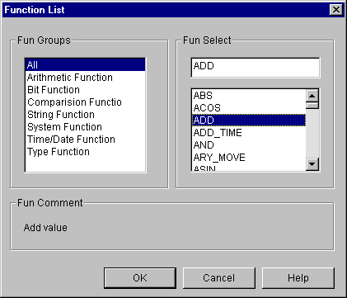
- Select a function group in Function List dialog box. Then only appropriate functions appear in the list.
- Select a desired function in Function List dialog box and click OK button.
- 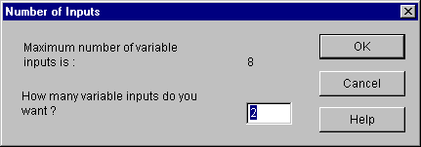If the selected function is an Extensible Function, then the following dialog box appears automatically.

- Enter the desired input number
You can enter a function between column 2 and column 30 in LD program.

Create a Function Block

- Select in Toolbox
- In LD program window, move the cursor to a desired position and click the left button.

- Move the cursor to the position that you want to insert a function in.
Select a function block (F9) of commands in Toolbox.
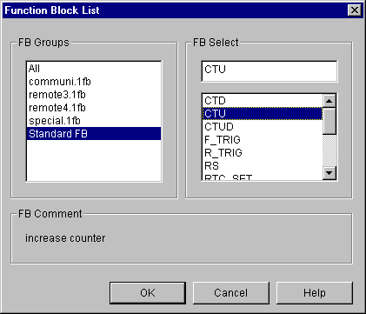
- Select a function block group in Function Block List dialog box. Then only appropriate function blocks appear in the list.
- Select a desired function block in Function Block List dialog box and click OK button.
- Insert a desired instance name of function block in Add Instance Name dialog box.

You can insert a function block between column 2 and column 30 in LD program.

Return

- Select in Toolbox.
- In LD program window, move the mouse to a desired position and click the left button.

- Move the cursor to the position that you want to insert Reurn in..
- Select Return (Shft-F7) of commands in Toolbox.

Return is inserted in the last (31st) column of LD program.

Jump and Label
In LD program, Jump command allows you to go directly to the position that you want to branch out. Destination is expressed as a label. Position of label must be inserted on the column ‘0’. In LD program having subroutine, the label included in the main program must be inserted into jump on the main program and the jump in the subroutine area can branch out to the label in subroutine only.
1) Jump

- Select in Toolbox.
- In LD program window, click the left button after moving a mouse to the position that you want.

- In LD program window, move the cursor to the position that you want to insert a jump in.
- Select a jump (Shft-F8) of commands in Toolbox.

Jump is inserted in the last (31st) column of LD program.

2) Label

- Select in Toolbox.
- In LD program window, move the mouse to column ‘0’ and double-click the left button.
- Select label in the Label/Rung Comment/The End of Program Body dialog box.
- Input a label name in Add Label dialog box. (Maximum 16 characters)

- In LD program window, move the cursor to column ‘0’.
- Press Enter key.
- Select Label in the Label/Rung Comment/The End of Program Body dialog box.
- Input a label name in Add Label dialog box.

When you designate a label in the jump command, input a label name on the position of jump command.
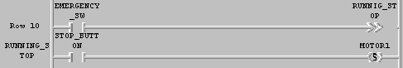Example )

Rung Comment

- Select in Toolbox.
- In LD program window, move the mouse to column ‘0’ of the first line in a desired rung and double-click the left button. But, if you want to edit and already existing rung comment move the mouse to that comment and double-click the left button on it.
- 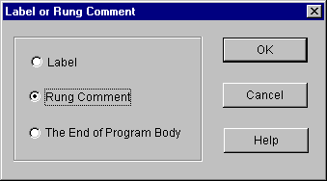Select Rung Comment in dialog box.
Enter the contents of rung comment in Rung Comment dialog box. (Maximum 170 characters)

- In LD program window, move the cursor to column ‘0’ of the first line in desired rung. But, if you want to edit a created rung comment, move a cursor to that comment.
- Press Enter key.
- Select Rung Comment in Label/Rung Comment dialog box.
- Input a rung comment into the Rung Comment dialog box.
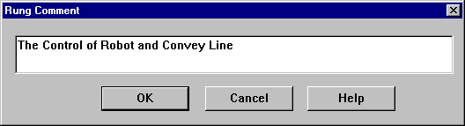

Rung comment is displayed in all through on line as below.
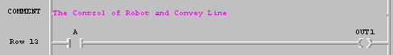

Subroutine Call

- Select in Toolbox.
- In LD program window, move the mouse to a desired position and click the left button.

- In LD program window, move the cursor to the position that you want to insert a subroutine name in.
- Select Toolbox-Subroutine Call <SCAL> (Shft-F9) in the menu.
Insert a subroutine name on the Subroutine Call.

End of Main Program

- Select in Toolbox.
- In LD program window, move the cursor to column ‘0’ of the row to designate as the end of main program.
- Select The end of Program Body in Label or Rung Comment dialog box.

- Move the cursor to column ‘0’ of the row to designate as the end of main program.
- Press Enter key.
- Select The End of Program Body in Label or Rung Comment dialog box.
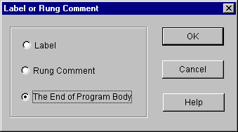

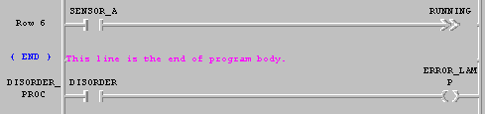 In the end of main program, like below picture, {END} is displayed in column ‘0’ of the appropriate row and “This line is the end of main program” is displayed from column ‘1’.

Program logic under the end sign of the main program is regarded as subroutine area.

Variable Input

- Select in toolbox.
- In LD program window, move the mouse on a desired contact, coil or I/O position of
Function block and double-click the left button.

- In LD program window, move the cursor a desired contact, coil or I/O position of
Function block and double-click the left button
- 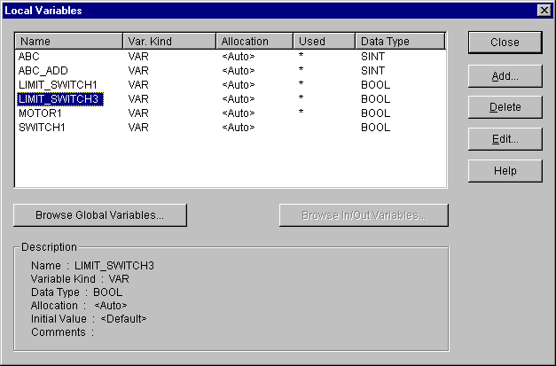Call a variable dialogue box by pressing Enter key.

- You can add, delete or edit a variable in Variables dialogue box.
- In Variables dialogue box, enter the variable name to be used and click OK button. If you enter an already declared variable name, then variable input is over here.
- If you enter a new variable name, Add/Edit Variables dialogue box, which determines the variable properties, appears.
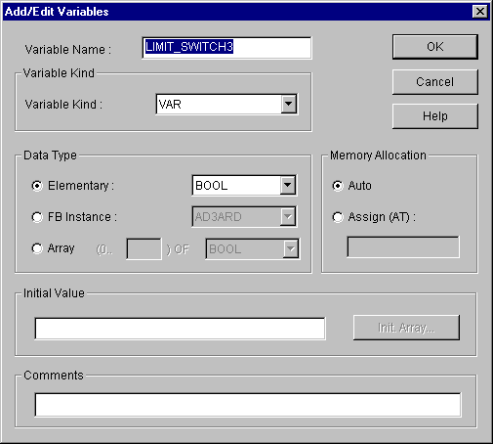
- Refer to the ‘5.5 Edit a Variable’ for detail information about Add/Edit Variables dialog box.
- Press OK button.

Edit a Block
Before editing a block, you must setup the range to be applied as a block.
Namely, if you want to copy or delete a continuous program, you must designate a range
desired s a block before selecting a block editing command.

- Select in toolbox.
- In LD program window, after moving a mouse to the start point of a block by pressing the left button, drag the selected range to the last row of the range to select.

- In LD program window, move the cursor to the start point of a block.
- With pressing Shift key, move the cursor with arrow key to the last row of range to select.
Note

When you setup a block, if the end of block range is in a function or function block,.
the function or function block is automatically included in the block.

Cut
After selecting a block,
- Select Edit-Copy(Ctrl+X, ) .

Copy
After selecting a block,
- Select Edit-Copy(Ctrl+C, ).

Paste
After copying or cutting a block,
- In LD program window, move the cursor to the position that you want to paste on.
- Select Edit-Paste(Ctrl+V, ).

Delete
After selecting a block,
    - Select Edit-delete(Delete, ).

Find
This command allows you to find a variable name, position of contact and etc, which are used in the program
Call Find dialog box by selecting Edit-Find ( ).
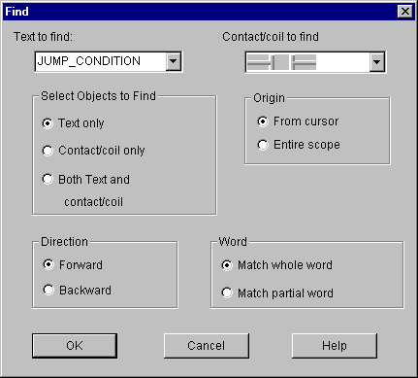

    - In Text to find edit box of Find dialog box, enter the string that you want
to find.
    - Select the following options to find and click OK button.

(1) Contact/Coil to find
Select the contact or coil that you want to find.

(2) Select Objects to find
Text only : Find only the content o character.
Contact/Coil only : Find only LD program elements like contact, coil or etc.
Both text and contact/Coil : Find a content of character and LD program elements
like contact, coil or etc. simultaneously.

(3) Origin
Select the range where find command is executed.
From cursor : Find from current cursor position.
Entire scope : Find through the whole program.

(4) Direction
Select the direction that find command is executed.
Down : Find command is executed downward.
Up : Find command is executed upward

(5) Sensitivity
Select an accordance degree in finding a content of character.
Match whole word only : Find only an exactly corresponding word.
Regular expression : Find also a partially corresponding word.

Replace
Call replace dialog box by selecting Edit-Replace( ).
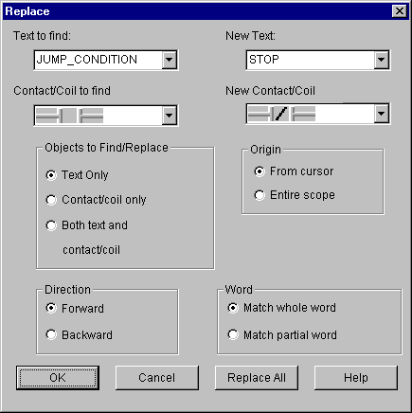
- Enter the character that you want to change in Text to find edit box.
- Select the element of LD program to change in Contact/coil list box.

- Enter the character that you want to replace in New text edit box.
- Select the element of LD program to replace in New Contact/Coil list box.
- 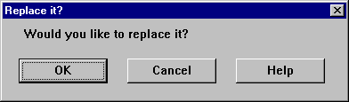Select the options in the same way of find command and click OK button.

    - Click OK button.

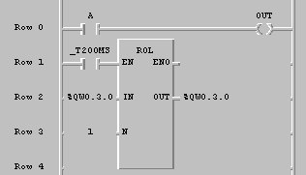
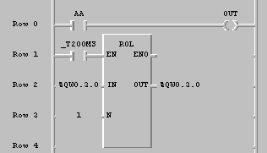
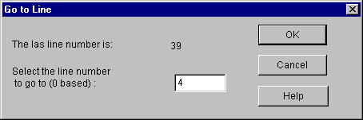 Before After

Find/ Replace Again
If you executed Find/Replace command before, execute that command again with the condition that designated before.
- Select Edit-Again(Ctrl+F3).

Go to
- Select Edit-Go to.
- In Go to line dialog box, enter the row number that you want to find.

- Click OK button.

zoom In/ Out
This command allows you to adjust the size of LD Program element.
- 메Call a dialog box by selecting Edit-Condense.
- Select a desired screen size in Condense Level dialog box.
(100%, 80%, 70%, 50%, 25%, 12%).

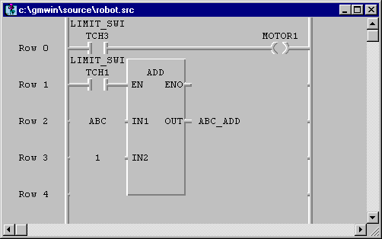Example) In case that compression rate is 100%

In case that compression rate is 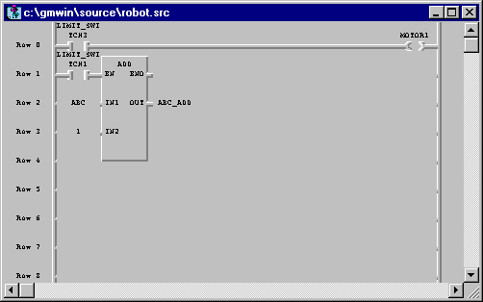75%
Note

In case that compression rate is 25%, 12%, LD program is not displayed as 3D type.

Variable Comment
LD program supports the function that indicates the comment of each variable.
- Select Edit-Variable comment (Ctrl+M) in the pull-down menu.
- If there is a check mark at the left side of Edit-Variable comment (Ctrl+M),
a current window is in the state that shows a variable comment and if there is
not, the window is in the state that does not show the comment.

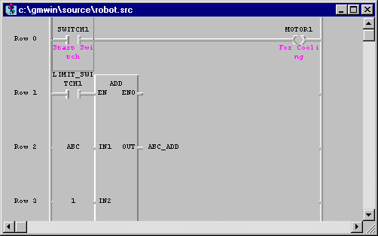Example) In case that express a variable comment

Delete Row
- Select ( ) in toolbox.
- In LD program window, move the mouse to the row that you want to delete and move the cursor with clicking a left button.
- Select Edit-Delete Line.
- In LD program window, move the cursor to the row that you wish to delete.
- Select Edit-Delete Line (Ctrl+D).

Delete Cell
Delete the cell that cursor is on.
If the current position of the cursor is empty space, this function deletes the empty cell by one column.
- Select ( ) in toolbox.
- In LD program window, move the mouse to the cell you want to delete and move the cursor with clicking a left button.
- Select Edit-Delete Cell.
- In LD program window, move a cursor to the cell to be deleted.
- Select Edit-Delete Cell (Delete).

5.6.20. Insert Line

- Select ( ) in toolbox.
- In LD program window, move the mouse to the position that you want to insert the row and move the dursor with clicking a left button.
- Select Edit-Insert Line(Ctrl+N).

- In LD program window, move the mouse to the position that you want to enter the row.
- Select Edit-Insert Line(Ctrl+N).

Insert Cell
Insert an empty cell in the position where a cursor is on.

- Select ( ) in toolbox.
- In LD program window, move the mouse to the position where you want to insert a cell and clicking a left button.
- Select Edit-Insert Cell(Ctrl+I).

- In LD program window, move the cursor to the position where you want to insert the cell.
- Select Edit-Insert Cell(Ctrl+I).

Move/Copy Cell

(for copy, mouse and keyboard are used simultaneously)
- Select ( ) in toolbox.
- In LD program window, move the mouse to the cell to move/copy.
- Drag to a desired position with clicking a left button of mouse.
- In case of moving, release the ldft button of the mouse.
In case of copy, release a left button of mouse with pressing CTRL key.

Pop-Up Menu

- Click a right button of the mouse on an arbitrary position or desired position.
- Select a desired command in menu that is appeared in right side.
Pop-Up Menu are various according to the position of the mouse. You can select frequently used functions in Pop-Up Menu.
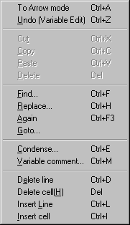
If you use a Pop-up menu, then you don’t need to use each command through the pull-down menu.
In the upper menu, To Arrow Mode is the command that changes the input state of a current
mouse into arrow mode to select or enter the data or elements of the program.

Undo
This command allows you to cancel previously edited action.

- Select Undo(Ctrl+Z , ).

- Select Undo(Ctrl+Z).

