Chapter 2. Getting Start

GMWIN is a programming tool that compiles a program, makes an execution file, transfers a file to PLC, monitors and debugs PLC data.
GMWIN uses the multiple document interface (MDI) method, so that it is possible to compile and debug several programs at the same time.

Create a Program


◆ Click button.
◆ Click Programs - GMWIN.

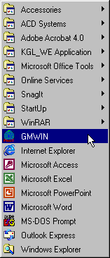
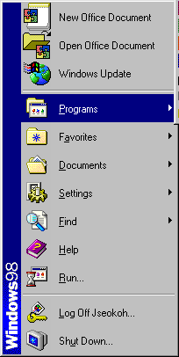

Then the initial window is shown as below.
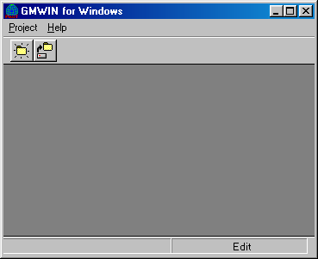
Step 1 : Create a Project
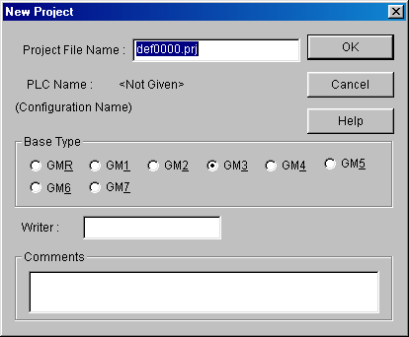
◆ Click New Project ( ) icon or select the dialog box by clicking Project - New….

◆ Enter the information to the text boxes on New Project dialog box.
Project File Name | Engine Line
Base Type | GM3
Writer | LG Industrial Systems
Comments | Welding Process in engine line

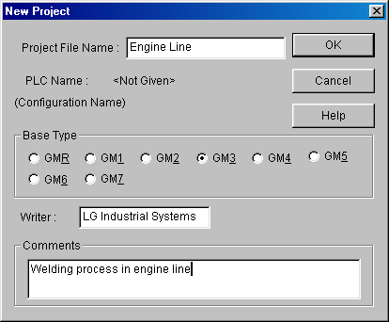

◆ Click OK button.

Step 2 : Define a Program
◆ Enter the information on the Define Program dialog box.
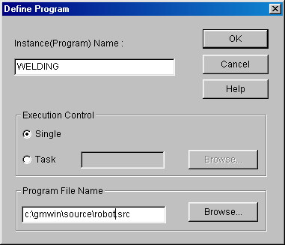

◆ Enter an instance(program) name in Instance Name text box.
◆ Enter ‘robot.src' for Program File Name and click OK button.
◆ Open New Program dialog box.

◆ Select kind of language to use for the new program.
◆ Type Comments for the description of the program in Comments box.
◆ Press Enter or OK button.
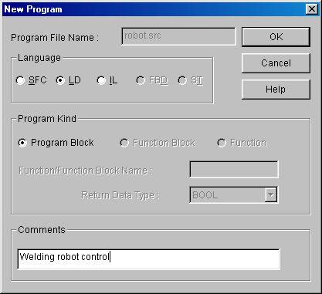
Step 3 : Editing a Program

1) Input a contact and output coil
◆ Click the left button of the mouse on the position of Row ‘0’ and Column ‘1’ in the LD window after selecting( ) icon in the toolbox.
◆ Click the mouse on the right side of contact of after selecting in the toolbox as below.
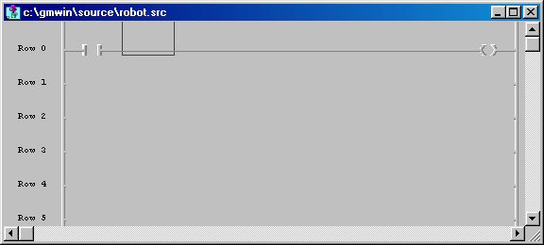

◆ Select in the toolbox and click the left button on the location of Row ‘1’ and Column ‘1’.
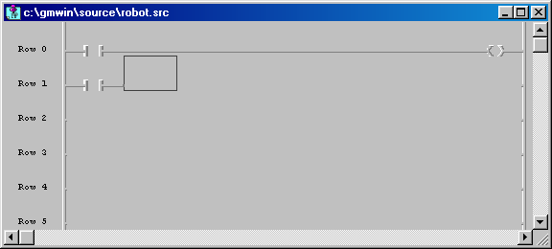

2) Insert a Function
◆ Select in the toolbox using a mouse.
◆ Click the left button of mouse on the position of Row ‘1’ and Column ‘2’.

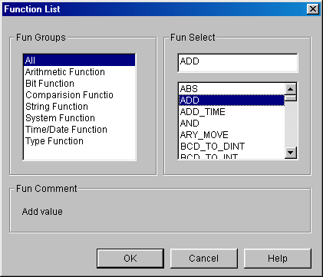

◆ Select Arithmetic Function `ADD' in Fun Select box and click OK button.
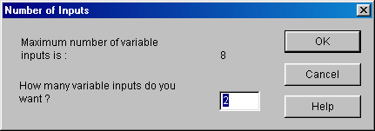

◆ Enter ‘2’ for the number of inputs.
◆ Click OK button.

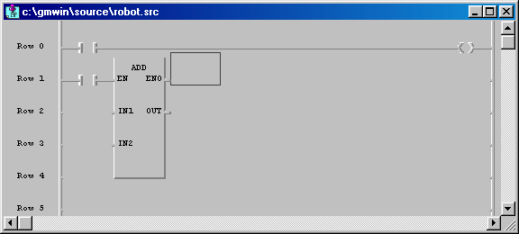

3) Variable Input
◆ Select in the toolbox and double-click the left button of mouse on the location of Row '0' and Column '1'.
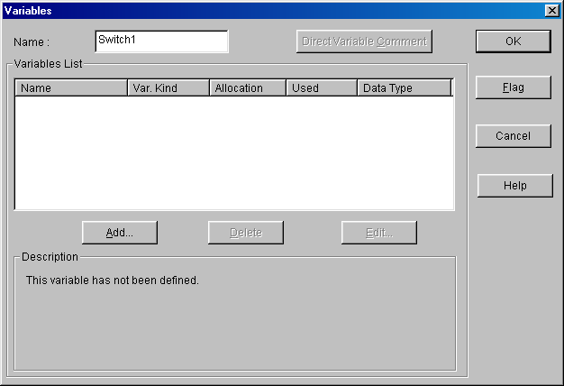

◆ Enter ’SWITCH 1’ in the Name edit control.
◆ Click OK button.
◆ Click OK button.

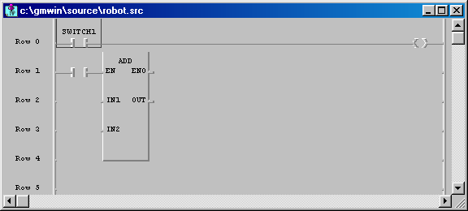

◆ How to assign a variable to output coil and the input contact for ADD Function are same as the above one.
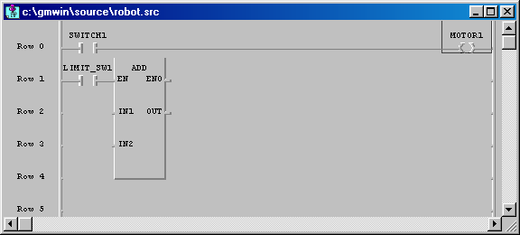

◆ Double-click the left button of mouse on the left of ‘IN1’ position (row ‘2’, column ‘1’) in the function ‘ADD’.
◆ Enter the variable name ‘ABC’ on the Name edit control in Variables dialog box.

◆ Click OK button. Then Add/Edit Variables dialog box appears.

◆ Click OK button. Then variable name 'ABC` is assigned as ‘IN1’ of the function ‘ADD’.
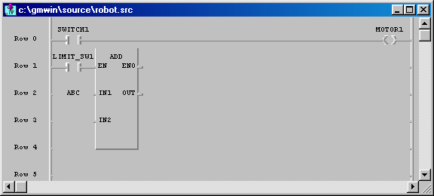

◆ Double-click the left button of the mouse on ‘IN2’ position (Row ‘3’, Column ‘1’).
◆ Then Variables dialog box appears.
◆ Enter Constant ‘1’ in the edit control of Name.

◆ Click OK button. Then Constant ‘1’ is assigned as ‘IN2’ of the function ‘ADD’.
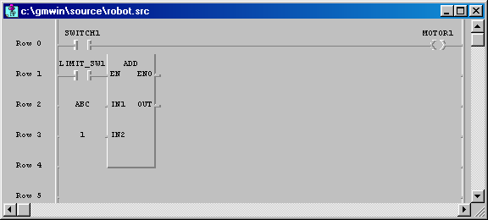

◆ Double-click the left button of the mouse on ‘OUT’ position (Row ‘2’, Column ‘3’) in the function ‘ADD’.
◆ Enter the variable name ‘ABC_ADD’ in the edit control of Name in the Variables dialog box.

◆ Click OK button.
◆ Click OK button. Then the variable name ‘ABC_ADD’ is assigned as ‘OUT’ in the function ‘ADD’.

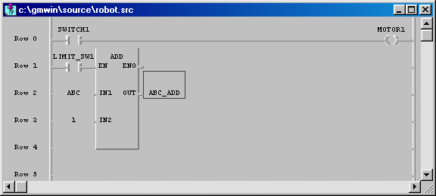

Step 4 : Compile a Program

◆ Select Compile - Make in the pull-down menu.
◆ Build the project file for the execution by running compiler.

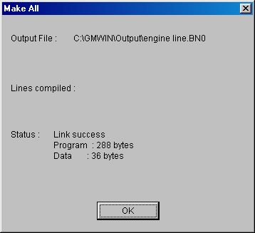

Step 5 : Download a Program

◆ Be sure to connect the cable between PC and PLC before downloading the program.
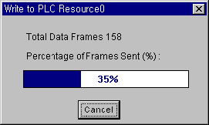
◆ Select Online - Connect + Write + Run + Monitor On.

◆ Then the execution file is downloaded to PLC.
◆ After downloading the program, PLC must be ‘Run’ mode to enable monitoring.
◆ In order to turn ‘SWITCH1’ On forcibly, double-click the left button of the mouse on the position of the contact. Then Force Variable dialog box appears.

◆ Enter the value of the contact as ‘1’ in the edit control of Value and click OK button.
◆ To turn ‘LIMIT_SW1’ On forcibly, execute the same order as the above.
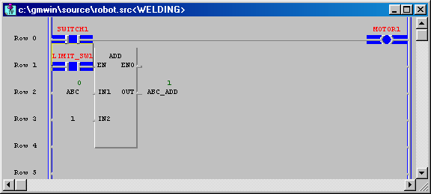

◆ The output coil ‘MOTOR1’ gets On/Off according to the condition of the input ‘SWITCH1’.
◆ Variable 'ABC_ADD' is increased by 1 according to the result of variable 'ABC’.

