Chapter 1. Introduction

Characteristics of GMWIN
GMWIN is a programming and debugging tool for the full range of GLOFA PLC.
GMWIN software has the following features.

Comfortable Interface
It is possible to compile and debug several programs at the same time and maximizes user's other convenience.

Supporting Various Languages
It supports various languages like LD, SFC, IL. So you can select and use applicable language to a system.

LD SFC IL
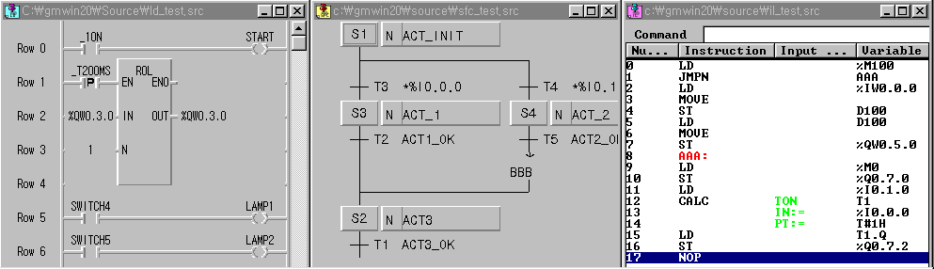

Using Variables by Symbol
You can create a program using symbols for easy understanding and memory address is also assigned automatically. It supports various data types. So you can create high-leveled programs.

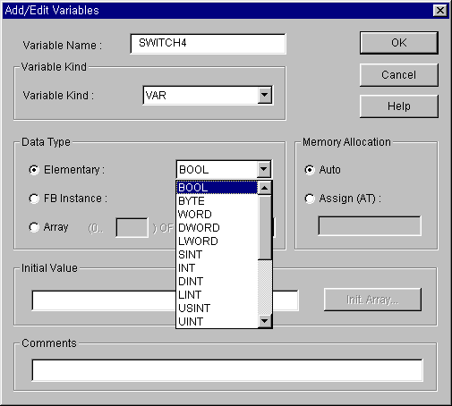

PLC System using Project Unit
It is very easy to create and test a program because you can include several programs in one PLC system.
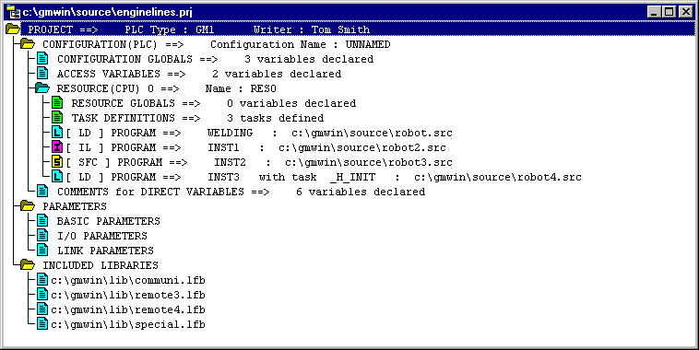

Connecting GMWIN to PLC by Easy Network
You can download and monitor programs not only in directly connected PLC but also in a local PLC connected by network.

Various PLC Information
It is available to monitor various PLC states and to use this function in the program mode.

User-Defined Libraries
Besides standard functions and function blocks, you can define a frequently used program as one of functions or function blocks for your convenience.

1.2 How to Connect GMWIN to PLC
In connection GMWIN to PLC, you must previously define two options – 『Method of Connection』and 『Depth of Connection』in Connect Option.
There are four kinds of methods of connection, using RS-232C, MODEM, Communication module ( GLOFA Fnet/Mnet for PC ) and Network ( Ethernet ), and three kinds of depth of connections such as Local, Remote 1 and remote 2.
When using Windows 3.x for operating system, the connections using Communication module and Network are not supported.

Select 『Connect option』in Project - Option menu.

Method of Connection

Connection using RS-232C
To use RS-232C connection, connect the RS-232C cable with the serial port in PC and serial port in PLC
◆ From the Project Menu, choose Option.

◆ Choose Connect Option tab in the Option dialog box.

◆ Select RS-232C in Method of Connection.
◆ Select Communication Port.
◆ Select Depth of Connection and click OK button.

Local Connection
◆ Select Local in Depth of Connection and click OK button.
◆ Choose Connect from the Online Menu

Remote Connection (See GLOFA Fnet/Mnet user's manual for more details),
◆ Open Network Type List and select a network type.
◆ Type a station number in Station No. Box.
◆ Select slot number.
◆ Click OK button.
◆ Choose Connect from the Online Menu.
Note

The specification of RS-232C cable connection

