6.10 Help

Shows the help of XGT-Editor.

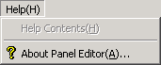

6.10.1 About XGT Editor

