Chapter 6. Panel Editor

6.1 Main screen of Panel Editor

The Panel Editor consists of four windows and functions of them are as follows

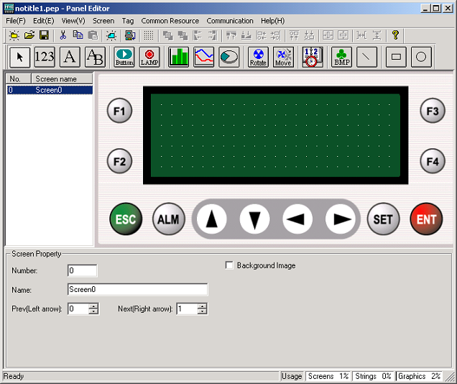

6.1.1 Menu and toolbar window

This window contains various menus and toolbar.

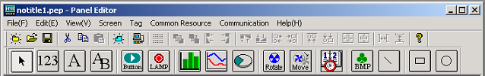

6.1.2 Screen editing window

This window displays an practical editing screen

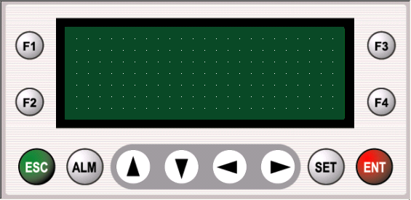

6.1.3 Screen selection window

You can select screen to edit from this windows

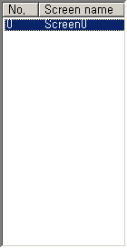

6.1.4 Properties window

This window is a window designating properties of various tags. Window configuration is changed according to the tag’s kind.

