Data Sheet

LG Programmable Logic Controller
High Speed Counter Module
GLOFA-GM
G6F-HSCA

LG Industrial Systems

● Beijing Branch ● Bangkok Branch
LG Industrial Systems LG Industrial Systems (Thailand)
Elevator Co., Ltd. Co., Ltd
T : +86-10-6462-3256 T : +66-2-381-8443
F : +86-10-6462-3255 F : +66-2-381-8445
● Bogota Branch ● Chicago Branch
LG Industrial Systems de LG Industrial Systems Co., Ltd.
Colombia S.A. Chicago Office
T : +57-1-310-6077 T : +1-708-692-4500
F : +57-1-310-5831 F : +1-708-692-4501
● Dalian Branch ● Hanoi Branch
Dalian LG Industrial Systems LG Industrial Systems Co., Ltd.
Co., Ltd. Hanoi Office
T : +86-411-281-2579 T : +64-4-821-0388
F : +86-411-281-2578 F : +64-4-821-0399
● Hong Kong Branch ● Shanghai Branch
LG Industrial Systems (HK) Ltd. Shanghai LG Industrial Systems Co., Ltd.
T : +852-2598-6615 T : +86-21-6248-2710
F : +852-2598-7105 F : +86-216248-3236
● Singapore Branch ● Taipei Branch
LG Industrial Systems Co., Ltd. LG Industrial Systems (Taiwan) Co. Ltd.
T : +65-323-7361 T : +886-2-516-5010
F : +65-323-7362 F : +886-2-516-5035
● Tokyo Branch
LG Industrial Systems Co., Ltd. Tokyo Office
T : +81-3-3589-6362
F : +81-3-3588-1810

LG Industrial Systems Co., Ltd.
● Head Office
LG Mullae Building 9th F, 10, Mullae-dong 6-ga, Yongdungpo-gu, Seoul, KOREA
Tel : +82-2-2006-3751~6 Fax : +82-2-2006-3951
Home page : http:www.lgis.lg.co.kr/fa

702005650
Before handling the product
Read this data sheet carefully prior to any operation, mounting, installation or start-up of the product.

Materials for GLOFA GM
Name | Code
GLOFA GMWIN (Programming software) | 702005047
GLOFA GMWIN (Instruction & Programming) | 702005058
GLOFA GM6 (User’s manual) | 702005581
GLOFA GM6 High Speed Counter (User’s manual) | 702005069

Name | GLOFA-GM G6L-CUEB/CUEC Data Sheet
Code | 702005650

□ Safety Precautions
Be sure to read carefully the safety precautions given in data sheet and user’s manual before operating the module and follow them.
The precautions explained here only apply to the GLOFA G6L-CUEB/CUEC module.
For safety precautions on the PLC system, please see the GLOFA GM6 user’s manual.
A precaution is given with a hazard alert triangular symbol to call your attention, and precautions are represented as follows according to the degree of hazard.
If not provided with proper prevention, it can cause death, fatal injury or considerable loss or property
If not properly observed, it can cause a hazard situation to result in severe or slight injury or a loss of property.
WARNING
!
CAUTION
!

However, a precaution followed with CAUTION can also result in serious condition. Both of two symbols indicate that an important content is mentioned, therefore, be sure to observe it.
Keep this manual handy for your quick reference in necessary.

□ Design Precaution
CAUTION
Do not run I/O signal lines near to high voltage line or power line. Separate them as 100mm or more as possible. Otherwise, noise can cause module malfunction

□ Installation Precaution
CAUTION
Operate the PLC in the environment conditions given in the general specifications
If the PLC is operated in other environment not specified in the general specification, it can cause an electric shock, a fire, malfunction or damage or degradation of the module.
Make sure the module fixing projections is inserted into the module fixing hole and fixed.
Improper installation of the module can cause malfunction, disorder or falling.

□ Wiring Precautions
CAUTION
CAUTION
When grounding a FG terminal, be sure to provide class 3 grounding which is dedicated to the PLC.
Before the PLC wiring, be sure to check the rated voltage and terminal arrangement for the module and observe them correctly.
Drive the terminal screws firmly to the defined torque. If loosely driven, it can cause short circuit, fire or malfunction.
Be careful that any foreign matter like wire scraps should not enter into the module. It can cause a fire, disorder or malfunction.

□ Test RUN and Maintenance Precautions
WARNING
Do not contact the terminals while the power is applied. It can cause malfunction.
When cleaning or driving terminal screws, perform them after the power has been turned off.
Do not perform works while the power is applied. It can cause disorder or malfunction.

Do not separate the PCB from the case of module, or do not remodel the module. They can cause disorder, malfunction, damage of the module or a fire.

□ Waste Disposal Precautions
CAUTION
When disposing the module, do it as an industrial waste.

1. Introduction
This data sheet contains the brief information about the characteristics, configurations, and operating of GM6 high speed counter module.
2. General Specifications

No. | Item | Specification |  |  |  |  |  | Standard
1 | Operating temperature | 0 ~ 55℃
2 | Storage temperature | -25 ~ 70℃
3 | Operating Humidity | 5 ~ 95%RH, non-condensing
4 | Storage humidity | 5 ~ 95%RH, non-condensing
5 | Vibration | Occasional vibration |  |  |  |  |  | IEC 1131-2
5 | Vibration | Frequency | Acceleration |  | Amplitude |  | Sweep count | IEC 1131-2
5 | Vibration | 10≤f∠57 Hz | - |  | 0.075 mm |  | 10 times in each direction for  X, Y, Z | IEC 1131-2
5 | Vibration | 57 ≤f≤150 Hz | 9.8㎨ {1G} |  | - |  | 10 times in each direction for  X, Y, Z | IEC 1131-2
5 | Vibration | Continuos vibration |  |  |  |  | 10 times in each direction for  X, Y, Z | IEC 1131-2
5 | Vibration | Frequency | Acceleration |  | Amplitude |  | 10 times in each direction for  X, Y, Z | IEC 1131-2
5 | Vibration | 10≤f∠57 Hz | - |  | 0.035 mm |  | 10 times in each direction for  X, Y, Z | IEC 1131-2
5 | Vibration | 57≤f≤150 Hz | 4.9㎨{0.5G} |  | - |  | 10 times in each direction for  X, Y, Z | IEC 1131-2
6 | Shocks | *Maximum shock acceleration: 147㎨ {15G}  *Duration time :11 ms  *Pulse wave: half sine wave pulse( 3 times in each of X, Y and Z directions ) |  |  |  |  |  | IEC 1131-2
7 | Noise immunity | Square wave impulse noise | ±1,500 V
7 | Noise immunity | Electrostatic discharge | Voltage :4kV(contact discharge) |  |  |  |  | IEC 1131-2  IEC 801-2
7 | Noise immunity | Radiated electromagnetic field | 27 ~ 500 MHz, 10 V/m |  |  |  |  | IEC 1131-2  IEC 801-3
7 | Noise immunity | Fast transient burst noise | Severity  Level | All power modules | Digital I/Os ( Ue ≥  24 V) | Digital I/Os  (Ue < 24 V) Analog I/Os communication I/Os |  | IEC 1131-2  IEC 801-4
7 | Noise immunity | Fast transient burst noise | Voltage | 2 kV | 1 kV | 0.25 kV |  | IEC 1131-2  IEC 801-4
8 | Atmosphere | Free from corrosive gases and excessive dust
9 | Altitude for use | Up to 2,000m
10 | Pollution degree | 2 or lower
11 | Cooling method | Self-cooling
3. Performance Specifications
5. 각 부의 명칭과 역할
Item | Specifications
Number of Channels | 1 channel
Counter input  signal | Signal | Phase A, Phase B or Phase Z
Counter input  signal | Signal level | 5 / 12 / 24 VDC (7mA)
Counter input  signal | Signal type | Voltage input
Counting range | 0 to 16,777,215 (24 Bits Binary)
Counting speed | Maximum 50 kHz
Preset Operation | Set by connector signal or program
Limit switch input | 24 VDC
Setting Increment /Decrement | 1-phase input |  | Set by program or Phase B is set
Setting Increment /Decrement | 2-phase input |  | Set by difference of phase automatically
External output | Type |  | Out 1, Out 2(One among ‘>’, ‘=’ and ‘<’ is selected)
External output | Signal type |  | Transistor output ( open collector output, 10 to 30 V)
Multiplication | The multiplication factor for the input pulse may be set to 1, 2 or 4  (Selected by DIP Switch adjustment)
Current consumption | 5 VDC, 180 mA
Weight | 160 g

4. I /O Specifications

1) Input Specifications

Item | Specifications
Rated input voltage / current | 5 VDC (7 mA)
Rated input voltage / current | 12 VDC (7 mA)
Rated input voltage / current | 24 VDC (7 mA)
' On ' guarantee voltage | 5 VDC | 4.5 V or more
' On ' guarantee voltage | 12 VDC | 11 V or more
' On ' guarantee voltage | 24 VDC | 14 V or more
' Off ' guarantee voltage | 5 VDC | 0.8 V or less
' Off ' guarantee voltage | 12 VDC | 1.5 V or less
' Off ' guarantee voltage | 24 VDC | 2.5 V or less

2) Limit Switch(L/S) and Preset(PSET) Input Specifications

Item | Specifications
Input voltage | 24 VDC
' On ' guarantee voltage | 19 VDC or more
' Off ' guarantee voltage | 6 VDC or less
On Delay Time | 1.5 ms or less
Off Delay Time | 2 ms or less

3) Transistor Output Specifications

Item | Specifications
Rated output | 24 VDC, 200 mA
Leakage current | 50 μA or less
Saturated voltage | 1.3V
On Delay Time | 50 μs or less
Off Delay Time | 50 μs or less
5. Parts Name and Descriptions

G6F-HSCA
RDY L/S
ΦA PRE
ΦB PRE
ΦC PRE

Description
Ready (RDY)

Turns on when the power is applied
Phase A Input (ΦA)

Turns on when voltage is applied to phase A input terminal.
Phase B Input (ΦB)

Turns on when voltage is applied to phase B input terminal
Phase Z Input (ΦZ)

Turns on when voltage is applied to phase B input terminal
Limit Switch Input (L/S)

Turns on when voltage is applied to limit switch input terminal
Preset Switch Input (PRE)

Turns on when voltage is applied to preset switch input terminal
Output 1 (OUT1)

Indicate the magnitude comparison result of CMP 1
Output 2 (OUT2)

Indicate the magnitude comparison result of CMP 2

2) DIP Switch Setting Part
The DIP Switch settings are used for phase-2/ phase-1 operation mode specification, Increment / Decrement count method specification at 1-phase operation, and multiplication specification at 2-phase operation.
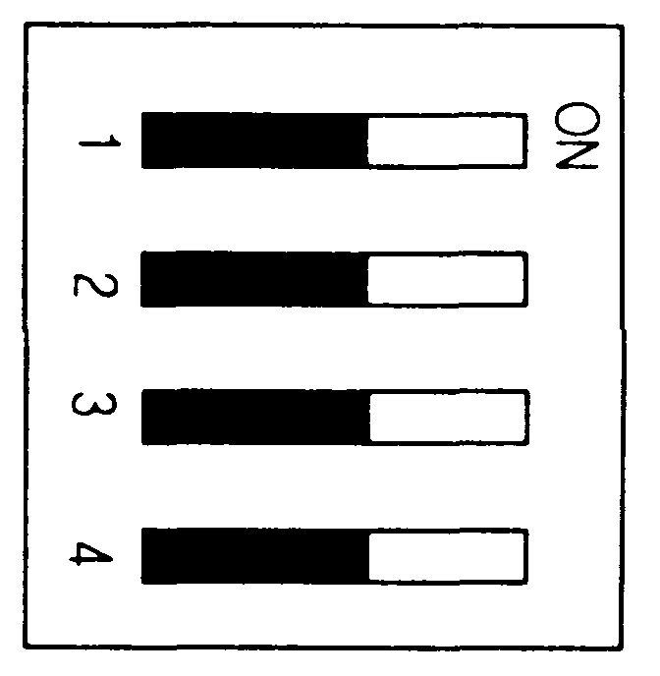

Switch | Functions
Switch | Status | Descriptions
SW 1 | ON | Specifies the 2 – phase pulse operation mode.
SW 1 | OFF | Specifies the 1 – phase pulse operation mode.
SW 2 | ON | Specifies the phase B pulse input mode as increment/decrement count method at 1 phase pulse inputs
SW 2 | OFF | Specifies the program input mode as increment/decrement count method at 1 phase pulse inputs
SW 3  SW 4 | ON  ON | Specifies multiplication 1
SW 3  SW 4 | ON  OFF | Specifies multiplication 2
SW 3  SW 4 | OFF  ON | No multiplication is applied
SW 3  SW 4 | OFF  OFF | Specifies multiplication 4

3) I/O terminal connector

6. Installation and Test Run
8. Dimension (mm)

6.1 Ambiance Requirements
Avoid installing this module in locations, which are subjected or exposed to:
▶ Water leakage and dust a large amount of dust, powder and other conductive power, oil mist, salt, of organic solvent
▶ Mechanical vibrations of impacts transmitted directly to the module body.
▶ Direct sunlight.
▶ Dew condensation due to sudden temperature change.
▶ High or low temperatures (outside the range of 0-55℃)

6.2 Installing and Wiring
▶ During wiring or other work, do not allow any wire scraps to enter into it.
▶ Install it on locations that are convenient for operation.
▶ Make sure that it is not located near high voltage equipment on the same panel.
▶ Make sure the distance from the walls of duct and external equipment be 50 mm or more.
▶ Be sure to be grounded to locations that have good noise immunity.

6.3 Test Run

REMARK
Please check the voltage level of input terminal is proper before the power is applied to the encoder.
For example, if 24 V is given for 5 V input, it can cause faults.

● Check Items before the Power Is Applied.
1. Check if the input signal is 1-phase, or 2-phase.
2. Check if the adjustment of DIP switch according to input signal type.
3. Check the wiring on terminal block is correct.
4. Check if the external power is correct.

7. Wiring

I/O | Internal Current | Terminal pin No. | Signal Name | Operation | Input guarantied  Voltage
Input |  | 1 | 24 V, Phase A pulse input | ON | 14~26.4 V
 |  |  |  | OFF | 2.5 V
 |  | 2 | 12 V, Phase A pulse input | ON | 11~13.2 V
 |  |  |  | OFF | 1.5 V
 |  | 3 | 5 V, Phase A pulse input | ON | 4.5~5.5 V
 |  |  |  | OFF | 0.8 V or less
 |  | 4 | COM
 |  | 5 | 24 V, Phase B pulse input | ON | 14~26.4 V
 |  |  |  | OFF | 2.5 V
 |  | 6 | 12 V, Phase B pulse input | ON | 11~13.2 V
 |  |  |  | OFF | 1.5 V
 |  | 7 | 5 V, Phase B pulse input | ON | 4.5~5.5 V
 |  |  |  | OFF | 0.8 V or less
 |  | 8 | COM
 |  | 9 | 24 V, Phase Z pulse input | ON | 14~26.4 V
 |  |  |  | OFF | 2.5 V
 |  | 10 | 12 V, Phase Z pulse input | ON | 11~13.2 V
 |  |  |  | OFF | 1.5 V
 |  | 11 | 5 V, Phase Z pulse input | ON | 4.5~5.5 V
 |  |  |  | OFF | 0.8 V or less
 |  | 12 | COM
Input |  | 13 | L/S input 24 V | ON | 19~26.4 V
 |  |  |  | OFF | 6 V or less
Input |  | 14 | L/S COM
Input |  | 15 | Preset input 24V | ON | 19~26.4 V
 |  |  |  | OFF | 6 V or less
Input |  | 16 | L/S COM
Output  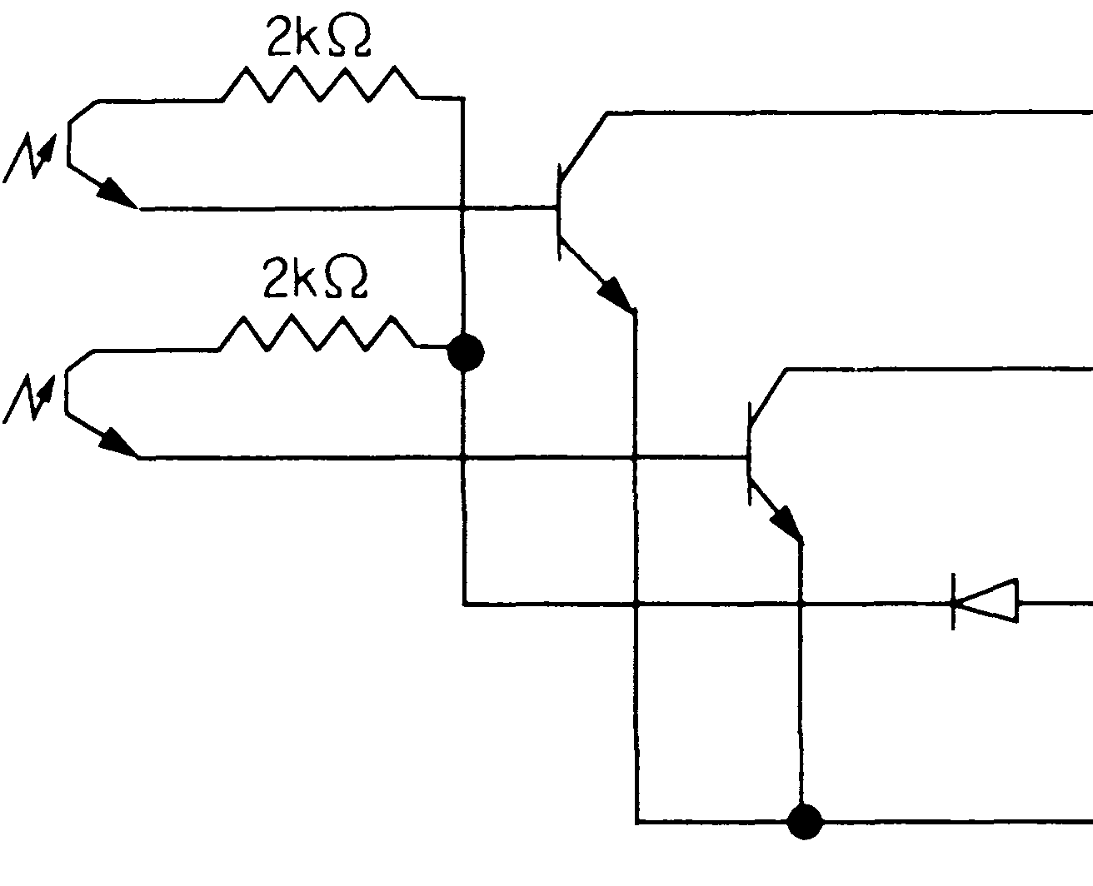 |  | 17 | Open collector output OUT1 | Rated output:  24VDC, 200 mA  Response time:  OFF →ON50μs or less  ON→OFF 50μs or less
 |  | 18 | Open collector output OUT2
 |  | 37 | External power supply output  24 V | Input voltage  10.2 ~ 30 V
 |  | 19 | External power supply COM  0 V

[ An example of wiring : DC5V, Voltage output]

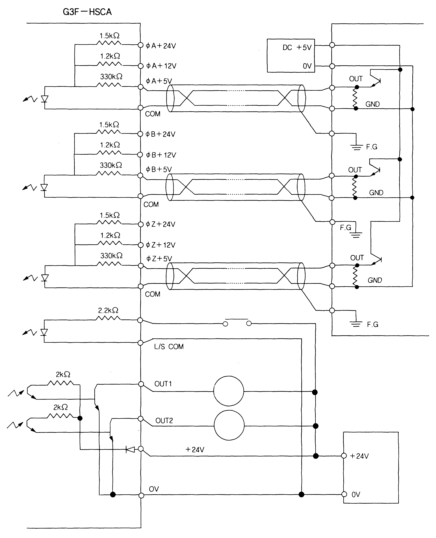
Shielded cable
Shielded cable
Shielded cable
External Power
Pulse Generator
Limit Switch
L/S input +24V
External power +24V
Relay
Relay
External power
270Ω
270Ω
820Ω
820Ω
820Ω
Preset input
Preset input +24V
Preset COM

[The output mode of encoder]

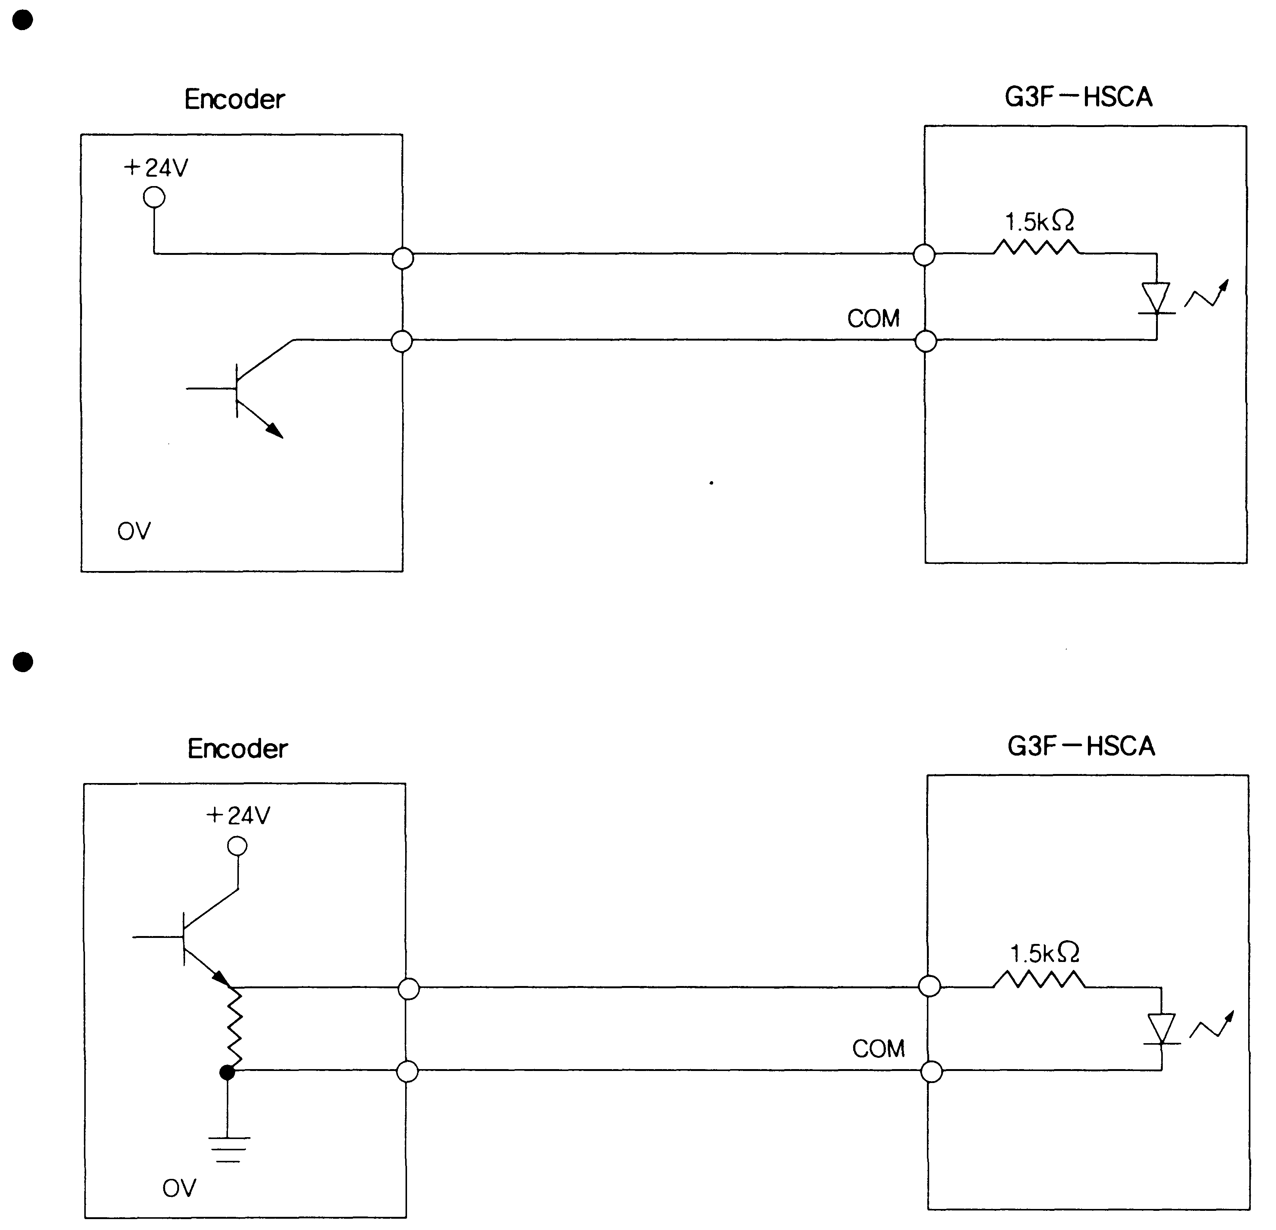
G6F-HSCA
3.3kΩ
G6F-HSCA
3.3kΩ
Open collector output
Voltage output

