DATA SHEET

LG Programmable Logic Controller
Analog to Digital Conversion Module
GLΟFA G6F-AD2A



LG Industrial Systems

● Beijing Branch ● Bangkok Branch
LG Industrial Systems Elevator Co., Ltd. LG Industrial Systems (Thailand) Co., Ltd
T : +86-10-6462-3256 T : +66-2-381-8443
F : +86-10-6462-3255 F : +66-2-381-8445
● Bogota Branch ● Chicago Branch
LG Industrial Systems de Colombia S.A. LG Industrial Systems Co., Ltd. Chicago Office
T : +57-1-310-6077 T : +1-708-692-4500
F : +57-1-310-5831 F : +1-708-692-4501
● Dalian Branch ● Hanoi Branch
Dalian LG Industrial Systems Co., Ltd. LG Industrial Systems Co., Ltd. Hanoi Office
T : +86-411-281-2579 T : +64-4-821-0388
F : +86-411-281-2578 F : +64-4-821-0399
● Hong Kong Branch ● Shanghai Branch
LG Industrial Systems (HK) Ltd. Shanghai LG Industrial Systems Co., Ltd.
T : +852-2598-6615 T : +86-21-6248-2710
F : +852-2598-7105 F : +86-216248-3236
● Singapore Branch ● Taipei Branch
LG Industrial Systems Co., Ltd. LG Industrial Systems (Taiwan) Co. Ltd.
T : +65-323-7361 T : +886-2-516-5010
F : +65-323-7362 F : +886-2-516-5035
● Tokyo Branch
LG Industrial Systems Co., Ltd. Tokyo Office
T : +81-3-3589-6362
F : +81-3-3588-1810

LG Industrial Systems Co., Ltd.
● Head Office
LG Mullae Building 9th F, 10, Mullae-dong 6-ga, Yongdungpo-gu, Seoul, KOREA
Tel : +82-2-2006-3751~6 Fax : +82-2-2006-3951
Home page : http:www.lgis.lg.co.kr/fa

Before handling the product
Read this data sheet carefully prior to any operation, mounting, installation or
start-up of the product.
Materials for GLOFA GM
Name | Code
GLOFA GMWIN (Programming Software) | 702005047
GLOFA GM (Instruction & programming) | 702005058
GLOFA-GM6 | 702005592
GLOFA G6F-AD2A  WARNING  ! | 702005763

Name | GLOFA G6F-AD2A Datasheet
Code | 702005729

□ Safety Precautions
Be sure to read carefully the safety precautions given in data sheet and user’s manual before operating the module and follow them. The precautions explained here only apply to the G6F-AD2A. For safety precautions on the PLC system, see the GLOFA GM6 User’s Manuals.
A precaution is given with a hazard alert triangular symbol to call your attention, and precautions are represented as follows according to the degree of hazard.
WARNING
!
If not provided with proper prevention, it can cause death, fatal injury or considerable loss of property.

CAUTION
!
If not properly observed, it can cause a hazard situation to result in severe or slight injury or a loss of property.
CAUTION
!
However, a precaution followed with can also result in serious conditions.
Both of two symbols indicate that an important content is mentioned, therefore, be sure to observe it. Keep this manual handy for your quick reference in necessary.

□ Design Precautions
CAUTION
!

▶Do not run I/O signal lines near to high voltage line or power line.
Separate them as 100 mm or more as possible. Otherwise, noise can cause module
malfunction.

□ Installation Precautions
CAUTION
!

▶Operate the PLC in the environment conditions given in the general specifications.
▶If operated in other environment not specified in the general specifications, it can
cause an electric shock, a fire, malfunction or damage or degradation of the module.
▶Make sure the module fixing pro-jections is inserted into the module fixing hole
and fixed.
▶Improper installation of the module can cause malfunction, disorder or falling.

□ Wiring Precautions
CAUTION
!

▶When grounding a FG terminal, be sure to provide class 3 grounding which is
dedicated to the PLC.
▶Before the PLC wiring, be sure to check the rated voltage and terminal arrangement
for the module and observe them correctly.
If a different power, not of the rated voltage, is applied or wrong wiring is provided,
it can cause a fire or disorder of the nodule.
▶Drive the terminal screws firmly to the defined torque.
If loosely driven, it can cause short circuit, a fire or malfunction.
▶Be careful that any foreign matter like wire scraps should not enter into the module.
It can cause a fire, disorder or malfunction.

□ Test RUN and Maintenance Precautions
CAUTION
!

▶Do not contact the terminals while the power is applied. It can cause malfunction.
▶When cleaning or driving a terminal screw, perform them after the power has been
turned off.
▶Do not perform works while the power is applied, which can cause disorder or
malfunction.

▶Do not separate the module from the printed circuit board(PCB), or do not remodel
the module.
They can cause disorder, malfunction, damage of the module or a fire.
When mounting or dismounting the module, perform them after the power has been
turned off.
▶Do not perform works while the power is applied, which can cause disorder or malfunction.

□ Waste Disposal Precautions
CAUTION
!

▶When disposing the module, do it as an industrial waste.

1. Introduction
The G6F-AD2A is analog/digital conversion module for use with the GLOFA PLC GM6 series CPU module. The A/D conversion module is to convert an analog input signal (voltage or current) from external sensors into a 12-bit signed Binary digital value.

No | Item | Specifications |  |  |  |  |  |  | Standard
1 | Operating temperature | 0 ~ 55℃
2 | Storage temperature | -25 ~ 70℃
3 | Operating Humidity | 5 ~ 95%RH, non-condensing
4 | Storage humidity | 5 ~ 95%RH, non-condensing
5 | Vibration | Occasional vibration |  |  |  |  |  |  | IEC 1131-2
5 | Vibration | Frequency | Acceleration |  |  | Amplitude |  | Sweep count | IEC 1131-2
5 | Vibration | 10≤f∠57 Hz | - |  |  | 0.075 mm |  | 10 times in each direction for  X, Y, Z | IEC 1131-2
5 | Vibration | 57 ≤f≤150 Hz | 9.8㎨ {1G} |  |  | - |  | 10 times in each direction for  X, Y, Z | IEC 1131-2
5 | Vibration | Continuos vibration |  |  |  |  |  | 10 times in each direction for  X, Y, Z | IEC 1131-2
5 | Vibration | Frequency | Acceleration |  |  | Amplitude |  | 10 times in each direction for  X, Y, Z | IEC 1131-2
5 | Vibration | 10≤f∠57 Hz | - |  |  | 0.035 mm |  | 10 times in each direction for  X, Y, Z | IEC 1131-2
5 | Vibration | 57≤f≤150 Hz | 4.9㎨{0.5G} |  |  | - |  | 10 times in each direction for  X, Y, Z | IEC 1131-2
6 | Shocks | *Maximum shock acceleration: 147㎨ {15G}  *Duration time :11 ms  *Pulse wave: half sine wave pulse( 3 times in each of X, Y and Z  directions ) |  |  |  |  |  |  | IEC 1131-2
7 | Noise immunity | Square wave impulse noise | ±1,500 V |  |  |  |  |  | LGIS  Standard
7 | Noise immunity | Electrostatic discharge | Voltage :4kV(contact discharge) |  |  |  |  |  | IEC 1131-2  IEC 801-2
7 | Noise immunity | Radiated electromagnetic field | 27 ~ 500 MHz, 10 V/m |  |  |  |  |  | IEC 1131-2  IEC 801-3
7 | Noise immunity | Fast transient  &  burst noise | Severity  Level | All power modules | Digital I/Os ( Ue ≥  24 V) |  | Digital I/Os  (Ue < 24 V) Analog I/Os communication I/Os |  | IEC 1131-2  IEC 801-4
7 | Noise immunity | Fast transient  &  burst noise | Voltage | 2 kV | 1 kV |  | 0.25 kV |  | IEC 1131-2  IEC 801-4
8 | Atmosphere | Free from corrosive gases and excessive dust
9 | Altitude for use | Up to 2,000m
10 | Pollution degree | 2 or lower
11 | Cooling method | Self-cooling

3. Performance Specifications

Items |  |  | Specifications
Analog Analog  input | Voltage |  | 1 ~ 5 VDC (input resistance 1㏁)  0 ~ 10VDC (input resistance 1㏁)  –10 ~ 10 VDC (input resistance 1㏁)
Analog Analog  input | Current |  | DC 4 ~ 20 mA (input resistance 250Ω)
Analog Analog  input | Voltage/Current selection |  | *. Selection by Terminal Wiring  (It has to be connected between V and I terminal to select current)  *. Selection of voltage range by switch on the side of module
Digital output |  |  | *. 16-bit (data: 12bit)signed binary(-48 ~ 4047, -2048 ~ 2047)  *. Digital Output value is selected by program
Maximum resolution | 1 ~ 5 VDC |  | 1 mV (1/4000)
Maximum resolution | 0 ~ 10VDC |  | 2.5mV(1/4000)
Maximum resolution | -10 ~ 10 VDC |  | 5 mV (1/4000)
Maximum resolution | DC 4 ~20 mA |  | 4㎂ (1/4000)
Overall Accuracy(%) |  |  | ±0.5% or lower (accuracy to full scale)
Maximum conversion speed  (ms/channel) |  |  | 5.0ms/1 channel
Maximum absolute input |  |  | Voltage(V):15, Current (mA):25
Number of analog input point |  |  | 4 channels/module
Isolation |  |  | Between input terminals and PLC: Photo coupler isolation  (Between channels : Non-isolated)
Terminals connected |  |  | 18-point terminal block
Internal current consumption(A) |  | +5VDC | 40mA
 |  | +15VDC | 50mA
 |  | -15VDC | 20mA
Weight (g) |  |  | 200g
CAUTION
!

▶The output range of GM6-PA1B is 0.5A with +15VDC and 0.2A with –15VDC.
Make sure there total current consumption of A/D and D/A conversion modules
▶Do not exceed the output range capacity of power supply module(GM6-PA1B).
▶The offset/gain value of A/D conversion modue is fixed.
▶The factory setting of output type is current output.

4. Parts Name and Functions
2. General Specifications

This following shows the names of parts and functions of G6F-AD2A module.
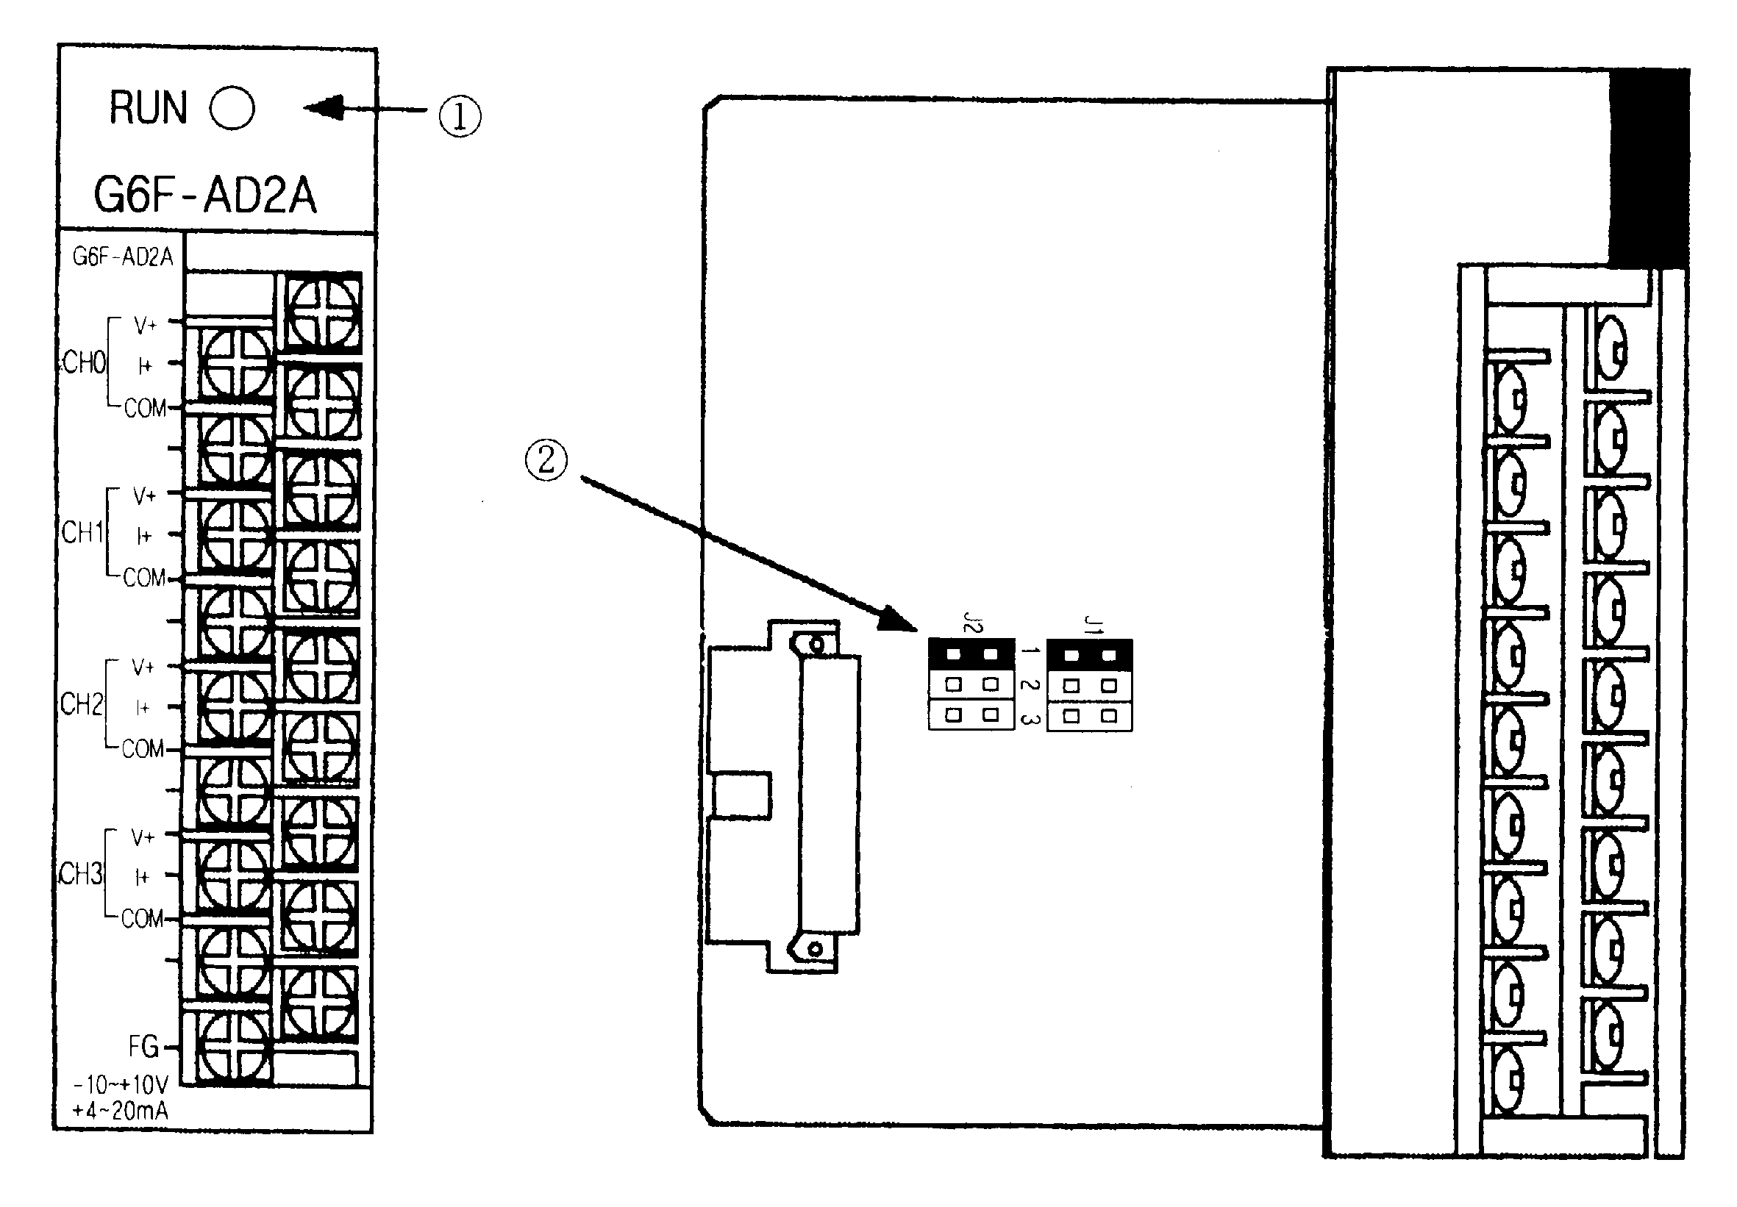

O | Description
① | RUN LED
① | Indicates the operating status of the G6F-AD2A.
②  J1  J2  J1  J2  J1  J2  J1  J2 | Selection Switch of Voltage/Current
  Analog Input |  | Input Range Selection Switch
  Voltage | 1 ~ 5VDC
  Voltage | 0 ~ 5VDC
  Voltage | -10 ~ 10VDC
  Current | 4 ~ 20mADC
5. Handling Precautions

From unpacking to installation, be sure to check the following:
1) Do not drop it off, and make sure that strong impacts should not be applied.
2) Do not dismount printed circuit boards from the case. It can cause malfunctions.
3) During wiring, be sure to check any foreign matter like wire scraps should not enter into the
upper side of the PLC, and in the event that foreign matter entered into it, always eliminate it.
4) Be sure to disconnect electrical power before mounting or dismounting the module.

6. Wiring

6.1 Wiring Precaution
1) Separate AC and external input signal of A/D conversion module wiring not to be affected by
surge or induced noise in the AC.
2) External wiring has to be at least AWG22(0.3㎟) and be selected in consideration of operating
ambiance and/or allowable current.
3) Separate wiring from devices and/or substances generating intense heat, and oil not to make
short-circuit which leads to damage and/or mis-operation.
4) Identify the polarity of terminal block before external power supply is made connected.
5) Separate external wiring sufficiently from high voltage and power supply cable not to cause
induced failure and/or malfunction.

6.2 Wiring example
1) Voltage Input(DC-10~10V)
R
R
*1
-15V
V+
I+
COM
R
+15V
1
2
3
J1
J2
FG
G6F-AD2A
Input range select switch
CH0
R
R
*1
V+
I+
COM
R
*2
CH3
*2
*2
*2
*2
*2
*1
*1
*3

2) Current Input(DC4~20㎃)
1
2
3
J1
J2
R
R
*1
-15V
V+
I+
COM
R
+15V
FG
G6F-AD2A
Input range select switch
CH0
R
R
*1
V+
I+
COM
R
*2
CH3
*2
*2
*2
*2
*2
*1
*1
*3

*1 For the cable, use a two-core twisted shielded wire.
*2 Input resistance has been shown.
*3 When there is much noise, FG of the power supply module must be grounded.
7. Dimension
(Unit : mm)
MEMO
MEMO
MEMO
MEMO
MEMO
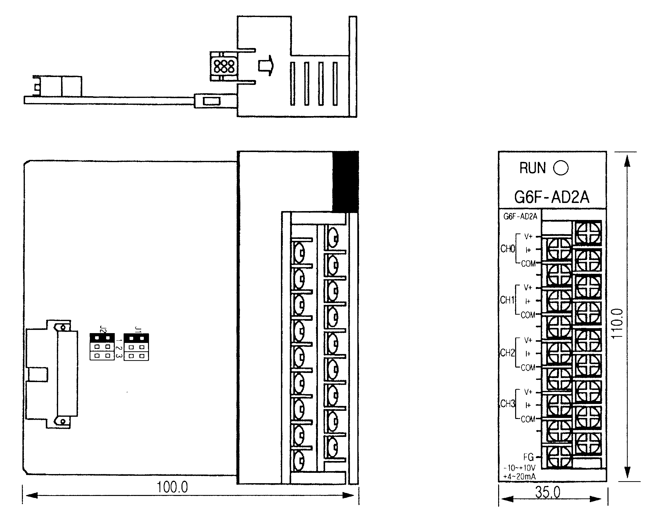

90.0

